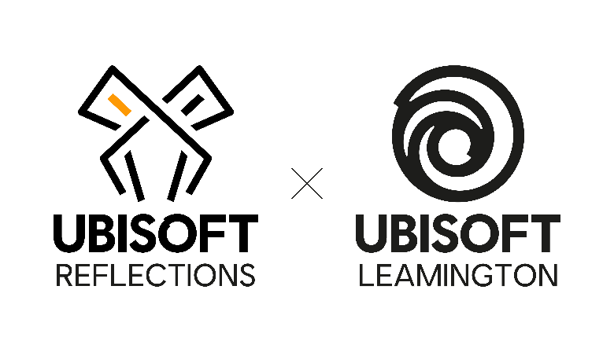

SENIOR ASSOCIATE PRODUCER
Job Purpose
Facilitate and monitor the production of multiple core project features and the major activities of the development team to ensure timely delivery at the required levels of quality, with efficient use of resources. The Senior Associate Producer implements new processes, tools and workable methods which optimises the whole production process using their key understanding of the gaming market, leadership and technology.
Reports To
Producer.
Direct Reports
Junior Associate Producer, Associate Producer as appropriate.
Responsibilities
- Simultaneously run teams of 15-25 developers and take responsibility for the delivery of multiple features and core areas of the project with significant corporate impact, comprising of 50+ developers;
- Master skills and knowledge in leadership, marketing and/or technology to advise and direct the project team;
- Manage Junior and Intermediate Associate Producers, sharing your knowledge and expertise aiding in their personal and professional growth;
- Implement the most efficient processes and pipelines to streamline development, increase productivity and improve day-to-day activities on both a team and project level;
- Create strategies, plans, roadmaps, schedules and capacity planning for your teams and the project on a sprint, milestone and project basis to effectively manage your given area of the mandate;
- Create and monitor tasks using the appropriate tools, updating and reporting on progress where necessary;
- Suggest and implement improvements to Production processes on the project;
- Collaborate with project Leads, Direction and Production groups to create necessary development plans and strategies in accordance with timescales;
- Facilitate, organise and follow up on development team’s meetings, assigning out actions as appropriate;
- Effectively plan sprints according to milestone targets and work with your given Leads to create the product backlog which is consistently optimised;
- Identify and implement innovative and optimal solutions to complex issues;
- Be a leader in the construction and guidance of a production team to reach the project's ambitions in terms of quality, timing and budget;
- Support the day-to-day management of Production team members and be a mentor to less experienced members of the group, sharing your knowledge and expertise;
- Mediate cross-discipline situations with a focus on delivery within the team and the project as a whole;
- Provide reports on tasks and issues relating to project management and the project as a whole, both within the team and the studio;
- Work directly with the teams to foster strong relationships and build collaboration efforts on the project as whole;
- Work with Co-Dev partners to build strong relationships outside the studio;
- Identify and mitigate all dependencies within your area of the project and the teams under your ownership;
- Identify, assess and manage risks, raising issues associated with the project, creating appropriate mitigation plans and subsequent actions, driving them forward to a resolution;
- Prioritise tasks, suggest relevant solutions to issues and track outcomes to milestones and other objectives relating to the project;
- Organise and define what is required from the team whilst managing the needs of the project in the short-term;
- Optimise the use of the budget relating to the project and measure the financial impact and value of the team’s plans;
- Conduct ad-hoc jobs related to content or project support as appropriate;
- Act as an internal reference on all project management topics;
- Collaborate with internal and external Quality Control teams to ensure bugs are fixed at an appropriate rate and to the correct priority;
- Be a positive and influential presence within project, local studio and wider Ubisoft group.
Skills and Knowledge
- A proven workable and extensive knowledge of Agile and Waterfall development methodologies;
- Ability to quickly adapt to change, work effectively under pressure and handle competing priorities while managing expectations;
- Exemplary written, interpersonal and communication skills;
- In depth knowledge of the video game industry and production processes;
- In depth knowledge of the video game market, qualities of leadership and/or knowledge of technology;
- Ability to adapt and effectively communicate using different styles when working with team members across the world with various cultural backgrounds;
- Strong emotional intelligence;
- Extensive knowledge of the Microsoft suite e.g. Word, Excel, OneNote, MS Project, PowerPoint and Outlook;
- Proven and workable knowledge of project management software (e.g. Jira, Hansoft) and other relevant task tracking tools.
Relevant Experience
- Experience in a full-time project management or transferrable role with relevant skills is essential;
- Experience in the video game or software development industry is desired but not essential;
- Proven and workable knowledge of project management software (e.g. Jira, Hansoft) and other relevant task tracking tools is desired but not essential;
- Experience in team and direct line management is essential.

