Position Description – Employment Consultant (WorkBC)

Position Description
Position title | Employment Consultant
Location | Metrotown
Reports to | Centre Manager
Direct reports | N/A
Travel requirements | N/A

Position purpose
The Employment Consultant (EC) assists clients to find and maintain employment. This role ensures successful outcomes for the client while ensuring all contract deliverables are achieved. The process of Case Management involves developing a positive relationship with the client, encouraging, motivating, and supporting the client to achieve sustainable employment, and increase independence and self-sufficiency as appropriate for each client. Key factors in Case Management include assisting clients with job placement opportunities, contacting employers, building confidence, self-motivation, building their skills, strengths, and abilities to achieve and maintain sustainable employment.

Success measures
Customer/Stakeholder Satisfaction | - Complete 4-5 new intakes each week
Program Outcomes | - Meet goals associated with 4-week, 24-week and 52-week outcomes  - Achieve Service Utilization targets as a percentage of clients  - Additional interventions provided to clients who have been in active services for >12 weeks

Core Responsibilities:
Case Management | - Conduct a Client Needs Assessment with eligible clients as the first step in their individualized action plan  - Collaborate with the client to develop, update and revise action plans, in line with policy  - Overall responsibility for the management of assigned client case files in the primary information system (ICM), including, documentation in client eligibility determination, and recording client progress and results  - Support and monitor the progress of each client by reviewing the client’s progress and comparing it against the client’s Action Plan, verify client engagement, ensure documentation requirements are being completed, and perform general oversight activities  - Collaborate with other organizations as necessary to coordinate a client’s Action Plan services and financial supports  - Refer client to internal and external community resources specified in their Action Plans and follow up on referrals as appropriate  - Provide individualized job search support, including: interviews, employer contacts, job matching, and negotiating the terms of the client’s employment  - Provide individualized Job Sustainment support to clients and employers when the client requires on-the-job support
Client Service & Community Engagement | - Provide services in a manner that is welcoming, safe and professional and ensures that client privacy is protected  - Stay up to date on any other employment programs or funding sources that clients may be eligible for  - May participate in community and employer events  - Research and identify employers and sector opportunities on behalf of clients
Other duties as required, including going beyond the job description whenever necessary

Capabilities and experience
Essential Requirements:
- Demonstrated experience in coaching clients; working with individuals with complex barriers and inclusion groups; working with individuals and building partnerships with employers, community agencies, and other stakeholders
- Successful track record helping clients to overcome barriers to meet identified goals and targets
- Knowledge of the local labour market, community resources, government programs, job search techniques, career development and issues relating to unemployment
- Solid understanding of confidentiality and other professional codes of conduct; must submit for a criminal record check
- Degree or diploma in a relevant field (e.g., career or employment development, vocational rehabilitation, social work, psychology, sociology, human services, counselling, education, or human resources management) preferred; or equivalent experience
- Computer literacy, including Microsoft Office Suite
- Ability to work Monday to Friday in Centre
- Flexibility and the ability to work in different locations in the catchment

Preferred Criteria:
- Certified Career Development Practitioner (CCDP) Designation
- Bilingual (French and English)
- Experience in the Employment Services Sector
- Experience with provincial government and other online tools such as ICM and online employment services

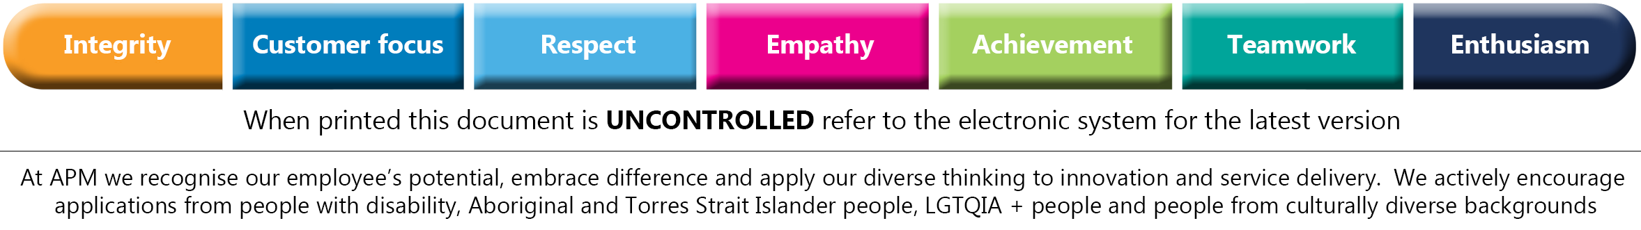
WCG is strengthened by diversity. We are committed to achieving a workplace that is equitable and representative of Canada’s diverse population. We actively work to attract, develop, and retain employees from diverse and equity-deserving backgrounds who have exceptional ability and the desire to make a difference. We continuously strive to support individual needs and differences in a work environment that is built on inclusivity and respect for everyone.
WCG is committed to providing an accessible, barrier free recruitment and selection process. If contacted for an employment opportunity, please advise us if you require accommodation in advance of any part of the recruitment and selection process.

