

Terms of Reference

Consultancy to develop a climate related agricultural input loan & insurance product for out-grower schemes in the cotton, dairy, and horticulture sectors

- Background

1.1 SNV Netherlands Development Organisation

SNV Netherlands Development Organisation (SNV) is a not-for-profit international development organisation founded in the Netherlands in 1965, with local presence in over 25 developing countries in Asia, Africa and Latin America. SNV provides advisory services, knowledge networking and supporting advocacy in the agriculture, water, sanitation and hygiene and renewable energy sectors. Driven by the Sustainable Development Goals (SDGs), SNV makes a lasting difference in the lives of people living in poverty by helping them raise incomes and access basic services.

1.2 The INCREASE Project

SNV is implementing a 7.29 million Euro SIDA funded project called INCREASE (Increasing Climate Resilience in Energy and Agricultural Systems and Entrepreneurship). INCREASE is running initially for 3 years, from 2020 up through 2022. The geographic focus is Southern, Lusaka, Central, Copperbelt and Eastern Provinces.

The INCREASE project aims to contribute to resilience in farming and agribusiness by working with targeted private companies, to encourage investment in climate smart agricultural practices and deploy decentralised energy systems (solar, biogas, etc) to increase and stabilise production in cotton, dairy and horticulture

The project follows a three-pronged approach:

- With farmers in out-grower schemes, the project seeks to improve income, food and energy security, largely through adoption of climate smart (CS) practices and increasing access to CS products, services and finance

- For businesses, the project facilitates better linkages between SMEs and companies, improving companies’ extension capacities and promoting expansion of and diversification into, CS products, CS services, and CS equipment

- For the enabling environment, the project promotes CS practices through government stakeholders, facilitates coordination of CS practices and extension services within the private sector, and strengthens the institutional environment for youth (self) employment.

The common denominator of the overall approach is that each value chain is organised through out-grower schemes (for dairy this is less apparent as business linkages between farmers and the dairy company pass through milk collection centers). The other common denominator is the agroforestry model promoted by SNV which is meant to strengthen the resilience of the farm plots both at individual farmer level as well as at out-grower level. By regulating the micro- climate and by improving soil fertility, the agroforestry model makes supply chains of cotton, dairy and horticulture more stable -and therefore more predictable. The overall results are higher yields and more profits for the respective stakeholders involved.

1.3 Context of the assignment

While agro-forestry enhances climate resilience of farming systems, it is not a magic bullet and also requires investment in new and different inputs. Agriculture remains a risky business. Droughts, pests, diseases, volatile input and commodity prices have and will continue to plague farmers and agri-businesses as the effects of climate change continue to unfold.

Unless risks are adequately managed, economic development will be stunted, poverty reduction will not be realized, and social inequities will be exacerbated. Depending on the context and the institutional environment, risks are managed in a variety of ways by farmers themselves (e.g conservation farming), by input suppliers (providing seeds/chemicals on credit), by financial service providers (eg. Micro finance for agricultural equipment), by governments, NGOs and relief agencies (various types of programs tackling agricultural risks) and by private insurers (eg. Crop Insurance).

1.4 Climate risk insurance

Reaching far-flung farmers remains particularly challenging and costly. One way of overcoming this challenge is Index Insurance. According to www.indexinsuranceforum.org Index insurance is an innovative approach to insurance provision that pays out benefits on the basis of a predetermined index (e.g. rainfall level) for loss of assets and investments, primarily working capital, resulting from weather and catastrophic events. Because index insurance does not necessarily require the traditional services of insurance claims assessors, it allows for the claims settlement processes to be quicker and more objective.

Before the start of the insurance period, a statistical index is developed. The index measures deviations from the normal level of parameters such as rainfall, temperature, wind speed, crop yield, or livestock mortality rates. One of the first financial products to be developed -also in Zambia is the Weather Index Insurance product which is highly correlated to local yields. Payouts are triggered by patterns of the index that are specified beforehand, as opposed to actual yields. This reduces the risks of fake claims and reduces, or even eliminates, the need for in-field assessments. A very attractive benefit of independently verifiable indexes is they can be reinsured, allowing insurance companies to transfer a significant part of their risk to international markets.

There are several kinds of index insurance on the market. These are mainly weather index insurance products and livestock mortality index products.

In Zambia, some Insurance companies have been leading providers of Weather Index Insurance on the market, teaming up with MTN and World Food Programme to introduce a mobile payment solution for small scale farmers. The focus has been to cover multi-peril crop insurance on summer crops such as maize, soya beans and fire and lightning on irrigated crops such as wheat, barley and standing cane. Some firms also covers livestock mortality risks for cattle, horses, pigs and poultry. Farmers can also access multi-pack cover on assets and legal liabilities.

1.5 Embedding climate risk insurance in credit schemes.

A further innovation includes bundling weather index insurance with input supplies. In Zambia this was done by Monsanto (Dkalb maize seeds) and was called “germination insurance”.

Bundling climate risk insurance with a loan/credit product (usually inputs or loans), reduces the need for borrowers to provide collateral as a condition for accessing credit. Because the insurance component can reduce the need for collateral, it is in theory more inclusive than conventional loan/credit products. Generally, the payment promise from the insurance reduces farmers’ debt obligation when the climate threatens agricultural production.

Farmers can receive credit upfront and loan repayment modalities depend on the production risk they face. Working in groups such as an out-grower scheme offers further scope of reducing production risks, particularly if the group is supported through extension services, including monitoring by the aggregator/buyer. Production risk is mitigated by investment in climate smart agricultural practices, such as agro-forestry because of the soil improvement benefits. This is where the INCREASE project is headed.

2. Objective of the consultancy

The overall objective of this assignment is to develop a climate related agricultural input loan and insurance product as well as a roadmap for its implementation. This potentially includes the adaptation of existing agricultural input loan and (climate) insurance products in order to make them relevant for the value-chains and specific geographical locations and out-grower schemes. This product can become fully owned by an interested financial institution, insurance broker and/or input supplier and be adjusted accordingly and according to the particular value chain.

SNV has agreements with Alliance Ginneries Ltd (cotton and soya), Lactalis Zambia Ltd (dairy) and PG Farms, Havillah Gardens and Hanfre Logistics (horticulture) to help adjust their respective supply chains to become more climate resilient. With the companies being the guaranteed market for farmers organized in an out-grower scheme (and for dairy organized under dairy cooperatives or milk collection centers). It is possible to pilot a new or adapted climate and credit product with the farmers supported by the companies and by SNV.

The three horticulture companies and the cotton company currently offer inputs to farmers on credit and deduct these costs upon harvest. The dairy company offers extension services on milk quality and hygiene and offers premiums on higher quality milk (Grade A milk as opposed to Grade B milk).

All partner companies support the SNV INCREASE agroforestry model as a climate resilience investment to stabilize their respective supply chains and reduce production risk.

Below is a diagram of the INCREASE agroforestry model (cotton/soya model), which can be adjusted to accommodate various other crops, including fodder grasses and vegetables. The model stabilizes production compared to conventional farming and reverses the soil fertility losses experienced throughout the country, thus increasing productivity from year 3 onwards (earlier if initially combined with mineral fertilizers).

Prices of the various models range from 10,000 kwacha per lima for the simplest rainfed model (€500 for 50 x 50 meters) to 140,000 Kwacha (€7,000) for the larger 1-hectare model that incorporates both a biogas digester (for cooking gas and organic fertilizer) and a drip irrigation set (for off season production).

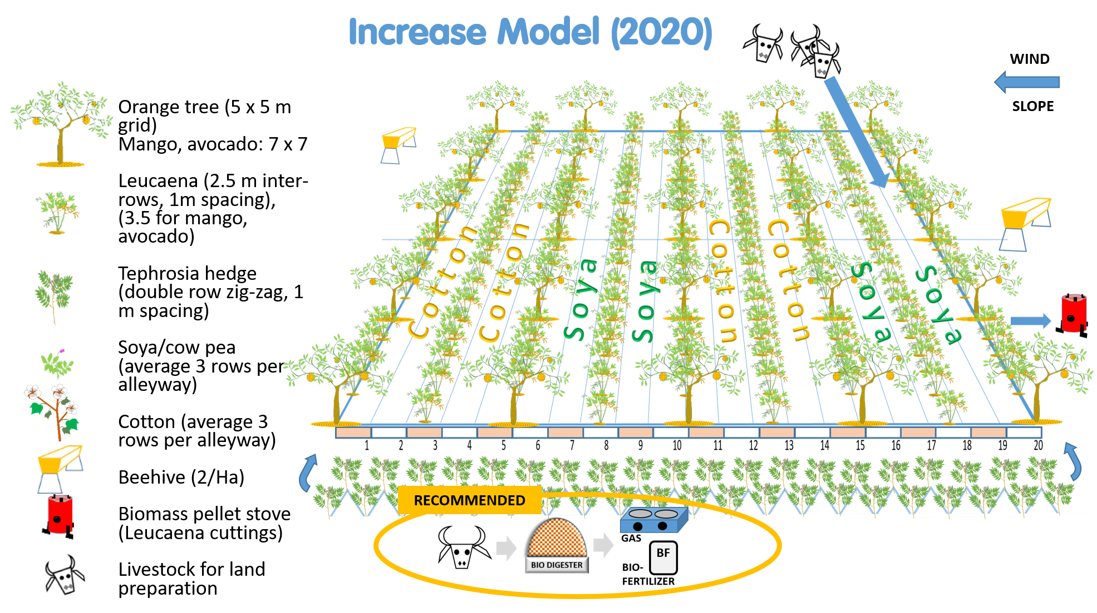

3 Outputs

The main outputs of the assignment will be:

- Identification and assessment of climate related input loans and insurance products both abroad and in Zambia that are/may be relevant to the three value chains supported under the project
- Development of a climate credit and insurance product, tailor made to the respective value chains of cotton, dairy and horticulture
- A roadmap to guide the project and project partners in piloting the climate credit and insurance product.

4 Deliverables

The assignment will have the following indicative timeframe and indicative elements:

No. | Deliverables | Days
A | Identification and assessment of climate credit and insurance products both abroad and in Zambia
1 | Kick off meeting with SNV after signing of contract | ½
2 | Inception report highlighting assignment implementation proposal, approach and methodology. Inception report includes a review of secondary data from both abroad and Zambia | 4
 | First payment 20%
3 | Consultation with SNV, Lactalis, Alliance Ginneries, PG Farms, Havillah Gardens and Hanfre/Trident Foundation on credit and insurance needs. | 3
4 | Consultations with Mayfair Insurance, Madison Insurance, Allianz Insurance, AB Bank, Zanaco, Stanbic Bank, MTN, WFP, FAO, WB | 4
5 | Presentation to SNV of consultation findings in the form of a SWOT analysis (PowerPoint) | ½
B | Development/adaptation of a climate credit and insurance product
6 | Development/adaptation of a climate credit and insurance product(s), determined to a large extent by the results of previous consultations and expression of interest by the would-be owner(s) of the new financial product | 4
7 | Presentation to SNV, SNV partners and would-be owner(s) of the draft product(s) | 1
8 | Draft report of assessment | 1
 | Second payment (50%)
C | A roadmap to pilot the climate credit and insurance product
9 | Road map for dairy | 2
10 | Road map for cotton | 2
11 | Road map for horticulture | 2
12 | Presentation to SNV, partners and would be owner(s) of the three road maps | 1
13 | Final report of the assignment | 2
 | Third and final payment (30%)
 | TOTAL DAYS (indicative) | 27

5. Approach and Methodology

- The assignment is recommended to start off with a broad -secondary research-sweep of international experiences. India, where the concept of Index Insurance was invented, has the most experience, covering over 20 million farmers, including embedded insurance/credit schemes. A good source of information is the Global Index Insurance Facility, a multi-donor trust fund managed IFC and the World Bank which operates in 31 countries and insures a total of 1.3 million farmers.
- Then, it is recommended to zero in on Zambia. A relevant landmark study is by the IFC : “Agriculture Finance Diagnostic in Zambia” (https://openknowledge.worldbank.org/bitstream/handle/10986/33400/Agriculture-Finance-Diagnostic-Zambia.pdf?sequence=5).
- A practical example of Weather Index Insurance involving SNV partner Alliance Ginneries and Mayfair Insurance exists, as does a “Germination insurance” with Monsanto (Dkalb maize)
- Adjusting or adapting existing insurance models and linking them to inputs/loans or other forms of credit will require a sound understanding of the INCREASE agroforestry model and how it fits within the wider out-grower schemes of the respective partner companies. The INCREASE agroforestry model itself is a risk reduction investment and should therefore ultimately reduce insurance premiums. The out-grower scheme may contribute to the concept of group insurance, as another risk reduction mechanism
- A critical part of the assignment is continuous consultation with stakeholders to ensure needs are fully understood and also to foster understanding of what is developed. At the end of the day, the partner companies will need to be willing to pilot the new product with their farmers. From the very beginning, the consultants need to be on the lookout for potential owners of the new financial product. These need to be brought on board and should be enabled to participate in the design of the product.
- The roadmap needs to be practical. Costs of setting up the new product and implementing it, will be important decision-making factors. A rough profit and loss calculation should indicate the break-even point and scale at which this needs to be implemented. What premiums should farmers pay? What percentage of the insurance can be re-insured internationally? How much credit can companies give? Can this scheme finance further investment into the INCREASE agroforestry model?

The consultant(s) work will be facilitated by the project staff, particularly during kick off when guidance is needed on the INCREASE approach and needs, but also in connecting with project partners. As the assignment will lay the foundation for strengthening the supply chains of specific partner companies, close involvement and consultation with SNV partners and the would-be owners of the new credit/insurance product will be crucial to developing a viable new product. The consultant(s) have the chance to be pioneers in developing new financial products that can support the shift to more climate resilient agribusiness.

6. Location and Period of Service

The assignment can be exclusively Lusaka/home based. Upon request, a site visit can be made to assess an actual INCREASE agroforestry model, as this is to be an integral part of the credit/insurance product in all three value chains. Costs for such a visit will be borne by SNV and according to SNV rates and logistics.

The assignment is to start in May 2022 and is to be finalized by July 2022. The consultant can plan and modify based on the indicative timeframes mentioned in the table above.

7. Competencies of the consultant(s)/consultancy firm

7.1 Basic competencies

The consultants/consultancy firm shall have a record of accomplishment in:
- Proven experience working in rural areas; experience with one or more of the value chains covered by the project is a plus
- Proven experience working with larger companies, preferably agribusinesses
- Proven research experience working on an innovative topic, preferably in agriculture or risk management
- Proven experience in designing at least one credit or insurance product; successful marketing of the product is a plus
- Knowledge and experience of gender relations concepts and how these can impact men and women differently in a credit and/or insurance capacity

7.2 Expected Level of Effort

The consultancy can be carried out by a consultancy team, a financial institution, a financial broker, an insurance company, an input supplier with prior experience in credit/insurance schemes, or any other relevant and experienced private or public entity.
The level of effort requires the team lead to be available full time for the duration of the assignment including firsthand involvement in the field activities (no outsourcing to junior staff is acceptable).

- Lead consultant/Team Leader is expected to hold a master’s degree in management, Business Administration, Economics, social sciences or other relevant field; or a professional qualification with at least 15 years’ experience. Fluency in English is a must.
- Support Consultants are expected to hold a bachelor’s (or higher) degree in Management, Business Administration, Accounting, or other relevant field; or a professional qualification preferably with a minimum of 10 years’ technical training experience. Fluency in English is also a must.

8. Application Procedure & deadline for submission

Interested consultants should submit a proposal detailing the background and record of accomplishment, methodology, work-plan, and staff profile amongst others, together with a separate financial proposal detailing itemized costs of services to SNV Zambia by close of business on 12th May 2022 .

The Consultants will submit a proposal detailing the background and record of accomplishment, methodology, work plan, and staff profile amongst others, together with a separate financial proposal detailing itemized costs of services.

8.1 Technical proposal

Based on the ToR and information provided by the INCREASE project, the consultant(s) will develop an overall technical proposal for the evaluation, including:

- A cover letter introducing the evaluator/organisation and how the skills and competencies described above are met, with concrete examples,
- A 2-3 pages outline of the understanding of the assignment, proposed evaluation process and methodology and time-lime,
- A CV not exceeding 3 pages demonstrating educational qualifications and professional experiences,

- At least one example of a relevant product developed by the consultant(s).

8.2 Financial proposal

- An indication of the consulting fees (excluding travels, DSA, accommodation, as these are borne by SNV). Communication, internet and other related expenses if any are covered under the proposed fees.

- Payment to the consultants will be based on three separate invoices submitted to SNV, according to the payment schedule outlined above).

- Please remember that Withholding tax of 15% is to be paid on fees, so this needs to be distinguished from other costs of the assignment

9. Evaluation Criteria

The consultant will submit a technical and financial proposal, including a summary work plan (simple GANTT chart), for implementation of this assignment.

The proposals received will be evaluated using the following criteria and other relevant criteria as may be considered appropriate by the evaluation/review committee:
- Relevant qualifications and years of experience (30%)
- Relevant work experience of the proposed team members (20%)
- Depth of proposal in addressing the ToR, but also suggestions/recommendations of improvement (50%)

Important notice!

This assignment has an exclusionary requirement, without which your application will NOT be evaluated: the consultant will need to have conceptualized and developed at least one relevant (financial/insurance/credit) product, previously. Preference will be given to those applicants that have successfully put such a product on the market.

Proposals and inquiries/queries should be submitted via email to:

The Contracts and Procurement Department: Zambiaprocurement@snv.org

