Terms of Reference (ToR)
for
A consultation to expand SNV’s capacity and capability to operate impactfully and responsibly in fragile contexts & conflict-affected situations (FCAS)

- Introduction to SNV
SNV is a mission-driven global development partner working in more than 20 countries across Africa and Asia. Building on 60 years of experience, and together with our team of over 1,600 people, we strengthen capacities and catalyse partnerships that transform the agri-food, energy, and water systems which enable sustainable and more equitable lives for all. Grounded in the 2030 Agenda for Sustainable Development, we work on the core themes of Gender equality and social inclusion (GESI), Climate adaptation and mitigation, and Strong institutions and effective governance.

By 2030, being thoughtful of our role and power alongside others, and working openly and collaboratively with global, national, local, and community-level institutions, SNV will contribute to advancing the systemic transformations required for progress towards the Sustainable Development Goals. These include:
- Building resilient agri-food systems that deliver food security and adequate nutrition while safeguarding the economic, social, and environmental foundations for future generations.
- Increasing reliable availability of an acceptable quantity and quality of water for health, livelihoods, ecosystems, and production, coupled with an acceptable level of water-related risks.
- Improving access to affordable and sustainable energy, with a focus on decentralised renewable energy solutions and energy efficiency.
- Realising water security, food security, and energy security where no one is left behind, resilience is increased, and climate footprints are meaningfully reduced.
- Improving gender equality and social inclusion so that systems, structures, and markets are fairer and more inclusive and enabling all people to have equal opportunities to live with dignity and thrive.
- Improving climate mitigation and adaptation so that our projects, programmes, and influence contribute to strengthening resilience and adaptive capacity to climate-related hazards.
- And strengthening institutional capacities to be more accountable, effective, and transparent, and governance systems to be inclusive, responsive, and representative.

In all these areas we set ambitious and measurable objectives, which we report on annually.

- Background to the consultation
More than a third of the value of SNV’s work globally is undertaken in fragile contexts or in pockets of fragility and violence within more stable contexts (Figure 1), and this proportion is set to increase with the reopening of an office in South Sudan.
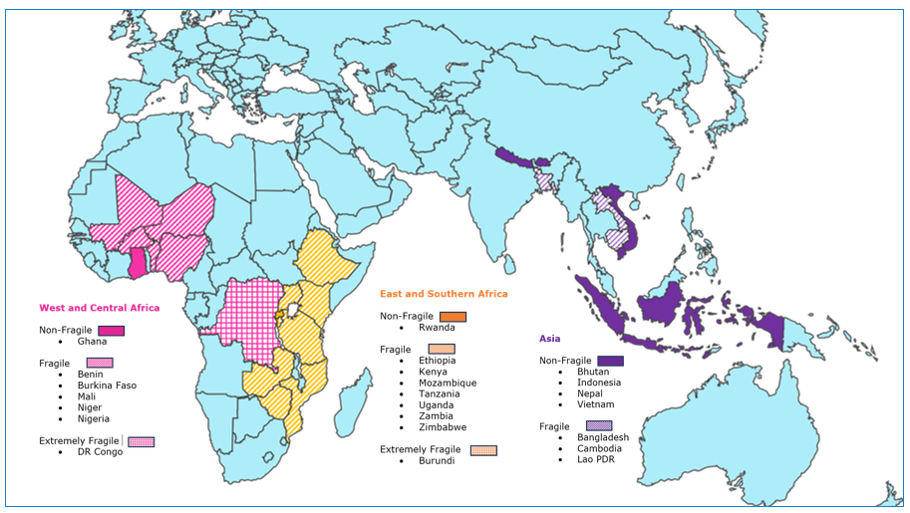
Figure 1. SNV intervention countries and their relative fragility (OECD, 2023).

It is essential that SNV has a commonly understood position on working in such contexts and that we can articulate our approach both internally to staff and externally to donors and partners. To be as impactful as possible, we also need increased capacity to design and implement practical conflict sensitive programming.

Fragile contexts Investment Project (IP)
During 2023, an internal working group, which included 8 staff from headquarters and field offices in the Sahel, initiated reflections around the following questions:
- What is our joint understanding of fragility?
- How does fragility affect and relate to SNVs impact (challenges and opportunities)?
- Why are we considering fragility as a strategic direction (emerging trends such as donor insistence on mainstreaming of conflict-sensitivity and HDP triple nexus approaches)?
- How might this focus on fragility articulate with SNVs work on root causes such as climate change, food insecurity, gender disparities and social exclusion?
- What are we doing currently? Where are we missing out?
- Where do we want to be in 2030?
- Why are we engaging in fragile contexts?
- What will be our objectives while working in and/or on fragility?
- How might we achieve these objectives in terms of approaches, guiding principles, context analysis, safety & safeguarding, partnerships, and support/expertise?
- What do we need to do to achieve this vision and these objectives? Who are the main stakeholders and how will they be involved? What additional resources are required?

These reflections resulted in a slide deck that was presented and discussed with the managing board (MB) in September 2023, and the submission and approval of a two-year investment project (2024-2025) to expand SNV’s capacity and capability to operate impactfully and responsibly in fragile contexts.

The current consultation will contribute to the refinement and implementation of this investment project.

- Objectives of the consultation
The overall objective is to develop an organisational strategy and operational guidelines for SNV interventions in fragile contexts and conflict-affected situations and contribute to their rollout.

The specific objectives are to:
- Analyse SNV’s current experience and practices in FCAS to identify the main challenges and best practices.
- Assess SNV’s capacity to design and implement conflict-sensitive projects and programming, propose, and prioritize appropriate reinforcement measures.
- Clarify SNVs position on working in FCAS and addressing fragility.
- Identify the partnerships and human resources needed to implement the ‘fragile contexts’ policy/strategy and propose a roadmap for it’s the effective rollout.

- Scope of Work
The geographical focus will be on West & Central Africa (Niger, Mali, Burkina Faso, northern Benin, Ghana, and Nigeria, and DRC), but will also include Ethiopia, Burundi, and Mozambique in East & Southern Africa.

The work will include:
- the utilisation of existing documents and relevant literature,
- regular exchanges with the ‘fragile context’ working group,
- interviews with key informants,
- consultation processes with a wide range of national & international SNV staff at different levels (project teams, country offices and headquarters) and across sectorial (agrifood, water and energy) and thematic teams,
- online staff surveys to collect information and ideas from a broader sample,
- and a benchmarking exercise of best practices developed by other organisations working in fragile contexts.

Suggested guiding questions for each of the specific objectives include (but are not limited to):

  - Analyse SNVs current experience and practices in FCAS
- How well do we understand the conflict contexts and power dynamics where we intervene?
- How are SNVs standard products and approaches affected by fragility and violent conflict?
- How are we managing the increased risks associated with FCAS?
- How are staff affected and how are they coping?
- Do staff, partners and service providers have the knowledge and skills required to keep them safe in FCAS? What additional support do they require?
- How are we applying conflict-sensitivity, GESI and triple nexus approaches?
- What mechanisms are in place to promote accountability, learning and adaptive management?
- What are we doing well and where are we falling short?
- What are the main challenges? And the strategies used to overcome them?

  - Assess SNVs capacity to design and implement conflict-sensitive projects and programming, propose, and prioritise appropriate reinforcement measures.
- How well does SNV integrate conflict-sensitivity in its project and program proposals?
- Do staff, partners and service providers have the knowledge and skills required to implement projects in a conflict-sensitive manner? What additional support do they require?
- How does SNV use internal and external conflict-sensitivity expertise throughout the project cycle?
- What tools exist for conflict-sensitive programming and how widely are they used?
- How do existing internal procedures support or hinder conflict-sensitive project implementation?
- How is conflict-sensitivity integrated into change theories and MEAL systems? How are sources of tension and conflicts linked to project interventions identified and addressed?
- To what extent do projects contribute directly to conflict transformation and sustaining peace?

  - Clarify SNVs position on working in FCAS
- How might market-based projects (sustainable energy markets, inclusive value chain development) intervene sustainably and inclusively in fragile contexts?
- How might SNV adapt its products and services in fragile contexts where traditional state partners are weak or absent and beneficiary groups are particularly vulnerable?
- How might SNV adapt its existing intervention approaches so that they have an increased impact on good governance, conflict transformation, and peacebuilding?
- How will SNV become more accountable to its clients and beneficiaries and detect sources of tension arising from its interventions?
- How will SNV include internally displaced and refugee populations where they exist in project intervention zones?
- How will SNV, a development organisation, partner with peacebuilding and humanitarian organisations to operationalise triple nexus HDP approaches and increase impact?
- How will SNV react to emergency and crisis situations which affect project delivery and the security of staff, partners, and project stakeholders?
- What are the red flags that might lead to the suspension or withdrawal of a project intervention in fragile and violent contexts?
- How might SNV employment packages for international and national staff take account of the increased stress and risk associated with working in fragile and conflict-affected situations?

  - Identify the partnerships and human resources needed to implement and rollout the ‘fragile contexts’ policy/strategy and propose a roadmap for it’s the effective rollout.
- Which existing internal human resources could be used more effectively? How?
- What additional internal human resources are required and how should they be deployed and used?
- Which local/national partners might contribute to the rollout of the fragile contexts policy? What might be their roles and responsibilities?
- Which international partners might contribute to the rollout of the fragile contexts policy? What might be their roles and responsibilities?

- Language
All the deliverables will be produced in both English and French.

- Deliverables
The selected consultant is expected to deliver:
- An inception report that clarifies the consultation methodology and program
- Reports for each consultation process/workshop organised (for francophone and anglophone participants)
- An organisational strategy or draft policy document that gives an overview of the challenges and clarifies SNV’s position on working in FCAS and on fragility.
- A set of operational guidelines for responsible, conflict-sensitive, adaptive, and impactful SNV interventions in FCAS, that addresses the different sectors and core themes.
- A benchmark of staff remuneration packages of other NGOs operating in fragile contexts together with proposed adjustments to SNV’s staff remuneration package for FCAS, including the definition of criteria for their application.
- A roadmap for the effective rollout of the ‘fragile contexts’ strategy and guidelines across the organisation by December 2024.
- A final report that summarises the consultation process and its keys findings and proposes recommendations for the successful implementation of the Fragile contexts Investment project road map.

- Consultant profile
Qualifications, knowledge, and experience required include:
- More than 7 years’ experience working in fragile and conflict-affected countries in Africa.
- Demonstrable knowledge and understanding of the root causes of fragility and violence in SNV intervention countries in Africa, particularly in the Sahel region.
- Demonstrable knowledge and understanding of the challenges that fragile and violent contexts pose to responsible and impactful development interventions in the agricultural, water and energy sectors.
- More than 7 years’ experience of organisational conflict-sensitivity mainstreaming at operational and strategic levels, including capacity-building in this area.
- An understanding of the links between fragility/violent conflict and climate change, youth employment, gender inequalities and social exclusion will add value.
- Experience working for or with a range of humanitarian, peacebuilding and development organisations will add value.
- Experience performing assignments of a similar or closely related nature.
- Evidenced excellent writing, analytical, and communication skills (in English and in French). An experience writing organisational policy documents, strategic plans and operational guidelines will add value.
We will only evaluate CVs of the proposed consultant(s). If the agency/consultant(s) feel the necessity for additional team members these may be proposed. There is no need to submit their CVs.
- Timeframe
The consultation is expected to be undertaken over a period of six (6) months from February – July 2024. Final timings will be agreed upon appointment of the consultant and review of the inception report.
- Reporting line
The consultant will report to the SNV IP project manager for each of the deliverables and will work closely with the MOPSS Senior Conflict-sensitivity Advisor and members of the ‘fragile contexts’ working group for day-to-day coordination.
- Payment terms
The contract payment terms are as follows:
- 40% upon signature of the contract
- 60% after submission of the final deliverables
SNV will make payments in compliance with the rules of the Netherlands Government.

- Key compliance issues
During the implementation of the work, the consultant must comply with the following:
- SNV Code of Conduct/Ethical Standards Policy and related procedures, which provide the guidelines for good conduct and directions on ethical matters and in situations of conflict of interest, and, if appropriate, make a report using the online reporting mechanism.
- SNV Environmental and social safeguarding requirements
- The Gender Practitioners Collaborative Minimum standards for mainstreaming gender equality
- SNV Security and Safety policy

- Evaluation Criteria
The following criteria will be followed to evaluate technical proposals received:
- Technical Score (80):
  - Experience in similar assignments (Work samples): 20
  - Overall understanding of the proposed assignment: 15
  - Methodology and implementation plan: 25
  - Profile of proposed consultant(s) 20
- Financial Proposal (20):
  - Competitiveness of the financial offer
  - Relevance and consistency with technical proposal
Technical and financial proposals will be reviewed separately. Only those Technical proposals that pass the minimum score of 60% will move forward for Financial review. The reviews are a closed process and not open to the public.
- Application
Interested consultants/agencies/firms are requested to develop and submit their technical and financial proposals in line with evaluation criteria mentioned in this ToR.

The Financial Proposal must include:
- A submission letter detailing the total amount of the financial proposition (before and after taxes)
- A detailed budget that includes daily costs, number of days and total costs for each person involved.
Note that the costs of any workshops and international travel will be born directly by SNV.

The Technical Proposal must include:
- Samples of previous similar work
- CVs of proposed consultant(s)
Note that all CVs must be accurate and signed by both the individual and an authorised official of the agency/consultancy firm.
An electronic copy of the proposal, duly signed, should be submitted in Smart Recruiters as an attachment before 7th of March 2024 3 p.m. CET. Late bids will be disqualified.
For any query related to the ToR, please email Megan Ritchie, IP manager Email: mritchie@snv.org.

