Request for Expressions of Interest

For Advisory members of Advisory Council

|  |  |
| --- | --- |
| **Organisation** | SNV Netherlands Development Organisation |
| **Project** | "Transforming the Rice Value Chain for Climate Resilient and Sustainable Development in the Mekong Delta," (TRVC project) |
| **Assignment** | Provide technical support and advisory consultancy for Advisory Council of the project “Transforming the rice value chain for climate resilient and sustainable development in the Mekong delta (TRVC)” |
| **Number of consultants** | 03 individual consultants (01 international consultant and 02 national consultant) |
| **Location** | An Giang, Dong Thap and Kien Giang |
| **Duration** | August 2025 – December 2027 |
| **Starting date** | August 2025 |
|  |  |

# About SNV

Stichting SNV Nederlandse Ontwikkelings Organisatie, (hereinafter referred to as “SNV Netherlands Development Organisation” or “SNV”) is established as a Foundation (Stichting) in The Netherlands, and is a not-for-profit international development organisation, that applies practical know-how to make a lasting difference in the lives of people living in poverty. We use our extensive and long-term in-country presence to apply and adapt our expertise in agriculture, energy and water to local contexts.

SNV has been working in Vietnam since 1995 in partnership with government agencies, the private sector, and local authorities across the agri-food, energy, and water sectors. We’re particularly proud of the work we’ve done to support the country’s most remote and deprived areas to strengthen their capacity to reduce poverty.

# Background of the assignment

Building on the 27-year-experience of implementing projects on sustainable agriculture development and market-based agrifood value chain development in Vietnam, and recently, the success of the "**AgResults Vietnam Emissions Reduction Challenge Project” (AVERP)** in Thai Binh province from 2016 – 2021 with Pay-for-Results mechanism. Funded by the Australian Department of Foreign Affairs and Trade (DFAT), SNV Netherlands Development Organization continues working with government partners at central and provincial levels to design and implement the project **“Transforming Rice Value Chains for Climate Resilient and Sustainable Development in the Mekong Delta (TRVC)” (“TRVC Project”** or **“Project”)**. The TRVC project is implementing in three (03) key rice-growing provinces in the Mekong Delta, including An Giang, Dong Thap, and Kien Giang, from 2023 to 2027. SNV, as the TRVC Project Manager (Project Manager), holds ultimate responsibility for the implementation and management of the Project's activities and resources. SNV, coordinating with the Department of Crop Production and Plant Protection (DCPPP) under the Ministry of Agriculture and Environment (MAE) which is previously known as Ministry of Agriculture and Rural Development (MARD), the Provincial People’s Committee, and the Department of Agriculture and Environment (DAE) which previously known as Department of Agriculture and Rural Development (DARD) of 3 provinces An Giang, Dong Thap and Kien Giang, will co-deploy and supervise the Project activities. The international verifier recruited by SNV (**Verifier**), along with the advisory council including international and Vietnamese scientists and policymakers (**Advisory Council**), will jointly monitor and supervise the verification process and results to ensure accuracy and transparency.

The TRVC Project is designed and implemented with the view to supporting the transition of green growth-oriented, multi-value integrated rice production and trading that meets the urgent needs for sustainable development in the context of climate change in the Mekong Delta; and at the same time carries out the national target on reducing Greenhouse Gas Emissions (GHG). Using the Pay-for-Results (PfRs) mechanism, the TRVC Project will incentivize and attract the participation of private enterprises in the Rice Value Chain, aiming to scale up innovative technologies to achieve higher economic outcomes for smallholder farmers (SHFs) and all Rice Value Chain actors, improve rice quality and inclusive social values while reducing greenhouse gas (GHG) emissions and mitigating environmental footprints as co-benefits. Thereby, the TRVC Project will support the implementation of the Australian Government's development priorities and commitments on climate finance in the region and a shared commitment with Vietnam on climate action. The Project will play a catalytic role in creating the transformation of rice production and trading towards sustainability and bringing inclusive values ​​in the most rice-intensive production provinces in the Mekong Delta; actively contributing to the goals of sustainable development, GHG emission reduction, and climate adaptation of Vietnamese Government in Mekong Delta on the basis of Decree 06/2022/ND-CP dated 11/07/2022 regulating the reduction of greenhouse gas (GHG) and the protection of ozone layer, Resolution 120/NG-CP dated November 17, 2017, on Sustainable and Climate Resilient Development of the Mekong Delta in Vietnam; Decision 555/QD-BNN-TT dated 26/01/2021 approving the "Scheme for restructuring of Vietnam's rice industry by 2025 and 2030" and Vietnam's priority policies for sustainable development.

The results of TRVC Project are expected to be achieved as follows:

* Formulating 10 – 20 inclusive Rice Value Chain
* Outreaching 50 – 60 co-ops and 300,000 SHFs on the production scale of 200,000 hectares
* Reducing equivalent to at least 200,000mt of CO2 emissions
* Achieving at least 30% profit for farmers from rice production

The TRVC Project’s Governing Structure is demonstrated in the following diagram:

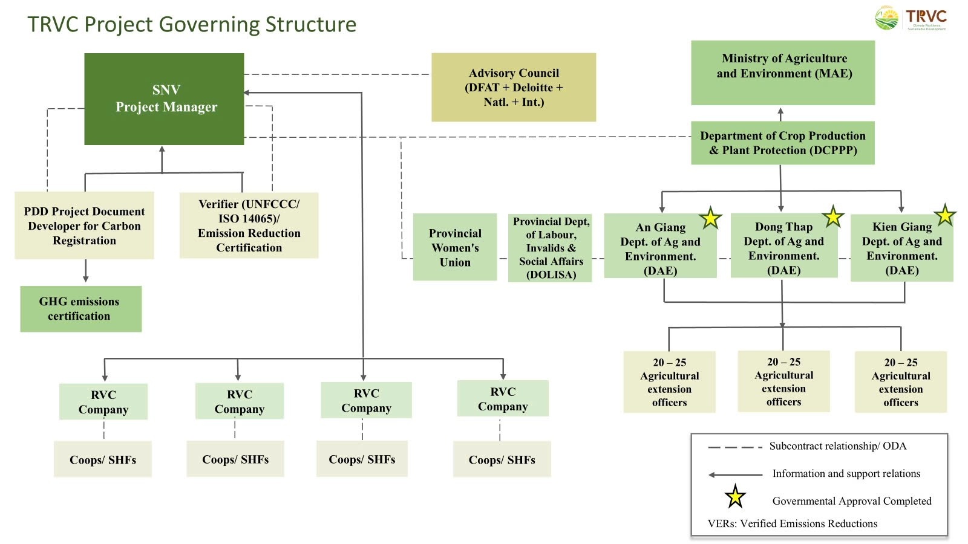

Figure 1: The TRVC Project Governing Structure

The Advisory Council (AC) will provide independent technical expertise and strategic guidance to the programme team, ensuring the scientific rigour, fairness, and transparency of the project. The Council will comprise independent experts, a representative from the Department of Crop Production and Plant Protection (DCPPP/MAE), and a representative from DFAT.

The specific composition of the Advisory Council for the TRVC project is as follows:

1. **The Lead of AC:** Deloitte USA
2. **International members:** Senior representatives from **DFAT** and international senior scientists with expertise in low-carbon agriculture and greenhouse gas (GHG) modelling.
3. **National members:** The Head of DCPPP/MAE; Leading national and international experts in rice research; Renowned GHG emissions scientists with experience in modelling tools such as DAYCENT and DNDC; Specialists in low-carbon agriculture and community development to support the adoption of low-emission practices by smallholder farmers; Senior government officials with experience in policy development and project scaling.

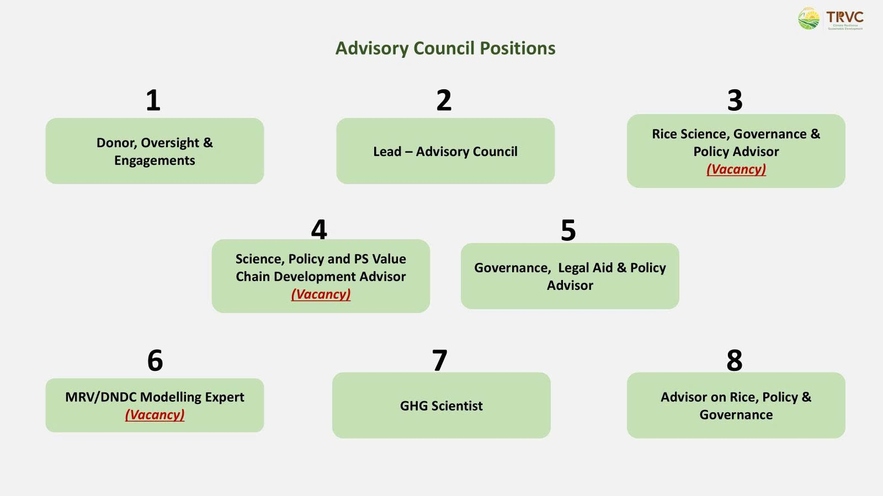

Figure 2: The TRVC AC Structure

# Objectives of the assignment

In 2024, the TRVC project successfully completed the implementation of the first of six seasonal rice crops (i.e., the Summer–Autumn 2024 crop) with the participation of eight rice value chain companies. These companies, recognized as key competitors in the three project provinces of An Giang, Dong Thap, and Kien Giang, were collectively awarded prizes totaling up to AUD 200,000 at the end of the crop cycle.

In 2025, ten rice value chain companies have enrolled as competitors for the second crop (i.e., the Winter–Spring 2024 – 2025) across the same three provinces. The verification of results from this crop is currently underway to determine award recipients.

To ensure continued technical support, effective oversight, and the integrity of the verification process and its outcomes, SNV is seeking to engage qualified international and national individual consultants (hereafter referred to as “the Consultant”). These consultants will serve as members of the Advisory Council, providing independent technical guidance and expert support to the TRVC project throughout the crop season evaluation process.

* 01 International consultant on Measurement, Reporting and Verification & Denitrification-Decomposition Modelling Advisory (MRV/DNDC Modelling)
* 01 National consultant on Rice Science, Governance & Policy Advisory
* 01 National consultant on Science, Policy and Private Sector Value Chain Development Advisory

The consultant, as an AC member, will collaborate with the other AC members, **Verifier** and TRVC project team to provide continuous technical support and consultancy to the project, including attending quarterly AC meetings, mid-season and post-season meetings, and providing support by phone and email to the Project Manager where a timely response is needed.

The objective of the assignment covers the expected technical support areas listed below and subject to be specified, changed and/or added during the project implementation period basing on the actual needs and be tailored to the title of each AC member with mutual agreement:

1. Support and ensure transparency, fairness and accuracy in the selection of competitors;
2. Review and validate verification protocols and results;
3. Refine prize competition rules based on lessons from implementation;
4. Provide support to troubleshoot challenges and recommend solutions;
5. Promote TRVC visibility and synergies nationally and internationally (scientific symposia, COP, CSA, Low-carbon forum etc.).

As the Project Manager, SNV will serve as the Council convener and moderator and will be responsible for the following activities and functions:

* SNV in consultation with the Lead of AC appoints Advisory Council Members. Members shall be invited to serve based on multiple Task Orders for up to 3-year terms and may be re-appointed for additional terms based on the actual need and mutual agreement between the members and SNV.
* Provide an Orientation Workshop with the Project Work Plan, its Phases and M&E system to all AC members
* Manage member relations including separation and amendment of terms of reference.
* Frequently liaise and contact with AC members to seek their advice, guidance, and feedback with regard to the AC’s roles and responsibilities.

The selected Consultant will enter a Framework for Professional Service (the “Agreement”) with SNV with expected timeframe from July 2025 – December 2027 covering the listed technical support areas. Based on the signed Agreement, the detailed tasks with allocated working days and timeline will be discussed and agreed under Tasks Orders for each mobilization period signed by the consultant and SNV authorized representative.

# Expected experience and qualifications

The expected experience and qualifications specified for each consultant position as follows:

**International Consultant on MRV/DNDC Modelling**

**Educational background:**

Advanced qualification and academic background in Environmental Sciences, Climate Science, Agricultural Engineering, or related fields

Demonstrated professional experience in applying biogeochemical models (e.g., DNDC) for quantifying GHG emissions in the agricultural sector

**Language:**

High level of proficiency in written, spoken, and presented English.

**Professional experiences:**

At least 10 years of experience in the development and implementation of biogeochemical or DNDC models in agricultural or land-use contexts.

Proven expertise in setting up and operating Measurement, Reporting, and Verification (MRV) systems, particularly those linked to greenhouse gas (GHG) emissions in agriculture or land-use sectors.

Demonstrated experience in providing technical review, quality assurance, and analysis for environmental/climate data models.

Familiarity with data integration and interface design between MRV systems and national/international reporting mechanisms (e.g., UNFCCC, IPCC frameworks**).**

**Regional experiences:**

Experience in projects in the Southeast Asian countries, particularly in rice-based agricultural systems

Working experience in Viet Nam, particularly in collaborating with agriculture research institutions

# Key Competencies and Skills

Deep understanding of GHG emissions modelling (especially with DNDC or similar models), and mitigation pathways in agriculture.

Strong analytical and systems-thinking skills with the ability to identify model improvements, troubleshoot errors, and interpret complex datasets.

Ability to engage in strategic discussions and provide practical recommendations to improve MRV system efficiency and relevance.

# Desired Experience

Experience working in Southeast Asia, particularly in rice-based agricultural systems.

Track record of contributing to or advising on international climate-related initiatives (e.g., NDCs, national GHG inventories, carbon credit mechanisms).

Participation in Advisory Councils, technical committees, or cross-disciplinary learning forums related to climate, agriculture, or environmental modelling.

**National consultant on Rice Science, Governance & Policy Advisory**

**Educational background:**

Advanced qualification and academic background in Agricultural Sciences, Plant Protection, Agricultural Engineering, Rural Development, or related fields

**Language:**

Native Vietnamese speaker with a high level of proficiency in written, spoken, and presented English.

**Professional experiences**

At least 10 years of experience providing strategic and technical advisory services on rice sector development, governance, and policy in Viet Nam, with a focus on climate-resilient and low-emission agriculture, particularly through collaboration with international organizations.

Demonstrated experience in supporting the alignment of project-level activities with national agricultural strategies and relevant sectoral initiatives, including contributions to policy development, inter-agency coordination, and regulatory frameworks.

of Monitoring, Reporting, and Verification (MRV) systems in the rice sector.

Experience in drafting and presenting evidence-based policy recommendations to advance the transition to a low-emission rice economy, including the integration of technical data into national policy processes.

Familiarity with certification and branding schemes for green/low-carbon agricultural products and active participation in national or international trade/policy events is considered an asset.

**Regional experiences:**

Experience in projects in Viet Nam and/or in the Southeast Asian countries, particularly in rice-based agricultural systems

Experience in VietNam with experience in DFAT funded projects is an asset.

# Key Competencies and Skills

Practical knowledge of Measurement, Reporting and Verification (MRV) systems for low-emission rice production.

Good understanding on Vietnam’s 1 Million ha High-quality Rice Program and related public-private initiatives is an advantage.

Deep understanding of rice production systems, climate-resilient agriculture, and greenhouse gas (GHG) mitigation strategies

Proven ability to develop evidence-based policy recommendations and influence multi-stakeholder decision-making; experience in policy formulation at government organizations is considered an asset.

Demonstrated capacity to provide policy advice to ministries, sub-national authorities, and agricultural departments

Experience in engaging with and supporting government entities such as the Department of Crop Production and other relevant departments of the Ministry of Agriculture and Rural Development (MARD) is an advantage

# Desired Experience

Experience supporting the formulation, review, or implementation of national strategies on sustainable agricultural programs or similar flagship initiatives.

Experience in science-based value chain development, including policy advisory on quality assurance, and sustainable branding (e.g., green, low-carbon rice certification).

Participation in Advisory Councils, technical committees, or cross-disciplinary learning forums related to climate, agriculture or related areas.

**National consultant on Science, Policy and Private Sector Value Chain Development Advisor**

**Educational background:**

Advanced qualification and academic background in Agricultural Sciences, Plant Protection, Agricultural Economics, Rural Development, or related fields

**Language:**

Native Vietnam speaker with proficiency in written, spoken, and presented English.

**Professional experiences:**

At least 10 years of progressive experience in agricultural science and research, value chain development, and/or policy advisory, with a focus on the rice sector

Proven track record of working across the science-policy-private sector interface, particularly in promoting innovations in rice-based production systems.

Proven track record in leading or advising on large-scale agricultural development projects with engagement of private companies, particularly in rice-producing regions.

Demonstrated experience in working with government agencies, research institutions, and international development organizations

Experience in advising on agricultural policy reform, regulatory frameworks, or sectoral governance to promote the engagement of private sector in the rice industry in Viet Nam

**Regional experiences:**

Experience in projects in Viet Nam and/or in the Southeast Asian countries, particularly in rice-based agricultural systems

Experience in VietNam with experience in DFAT funded projects is an asset.

# Key Competencies and Skills

Practical knowledge of Measurement, Reporting and Verification (MRV) systems for low-emission rice production.

Good understanding on Vietnam’s 1 Million ha High-quality Rice Program and related public-private initiatives is an advantage.

Deep understanding of rice production systems, climate-resilient agriculture, and greenhouse gas (GHG) mitigation strategies

Ability to develop evidence-based policy recommendations and influence multi-stakeholder decision-making.

Demonstrated capacity to provide policy advice to ministries, sub-national authorities, and agricultural departments.

# Desired Experience

Experience supporting the formulation, review, or implementation of national strategies on sustainable agricultural programs or similar flagship initiatives.

Experience in science-based value chain development, including market linkages, quality assurance, and sustainable branding (e.g., green, low-carbon rice certification).

Participation in Advisory Councils, technical committees, or cross-disciplinary learning forums related to climate, agriculture or related areas.

**Remark**: Applicants may express their interests in one or more positions; however, each selected consultant will be contracted for only one role

# Submission requirements

Interested individual consultants should submit the **Letter of Interest** via the instructions in the link [**https://smrtr.io/sbrzp**](https://smrtr.io/sbrzp) with the following information:

**Signed Letter of Interest includes the followings:**

***Attachment 1: CVs of individual consultants   
Attachment 2: Qualifications and certificates  
Attachment 3: Scanned copies of the identity card or Passport of individual consultants.***

***Attachment 4: Complete Due Diligence Registration Form*** [***https://c.smartrecruiters.com/sr-company-attachments-prod-aws-dc5/58919688e4b0672cc03331a9/e1a9f7eb-0b96-47dd-a371-0e0c7798251a?r=s3-eu-central-1***](https://c.smartrecruiters.com/sr-company-attachments-prod-aws-dc5/58919688e4b0672cc03331a9/e1a9f7eb-0b96-47dd-a371-0e0c7798251a?r=s3-eu-central-1)

**Deadline** for EOIs submission is by 17.00 p.m on **July 30, 2025.**

All questions regarding this call should be sent to [snvvietnamprocurement@snv.org](mailto:snvvietnamprocurement@snv.org)

# Selection process

SNV will review all EOIs received in accordance with the guidelines and criteria in this solicitation. SNV reserves the right to exclude any EOIs that do not meet the guidelines. Please note that SNV is unable to provide detailed feedback to those EOIs that are not selected.

**Step 1:** SNV will shortlist selected EOIs. Successful applicants will be contacted by SNV for Framework Agreements for Consultancy Services or informed to keep on our consultant roster for two years.

**Step 2:** SNV will release Task Orders for the specific activities with the selected consultants based on the Framework Agreements signed accordingly.