Advocate
Job Description and Personal Specification
Job title: | Advocate (Pastoral)
Place of work: | School based- home working up to 3 days a week.
Hours of work: | 37 hours per week
Banding: | Pupil Support & Welfare
Reports to: | Pastoral Manager and Assistant Heads
Level of screening: | Enhanced DBS

Who we are
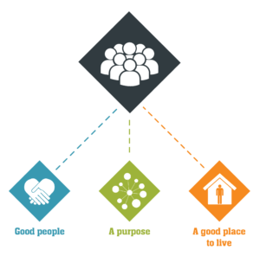
Job Title: Education Support Manager
About Catch22:
Catch22 is a social enterprise committed to designing and delivering services that foster resilience and aspirations within individuals and communities. Our approach centers on the belief that individuals can thrive when they have stable housing, supportive relationships, and a fulfilling purpose. These elements form the foundation of our “3Ps” philosophy.
We are dedicated to transforming lives and would love to hear from individuals who share our passion and values.
Role Overview:
Catch22’s Education Hub provides alternative and special education to young people aged 4 to 18, helping them progress toward sustained education or employment. Our approach combines high-quality teaching and learning, underpinned by strong relationships, to support the achievement of life skills and meaningful qualifications.
As an Education Support Manager, you will manage, support, and develop a caseload of marginalized young people and their families. You will work to build trusting relationships through individual sessions, group work, family visits, and other interventions. You will oversee a holistic, person-centred approach to each young person’s educational journey, bridging the gap between academic, behavioural, and therapeutic needs.
Key Responsibilities:
Service Delivery:
- Collaborate with the Assistant Head to create and manage a caseload of students, conducting initial assessments of educational, emotional, and behavioural needs, and tailoring support programs accordingly.
- Develop and review individual development plans for each student, considering their specific needs as identified in assessments. Ensure key metrics, such as attendance, attainment, and predicted grades, are tracked and performance monitoring is implemented.
- Work closely with teaching staff to ensure consistent and impactful delivery of educational and social learning outcomes.
- Organize and deliver targeted 1:1 and small group support, including advice, guidance, practical assistance, and mentoring.
- Regularly risk-assess all students in your caseload to identify vulnerabilities and mitigate risks to safety.
- Work with the Assistant Head and multidisciplinary team using the Common Assessment Framework to ensure the development of effective service responses and compliance with Ofsted standards.
- Cultivate strong relationships with key partners, including schools, Local Education Authorities, Social Services, Youth Offending Services (YOS), parents, and community organizations.
- Monitor the educational progress of students in your caseload, tracking school performance, classroom behaviour, and the risk of exclusion, and adjust interventions as needed.
- Collaborate with the Assistant head to refer students to external agencies when appropriate.
- Actively participate in multi-disciplinary meetings such as PEPs (Personal Education Plans), core group meetings, and planning and review sessions.
- Be flexible in working across various settings, including schools, colleges, courts, police stations, and young offender institutions. Willingness to work evenings and on residential trips may be required.

Resource Management:
- Maintain accurate and up-to-date records of student interactions, supporting case reviews and evaluations.
- Ensure the effective management and organization of learning resources, including digital technologies, ensuring they are appropriately risk-assessed and suitable for students with emotional and behavioural difficulties.
Inclusion and Diversity:
- Contribute to the creation of an inclusive culture that celebrates and embraces diversity.
- Promote and implement Catch22’s Equality and Diversity Policy and demonstrate anti-discriminatory practice.
Health, Safety, and Wellbeing:
- Follow safe systems of work in line with Catch22’s Health and Safety policies.
- Take reasonable care of your own health, safety, and wellbeing, and support others in doing the same.
Other Requirements:
- Reflect the vision, mission, and values of Catch22 in all aspects of the role and act as a role model for others.
- Complete mandatory training in line with Catch22’s policies and procedures.
- The duties outlined in this job description may be subject to change based on the evolving needs of the organization. The post-holder may be required to undertake additional responsibilities as necessary, commensurate with the role.
Success Indicators:
- Enhance student attitudes and engagement in learning.
- Provide management with regular reports on student progress at both the individual and group levels.
- Enable students to make measurable academic progress.
- Effectively manage and support Teaching Assistants to ensure they meet expectations and deliver quality support to students.
- Ensure Teaching Assistants are fully integrated into lesson planning, so they understand their roles and expectations in each lesson.

Organisational Relationships

- Colleagues within the Education hub

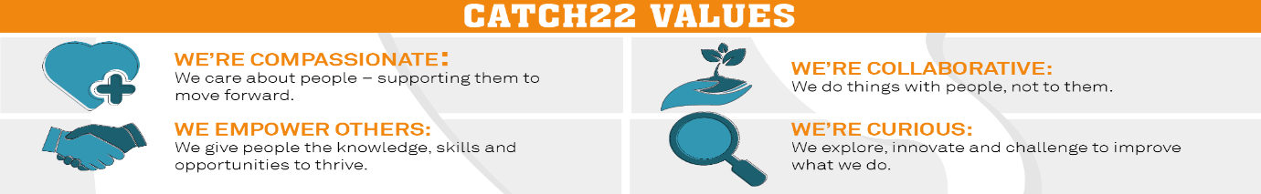

Job Title: Advocate Person Specification
COMPETENCY | ESSENTIAL | DESIRABLE | ASSESSMENT
QUALIFICATIONS | A relevant professional qualification (NVQ level 2) in working with young people, e.g. teaching, youth and community work, social work, counselling, mentoring. Level 2 English and Maths. | Team leader qualification | Application
KNOWLEDGE | - An understanding of the political and educational context of social inclusion.  - A knowledge of behavioural management techniques and understanding of de-escalation techniques.  - An understanding of the social, emotional and intellectual needs of young people and families.  - An understanding of multi-agency work and the roles of these disciplines.  - An understanding of childcare, child development and supporting theories. Emotional literacy, attachment, brain development, etc.  - A knowledge and understanding of influences on children and young people. E.g. peer pressure, gang culture, bullying, etc.  - Knowledge of Safeguarding & Equality acts. |  | Application/ Interview
EXPERIENCE | - Experience of working with our cohort of young people including those with complex, high behaviour and additional learning needs.  - Extensive behaviour management experience with students who have complex needs and extreme behaviour.  - Experience of working with complex young people and families who have social, emotional and behavioural difficulties. Including those who are from a variety of ethnic groups and cultures or who may be vulnerable or disadvantaged.  - Experience of working within a learning environment and being actively part of supporting the learning process.  - Building sustainable relationships with young people and their families, both formally and informally.  - Assessing family situations and needs to develop and implement effective strategies, risk assessments and individual educational/learning support plans.  - Working with a range of issues affecting young people and their families, such as substance misuse, domestic violence, multiple exclusions, offending behaviour.  - Using a holistic person-centred approach when working in or with multi professional teams/agencies. |  | Application/ Interview
SKILLS & ABILITIES | - Maintain records and prepare written reports. · Communicate effectively, both verbally and in writing, with colleagues, parents/carers and other agencies.  - Good interpersonal skills to maintain productive working relationships.  - Have a flexible and creative approach to service delivery.  - Proven ability to negotiate with and influence a variety of internal and external stakeholders. Application/Interview  - Be emotionally resilient and be able to work in a challenging environment.  - Manage a significant caseload and deliver targets. · Ability to organise and manage your own work routines/caseloads effectively with a minimum of supervision and support.  - Ability to perform all requested administration activities relating to data capture, evaluation and reporting.  - Advocacy and Counselling skills.  - Competency with certain IT applications, specifically Outlook, MS Word, Internet Explorer.  - Ability to assess risks in working with young people and their families. |  | Application/ Interview
OTHER | - Share Catch22 values  - Awareness of and commitment to Equality & Diversity  - Willing to travel and work flexibly  - Desire to develop and undertake training as required |  | Application/ Interview

