
JOB DESCRIPTION

JOB TITLE | Operations Director – Employability, Health & Wellbeing
TEAM | Operations
PORTFOLIO | Impactful Services and Sustainable Growth
LOCATION | National
SALARY BAND | Director
HOURS & CONDITIONS | Catch22 Standard – 37 hours full time
CRIMINAL RECORDS CHECK (DBS LEVEL): | Enhanced

WHAT WE ARE LOOKING FOR
As Operational Director you will provide strategic and operational leadership across Catch22’s Employability, Health and Wellbeing services, with clear accountability for safe, high-quality and sustainable delivery that improves outcomes for people and their communities through high-quality advice, guidance and support.
You will translate strategic ambition into high-performing services, balancing impact, safeguarding, quality, compliance, financial sustainability, and growth. Safeguarding, risk management, and assurance will be embedded as core operational priorities, with clear oversight, escalation, and accountability.

As a core member of the Mission Delivery Groups (MDG), you will contribute to collective organisational leadership in support of Mission 2030, ensuring services are effective, financially robust and impact-led, while building capable leadership and a values-led, inclusive culture. You will operate within a matrix model, combining direct portfolio accountability with shared leadership to strengthen delivery assurance and commissioner confidence.

JOB DESCRIPTION
(Continued)

WHAT YOU WILL DO

Key duties: What you are accountable for
As Operational Director you are accountable for the overall performance, quality, safeguarding and sustainability of our Employability, Health and Wellbeing services for both adults and young people. You will provide clear strategic and operational leadership across a diverse portfolio, ensuring services deliver agreed outcomes, meet contractual and statutory requirements, and maintain strong commissioner confidence.
You will lead the development and delivery of operating models aligned to organisational priorities, commissioner expectations and system reform. You will translate strategy into clear priorities, delivery plans and decisions, maintaining a strong line of sight from ambition to impact.
You are the accountable portfolio-level decision-maker, providing pace, consistency and delivery confidence across services. This includes full accountability for financial sustainability, budget delivery and value for money, alongside robust governance, assurance and risk management.
Working collaboratively with Business Leaders, services and partners, you will strengthen how services operate as part of a connected system, ensuring learning, insight and good practice are shared and applied consistently.
You will champion a strong, evidence-led approach to impact measurement, using data, insight and feedback to demonstrate outcomes, strengthen assurance and drive continuous improvement. Safeguarding, safety, wellbeing and compliance are core operational priorities.
You will ensure clear accountability, effective assurance arrangements and timely escalation across all services, maintaining inspection-readiness and high standards of practice at all times.
You will identify and progress opportunities to grow, expand and evolve this portfolio of provision in response to commissioner need, policy change and evidence of impact, while acting as a visible senior leader and ambassador for Catch22 with commissioners, partners and external stakeholders.

JOB DESCRIPTION
(Continued)

WHAT YOU WILL DO

Key duties: how you will run your portfolio Operational delivery
- Lead operational planning, performance management and risk across services, ensuring strong grip, assurance and delivery confidence.
- Ensure compliance with all relevant safeguarding, health & safety, contractual, regulatory and governance frameworks, as well as quality of delivery.
- Provide portfolio level oversight of safeguarding, pastoral care and risk, ensuring robust assurance, clear accountability and consistent practice across geographically dispersed services with differing commissioner requirements.
- Lead financial planning and delivery, balancing risk, affordability, income and value for money. Ensure effective systems, processes and governance support safe, compliant and efficient delivery.
- Maintain strong operational grip across a geographically diverse portfolio, balancing local commissioner expectations with consistent standards, compliance and quality assurance.
- Ensure all services have researched, evidence-based theories of change and outcomes frameworks which enable effective impact reporting and evaluation.

Risk & Governance
- Hold senior accountability for portfolio-level risk management across services, ensuring risks are identified early, mitigated effectively and escalated appropriately.
- Ensure strong governance, assurance and control frameworks are in place and operating effectively, including safeguarding, health & safety, information governance and contractual compliance.
- Maintain inspection-readiness and assurance oversight, responding proactively to audits, reviews, incidents and regulatory findings.
- Use data, assurance activity and professional judgement to provide clear visibility of risk, issues and delivery confidence Executive colleagues.
- Operate effective governance and decision-making frameworks, ensuring clarity of authority, pace, transparency and auditability.

JOB DESCRIPTION

WHAT YOU WILL DO

Performance & Continuous improvement
- Own performance across services, delivering agreed KPIs, outcomes, service standards and contractual requirements.
- Use data, insight and feedback to continuously improve quality, consistency and impact of services.
- Support service mobilisation, recovery, redesign and growth where required, ensuring
delivery is sustainable throughout the contract lifecycle.
- Shape the long-term sustainability of your portfolio by identifying new opportunities, responding to system and commissioner change, and supporting services to adapt, stabilise and grow where appropriate.

People leadership
- Lead, coach and develop senior leaders and teams, building strong succession planning and leadership capability.
- Promote accountability, collaboration and a high-performance culture rooted in Catch22 values.
- Support workforce planning and talent strategies that strengthen resilience, wellbeing, retention and performance.
- Commit to continuous learning and evolution of practice for our people to develop individuals, teams and services.

Organisational leadership responsibilities
- Contribute to collective leadership across Catch22, taking shared accountability for organisational performance, risk, culture and delivery confidence beyond your portfolio.
- Work collaboratively with fellow Business Leaders to strengthen organisational systems, governance, assurance and continuous improvement, modelling a One Catch22 approach.
- Support organisation-wide priorities, transformation activity and change programmes, contributing capacity, insight and leadership where required.
- Work collaboratively within a matrix leadership model, leading and influencing
multi-disciplinary teams to maximise organisational capacity, capability and delivery across shared priorities.

JOB DESCRIPTION

WHAT YOU WILL DO

Decisions, external leadership & success Stakeholder management & external leadership
  - Build and maintain trusted relationships with commissioners, partners, regulators and sector stakeholders.
  - Horizon scan external policy, funding and system changes and assess their impact on organizational services.
  - Represent Catch22 externally, amplifying our expertise, learning and impact.
  - Navigate complex commissioning environments, building confidence and consistency across
multiple commissioners with different requirements, expectations and funding models.
  - Influence system reform across policy landscapes, using insight, evidence and service learning to shape commissioning and partnership approaches.

Key decisions & accountabilities
  - Act as the accountable decision-maker for services within delegated authority, enabling pace and delivery confidence.
  - Translate strategic intent into measurable outcomes and prioritised delivery plans
  - Lead performance, capability and risk across services, ensuring financial sustainability and strong governance.
  - Set the long-term strategic direction for the portfolio, ensuring sustainability through proactive opportunity identification, sound risk management and effective stewardship of geographically spread services.

JOB DESCRIPTION

Measures of success
  - Strategy is translated into clear, portfolio-level delivery plans, delivered consistently to time, quality and budget.
  - Strong and sustained performance against agreed KPIs, outcomes, quality standards and contractual requirements across employability, health and wellbeing services.
  - Effective risk management and assurance, evidenced through positive audit and regulatory outcomes, reduced cost of failure and strong governance.
  - Financial sustainability demonstrated through budget delivery, accurate forecasting and clear efficiency gains.
  - Strong operational grip, with robust systems, performance management and governance providing delivery confidence and transparency.
  - High-performing leadership teams and a consistent One Catch22 culture, with leaders modelling accountability, collaboration and values-led delivery.
  - Teams are well supported and thriving, evidenced through strong capability, engagement, wellbeing outcomes, low avoidable turnover and reliable performance.
  - Strong commissioner confidence, stable contracts and a credible platform for growth and development.
  - Multi-disciplinary teams operate effectively within a matrix model, with clear accountability, strong collaboration and increased organisational capacity to deliver shared priorities

WE WILL NEED YOU TO HAVE THIS

SKILLS & QUALIFICATIONS | WHY WE NEED YOU TO HAVE THIS
Educated to degree level or equivalent  professional experience | To bring the analytical capability and professional judgement required to lead complex services and make sound, evidence-based decisions.
Senior leadership or management qualification, or equivalent experience | To demonstrate the leadership capability needed to lead large, multi-disciplinary teams through operational, performance and cultural challenges
Strong ability to lead, develop and inspire people | To build motivated, capable teams, strengthen leadership at all levels and create an environment where people feel supported, engaged and able to perform at their best.
Excellent communication skills, both written and verbal | To provide clear direction, influence diverse stakeholders and communicate with confidence at all levels.
Strong influencing and relationship-building skills | To navigate complexity, maintain commissioner confidence and enable effective decision-making across partners and teams.
EXPERIENCE & KNOWLEDGE | WHY WE NEED YOU TO HAVE THIS
Senior operational leadership experience within employability, health, wellbeing or related public services | To provide credible leadership and ensure high-quality, consistent delivery at scale.
Experience of delivering services to rigorous contractual, quality and safeguarding standards | To ensure services are safe, compliant and inspection-ready, supported by effective assurance and risk management.
Proven experience of improving performance, quality and outcomes | To drive continuous improvement, respond to challenge and deliver meaningful impact for service users.
Demonstrable financial management and budget accountability | To ensure services are financially sustainable, deliver value for money and operate within agreed resources.
Experience of working with commissioners,  partners and external stakeholders | To build strong relationships, support contract  stability and enable growth and development.
Ability to translate strategy into operational delivery | To turn organisational ambition into clear plans, measurable outcomes and reliable day-to-day performance.
Demonstrable experience of holding senior accountability for safeguarding, risk management and assurance within complex service environments. | To ensure services are safe, compliant and impactful, managing risk effectively.

WHERE THE ROLE FITS WITHIN CATCH22

Our structure

Operational Delivery sits within the portfolio of the Chief Officer responsible for Impactful Delivery and Sustainable Growth, who the Operations Directors will report too.

The Operations Director – Employability, Health and Wellbeing will be accountable for our Employability, CYP Substance Misuse, Emotional Wellbeing and Advice Services. This role collaborate with other Operations Directors to report key information into our Trustee People and Performance Committee.

Key working relationships and stakeholders include People and Performance trustees, Chief Officer Group, other business leaders (particularly Operations Directors and Director of Practice and Performance).

The Operations Director – Employability, Health & Wellbeing will have the following direct reports:

Head of Operations - Health and Wellbeing

Head of Operations – Employability and Advice

With oversight of a portfolio of:

Employability Programmes (Corporate Funded and DWP)

Advice Services: Financial Conduct Authority (FCA) accredited debt advice services and wider advice and guidance.

Children & Young People Health Programmes – including mental health & emotional wellbeing and substance misuse.

Adult Health Programmes– community connectors/navigation, health screening and community engagement programmes.

Community Services – a diverse portfolio of localised, place-based support services, including those based at Community Links.

REPORTS TO | Chief Officer – Impactful Services and Sustainable Growth
LINE MANAGEMENT RESPONSIBILITY | 2 FTE
BUDGET RESPONSIBILITY | Circa £7.6m

OUR BEHAVIOURS

Who we are at Catch22 is determined by ‘The How’ (our behaviours) and ‘The What’ (our capabilities and skills). Our Behaviour Framework (‘The How’) guides how we work, make decisions, and engage with others. It is important because it ensures our values are reflected in everything we do, helping us build trust, deliver consistently high-quality outcomes, and create a positive, inclusive workplace.
EMPOWER

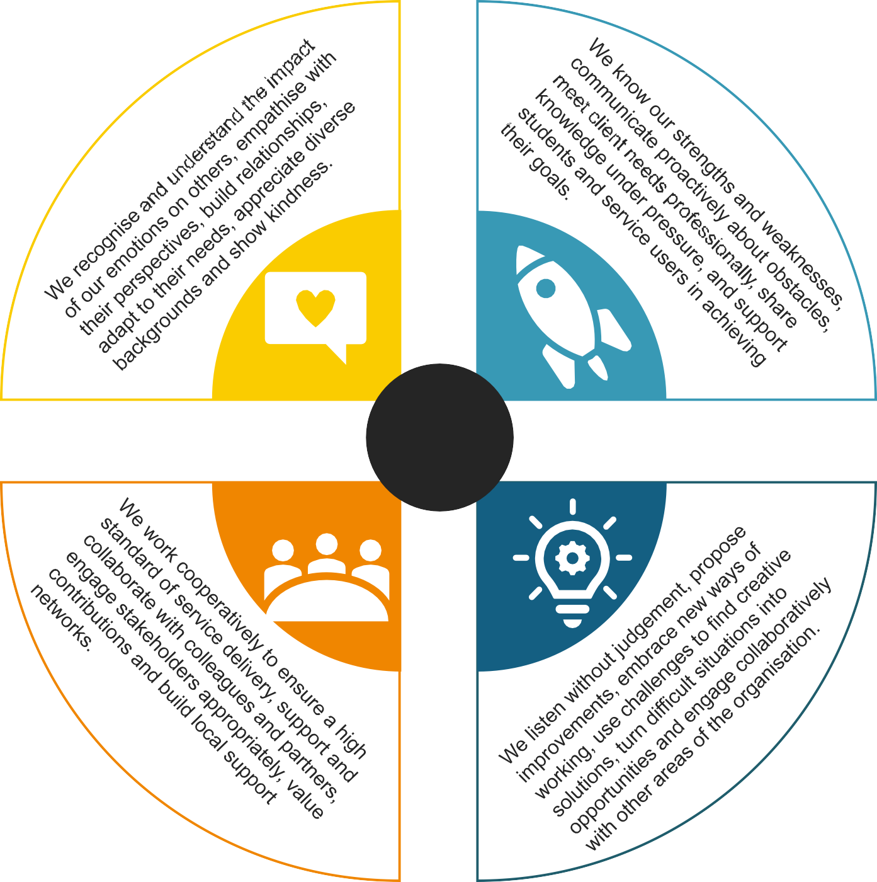




COMPASSIONATE
COLLABORATIVE
VALUES

CURIOUS

OUR VALUES

Our values are at the heart of everything we do. They were created by colleagues across Catch22 and guide how we work together to support others.



We’re curious
We explore, innovate, and challenge to improve what we do.

We’re
collaborative
We do things with people, not to them.

We empower others
We give people the knowledge, skills, and opportunities to thrive.

We’re compassionate
We care about people, supporting them to move forward.

ADDITIONAL INFORMATION

The post holder will be required to comply with all policies and procedures issued by Catch22.
This job description cannot cover every issue or task that may arise within the post at various times and the post-holder will be expected to carry out other duties from time to time which are broadly consistent with those in this document.

This job description does not form part of the contract of employment.

