|  |  |
| --- | --- |
| **Job Description and Personal Specification** | |
|  |  |
| **Job title:** | Senior Advisor (Welfare Benefits) |
| **Place of work:** | Community Links, 105 Barking Road, E16 4HQ |
| **Hours of work:** | Full time, 37 hours per week / fixed-term (12 months) |
| **Salary/Grade:** | Operations, Team Leader. (£35,000 per annum) |
| **Reports to:** | Advice and Communities Programme Manager |
| **Level of screening:** | Enhanced DBS |
|  | |
| Who we are | |

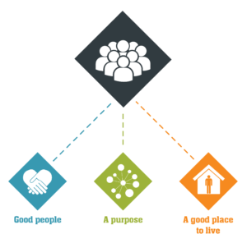

Catch22 is a social business which design and delivers services that build resilience and aspiration in people and communities. We believe that people can thrive when they have a good place to live, good people around them, and a fulfilling purpose. [We call these our '3Ps'.](https://www.catch-22.org.uk/about/our-vision/)

All Catch22 services deliver at least one (and often all three) of these outcomes.

If you share our values and commitment to transforming people’s lives, get in touch!

|  |
| --- |
| Where you fit in |
| This role presents an exciting collaboration between Community Links, and the Finance, Benefit, and Debt (FBD) Team. You will be based at, and will be managed by, Community Links. However, you will provide services for, and specifically liaise with, clients and staff from across both the FBD Service (90%) and Community Links (10%).  **Community Links**  [Community Links](http://www.community-links.org/) is rooted in east London, providing support and opportunities to thousands of people every year. We have been transforming lives for over 45 years and are founded on two principles: to find new solutions to old problems and to deliver them with the whole community.  Our Mission is to support people in coming together, overcoming barriers, building purpose and making the most of the place they live in. From our base in East London, we apply the learning from our local work to influence and achieve positive national change.  Our Vision is of Ready for Everything Communities: groups of people who support each other to overcome problems, prevent them from occurring again and help each other to thrive and achieve their goals. You will be joining a small energetic and passionate team with a fun but hardworking culture, all relentlessly committed to Community Links core mission and purpose.  **Finance, Benefit, and Debt Team**  We provide a comprehensive, wrap-around service delivering debt, welfare, housing and legal advice to people in crisis, thanks to a team of in-house front-line advisers and volunteers who rapidly pivoted to remote advice delivery during lockdown.  Ordinarily we deliver workshops, walk-in sessions and a by-appointment advice desk to ensure our services are accessible to as many people as possible.  We connect people to the support they need, enable them to support each other and build capacity within the community to identify and overcome issues and prevent them from occurring again. The Advice Team provides support to people through different elements, such as:   * Welfare Benefits advice delivered to the Advice Quality Standard * Welfare Benefit applications * Debt Advice from accredited qualified experts * An emergency Food Support Service |
| Main Duties & Accountabilities |

As a senior welfare benefits adviser you will be:

1. Providing high-quality welfare benefits advice and casework, assisting clients to access their rights and entitlement.
2. Receiving and processing referrals from the FBD team, to support different types of service users.
3. Carry out benefits calculations, form filling and other income maxmimzation through take -up of appropriate benefits
4. Advice and advocate for clients in challenging benefist decision, such as Mandatory reconsideration application and appeals.
5. Conduct face – face interviews, to clients: (including at outreach locations), via phone, by email and online. Assessing the wider situation of the client, refer to internal and external partners appropriately
6. Conducting case file reviews and supervising staff and volunteers, whilst working supportively with other members of the Advice Team
7. Delivering training, to clients with the aim of improving their understanding of basic benefits entitlement and take – up
8. Providing cover for other advisers when required.
9. Meeting individual service level targets as set out by the Advice Programme Manager
10. Keeping accurate, auditable records of interactions with clients. Completing all necessary paperwork and uploading required monitoring information onto our IT system (easy to use, Advice Pro).
11. Reflecting on your work and sharing learning on the needs of beneficiaries with your line manager, and our policy, fundraising and evaluation teams, to improve our service, lobby for wider change and secure funding.
12. Carry out any other tasks that may be within the scope of the role to ensure the effective delivery and development of the service.
13. Attend all necessary training and development activity, including keeping up-to-date with legislative changes, as required to maintain competence.

|  |
| --- |
| What does good look like for this role? |

A senior welfare benefits adviser, who is a good team player, with at least two years’, full-time experience of providing welfare benefits casework.

|  |
| --- |
| Organisational Relationships |

Community links are proud to be part of the Catch22 group. Catch22 exist to help build a society where everyone has a good place to live, good people around them, and a fulfilling purpose. [We call these our '3Ps'.](https://www.catch-22.org.uk/about/our-vision/)

We achieve this in two ways. We improve lives on the frontline through delivery of public services. Secondly, we use our knowledge to change 'the system', to fix the complex web that can trap and disempower those it was set up to help. With the heart of a charity and the mindset of a business, we are uniquely placed to deliver on this challenging agenda.

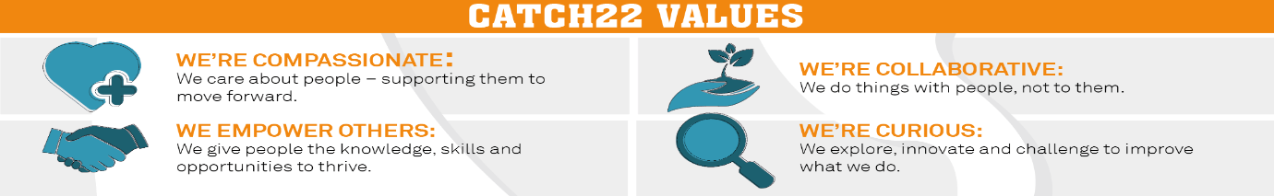

|  |  |  |  |
| --- | --- | --- | --- |
| Job Title: Person Specification | | | |
| **COMPETENCY** | **ESSENTIAL** | **DESIRABLE** | **ASSESSMENT** |
| **QUALIFICATIONS** | * Desire to develop and undertake training as required | * NVQ Level 3 in Advice and Guidance or above | CV/ Application/Interview |
| **KNOWLEDGE** | * Specialist knowledge of welfare benefits, including legacy benefits and universal credit: * Eligibility to benefits * Challenging decisions * Backdating * Overpayments * Overlapping benefits * Small grant applications (eg Family Fund) | * Case management system experience (we use Advice Pro). * Knowledge of east London. | CV/ Application/Interview |
| **EXPERIENCE** | * Two years’ experience of giving welfare benefits advice, at casework level * A track record of providing excellent service to all beneficiaries who will use the service by offering high standards of customer care at all times and the ability to meet organisational standards in the provision of a responsive service. * A track record of strong record keeping. |  | CV/ Application/Interview |
| **SKILLS & ABILITIES** | * Assisting clients with high-quality welfare benefits advice, including casework. * Assessing the wider situation of the client and appropriately referring to internal and external support. * Delivering advice in the most appropriate way to clients: face-to-face (including at outreach locations), via phone, by email and online. * Co-ordinating our 'open door’, ‘benefits check’ and ‘form filling’ services, including triaging clients when they first arrive at Community Links and providing general advice. * Supervising staff and volunteers, whilst working supportively with other members of the Advice Team, both paid and voluntary. * Delivering training, for example, to clients with the aim of improving their understanding of basic advice. * Providing cover for other advisers when required. * Meeting individual service level targets as set out by the Program Manager. * Keeping accurate, auditable records of interactions with clients. Completing all necessary paperwork and uploading required monitoring information onto our IT system (easy to use, Advice Pro). * Reflecting on your work and sharing learning on the needs of beneficiaries with your line manager, and our policy, fundraising and evaluation teams, to improve our service, lobby for wider change and secure funding. * Carry out any other tasks that may be within the scope of the role to ensure the effective delivery and development of the service. * Attend all necessary training and development activity, including keeping up-to-date with legislative changes, as required to maintain competence. |  | CV/ Application/Interview |
| **OTHER** | * Willing to share Community Links and Catch 22 values. * A commitment to equality, diversity and inclusion. * Willing to undertake reasonable travel. | * A good understanding of the aims, policies & principles of Community Links. | CV/ Application/Interview |