Job Title: People Team Systems Administrator
Job Description and Personal Specification
Job title: | People Team Systems Administrator
Place of work: | Hybrid/Brasted
Hours of work: | 18.5 hours a week - flexible
Salary/Grade: | Coordinator
Reports to: | People Systems Manager
Level of screening: | N/A

Who we are
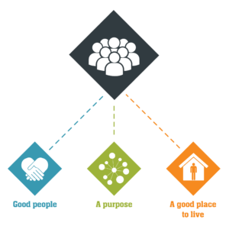
Catch22 is a social business which design and delivers services that build resilience and aspiration in people and communities. We believe that people can thrive when they have a good place to live, good people around them, and a fulfilling purpose. We call these our '3Ps'.
All Catch22 services deliver at least one (and often all three) of these outcomes.
If you share our values and commitment to transforming people’s lives, get in touch!

Where you fit in
About Catch22’s Corporate Services
Our corporate services in Catch22 include finance, IT, The People Team, (incorporating human resources, learning and development and employee relations), Health and Safety, Development (including business development, partnerships and communications). We service staff across the Catch22 hubs: Justice, Education, Employability and Skills and Young People and Families.
About the People Team
In this role you will be responsible for the day-to-day system administration and development of our HR system People First, whilst providing support and guidance to managers and staff on the effective utilisation of the system. You will also support with the administration of any other HR related systems across the team, including our payroll system iTrent.

Main Duties & Accountabilities

HR Systems

- Be the first point of contact for all enquiries:
- Notifying/discussing system problems, outages and bugs which need to be addressed by external providers and escalating these accordingly.
- Providing technical advice, support and guidance to system users (e.g., log in issues) and be able to provide ad hoc training to users to resolve these issues.
- Be responsible for User account set up, maintenance and control:
  - Ensure all users have appropriate access to fulfil their role and functions within the system.
  - Ensure all new starters and leavers are given access / access withdrawn in accordance with SLA timescales.
- Security maintenance – ensuring any changes or creation of new security profiles work (i.e., are tested following any build or maintenance)
- To support with the performance of system upgrades, patches, and fixes.
  - Liaise in a timely manner with Catch22 teams (HR, Payroll); and other Catch22 umbrella organisations respectively on the timing of patches/upgrades.
  - Ensure relevant parties are aware of improvements/impacts of any upgrades e.g., new functionality, standard reports, etc.
  - Supporting with any post upgrade actions
- Data conversion – support Catch22 HR and Payroll with any data conversions required.
- Supporting with the timely implementation of pay uplifts, annual leave changes and changes to terms and conditions.
- Plan and carry out system audits and undertake the necessary actions as a result
- Support with the training of the HR team and other new starters within the organisation.
- Be able to extract reports and data out of the HR system as requested, and complete external surveys and data requests.
- Deliver training sessions to new users of the system.
- Prepare user guides and videos to help users understand how to carry out processes, and keep these up to date with functionality enhancements and changes.
- Support with project work.
- Ensure compliance with GDPR and other data protection regulations.

Other systems

- Create new accounts and manage access permissions.
- Support with the implementation of any new systems.
- Train system users on functionalities and new features, including producing guides and videos.
- Troubleshoot and report technical issues.
- Produce reports and extract data as required.

Other
- To carry out such other relevant duties, as may be required and as are commensurate with the nature and grading of the post.

What does good look like for this role?

- Employees experience positive interactions with any questions or queries they raise. All questions and queries raised are resolved accurately or appropriately signposted to be resolved elsewhere.
- The systems used in the People team are maintained efficiently and effectively.
- All administration tasks are carried out to a high standard, with an eye for attention to detail, all with end users in mind and ultimately to ensure that people are paid correctly and in a timely fashion.

Organisational Relationships

- Reports to People Systems Manager.
- Liaise closely with People Services and Payroll teams.
- Liaise with Catch22 HR, Payroll; and other Catch22 umbrella organisations.
- Liaise with all managers and staff within Catch22, both at Head Office and in the services.
- Liaise with relevant 3rd party suppliers.

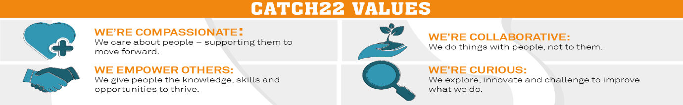

People Team Systems Administrator: Person Specification
COMPETENCY | ESSENTIAL | DESIRABLE | ASSESSMENT
QUALIFICATIONS | Level 2 qualifications including – English and Maths | Working towards CIPD level 3 or equivalent
KNOWLEDGE | Must be PC-literate and self-sufficient in the Microsoft 'Office' suite of products.  Experience of carrying out administrative tasks including the use of databases.  Knowledge of HR databases and business intelligence reporting tools at the highest level, and how they can be used to provide people data. | Knowledge of HR and/or Payroll  Knowledge of SQL
EXPERIENCE | Experience of working with and maintaining HR and Payroll systems.  Experience of providing help/support and technical guidance on to Users.  Experience of maintaining system security profiles and passwords.  Experience of running and maintaining reports. | Experience of supporting and configuring the following specific Business Systems:  - People First  - iTrent  - SmartRecruiters  - SAP Business Objects  - Moodle  - Power BI  Experience of working in a busy Human Resources Department and / or Experience of working in a busy Finance Department.
SKILLS & ABILITIES | Ability to build and develop good working relationships at all levels and with external suppliers.  Excellent communication skills including ability to convey complex technical information to a range of audiences.  Ability to work in a systematic manner organising own workload to meet deadlines, maintaining accurate records and ability to resolve day to day conflicting priorities.  A pro-active approach to work, excellent attention to detail, and ability to identify issues and inaccuracies quickly.  Ability to review and document processes and procedures to find a technical solution.  Ability to produce reports and management information.  Pro-active, customer-focused, and solutions-oriented.  Able to work effectively under pressure.  Able to maintain confidentiality.  Willingness to work flexibly as required.
OTHER | Share Catch22 values.  Awareness of and commitment to Equality & Diversity  Willing to travel and work flexibly.  Desire to develop and undertake training as required

