|  |  |
| --- | --- |
| Teacher **Job Description and Personal Specification** | |
|  |  |
| **Job title:** | Teacher |
| **Place of work:** | At one of the sites within the school |
| **Hours of work:** | Full Time |
| **Salary/Grade:** | Education, Teacher – Unqualified/Qualified |
| **Reports to:** | Head Teacher or Curriculum Learning Lead (as appropriate) |
| **Level of screening:** | Enhanced DBS |
|  | |
| Who we are | |

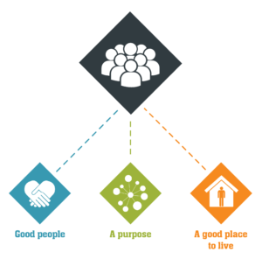

Catch22 is a social business which design and delivers services that build resilience and aspiration in people and communities. We believe that people can thrive when they have a good place to live, good people around them, and a fulfilling purpose. [We call these our '3Ps'.](https://www.catch-22.org.uk/about/our-vision/)

All Catch22 services deliver at least one (and often all three) of these outcomes.

If you share our values and commitment to transforming people’s lives, get in touch!

|  |
| --- |
| Where you fit in |
| Catch22 provides young people aged 4 to 18 with alternative and special education in order for them to progress and succeed in sustained education or employment. We do this through high quality teaching and learning based on effective relationships that enable the achievement of life skills and meaningful qualifications.  Provide professional high-quality teaching for learners by planning, organising and delivering a high-quality curriculum that meets national curriculum requirements and or awarding body standards.  Work to support a culture and quality of delivery, that has an impact on the learner’s learning and the progress they make from their starting points with consideration of complex and vulnerable student’s needs.  Work with colleagues to implementation whole school strategies relating to engagement, behaviour management and inclusion  About the [INSERT TEAM]  100 words on the team |
| Main Duties & Accountabilities |

**Teaching and Learning**

Deliver teaching, learning and assessment activities that appropriately stretch and challenge all learners and ensure that learners with additional support needs receive the appropriate level of support they need at the right time.

Develop schemes of learning and develop lesson plans to ensure compliance with curriculum best practice and quality targets and to meet the individual needs and motivations of individual and groups of learners

Assist in the development of educational materials ensuring quality and consistency of approach.

Develop, update and monitor individual Education/Leaning Plans; monitor progress and undertake assessments so that learners receive appropriate support and make expected progress towards target outcomes and attain recognised qualifications.

Pro-actively develop links with external agencies and organisations that can contribute to the delivery of the planned curriculum programme

Embed young person’s involvement into sessions so that learners are encouraged to contribute their views.

Provide a stimulating classroom environment and remote learning activities when required, where resources can be accessed appropriately by all pupils.

Identify clear teaching objectives, learning outcomes and IEPs.

Provide management information and other statistical data as required.

Build effective and supporting relationships with students and families/carers; embed that trust and support within the education process.

Undertake relevant administrative tasks associated with the teaching function including examination/accreditation entries for learners, register taking and invigilation.

**For People (For Staff, students and volunteers)**

Participate in meetings which relate to the curriculum, organisation or administration of the school, including pastoral and care arrangements.

Lead, organise and direct the work of designated Teaching Assistants.

Participate in the Pupil Annual Review process as appropriate.

Record attendance on a daily basis for a designated group of pupils.

Ensure a good standard of learner behaviour. Support learners to appropriately manage their emotions and feelings to being in the secure estate and motivate them to engage and see the value of education, relaying any concerns about learners to subject leads and established lines of reporting.

Contribute to reports and liaise with other professionals and consultants to ensure that individual pupils receive specific help where required.

**For Resources**

Ensure the effective and efficient management and organisation of learning resources, including digital technologies.

Identify opportunities to develop new resources (within the delegated budget) from a wide range of sources inside and outside the school.

Use accommodation and resources to create an effective and stimulating environment for teaching and learning.

Ensure that all resources have been properly risk assessed and are appropriate for use by pupils with emotional and behavioural difficulties.

**Inclusion**

Actively contribute to our ambition of creating an inclusive culture, recognising and embracing difference. Act in line with, promote and carry out all responsibilities with full regard to Catch22’s Equality and Diversity Policy. Promote and demonstrate anti-discriminatory practice.

**Health, Safety and Wellbeing**

Follow safe systems of work at all times in accordance with your responsibilities as an employee of Catch22. Report incidents in line with Catch22’s Health and Safety policy, so that remedial action can be taken to prevent an accident or ill health. Take reasonable care of your own health, safety and wellbeing and help support those around you with theirs.

**Other requirements**

Reflect the vision, mission aims and values of Catch22 at all times. Role model Catch22 behaviours.

Complete mandatory training in line with Catch22’s policy and procedures

This Job Description and Person Specification reflect the duties of the post as they exist at this time and may be subject to change based on the needs of the organisation. The post-holder may be required to undertake other duties commensurate with the salary and competence requirements of this post from time to time as required.

|  |
| --- |
| What does good look like for this role? |

* Improve attitude and engagement of pupils
* Enable pupils to make academic progress
* Teaching to be at a high level by employing a range of strategies to effectively manage the classroom to enable pupils to engage

|  |
| --- |
| Organisational Relationships |

* Reports to the Head Teacher or Curriculum and Learning Lead (as appropriate)
* To become part of the team around the child that shapes education, social and cognitive development.
* Develops positive relationships with students, parents/carers, external agencies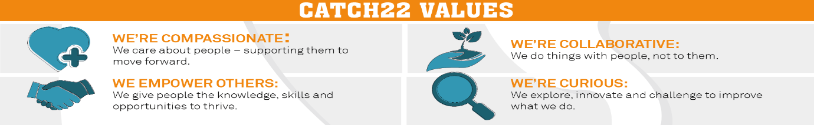

|  |  |  |  |
| --- | --- | --- | --- |
| Job Title: Teacher Person Specification | | | |
| **COMPETENCY** | **ESSENTIAL** | **DESIRABLE** | **ASSESSMENT** |
| **QUALIFICATIONS** | A recognised higher qualification with significant experienced of teaching and planning with a willingness to work towards QTS.  Degree in related subject. |  | Application |
| **KNOWLEDGE** | A clear understanding of the National Curriculum and its application.  A robust knowledge of behavioural techniques and theories and their application.  Knowledge of the statutory requirements of equal opportunities, discrimination, health and safety, safeguarding and child protection.  A sound knowledge of planning and assessment techniques.  A secure knowledge and understanding of subject(s)/curriculum area(s) and related pedagogy.  An extensive knowledge and understanding of how to use and adapt a range of teaching, learning and behaviour management strategies, including how to personalise learning to provide opportunities for all learners to achieve their potential. |  | Application/Interview |
| **EXPERIENCE** | Experience of working with our cohort of young people including those with complex, high behaviour and additional learning needs.  Extensive behaviour management experience with students who have complex needs and extreme behaviour. Relevant classroom teaching experience. |  | Application/Interview |
| **SKILLS & ABILITIES** | Ability to work effectively with students with complex needs  Ability to communicate effectively both in verbal and written form.  Ability to effectively use a variety of teaching and organisational styles and resources, including ICT to deliver outstanding teaching and learning  Ability to work as part of a team to deliver a holistic educational package.  Ability to cope with emotionally demanding situations.  Ability to manage your time effectively.  Flexible creative and adaptable approach. |  | Application/Interview |
| **OTHER** | Share Catch22 values  Awareness of and commitment to Equality & Diversity  Willing to travel and work flexibly  Desire to develop and undertake training as required |  | Application/Interview |