|  |  |
| --- | --- |
| **Career Coach**  **Job Description and Personal Specification** | |
|  |  |
| **Job title:** | Career Coach |
| **Place of work:** | Home Based (regional travel when necessary) – Bath/Bristol |
| **Hours of work:** | 37 hours per week |
| **Salary/Grade:** | £25,000 - £27,00 per annum |
| **Reports to:** | Operations Manager |
| **Level of screening:** | Enhanced DBS |
|  | |
| Who we are | |

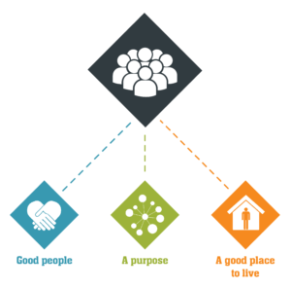

Catch22 is a social business which design and delivers services that build resilience and aspiration in people and communities. We believe that people can thrive when they have a good place to live, good people around them, and a fulfilling purpose. [We call these our '3Ps'.](https://www.catch-22.org.uk/about/our-vision/)

All Catch22 services deliver at least one (and often all three) of these outcomes.

If you share our values and commitment to transforming people’s lives, get in touch!

|  |
| --- |
| Where you fit in |
| Working within our Employability division, you will be an experienced Career Coach or Employment Advisor working within local communities to support individuals to progress into their chosen career paths.  You will manage a small caseload of up to 40 at any given time and develop bespoke plans to support these individuals throughout their journey towards progression.  **Employability and Skills**  We work with employers and individuals to provide sustainable jobs for everyone. Through our local and national partnerships in London, Essex, Bristol and Liverpool, our services help people who have struggled to find work through conventional routes.  Case workers base themselves in the heart of communities and reach out directly to individuals. Our tailored service removes significant barriers to work and enables employers to reach the hardest to reach individuals.  We also run a number of Colleges, offering learning and training opportunities for students aged 16-19 who, for whatever reason, don’t want to stay in a traditional academic environment. We provide our students with a different option – the opportunity to carry on their learning in a smaller, highly supportive environment where the focus is on providing learning and training options to help you gain the skills, qualifications and experiences students need to achieve their goals in life.  **Employability and Skills**  We work with employers and individuals to provide sustainable jobs for everyone. Through our local and national partnerships in London, Essex, Bristol and Liverpool, our services help people who have struggled to find work through conventional routes. Case workers base themselves in the heart of communities and reach out directly to individuals. Our tailored service removes significant barriers to work and enables employers to reach the hardest to reach individuals.  **About the role**  We are delivering a creative and digital skills programme for participants who are not in education, employment or training. Tackling unemployment and helping England to build back better as part of the national recovery, the programme will support young people onto long-term, education, work and training opportunities in the creative and digital sectors. |
| Main Duties & Accountabilities |

* To support a diverse caseload of participants who are looking to get into technology related job roles
* To understand their challenges, career ambitions, strengths & development areas, future job roles and / or training opportunities.
* To engage with the local community and develop strategic relationships with Local Authorities and referral partners to successfully identify participants for programme
* To effectively engage participants, induct and enroll on the programme and sustain a professional relationship with throughout their journey
* To deliver high quality end to end Information, Advice and Guidance to participants to create a bespoke career action plan
* To promote and develop the mind-set, emotional intelligence qualities, self-confidence and esteem so that the participants succeed in the world of work.
* To complete goal focused action plans for all referred participants and provide support and motivation for clients to implement their action plans.
* To `coach’ the participants on a one to one and group based employability sessions including Interview skills, job search methods, confidence building and other bespoke sessions
* To prepare CVs, cover letters and job/apprenticeship application forms with participants.
* To introduce participants to a `strengths based’ recruitment approach to succeeding in job interviews.
* To short list, pre-select and match/submit participants to vacancies/work experience opportunities generated by the Partnership Development Manager or Employment Engagement Officer.
* To prepare job packs on specific vacancies/work experience opportunities for participants.
* To arrange interviews for participants where appropriate.
* To prepare participants to a high standard for interview with employers.
* To engage and maintain regular contact with participants at agreed intervals to ensure they sustain their apprenticeship or employment
* To deliver high quality In Work Support which effectively sustains participants in line with the programmes expectations
* To get feedback and act on regular feedback from participants and employers.
* To take responsibility for delivering on own on operational targets.
* To undertake travel as required to deliver coaching to participants
* To use case management/performance management systems are in used effectively in accordance to the requirements of the programme
* To ensure that timely input and communication of key documents and information is delivered.
* To ensure contractual and Catch22 compliance is maintained to the highest standard at all times
* Seek to improve his/her own performance, contribution, knowledge, skills and participate in training and developmental activities as required.

|  |
| --- |
| What does good look like for this role? |

* + Developing strong relationships with referral partners, customers, training providers and employers.
  + Strong interpersonal skills, with ability to develop strong rapport. Approachable, adaptable, and supportive to the range of stakeholders involved in this programme.
  + Service is delivered in line with contract requirements and all targets are met.
  + Service is delivered in budget and margin is met.
  + Service is delivered safely, and risks/areas of underperformance are identified and managed appropriately.
  + Hub outcomes are achieved.
  + Service users have a positive experience and achieve their goals.

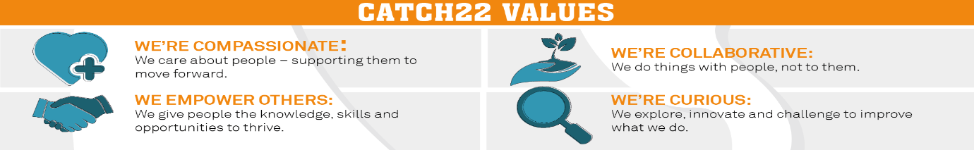

|  |  |  |  |
| --- | --- | --- | --- |
| Job Title: Person Specification | | | |
| **COMPETENCY** | **ESSENTIAL** | **DESIRABLE** | **ASSESSMENT** |
| **QUALIFICATIONS** | Qualification in Careers Guidance (QCG) or NVQ Advice & Guidance | Coaching qualification | Application |
| **KNOWLEDGE** | * Knowledge of approaches including those relating to coaching, emotional intelligence that ensure people are well prepared for the world of work * Sound knowledge of the local labour market |  | Application/interview |
| **EXPERIENCE** | * Experience of providing high quality CV, job search, interview support to learners/job seekers Experience of providing high quality coaching support that ensures access employment and apprenticeships * Experience of coaching and advising towards careers in a broad range of sector * Able to build learners/job seekers self-confidence, self-esteem, motivation to help them achieve in the world of work and lasting employment/career development * Experience of liaising with employers to arrange interviews and getting feedback on candidates. Identifying skills and qualities in a learner to match appropriately with vacancies * Progressing learners and job seekers into apprenticeships and employment and sustaining them in these * Ability to build and maintain strong working relationships with referral partners and other stakeholders |  | Application/interview |
| **SKILLS & ABILITIES** | * Positive, enthusiastic approach to problem solving with a “can do” attitude * Strong written and spoken communication skills Ability to gain people's confidence and put them at ease Be persuasive, persistent and patient * Be able to cope with pressure * Be flexible and adaptable and self-motivated to deliver on own and team objectives * Have good organisational and administrative skills * Have the ability to prioritise * Have excellent all round ICT skills * Be able to work to deadlines and produce reports Target and results driven | * Can use performance management systems * Can work well to KPI’s and targets | Application/Interview |
| **OTHER** | Share Catch22 values  Awareness of and commitment to Equality & Diversity  Willing to travel and work flexibly  Desire to develop and undertake training as required |  |  |