Executive Assistant and Administrator

|  |  |
| --- | --- |
| **Role:** | Executive Assistant and Administrator |
| **Place of work:** | Hybrid working with 1-2 days based in the office-  27 Pear Tree Street, London, EC1V 3AG |
| **Hours of work:** | 4 days per week – Working days must include Monday and Wednesday  Fixed term contract for 1 year. |
| **Salary/Grade:** | Part-time £25,600 – 29,600 (£32,000 - £37,000 FTE) |
| **Reports to:** | Director |
| **Level of screening:** | Enhanced DBS |

## About Lighthouse Pedagogy Trust

Lighthouse Pedagogy Trust is a charity creating life-changing, education-focused children’s homes to ensure that children in care have the same opportunities as everyone else. We believe that children growing up in residential care should go on to achieve great things and lead fulfilling lives. We believe that social pedagogy, a focus on education, people and place is the best approach to supporting young people.

The Lighthouse Pedagogy Trust team is driven by a shared commitment to creating empowering places where everyone has the opportunity to grow and learn. We follow our key values of Empowerment, Curiosity, Play, Compassion, Commitment and Difference.

In February 2022, we opened our first children's home in Sutton, which can support up to six 12-18 year olds. It is an award-winning building and sets a new standard for children's homes in the UK. You can read more about the home [here](https://lptrust.org.uk/sutton-london/) and see a virtual tour of the building [here](https://my.matterport.com/show/?m=ZmCZntDjkVj).

Over the next three years, we will be opening two more children’s homes, launching a Graduate Diploma for residential care workers and developing a leadership programme for children’s home Registered Managers.

We are hiring an Executive Assistant and Administrator to provide efficient support to the LPT Director and team, as well as business support to contribute to Lighthouse Pedagogy Trust's goal of improving outcomes for children in care.

Difference is one of our core values, and we strive to take the broadest possible view of diversity. We value people from all backgrounds – by this, we mean ethnicity, gender, age, and any other visible or invisible quality that makes you unique. We welcome that every person brings their own perspective and experience to our children’s homes, to contribute to our vision.

## Your role

As the Executive Assistant and Administrator, you will make a significant contribution to the smooth running of the organisation. Key responsibilities include:

* **Executive Assistant to the LPT Director** – This includes managing the director's diary and inbox, preparing meeting documents, booking rooms, and making travel arrangements.
* **Support the delivery of strategic projects** - You will project manage and support the delivery of Lighthouse Pedagogy Trust’s strategic goals, including managing the project plan and preparing relevant materials.
* **Provide administrative and operational support to the core team** – You will help the core team with administrative and operational tasks, such as organising team meetings and events, managing expenses and invoicing, and coordinating organisational policy reviews.
* **Assist the Head of LPT Talent and Professional Development with recruitment** – You will provide administrative support for recruitment and onboarding, such as screening applications, scheduling interviews, communicating with candidates and supporting onboarding checks.
* **Plan and coordinate governance meetings** – You will organise Project Forum meetings, including drafting and circulating papers, taking minutes, coordinating with attendees, and tracking actions.
* **Prepare and review LPT materials –** You will draft and proofread documents for internal and external stakeholders.

This is a new role in the organisation joining our core team (see team structure below).

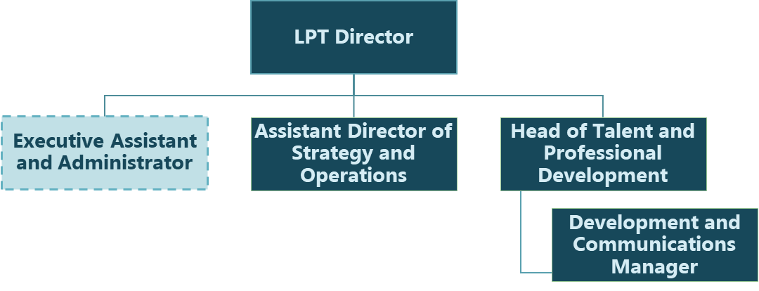

## About you

This role will suit someone who enjoys working in a collaborative environment and possesses strong administrative and problem-solving skills. It will also suit someone with an eye for detail, who works efficiently and likes to get things running smoothly.

The right person for this role will be a great proofreader with strong drafting skills and comfortable reviewing both written and financial information. You will be a stickler for detail and be great at preparing documents for a wide variety of stakeholders. This will include PowerPoint Presentations, minutes from meetings and briefing documents. You will be a self-starter and enjoy solving problems, especially when there is no obvious solution.

You will need to have experience working in an administrative, operational or assistant role and be capable of planning and prioritising your workload. This role is suited for individuals who thrive when working in close collaboration with a small team. You will be forward-thinking and good at proactively anticipating issues that may arise.

You will need to have a strategic mindset and be capable of supporting the delivery of strategic projects by aligning activities with the organisation’s long-term goals. This will include prioritisation and balancing competing priorities.

You will need to be confident working with Microsoft Office (Outlook, Word, Excel). You will need to be well organised, with strong written and verbal communication.

**Safer Recruitment**

At Lighthouse Pedagogy Trust, we are committed to safeguarding all children and young people in our care. As part of our recruitment process, we conduct rigorous checks and vetting of all applicants in line with legal and regulatory requirements, and best practice.

Everyone who works in our homes will be responsible for safeguarding young people and putting their safety and wellbeing first.

This post is subject to an Enhanced Disclosure and Barring Service (police records) check, including overseas police checks where necessary.  Please note that this post is exempt from the limitations of the Rehabilitation of Offenders Act, and as such all previous cautions and convictions will need to be disclosed as part of any application.  

For further information about the process please go to: <https://www.gov.uk/dbs-check-applicant-criminal-record>

## Role and responsibilities

**Executive Assistant to the LPT Director**

* Organise the Director's schedule, including scheduling meetings and events to ensure it reflects current priorities and responds to emerging needs.
* Manage the Director's email inbox by prioritising messages for their review and drafting responses.
* Prepare meeting agendas and assist with presentations that the Director will deliver.
* Arrange travel arrangements, including train and hotel bookings.
* Communicate with colleagues, partner organisations, funders and other stakeholders on behalf of the Director.

**Support the delivery of strategic projects**

* Create and maintain strategic planning documentation, including project plans and meeting minutes.
* Support with business planning by reviewing and updating project timelines.
* Help to deliver LPT’s wider strategic objective as needed, such as supporting the search for properties for future children’s homes and liaising with estate agents and developers.
* Maintain a risk register to identify future risks and support the core team in the implementation of mitigations.
* Ensure accurate and effective communication between stakeholders.

**Provide Administrative and Business Operations support to the core team**

* Support with organisational processes such as policy reviews and other processes as needed.
* Support financial processes, such as raising invoices, POs, managing expenses and expense card reconciliation
* Manage our website enquiries mailbox and respond to queries that come in.
* Arrange meetings, book rooms, and arrange travel and accommodation.
* Organise team away days, strategy days and social events.
* Maintain a calendar of events for the year, research useful events for the team to attend, and inform staff of upcoming events that they need to prepare for
* Take meeting minutes and maintain an actions tracker to ensure actions are followed up on afterwards.
* Provide ad-hoc support and/or holiday cover to Children’s Home Team assistant.

**Support the Head of LPT Talent and Professional Development**

* Provide administrative support to the Head of Talent and Professional Development for recruitment and onboarding, including scheduling interviews, candidate communications, onboarding checks and maintaining recruitment files.
* Assist in the coordination of recruitment events, such as online information events.
* Screen and score applications to identify qualified candidates for interview.
* Prepare interview materials and ensure candidates and interviewers are briefed on the interview process.
* Conduct 6 monthly audits of employee files to ensure our records are up to date and meet regulatory requirements.

**Plan and coordinate governance meetings**

* Plan, schedule and coordinate Project Forum and sub-committee meetings, including circulating agenda and papers in advance.
* Draft Project Forum papers and coordinate with core team members to gather their input and prepare updates for project forum meetings.
* Maintain records of meeting minutes, actions, and project-related documentation, ensuring accurate and up-to-date information is accessible to all Project Forum members.
* Follow up on actions agreed at Project Forum meetings, track and monitor deadlines, and provide regular updates on progress.

**Prepare and review LPT materials**

* Create written materials such as minutes, presentations, and briefings, and adapt material to a variety of audiences.
* Support with collating content for communications and information for funder applications and reports.
* Proofread materials and review for clarity and coherence.
* Ensure consistency in formatting and design in line with LPT design guidelines.
* Research information from various sources to support the content of written material.
* Ensure that the shared drive is organised for efficient document storage and retrieval.

**Working for Lighthouse Pedagogy Trust**

* Regularly attend supervision with your line manager, participate in performance appraisal processes and maintain your own professional knowledge and skills through training and professional development activities.
* Maintain discretion and confidentiality in handling sensitive information and documents.
* Promote and embed Lighthouse Pedagogy Trust’s vision and values in our children’s homes.
* Uphold and promote Lighthouse Pedagogy Trust’s equality and diversity policy and proactively challenge discriminatory practices.
* Continually seek out ways to improve Lighthouse Pedagogy Trust and Catch22’s services and identify new opportunities.

The duties as outlined in this job description are not exhaustive and may change from time to time due to the changing nature of the working environment. You are expected to carry out all appropriate tasks necessary to meet the needs of the organisation, or as may be requested by your manager.

|  |  |  |  |
| --- | --- | --- | --- |
| **Executive Assistant and Administrator: Person Specification** | | | |
| **COMPETENCY** | **ESSENTIAL** | **DESIRABLE** | **ASSESSMENT** |
| **QUALIFICATIONS** | * GCSE English and Maths grade C or above, or equivalent, or able to evidence ability at an equivalent level. | * Other relevant professional qualifications | Application |
| **KNOWLEDGE/ EXPERIENCE** | * Demonstrable experience in a broadly similar role * Experience providing administrative support * Experience of diary management * Experience communicating with a range of stakeholders | * Evidence of having established, developed and managed effective relationships with a range of senior stakeholders * Experience providing co-ordination and administrative support to a team of people (as opposed to supporting one person) * Experience of working in a start-up or charity * Experience writing meeting minutes | Application / Interview |
| **SKILLS & ABILITIES** | * Ability to communicate clearly, logically and effectively both orally and in writing * A sharp attention to detail and a thorough approach * Strong Microsoft Office skills, including Outlook, Word, Excel and PowerPoint * Well organised with strong administrative skills * Ability to prioritise and plan own workload and manage the workload of others * Able to review both written and financial information | * Ability to work in a fast-paced, constantly changing environment * Ability to deal with conflicting priorities and work with minimal supervision. | Interview |
| **OTHER** | * A personal commitment to professional development. * Willingness to undergo enhanced DBS check and register with the online update service (this check will be carried out prior to starting and funded by Lighthouse Pedagogy Trust, you do not need to currently hold a DBS to apply). | * An interest in innovative approaches to children’s residential care. | Interview |