Advocate
Job Description and Personal Specification
Job title: | Advocate
Place of work: | At one of the sites within the school
Hours of work: | 37 hours per week
Salary/Grade: | Pupil support and welfare
Reports to: | Curriculum Learning Lead or Deputy Head Teacher
Level of screening: | Enhanced DBS

Who we are
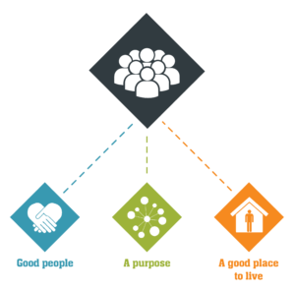
Catch22 is a social business which design and delivers services that build resilience and aspiration in people and communities. We believe that people can thrive when they have a good place to live, good people around them, and a fulfilling purpose. We call these our '3Ps'.
All Catch22 services deliver at least one (and often all three) of these outcomes.
If you share our values and commitment to transforming people’s lives, get in touch!

Where you fit in
About Catch22’s Education hub
Catch22 provides young people aged 4 to 18 with alternative and special education in order for them to progress and succeed in sustained education or employment. We do this through high quality teaching and learning based on effective relationships that enable the achievement of life skills and meaningful qualifications.
To manage, support and develop a group of marginalized young people and their families by building trusting relationships using individual sessions, group work, family visits and other interventions. To oversee a holistic person-centred approach to a young person’s journey from entry to exit, bridging the gap between their academic, behavioural and therapeutic needs.
To develop individual education/learning plans that brings together internal, external and multi-agency professionals in order to support development, attainment and progression.

Main Duties & Accountabilities
Service Users

- Work with the Curriculum and Learning lead to develop a case load and support students to engage within the school environment by providing initial interview/assessment of learners’ educational, emotional and behavioural needs and tailor advocacy and support programs around these.
- To work with colleagues to design, implement and review individual development plans for each young person in caseload according to identified needs at assessment. Specific consideration should be given to establishing critical baseline data regarding attendance, attainment and predicted grades followed by the use of agreed performance monitoring methodology relating to soft and hard outcomes.
- To work closely with teaching staff to ensure continuity of delivery and concretization of learning lessons whether they be educational or social.
- To organise and deliver 1:1 and small group targeted support, advice, guidance, practical help and mentoring for learners as appropriate to their needs and context.
- To ensure all young people in caseload are risk assessed regularly to identify issues and concerns relating to vulnerability and risk of harm to self or others.
- To work with Curriculum and Learning lead to assess need using the Common Assessment Framework in conjunction with the multi-disciplinary team to develop effective service responses and to ensure Ofsted compliant.
- Establish close collaborative and informative relationships with a range of partners including schools, LEA’s, Social Services, YOS, parents and communities.
- To track educational progress of the young people in your caseload with regards to school attainment, classroom behaviour and risk of exclusion in order to inform development and review of intervention content.
- Under the guidance of the Curriculum and learning lead, liaise with, and make referrals to, other agencies where necessary.
- Participate in multi-disciplinary teams and meetings, for example PEPs, planning and review, core group.
- Willingness to work in a range of settings including school, college, court, police station and young offender’s institutions. Working in a flexible manner to include occasion evening and residential trips.
For People (For Staff, students and volunteers)
- Management of the Teaching Assistants
- To deputise when the Curriculum and Learning Leader is offsite or absent.

For Resources
Keep accurate records, which might be used in case conferences and regular professional meetings. To efficiently record all details of each contact or work session with young people using the agreed database system, to keep that data management system up to date and to produce reports to support case reviews and evaluations as requested.

Ensure the effective and efficient management and organisation of learning resources, including digital technologies.

Ensure that all resources have been properly risk assessed and are appropriate for use by pupils with emotional and behavioural difficulties.

Inclusion
Actively contribute to our ambition of creating an inclusive culture, recognising and embracing difference. Act in line with, promote and carry out all responsibilities with full regard to Catch22’s Equality and Diversity Policy. Promote and demonstrate anti-discriminatory practice.

Health, Safety and Wellbeing
Follow safe systems of work at all times in accordance with your responsibilities as an employee of Catch22. Report incidents in line with Catch22’s Health and Safety policy, so that remedial action can be taken to prevent an accident or ill health. Take reasonable care of your own health, safety and wellbeing and help support those around you with theirs.

Other requirements
Reflect the vision, mission aims and values of Catch22 at all times. Role model Catch22 behaviours.
Complete mandatory training in line with Catch22’s policy and procedures
This Job Description and Person Specification reflect the duties of the post as they exist at this time and may be subject to change based on the needs of the organisation. The post-holder may be required to undertake other duties commensurate with the salary and competence requirements of this post from time to time as required.

What does good look like for this role?
- Improve attitude and engagement of pupils
- Provide reports to management of progress by pupil, class and school
- Enable pupils to make academic progress
- Line manage and support Teaching Assistants in carrying out their duties effectively
- Ensure that Teaching Assistants are part of afternoon and morning planning to ensure that they are clear about the expectations for them and the pupils form each lesson
- Provide supervisions for Teaching Assistants and feedback to CLL needs and CPD as required

Organisational Relationships

- Colleagues within the Education hub

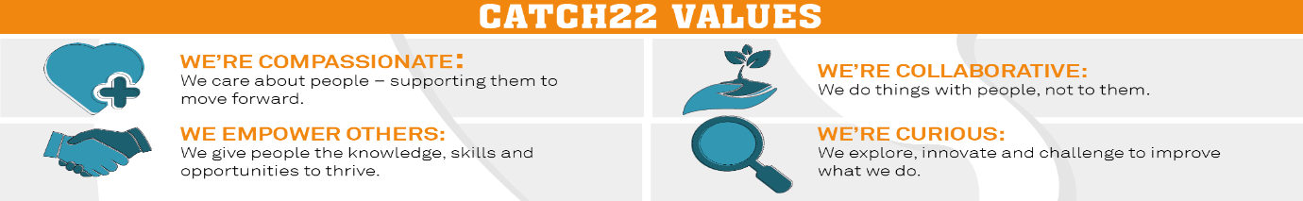

Job Title: Advocate Person Specification
COMPETENCY | ESSENTIAL | DESIRABLE | ASSESSMENT
QUALIFICATIONS | A relevant professional qualification (NVQ level 2) in working with young people, e.g. teaching, youth and community work, social work, counselling, mentoring. Level 2 English and Maths. | Team leader qualification | Application
KNOWLEDGE | - An understanding of the political and educational context of social inclusion.  - A knowledge of behavioural management techniques and understanding of de-escalation techniques.  - An understanding of the social, emotional and intellectual needs of young people and families.  - An understanding of multi-agency work and the roles of these disciplines.  - An understanding of childcare, child development and supporting theories. Emotional literacy, attachment, brain development, etc.  - A knowledge and understanding of influences on children and young people. E.g. peer pressure, gang culture, bullying, etc.  - Knowledge of Safeguarding & Equality acts. |  | Application/ Interview
EXPERIENCE | - Experience of working with our cohort of young people including those with complex, high behaviour and additional learning needs.  - Extensive behaviour management experience with students who have complex needs and extreme behaviour.  - Experience of working with complex young people and families who have social, emotional and behavioural difficulties. Including those who are from a variety of ethnic groups and cultures or who may be vulnerable or disadvantaged.  - Experience of working within a learning environment and being actively part of supporting the learning process.  - Building sustainable relationships with young people and their families, both formally and informally.  - Assessing family situations and needs to develop and implement effective strategies, risk assessments and individual educational/learning support plans.  - Working with a range of issues affecting young people and their families, such as substance misuse, domestic violence, multiple exclusions, offending behaviour.  - Using a holistic person-centred approach when working in or with multi professional teams/agencies. |  | Application/ Interview
SKILLS & ABILITIES | - Maintain records and prepare written reports. · Communicate effectively, both verbally and in writing, with colleagues, parents/carers and other agencies.  - Good interpersonal skills to maintain productive working relationships.  - Have a flexible and creative approach to service delivery.  - Proven ability to negotiate with and influence a variety of internal and external stakeholders. Application/Interview  - Be emotionally resilient and be able to work in a challenging environment.  - Manage a significant caseload and deliver targets. · Ability to organise and manage your own work routines/caseloads effectively with a minimum of supervision and support.  - Ability to perform all requested administration activities relating to data capture, evaluation and reporting.  - Advocacy and Counselling skills.  - Competency with certain IT applications, specifically Outlook, MS Word, Internet Explorer.  - Ability to assess risks in working with young people and their families. |  | Application/ Interview
OTHER | - Share Catch22 values  - Awareness of and commitment to Equality & Diversity  - Willing to travel and work flexibly  - Desire to develop and undertake training as required |  | Application/ Interview

