|  |  |
| --- | --- |
| Case Worker, missing from home **Job Description and Personal Specification** | |
|  |  |
| **Job title:** | Case Worker (missing from home) |
| **Place of work:** | Knowsley |
| **Hours of work:** | 37 hours per week |
| **Salary/Grade:** | D |
| **Reports to:** | Service Coordinator |
| **Level of screening:** | Enhanced DBS |
|  | |
| Who we are | |

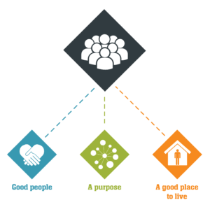

Catch22 is a social business which design and delivers services that build resilience and aspiration in people and communities. We believe that people can thrive when they have a good place to live, good people around them, and a fulfilling purpose. [We call these our '3Ps'.](https://www.catch-22.org.uk/about/our-vision/)

All Catch22 services deliver at least one (and often all three) of these outcomes.

If you share our values and commitment to transforming people’s lives, get in touch!

|  |
| --- |
| **About Catch22’s Young People and Families**  **Young People and Families**  Catch22 delivers a wide range of integrated support services designed to help resolve complex difficulties experienced by young people and their families/carers.  Support is provided to people who find themselves in a range of circumstances; they may be missing from home or have emotional, housing or substance misuse issues. We also support families where parents/carers are experiencing domestic abuse, substance misuse, emotional issues, homelessness, or unemployment. Whatever the situation, we work alongside young people and their carers to find a way of stabilising their lives.  **About the [INSERT TEAM]**  100 words on the team |
| Main Duties & Accountabilities |

* To undertake return interviews for all notifications received from the Police/CYPD within 72 hours
* To determine appropriate support plans and pathways for all young people, including the provision of interventions and direct work
* To undertake one to one work with children and young people vulnerable to Child Exploitation to inform a risk reduction plan.
* To undertake assessments of young people
* To work in partnership with Children’s Social Care to facilitate support where CE is highlighted as a risk.
* To offer educational awareness raising within local authority residential homes for young people who are cared for to enable others to manage and reduce the risks associated with young people being exposed to CE.
* To co-deliver CE awareness training as required by the Commissioner
* To work with the Local Authorities and their Local Safeguarding Children’s Board to ensure positive media messages and marketing of the service to young people
* To work in association with and support the Pan Merseyside Missing and Child Exploitation protocols.
* To undertake Child Exploitation Training to inform best practice when working with young people at risk of CE.
* Plan and deliver support interventions in accordance with Catch22 policies and procedures and local authority guidance, to ensure effective use of resources and targets are achieved.
* Identify and support access to additional or specialist services for young people and parents where necessary to ensure their needs are met and risks factors are reduced.
* Develop and sustain productive working relationships with referring agencies to ensure the regular and appropriate referrals are received.
* Record all intervention, contacts and multi-agency correspondence in accordance with the service specification within prescribed Management Information Systems
* Complete all required monitoring information by set timescales to assist the production of feedback reports to funders and stakeholders to track and monitor progress against outcome targets, KPIs etc
* To support and supervise volunteers and student social workers on placement as required

|  |
| --- |
| What does good look like for this role? |

Catch22 vision and values are embedded across portfolio of services

* All services are meeting their contractual targets and KPIs
* All services are meeting their financial performance targets and delivering margin
* Managing risk and making appropriate remedial action
* Our Services Users experience one or more of the Catch22 3P’s (good people, Purpose and place) IMPACT
* Service improvement / new business opportunities are identified with key stakeholders

|  |
| --- |
| Organisational Relationships |

Reports to Service Coordinator

Part of a multi-agency team consisting of Social Care, Police, Health, and Education.

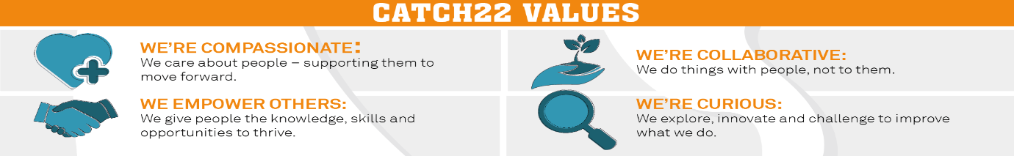

|  |  |  |  |
| --- | --- | --- | --- |
| Job Title: Person Specification | | | |
| **COMPETENCY** | **ESSENTIAL** | **DESIRABLE** | **ASSESSMENT** |
| **QUALIFICATIONS** | * Minimum 5 GCSE’s or equivalent, grade “C” or above Experience of working directly with young people on level 2- 4 on the continuum of need presenting a variety of support needs * Experience of planning, delivering and evaluating support activities for and with young people and their carers * Experience and understanding of case management including assessment, action planning and reviews. * Experience and application of Health and Safety and risk management procedures. * Experience of working in partnership with a variety of agencies to achieve agreed outcomes. * Experience and understanding of Child Protection including Safeguarding processes and procedures | * Relevant professional qualification in Youth/community work, Social Care, Health or Education * Experience of working with people from a variety of ethnic groups, cultural and social backgrounds * Experience of working in a multi-agency team | A,I,E |
| **EXPERIENCE/ KNOWLEDGE** | * Knowledge of the issues affecting young people at risk of exploitation. * Knowledge and understanding of Equality & Diversity issues. | * Knowledge and understanding of relevant legislation e.g. Children’s Act, Relevant protocols. | A,I,E |
| **SKILLS & ABILITIES** | * Ability to work flexible hours which could include evenings and weekends. * Punctual and reliable to ensure professional service. * Creative and flexible and able to work well with others in a team * Commitment to personal and professional development. |  | Interview |
| **OTHER** | Ability to travel in relation to the post.  Willingness to undertake training as required. |  | Interview |