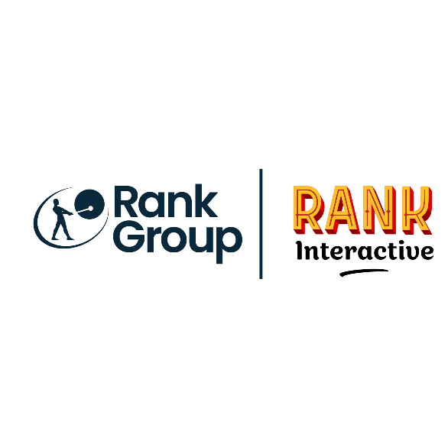

|  |  |
| --- | --- |
| **Job Title:** |  |
| **Location:** |  |
| **Duration:** |  |
| **Reports to / Line Manager:** |  |
| **Number of direct reports:** |  |
| **Budget responsibilities:** |  |

**Job Purpose:**

*As a mentor, the Design Team Lead has ability to maximize the potential of the design team members. And as a coach, the Design Team Lead is intent on helping the team members grow, bringing out the best in the creative department while being capable of identifying everyone’s strengths and weaknesses. The Design Team Lead has a proven ability to also lead projects through to delivery and is a leading performer who also contributes to the day-to-day delivery of assets to the business, working on visual concepts, using design software to communicate ideas that inspire, inform, and captivate the audience.*

**Main Accountabilities & Responsibilities:**

***Leadership:***

* *Mentor the career growth of team members, ensure a balanced workload, and oversee the work of team members.*
* *Assist the team with ideas and provide them with creative input for new designs.*
* *Guide team members in the creation of creative assets for digital, print, social, and video projects*
* *Maintain a proper quality control check on deliverables by team members.*
* *Ensure consistent execution and high-quality design deliverables to the business.*
* *Assign projects to team members.*
* *Assist in the recruitment of digital/interactive/graphic designers. Strategize and execute their training and self-development plan.*
* *Conduct weekly/daily one-to-ones with team members.*
* *Conduct performance appraisal.*
* *Collaborate with the whole Creative Team within the business.*
* *Interact with other departments (marketing and delivery teams) to understand their needs and develop better designs.*
* *Communicate information, concepts, ideas, and outcomes of research to team members to maintain a smooth flow of information.*
* *Promote a spirit of innovation and creativity within the design team to ensure that new ideas keep coming.*
* *Foster a culture of creativity, design excellence, accountability, and results.*
* *Attract, recruit, retain and develop appropriate talent to successfully complete established work plans.*

***Productivity:***

* *Deliver creative, pioneering, engaging collateral from conception through to execution.*
* *Design innovative and creative assets and oversee all the necessary design changes that are to be made for a better user experience.*
* *Ability to develop quick design ideas based on stakeholders’ briefs and ensure that all deadlines are followed.*
* *Staying in touch with the latest technology and strategies in the design and gaming industry and putting them to perfect use for the company's benefit.*
* *Develop outstanding graphics including but not limited to website promotions, social media images, video animation using design software.*
* *Contribute to brainstorming sessions, undertaking research projects, conceptualising ideas, and creative direction.*
* *Work off-site when required to support the business needs.*
* *Pitch conceptual designs and creative ideas, engaging stakeholders.*
* *Think players/users first and design a top-notch user experience.*
* *Take ownership of continual professional development utilising the latest technologies and trends across digital and print to consistently deliver a high standard of creative excellence.*
* *Provide accurate time estimates required to complete work and take ownership to deliver work accordingly.*
* *Understand the brands and the gaming industry, adding value by applying this knowledge to deliver innovative solutions in different situations.*
* *Other duties as assigned by senior management.*

*.*

**What’s needed for success – Experience & Qualifications:**

*The ideal candidate will have a proven track record in design leadership, demonstrating both creative excellence and strong management skills. They should possess a relevant degree in Design, Fine Arts, or a related field, coupled with significant experience in a creative leadership role.*

*Key qualities include:****Creativity***

* *Master creativity and innovation*
* *Think outside the box to generate creative concepts*
* *Have a strong creative flair to convey ideas through typography and images*
* *Can rapidly execute freehand drawings which serve as a visual brainstorming to consider first thoughts in greater depth*
* *Know how to tap into one’s creative resources and come up with new ideas and innovative designs*
* *Have a strong visual eye on various media*
* *Create excellent aesthetics in a design or product that leads to better usability and user experience*
* *Graphics are aesthetically pleasing that bring up a positive attitude in the players and thus a call to action*
* *Concept and produce visually strong, compelling creatives for social platforms, websites and prints*
* *An exceptional analytical thinker who solves problem quickly and effectively*
* *Very open-minded and incorporate the beliefs that others should be free to share their knowledge*
* *Strongly organised and have an outstanding attention to details*
* *Passionate about design*
* *Outstanding technical abilities*

***Communication***

* *Speaking, presentation and writing skills are clear and concise*
* *Fully concentrate, understand, respond and listen with all senses to the stakeholders*
* *Process and accept feedbacks in a constructive way*
* *Give useful critiques to other team members*
* *Body-language and tone of voice serve as a reflection of one’s positive mindset*
* *Have a professional and respectful attitude*
* *Communicate openly and honestly*
* *Strong, confident communicators with colleagues below, above, and adjacent to them*

***Typography and Design Principles***

* *Have the ability to make the copy not only legible but also visually appealing*
* *Highly trained and understand how fonts are made and utilised in an effective way*
* *Have a strong knowledge of leading, tracking and kerning*
* *Make an excellent use of typographic hierarchy and style*
* *Strong sense of layout, photography, form, colour, imagery and composition*

***Adobe’s creative applications and Interactive media***

* *Master Adobe softwares including but not limited to Photoshop, Illustrator, InDesign and After Effects*
* *Have an excellent knowledge of the keyboard shortcuts and use them productively*
* *Explore the best design blogs and tutorials to innovate on each promotion*
* *Expose to different media that actively engage the players through gif animation, video and audio*

***Branding***

* *Competently understand the identity and guidelines of each casino and bingo brand*
* *Successfully follow the style and feel of each website while bringing innovative ideas*
* *Potentially work on the rebranding of a website and make it a success*

***Productivity***

* *Design graphics of exceptional quality*
* *Create and produce a large amount of assets that provide a positive result in deposits and opt ins*
* *Efficiently complete multiple projects to meet shifting needs and deadlines*
* *Prioritise and manage time effectively*
* *Self-motivate oneself and strive to meet personal goals*
* *Manage stress through organisation and delegation whenever required*
* *Is always punctual*

***Technology***

* *Very competent in the use of modern technology*
* *Curious and willing to learn new trends and innovations*
* *Up to date with the online gaming trends*
* *Keep in touch with new software improvements*

***Interpersonal and Social skills***

* *Show self-confidence and maturity*
* *Have the right positive attitude and mindset*
* *Have a down to earth and approachable personality*
* *Embrace a strong working relationship with the creative team members and other collaborators*
* *Build a strong team spirit and environment within the creative department*
* *Value team work*
* *Listen and participate in debate on design critique*
* *Accountable of one’s work and responsibility*
* *Work independently as well as collaboratively with peers*
* *Very flexible and reliable*
* *Open to share knowledge*
* *Forcefully consistent in the role and embrace new challenge*
* *Enthusiastic, Personable, Collaborative, Proactive, Detailed, Articulate, Fun*
* *Ability to cope with the stress associated with a challenging work environment driven by results and where deadlines are respected.*
* *Has a positive and self-driven attitude, and is enthusiastic to build a design team*
* *Is an inspiring leader with deep insights into the personal motivations of team members*
* *Has a strong ability to lead a design team through influence and inspiration*
* *Possess intelligent decision-making and problem-solving skills through effective work management, organizational expertise, acute attention to detail, and effective prioritization*

***Evolution***

* *Aware of the areas for improvement*
* *Focus on continuous professional and personal growth*
* *Seek new inspiration to level up the quality of the work*
* *Constant research of the gaming and design industry*

**What will you get in return?**

*Join us to unlock benefits and opportunities that will boost your career journey in a vibrant, inclusive and fulfilling work environment – so you can* #[BeYourself](https://careers.rank.com/why-join-us/equality-diversity-inclusion)*.*

Wellbeing@Rank *is important... From hybrid working and colleague support networks to menopause support and weekly* PepTalks*, we’re here for you.*

*We’ll also invest in your growth by providing* [*development*](https://careers.rank.com/why-join-us/development) *opportunities, leadership training and cutting-edge industry certifications so you have the tools and resources to help* you work, win and grow with [*us*](https://careers.rank.com/why-join-us/our-people)*.*

*Immerse yourself in new cultures and gain international exposure through our global business. Collaborate with colleagues from around the globe.*

*From pensions to bonus schemes, and private medical insurance to life insurance – we've got you covered.*

*\*Our benefits vary by brand and/or location. Please have a chat with your local Talent Acquisition specialist to find out what’s in place in your location.*

*The Rank Group are committed to being an inclusive employer, ensuring that we better understand and meet the needs and requirements of our candidates and customers.*

*We aim to do this by facilitating fair and equal access to our services. If you require a reasonable adjustment to be made, please reach out to let us know ahead of your interview.*