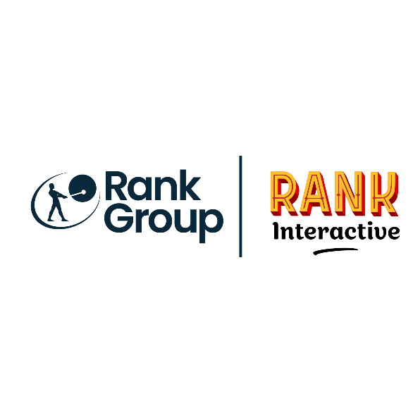

|  |  |
| --- | --- |
| **Job Title:** | **Junior Graphic Designer** |
| **Location:** | **Mauritius** |
| **Duration:** | **Full Time** |
| **Reports to / Line Manager:** | **Lucas Pugin (Team Lead)  Design Manager: Aurelie Castagnette** |
| **Number of direct reports:** | **N/A** |
| **Budget responsibilities:** |  |

**Job Purpose:**

*The Junior Designer will play a key role in shaping our brand’s visual identity by creating engaging and dynamic online projects. Your responsibilities will include conceptualizing and producing a diverse range of materials, such as promotional banners, email templates, and landing pages. You will collaborate closely with the Design Department, supporting various initiatives while also taking the lead on design briefs. This role offers the exciting opportunity to interact directly with stakeholders across multiple departments, ensuring the successful execution of projects from inception to completion. Join us and contribute to making our brand stand out with your creativity and design expertise.*

**Main Accountabilities & Responsibilities:**

* *Conceptualise & produce animated html5/gif banners and landing pages for our brand and affiliate sites;*
* *Produce and update brand templates;*
* *Prepare and provide digital assets for our affiliate sites;*
* *Assist with the maintenance of our brand websites including updates, promotional creative assets and site banners;*
* *Ability to take direction and support more senior staff in the delivery of big projects;*
* *Working with project team members including project stakeholders and other Designers on a daily basis;*
* *Maintain brand consistency throughout the creative assets;*
* *Keep abreast of new technology and new applications;*

*Any other responsibility required to effectively manage the retention and marketing activities for the network.*

**What’s needed for success – Experience & Qualifications:**

*Ability to deliver excellent results against challenging time deadlines;  
• Ability to simultaneously manage a range of creative tasks;  
• Proactive, enthusiastic and positive attitude combined with an open, honest, enthusiastic and resilient approach;  
• Manage change and operate effectively in a fast moving and dynamic environment;  
• A proven ability in task management, prioritising and the ability to take ownership of daily workload;  
• A willingness to learn about all aspects of the gaming industry;  
• Demonstrate a calm manner and an ability to handle complex situations;  
• Strong personal commitment to the delivery of excellent customer service;*

*• Excellent communication and presentation skills;  
• Strong Photoshop, Illustrator and Indesign skills;  
• Strong skills in typography, layout and design;*

*Animation, 3D and Ai skills are a bonus.*

**What will you get in return?**

*Join us to unlock benefits and opportunities that will boost your career journey in a vibrant, inclusive and fulfilling work environment – so you can* #[BeYourself](https://careers.rank.com/why-join-us/equality-diversity-inclusion)*.*

Wellbeing@Rank *is important... From hybrid working and colleague support networks to menopause support and weekly* PepTalks*, we’re here for you.*

*We’ll also invest in your growth by providing* [*development*](https://careers.rank.com/why-join-us/development) *opportunities, leadership training and cutting-edge industry certifications so you have the tools and resources to help* you work, win and grow with [*us*](https://careers.rank.com/why-join-us/our-people)*.*

*Immerse yourself in new cultures and gain international exposure through our global business. Collaborate with colleagues from around the globe.*

*From pensions to bonus schemes, and private medical insurance to life insurance – we've got you covered.*

*\*Our benefits vary by brand and/or location. Please have a chat with your local Talent Acquisition specialist to find out what’s in place in your location.*

*The Rank Group are committed to being an inclusive employer, ensuring that we better understand and meet the needs and requirements of our candidates and customers.*

*We aim to do this by facilitating fair and equal access to our services. If you require a reasonable adjustment to be made, please reach out to let us know ahead of your interview.*