



Role Specification

Non-Executive Director

Genomics England




Contact:
genomicsengland@egonzehnder.com

Contents
Introduction 3
The role 4
Candidate profile 5
How to apply 6
Background 7
Strategy 9
How we fulfil our mission 10
Our initiatives 11
Genomics England Board 12
About Us 14

Introduction
Genomics England is a global leader in enabling genomic medicine and research, focused on creating a world where everyone benefits from genomic healthcare. Our mission is to provide the evidence and digital systems so that by 2035 genomics could play a role in up to half of all healthcare interactions, whilst securing the UK’s position as the best place to discover, prove and benefit from
genomic innovations.
Genomics England hosts the National Genomic Research Library (NGRL), one of the largest genomic research databases in the world accessible to researchers globally. It is already the largest resource of whole genome sequencing data for rare disease research and for several cancers, and we expect it will grow to over half a million participants by 2030 enabling population-level and common disease research as well. We will also be delivering large scale clinical research programmes focused on using genomic data for population level screening, pre-emptive pharmacogenomics, and enabling patient access to clinical trials.
We are looking to bring on board a new Non-Executive Director. The ideal candidate will be a senior figure in scientific circles, holding a PhD or medical degree, with substantial experience in scientific research and an understanding of clinical translation pathways. They should bring deep insight into the challenges and opportunities facing the life sciences and healthcare sectors, combining scientific rigor with awareness of real-world health research application.

The Genomics England Board is accountable for overseeing the strategic direction of the organisation as set by the CEO and Executive Leadership Team. This Non-Executive Director will be expected to support this oversight with scientific knowledge and advice to both the rest of the Board and executives.
The successful candidate will be confident and grounded in scientific research, with deep knowledge of genomics. We would particularly value contributions on how scientific discoveries translate into clinical and healthcare impact, from someone who has experience working within or alongside government and NHS contexts. The ability to navigate complex stakeholder environments and contribute strategic insight at the intersection of science, health policy, and healthcare delivery would be highly advantageous.

The role

Key responsibilities are to:
- Support the Chair of Genomics England to examine, challenge and support strategy development, operational delivery and wider implications of Genomics England programmes and associated political and policy challenges
- Provide specific challenge and support to GEL decisions and risk monitoring.
- Bring an independent perspective to the work of Genomics England, with specific, recognised subject matter expertise in clinical science and research focused on genomics.
- Champion an open, honest, and transparent culture within the organisation.
- Ensure that the organisation values diversity and demonstrates equality of opportunity in its treatment of staff and service users and in all aspects of its business.
- Contribute effectively to discussions on the leadership and performance of Genomics England at Board and Executive/Non-Executive meetings.
- Work with the Chair and the senior management team to scrutinise Genomics England’s management information to ensure performance and delivery of the Annual Business Plan, and that other key objectives are ambitious and achievable.
- Contribute as chairs or members of Board sub-committees within Genomics England’s corporate governance framework.


Appointment
This is a Ministerial appointment
This role attracts £7,883 per annum. It is non-pensionable and payable via PAYE. Reasonable expenses are also payable in accordance with our Travel and Expenses Policy, but expenses incurred in relation to travel to our London office are taxable.
Term of appointment:
Three years, renewable for a further term, and in exceptional circumstances renewal for a third term.
Time commitment:
The anticipated time commitment is circa 15 to 20 days per annum. The role involves attendance at Board and the Audit Committee, providing advice as required, preparation time, travel and some work outside of meetings.

Candidate profile


Essential criteria
- Extensive scientific leadership experience in genomics from health, research, or innovation, with an ideal candidate bringing a mix of experience from academic, NHS, industry, or similar organisational settings.
- The ability to contribute to strategic discussions at board level, with a specific focus on clinical science credibility in the field of genomics.
- Proven ability to bridge the worlds of science, policy, and industry, ensuring alignment between research excellence, public health priorities, and economic growth.
- Commitment to advancing healthcare outcomes, research excellence, and innovation with a focus on transparency, and ethical stewardship.
- Experience at executive and
non-executive level.
- Strong communication skills, including the ability to offer challenge and support in a constructive, straightforward, and open manner on both strategic and operational matters.
- A strong commitment to the highest ethical standards of integrity and honesty.

Desirable criteria
- Experience in patient engagement, consent processes, and ethical considerations in research.
- Senior-level experience and knowledge of effective governance in complex organisations in the private and/or public sectors – preferably at board level.
- Strong commercial judgement and ability to challenge executive management constructively.
- Knowledge of UK health and life sciences policy, with influence in Whitehall and relationships across HM Government, the Department of Health and Social Care, NHS England, the Treasury, and regulatory bodies.

How to apply
Application process:
Key Dates:
- Applications will remain open for 4 weeks, closing on 10th March 2026.
- Selected candidates will be invited to stakeholder meetings and a panel interview with Genomics England due to be held in London in May 2026. Full details of the assessment process will be shared with candidates shortlisted to interview.
Selection Panel
- The selection panel for this role will be chaired by Baroness Nicola Blackwood (Chair)
- Other panel members will be confirmed to shortlisted candidates.
How to apply:
In order to apply, please submit a comprehensive CV along with a short covering letter which sets out your interest in the role and encapsulates the aspects of your experience relevant to the required criteria.
Please email your application to genomicsengland@egonzehnder.com
Please note that references and open-source due diligence checks (including into social media accounts) may be undertaken for all short-listed candidates.
Please note that all applicants must have the Right to Work in the UK.
If you require any adjustments to make the recruitment process more accessible, please contact Egon Zehnder at genomicsengland@egonzehnder.com
Contact point for all applicants:
- Name: Egon Zehnder
- Email: genomicsengland@egonzehnder.com
Contact point for all applicants:
- Name: Egon Zehnder
- Email: genomicsengland@egonzehnder.com

Background

About Genomics England

Genomics England is a global leader in enabling genomic medicine and research, focused on creating a world where everyone benefits from genomic healthcare. Genomics is a ground-breaking area of medicine that uses our unique genetic code to help diagnose, treat and prevent illnesses.
The UK is a world leader in genomics, and British scientists and healthcare professionals have been at the heart of the global genomics revolution so far. From uncovering the structure of DNA to contributing to the first sequencing of the human genome and delivering landmark initiatives like the 100,000 Genomes Project, the UK has consistently led the way, backed by long-term government investment and support.
Today, Genomics England supports the UK’s continued leadership by:
- Pioneering the world’s first national whole genome sequencing service embedded in routine clinical care — and linking it to ongoing research
- Delivering the Generation Study, a world-first national-scale research study to explore newborn genome sequencing
- Managing the National Genomic Research Library, which houses one of the richest whole genome sequencing datasets available.
Genomics England is wholly owned by DHSC with the Secretary of State as our only shareholder. We work hand-in-hand with the seven NHS Genomics Laboratory Hubs across England, and the National Genomic Medicine Services team.
Genomics England plays a unique role as the data and evidence engine for national genomic healthcare, research and innovation. Our specialist national digital infrastructure links routine NHS care to research and innovation through the National Genomic Research Library. This creates a virtuous cycle and a repeatable blueprint for testing innovations and supporting their rapid adoption in the clinic. This means the UK can innovate at pace and lead the way in genomics, for example our work with leading AI companies such as DeepMind and our Generation Study.
We combine this with our unique expertise in ethics, equity and public engagement, ensuring innovations are tested and rolled out equitably, aligned with public expectations, and that we remain a trusted data custodian. We are helping tackle persistent health inequalities, including embedding the learnings and impact of our Diverse Data programme.

The story behind us and the 100,000 Genomes Project
What began with the 100,000 Genomes Project more than a decade ago sparked something bigger. Since Genomics England was formed in 2013, we have developed expertise that drives data and evidence generation to advance genomic healthcare, research, and innovation nationally.
This includes:
- Building and running digital systems that support the NHS’s national diagnostic whole genome sequencing service and providing approved researchers with access to the National Genomic Research Library.
- Developing evidence to support adoption of genomic innovations - ranging from finding answers for patients and discovering new scientific insights, to testing the latest algorithms and running large-scale research studies (like the Generation Study), and establishing expertise in ethics and engagement to ensure that genomic advances align with public views and expectations and that the benefits are felt equitably.
- Working with the Participant Panel at Genomics England to keep participants’ interests at the heart of everything we do.
Together, this growing expertise has supported our transition over time — from an organisation focused on delivering a single project to one managing multiple services and programs aligned with our overarching vision and mission.

Strategy

Our Vision
Our vision is a world where everyone benefits from genomic healthcare.
This shared vision with the NHS sets the direction for what we want to achieve with our partners on a national scale.

Our Mission
Our mission is to provide the digital systems and evidence so that by 2035 genomics could play a role in up to half of all healthcare interactions, and the UK’s position as the best place to discover, test and benefit from genomic innovation is secured.
Our mission outlines how we as an organisation will contribute to get us there.
Crucial to our impact is the way our work connects and builds over time, so every project, collaboration and achievement strengthens the next.

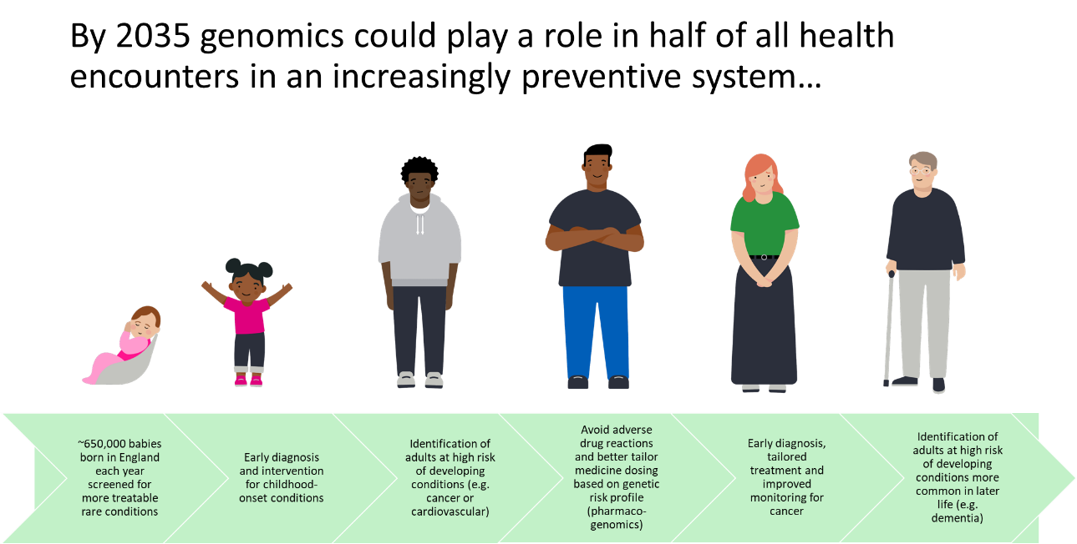

How we fulfil our mission
More data: With more NHS patients and participants taking up the offer of genomic sequencing and storage of their genomic and health data in the National Genomic Research Library, our world-leading dataset continues to grow and evolve.

Improved health outcomes: More personalised diagnosis, treatment and care results in better health outcomes, and in turn builds trust in the value of genomics for patients, research participants and the public.
Better evidence and insights: The growth of this dataset, and the number of approved researchers who use it, helps advance our understanding of disease and deliver insights to support the development and testing of new diagnostics, technologies and therapies. Through groundbreaking initiatives such as the Generation Study, we are also building the evidence to support the adoption of proven genomic innovations into routine clinical care.
Increased adoption and investment: The wider adoption of genomics across healthcare attracts increased investment from government, the NHS and industry — from large pharmaceutical and biotech companies to small and medium sized enterprises (SMEs). This momentum aligns with our mission, to support the role of genomics in up to half of all healthcare interactions and secure the UK’s position as the best place to discover, test and benefit from genomic innovation by 2035.
Expanded clinical application in the NHS: The knowledge and evidence generated by our programmes, those accessing data in the National Genomic Research Library or elsewhere can be rapidly adopted at national scale, translating into improved diagnostics and treatment and more personalised care in the NHS.
Our initiatives
In summer 2024 we launched the Generation Study, which aims to sequence the genomes of 100,000 newborns to look for a specific set of rare genetic conditions that affect babies and can be acted on.
We have already recruited >41,000 families to the study, which is currently being offered to mothers in 62 hospitals and counting.

The Generation Study: a newborn genomes programme

Adult Population Genomics Programme

This programme will be delivered in partnership with the NHS, offering adults the opportunity to have their genome mapped. It will generate evidence and build digital infrastructure to support decisions by policy makers and the NHS on how pre-emptive genomic testing is best adopted to improve health outcomes for the adult population. This will embed genomics in routine care to deliver real-time benefits to patients whilst catalysing the build of digital systems to return genomic insights at the point of care – and link data with clinical outcomes.

Participant panel and their stories

Participants in genomic medicine and research come from a variety of backgrounds but share a common interest in wanting the benefits of genomic medicine to be available quickly and widely – for themselves, their families, their communities and society as a whole.
In return, we make sure that participants have a say in how their data is shared and in shaping the programmes that use it, because it leads to better decisions about how genomics can have an impact on our healthcare and our lives.
Read here for participants who share their stories on how genomic testing and medicine impacted their lives, including what getting a diagnosis meant for them: https://www.genomicsengland.co.uk/patients-participants/stories

Genomics England Board
Further documents
Genomics England Board
Board calendar 2026:
  - 9th March 1pm – 5pm
  - 1st June 2pm – 5pm
  - 12th October 1pm – 5pm
  - 7th December 2pm – 5pm
Genomics England Board
Nicola Perrin MBE
Non-Executive Director
Dr Sergei Yakneen
Non-Executive Director
Dr Keith Stewart
Non-Executive Director
Professor Ewan Birney
Non-Executive Director
Dr Annalisa Jenkins
Non-Executive Director
Professor Matt Brown
Chief Scientific Officer
Baroness Nicola Blackwood
Chair
Dr Vikram Bajaj
Non-Executive Director
Dr Richard Scott
Chief Executive Officer
Board calendar 2026:
  - 9th March 1pm – 5pm
  - 1st June 2pm – 5pm
  - 12 October 1pm – 5pm
  - 7 December 2pm – 5pm
Genomics England Board
  - Life Sciences Sector Plan (2025)
  - NHS 10 Year Health Plan (2025)
  - Genomics England Annual Report 2022
  - GENOMICS ENGLAND LIMITED Companies House
  - Genomics England Board



About Us


Egon Zehnder is the world’s preeminent leadership advisory firm, inspiring leaders to navigate complex questions with human answers. We help organizations get to the heart of their leadership challenges and offer honest feedback and insights to help leaders realize their true being and purpose.
We are built on a foundation that supports partnership in the truest sense of the word and aligns our interests with the interests of our clients. Our 600 consultants across 70 offices and 36 countries are former industry and functional leaders who collaborate seamlessly across geographies, industries and functions to deliver the full power of the Firm to every client, every time.
We partner closely with public and private corporations, family-owned enterprises, and non-profit and government agencies to provide executive search, leadership solutions, CEO search and succession, board advisory, and diversity, equity & inclusion.
Our services include discovering leaders, developing leadership, advancing governance, shaping successions, and unlocking transformations. We partner with Mobius Executive Leadership to offer highly experiential, personalized and transformational programs for senior leaders.
We believe that together we can transform people, organizations and the world through leadership.
For more information, visit www.egonzehnder.com and follow us on LinkedIn.



Confidentiality
This document and the information contained within is confidential and proprietary information of Egon Zehnder; it is intended only for its recipient(s). It may neither be used in violation of any applicable laws, including without limitation privacy laws, nor for any purpose other than the present assignment. It may not be copied, distributed, reproduced or shared with any third party in whole or in part without Egon Zehnder’s authorization. Any candidates and referees named in this document may only be contacted upon consultation with Egon Zehnder.
Any evaluations, statements and recommendations are relative only to the present assignment and subject to future verification or correction.
© 2026 Egon Zehnder
Confidentiality
This document and the information contained within is confidential and proprietary information of Egon Zehnder; it is intended only for its recipient(s). It may neither be used in violation of any applicable laws, including without limitation privacy laws, nor for any purpose other than the present assignment. It may not be copied, distributed, reproduced or shared with any third party in whole or in part without Egon Zehnder’s authorization. Any candidates and referees named in this document may only be contacted upon consultation with Egon Zehnder.
Any evaluations, statements and recommendations are relative only to the present assignment and subject to future verification or correction.
© 2026 Egon Zehnder

