Candidate brief for
Genomics England
For the position of Chair
June 2026

Contents
Introduction 3
Background 5
How we fulfil our mission 8
Our initiatives 10
Participant panel and their stories 11
Further documents 11
Job description: Chair 12
Person specification 15
How to apply 17

The information contained in this report may include sensitive personal and commercial details. The distribution of this report should therefore be limited to those directly involved. Every care has been taken to ensure the accuracy of the contents of this report. The information set out below is given in good faith but without liability on the part of the Company, its employees or its agents.

Introduction


Thank you for your interest in Genomics England and the role of Chair. This represents a rare board leadership opportunity in a pioneering national body with the potential to impact the lives of millions of people.
It has been a privilege to work alongside an exceptional team to help advance the role of genomics in healthcare and research. Our mission is to provide the evidence and digital systems so that by 2035 genomics could play a role in up to half of all healthcare interactions, whilst securing the UK’s position as the best place to discover, prove and benefit from genomic innovations. We are accelerating our impact and working with patients, doctors, scientists, government and industry to improve genomic testing, and help researchers access the health data and technology they need to make new medical discoveries and create more effective, targeted medicines for everybody.
Together, we have strengthened our partnership with the NHS, enabled world-leading research, and continued to build a trusted system for the responsible use of genomic data. We have also launched major national initiatives, including the Generation Study – a world-leading initiative to sequence 100,000 newborns, helping to identify rare conditions earlier and give families faster access to care and support.
This work matters far beyond a single organisation. Genomics is a critical part of the UK’s life sciences ecosystem, supporting ambitions set out in the Life Sciences Vision and the NHS long-term plan, and creating the conditions for research, innovation and improved patient care at scale.
I am particularly proud of the way Genomics England has helped demonstrate how genomics can move from a specialist capability into a routine part of healthcare, improving diagnosis, supporting more personalised treatment, and opening up new opportunities for research and innovation.
None of this would have been possible without the expertise and commitment of colleagues across the organisation, the Board, and our partners across the NHS, academia and industry, as well as the participants who make this work possible.
We're on the cusp of big changes with the real prospect of genomics becoming the fabric of everyday healthcare throughout the lifetime – from birth to old age.
Candidates for this important and visible role are likely to be experienced chairs and/or board members, accustomed to managing complexity and to dealing with external stakeholders at an appropriately senior level, including within Government.
The successful candidate will lead an exceptional Board, each member bringing a range of experience and capabilities and having a passionate interest in, and responsibility for, our work. They will provide support and challenge to our Chief Executive and work closely with key strategic stakeholders. They will also act as an ambassador and the public face of the organisation in partnership with the Chief Executive, working constructively and openly with the Department of Health and Social Care and our sole shareholder, the Secretary of State for Health and Social Care.
We hope you will feel inspired to embrace the challenge.

Baroness Nicola Blackwood
Chair, Genomics England

Background

About genomics england
Genomics England is a global leader in enabling genomic medicine and research, focused on creating a world where everyone benefits from genomic healthcare. Genomics is a ground-breaking area of medicine that uses our unique genetic code to help diagnose, treat and prevent illnesses.
The UK is a world leader in genomics, and British scientists and healthcare professionals have been at the heart of the global genomics revolution so far. From uncovering the structure of DNA to contributing to the first sequencing of the human genome and delivering landmark initiatives like the 100,000 Genomes Project, the UK has consistently led the way, backed by long-term government investment and support.
Today, Genomics England supports the UK’s continued leadership by:
- pioneering the world’s first national whole genome sequencing service embedded in routine clinical care — and linking it to ongoing research;
- delivering the Generation Study, a world-first national-scale research study to explore newborn genome sequencing;
- managing the National Genomic Research Library, which houses one of the richest whole genome sequencing datasets available.
Genomics England is wholly owned by DHSC with the Secretary of State as our only shareholder. We work hand-in-hand with the seven NHS Genomics Laboratory Hubs across England, and the National Genomic Medicine Services team.
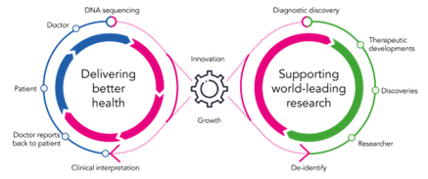
Genomics England plays a unique role as the data and evidence engine for national genomic healthcare, research and innovation. Our specialist national digital infrastructure links routine NHS care to research and innovation through the National Genomic Research Library. This creates a virtuous cycle and a repeatable blueprint for testing innovations and supporting their rapid adoption in the clinic. This means the UK can innovate at pace and lead the way in genomics, for example our work with leading AI companies such as DeepMind and our Generation Study.
We combine this with our unique expertise in ethics, equity and public engagement, ensuring innovations are tested and rolled out equitably, aligned with public expectations, and that we remain a trusted data custodian. We are helping tackle persistent health inequalities, including embedding the learnings and impact of our Diverse Data programme.

The story behind us and The 100,000 Genomes Project
What began with the 100,000 Genomes Project more than a decade ago sparked something bigger. Since Genomics England was formed in 2013, we have developed expertise that drives data and evidence generation to advance genomic healthcare, research, and innovation nationally. This includes:
- building and running digital systems that support the NHS’s national diagnostic whole genome sequencing service, and provide approved researchers with access to the National Genomic Research Library;
- developing evidence to support adoption of genomic innovations, ranging from finding answers for patients and discovering new scientific insights, to testing the latest algorithms and running large-scale research studies like the Generation Study;
- establishing expertise in ethics and engagement to ensure that genomic advances align with public views and expectations, the benefits are felt equitably;
- and, working with the Participant Panel at Genomics England to keep participants’ interests at the heart of everything we do.
Together, this growing expertise has supported our transition over time, from an organisation focused on delivering a single project to one managing multiple services and programmes aligned with our overarching vision and mission.

Strategy
Our vision is a world where everyone benefits from genomic healthcare.
This shared vision with the NHS sets the direction for what we want to achieve with our partners on a national scale.
Our mission is to provide the digital systems and evidence so that by 2035 genomics could play a role in up to half of all healthcare interactions, and the UK’s position as the best place to discover, test and benefit from genomic innovation is secured.
Our mission outlines how we as an organisation will contribute to get us there.
Crucial to our impact is the way our work connects and builds over time, so every project, collaboration and achievement strengthens the next.

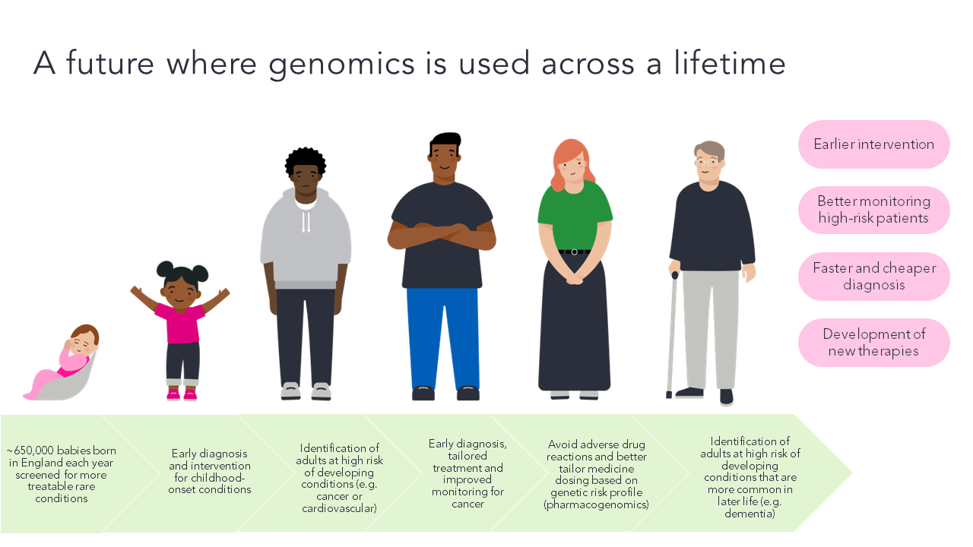

How we fulfil our mission
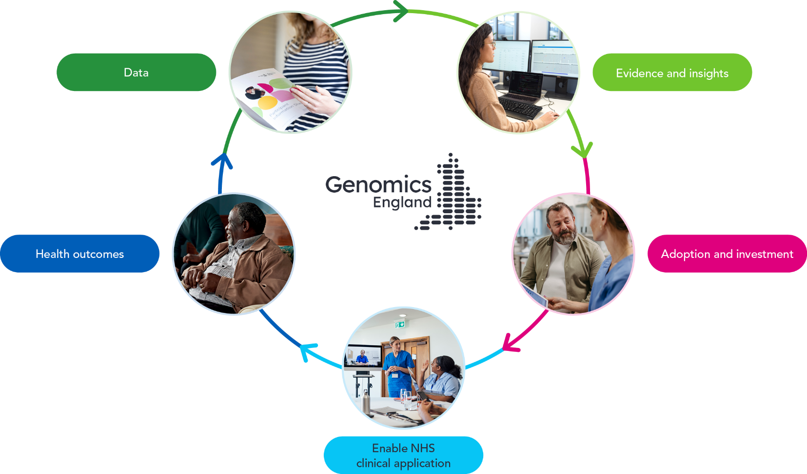

More data: With more NHS patients and participants taking up the offer of genomic sequencing and storage of their genomic and health data in the National Genomic Research Library, our world-leading dataset continues to grow and evolve.
Better evidence and insights: The growth of this dataset, and the number of approved researchers who use it, helps advance our understanding of disease and deliver insights to support the development and testing of new diagnostics, technologies and therapies. Through groundbreaking initiatives such as the Generation Study, we are also building the evidence to support the adoption of proven genomic innovations into routine clinical care.
Increased adoption and investment: The wider adoption of genomics across healthcare attracts increased investment from government, the NHS and industry — from large pharmaceutical and biotech companies to small and medium sized enterprises (SMEs). This momentum aligns with our mission, to support the role of genomics in up to half of all healthcare interactions and secure the UK’s position as the best place to discover, test and benefit from genomic innovation by 2035.
Expanded clinical application in the NHS: The knowledge and evidence generated by our programmes, those accessing data in the National Genomic Research Library or elsewhere can be rapidly adopted at national scale, translating into improved diagnostics and treatment and more personalised care in the NHS.
Improved health outcomes: More personalised diagnosis, treatment and care results in better health outcomes, and in turn builds trust in the value of genomics for patients, research participants and the public.



Our initiatives
Cancer 2.0 (programme completed)
Since the launch of the 100,000 Genomes Project, researchers and clinicians partnered with Genomics England to collect and analyse genomic and long-term clinical data (from health records) to gain insight into the nature of genetic changes that drive cancer evolution.
In the latest step of our cancer programme, we explored two new technologies for the clinic and research: long-read sequencing and multi-modal data. Through this we:
- Accelerated global research through the world’s largest public long-reads cancer dataset.
- Forged a pathway to faster, more comprehensive cancer diagnosis.
- Advanced tools for cancer investigation.
- Validated technical capabilities for next-generation research.

Diverse Data (programme completed)
Our vision is that all patients, regardless of their background, receive the same quality of genomics-enabled personalised medicine, supported by the latest research on people like them. You can view our Diverse Data strategy paper here. We have recently finished recruitment for this study, having reached 13,000+ participants.
The Generation Study: a newborn genomes programme
In summer 2024 we launched the Generation Study, which aims to sequence the genomes of 100,000 newborns to look for a specific set of rare genetic conditions that affect babies and can be acted on.
We have already recruited 70,000 families to the study, which is currently being offered to mothers in 77 hospitals and counting.
Adult Population Genomics Programme
This programme will be delivered in partnership with the NHS, offering adults the opportunity to have their genome mapped. It will generate evidence and build digital infrastructure to support decisions by policy makers and the NHS on how pre-emptive genomic testing is best adopted to improve health outcomes for the adult population. This will embed genomics in routine care to deliver real-time benefits to patients whilst catalysing the build of digital systems to return genomic insights at the point of care and link data with clinical outcomes.

Participant panel and their stories
Participants in genomic medicine and research come from a variety of backgrounds but share a common interest in wanting the benefits of genomic medicine to be available quickly and widely – for themselves, their families, their communities and society as a whole.
In return, we make sure that participants have a say in how their data is shared and in shaping the programmes that use it, because it leads to better decisions about how genomics can have an impact on our healthcare and our lives.
Read here for participants who share their stories on how genomic testing and medicine impacted their lives, including what getting a diagnosis meant for them: https://www.genomicsengland.co.uk/patients-participants/stories

Further documents
- Life Sciences Sector Plan (2025)
- NHS 10 Year Health Plan (2025)
- Genomics England Annual Report 2022
- GENOMICS ENGLAND LIMITED Companies House
- Genomics England Board

Job description: Chair
Genomics England is a global leader in enabling genomic medicine and research, focused on creating a world where everyone benefits from genomic healthcare. Our mission is to provide the evidence and digital systems so that by 2035 genomics could play a role in up to half of all healthcare interactions, whilst securing the UK’s position as the best place to discover, prove and benefit from genomic innovations.
We are seeking a new Chair, to succeed Baroness Blackwood as she comes to the end of her term. This appointment is subject to Ministerial approval, with Genomics England leading on the search and selection management, working in partnership with the Department of Health and Social Care.
The Chair has strategic leadership responsibility for Genomics England. He or she supports and challenges the Chief Executive and works closely with key strategic stakeholders. The Chair ensures that the Board functions well, works closely with the Executive Leadership Team to achieve agreed objectives, and acts as an ambassador and the public face of the organisation in partnership with the Chief Executive. The Chair is expected to work constructively and openly with the Department of Health and Social Care and our sole shareholder, the Secretary of State for Health and Social Care.
Candidates for this important and visible role are likely to be experienced chairs and/or board members, accustomed to managing complexity and to dealing with external stakeholders at an appropriately senior level, including within Government.

Job Specification
Key responsibilities are to:
- Chair the Genomics England Board and relevant committees, providing oversight of the strategic direction of the company and leading the organisation to deliver agreed strategic goals and outcomes, as agreed by the Board.
- The Chair leads the board, sets its agenda and ensures it operates as an effective and cohesive group. This role requires fostering a culture of openness and constructive debate maintaining clear and timely communication with key stakeholders and ensuring all board members are well-informed.
- Building and maintaining a constructive relationship between the Board and the Chief Executive and executive leadership team, ensuring they are held to account for achieving agreed strategic outcomes.
- Representing the organisation with key stakeholders, including Ministers, participants and other user groups.
- Providing strategic oversight and scrutiny of delivery against plan, to support continuous improvement in organisational performance.
Strategic leadership and governance
- Provide leadership to the organisation and its Board, ensuring that Genomics England deploys its resources efficiently, and partners effectively, to deliver maximum impact for patients and the public whilst ensuring that GELs activities align to wider government priorities such as the Life Sciences Sector Plan and NHS 10 Year Health Plan.
- Ensure that the Board operates within its powers and provides clear strategic direction.
- Ensure that Board members fulfil their governance responsibilities, including financial accountability, and reviewing major risks and associated opportunities.
- Ensure full alignment with public appointment requirements and DHSC governance standards by ensuring robust governance frameworks are in place and operating effectively whilst proactively managing conflicts of interest and upholding clear shareholder accountability.
- Develop the capability of Board members and ensure that the Board incorporates the right balance of skills, knowledge and experience needed to lead the organisation effectively.
- Appraise the performance of the Board on a regular basis.
External Relations
- Establish productive working relationships with a range of key stakeholders including Ministers, senior public officials from across Government and the NHS, as well as partners from the wider life sciences sector, industry, academia and the media.
- Likewise, building and maintaining strong relations with the main participant, patient and public constituencies to build and maintain trust and ensuring their views are consulted in policy decisions will be key.
- Act as an ambassador for Genomics England. Be a key spokesperson for the organisation and represent Genomics England at external functions, meetings and events.

Relationship with the Chief Executive
- Develop and maintain an open and supportive relationship with the Chief Executive, respecting the boundaries between the two roles.
- Conduct an annual appraisal and remuneration review for the Chief Executive in consultation with other Board members. Ensure that the Chief Executive has opportunities for professional development.
- Provide counsel, advice and support to the Chief Executive and other senior leaders in the organisation.
Efficiency and effectiveness
- Chair meetings of the Board effectively and efficiently, ensuring inclusivity, impartiality and objectivity in the decision-making process.
- Ensure that Board members are fully engaged and that resolutions are made in the best long-term interests of Genomics England, with collective Board ownership.
- Monitor the implementation and evaluation of Board-level decisions.

Person specification

Essential criteria:
- Strong strategic capability with a significant record of achievement in the public or private sectors.
- Ability to lead the Board of a national organisation, delivering robust board level governance and accountability, and developing executive and board performance.
- An understanding of the pivotal role genomic medicine is currently playing, and can in the future play, in transforming healthcare.
- An appreciation of the complexities and opportunities presented when growing and scaling a technology and data enabled businesses or services.
- Excellent understanding of how government companies and ALBs are governed, and how government policies and political decisions impact a government company.
- An excellent communicator with experience of working in a complex, multi stakeholder environment and a track record of building effective partnerships across organisational boundaries.
- A solid commitment to the highest ethical standards of integrity and honesty.
Appointment:
This appointment is subject to Ministerial approval.
Remuneration:
This role shall pay to you directors’ fees of £26,600 per annum, in twelve monthly instalments, with tax and/or National Insurance contributions administered at source via the company’s payroll. No further fees shall be payable to you unless approved by the Shareholder. Reasonable expenses are also payable in accordance with our Travel and Expenses Policy, but expenses incurred in relation to travel to our London office are taxable.
Term of appointment:
Three years, renewable for a further term, and in exceptional circumstances renewal for a third term.
Time commitment:
It is anticipated that you will be required to devote approximately 4-6 days per month to your role. This will include attendance at board meetings and any other requirements to be agreed with the Shareholder and consideration of all papers prior to the meeting. By accepting the appointment, you confirm that you are able to commit sufficient time to the role to meet the Company’s expectations.



How to apply

Key Dates
Closing date for applications – 10th August
Selected candidates will be invited to attend a preliminary interview with Odgers in early September. Then, following a formal shortlist meeting, those candidates selected for shortlist will undertake stakeholder meetings and a final interview with Genomics England due to be held in October 2026 (Date TBC).

How to Apply
In order to apply, please submit a comprehensive CV along with a covering letter which sets out your interest in the role and encapsulates the aspects of your experience relevant to the required criteria. Please include referee details which cover six years of your most recent employment. Referees will not be approached until the final stages and not without prior permission from candidates.
The preferred method of application is online at: www.odgers.com/96303
If you are unable to apply online, please email: 96303@odgers.com
All applications will receive an automated response.
Any postal applications should be sent direct to Peter Mason, Odgers, 20 Cannon Street, London, EC4M 6XD.
All candidates are also requested to complete an online Diversity Monitoring Form which will be found at the end of the application process. This will assist Genomics England in monitoring selection decisions to assess whether equality of opportunity is being achieved. Any information collated from the Diversity Monitoring Forms will not be used as part of the selection process and will be treated as strictly confidential.

Personal Data
In line with UK GDPR, we ask that you do NOT send us any information that can identify children or any of your Sensitive Personal Data (racial or ethnic origin, political opinions, religious or philosophical beliefs, trade union membership, data concerning health or sex life and sexual orientation, genetic and / or biometric data) in your CV and application documentation. Following this notice, any inclusion of your Sensitive Personal Data in your CV/application documentation will be understood by us as your express consent to process this information going forward. Please also remember to not mention anyone’s information or details (e.g. referees) who have not previously agreed to their inclusion.

Due diligence
Due diligence will be carried out as part of the application process, which may include searches carried out via internet search engines and any public social media accounts.

Contact Details
For a conversation in confidence, please contact: Peter Mason via vicky.graham@odgers.com
We are committed to ensuring everyone can access our website and application processes. This includes people with sight loss, hearing, mobility and cognitive impairments. Should you require access to these documents in alternative formats, please contact vicky.graham@odgers.com.
Also, if you have any comments and/or suggestions about improving access to our application processes please don't hesitate to contact us response.manager@odgers.com

