**附件四：入职体检须知**

**Appendix IV: NEW HIRES PHYSICAL EXAMINATION**

1. **体检时间点**

**The time of your physical examination**

* 1. **请在你接受AECOM的聘用意向书后，且距预计报到日5个工作日之前完成你的入职体检。**

**Please attend the physical examination after you accept AECOM offer letter and complete the physical examination before 5 working days of your onboarding date.**

* 1. **如果你在2个月之内做过体检，你可以选择不参加AECOM入职体检，但是需要把体检报告交至AECOM 人力资源部指定同事。**

**If you have had a physical examination within 2 months, you can choose not to attend AECOM new hires physical examination, but you need to submit the physical examination report to the** **designated HR colleague.**

1. **体检安排**

**Logistics Arrangement**

* 1. **预约方式**

**Appointment method**

* + 1. **请使用体检卡号及密码进行预约，卡号及密码请参考你的聘用意向书邮件正文。**

**Please use the** **No. of** physical examination card and related code to make the appointment. Please refer to the content in the email which issued the offer letter for **No. of** physical examination card and related code.

* + 1. **拨打4008-100-120，按“2”号键进入，根据语音提示接入人工服务，根据客服提示完成预约。**

Dial 4008-100-120, press the "2" key to enter, access the manual service according to the voice prompt, and complete the appointment according to the customer service prompt.

* + 1. **登录****<http://www.ikang.com>，点击网页左边预约处旧版卡密登录，输入卡号、密码，点击“登录”，输入或确认个人信息，体检方案，选择体检中心和体检日期**。

Login in http://www.ikang.com, click on the old card password to log in, enter the card number and password, click "physical examination appointment", enter or confirm personal information, physical examination plan, and select the physical examination center and date. Please be noted that the web site only support the Chinses service.

* + 1. 扫描以下二维码，下载爱康APP，输入卡号及密码，点击“体检预约”，根据个人情况选择体检中心、体检日期进行预约。

Scan the QR as below to Download ikang APP, enter the card number and password, click "physical examination appointment", and select the physical examination center and the date of physical examination according to personal situation. Please be noted that this approach only support the Chinses service.



* + 1. AECOM专属联系人：金先生，手机号码：15056443112，周一至周五9:00-18:00，节假日除外。

AECOM Contact Person ：Mr. Jin, Tel. No.：15056443112, you can contact him during 9 am to 6 pm from Monday to Friday, except Holiday

* 1. **体检时间**

**The time of physical examination**

* + 1. 体检预约成功后，体检当日7:30—10:00持身份证至体检中心体检。

After the appointment is successful, take the ID card to the physical examination center at 7:30 am -10:00 am on the day of physical examination.

* 1. **体检地址，见后续表一**

Address of **physical examination center, please refer to the address list in Table I**

* 1. 体检流程, 见后续表二

The workflow of **physical examination, please refer to the Table II**

1. **体检前注意事项**

**Pre-notices for physical examination**

* 1. **检前三天注意饮食，不吃高脂高蛋白食物，不饮酒。**

Three days before the examination, pay attention to diet, do not eat high-fat and high protein food, do not drink.

* 1. **体检前一天晚上8点后，避免进食和剧烈运动，保持充足睡眠，以保证体检结果的准确性**

After 8:00 p.m. the day before physical examination, have a good sleep, avoid eating and strenuous exercise to ensure the accuracy of **physical examination next Morning.**

* 1. **不化妆，体检前对口腔、鼻腔、外耳道进行清洁，便于医生检查、诊断。**

Do not make up, before physical examination, oral cavity, nasal cavity, external auditory canal should be cleaned, convenient for doctors to check and diagnose

* 1. **抽血后立即轻轻压迫针孔三分钟，防止出血，勿揉局部。**

Immediately after drawing blood, gently press the pinhole for 3 minutes to prevent bleeding and do not rub the local area.

* 1. **疫情期间，手机短信会收到防疫“问卷调查”，请按照实际情况填写。**

During the epidemic period, mobile phone messages will receive the epidemic prevention "questionnaire survey", please fill in according to the actual situation

* 1. **以下仅供女性注意**

**For Ladies only**

* + 1. **女性在月经期内请不要留取尿液标本，避开妇检检查，月经期后再作检查。**Women in the menstrual period, please do not take urine samples, avoid gynecological examination, you can make an appointment for another date.
    2. **备孕或女性怀孕期间体检，不能做X线检查以及有辐射项目。**

Women during pregnancy physical examination, can not do X-ray examination and radiation items

1. **体检报告**

**Physical examination report**

* 1. **电子报告**

**Electronic Report**

检后2个工作日短信发送至手机，或请登陆爱康官网[**http://www.ikang.com**](http://www.ikang.com)，点击“体检报告查询”，通过卡号密码即可查询及下载体检报告，请把下载的体检报告按照聘用意向书邮件内指引发送给相应的人力资源部同事。电子报告下载指引请参考表三。

2 working days after you completed the physical examination, you can receive the SMS in your mobile phone, or please login in ikang official website http://www.ikang.com , click "physical examination report query", you can query and download the physical examination report through the card number and password. Please provide your physical examination report to HR colleagues listed in the email which issue the offer letter to you.

* 1. **纸质版报告**

**Paper Report**

**你也可以获得纸质版的体检报告，如需，请在体检中心前台填写快递表格，纸质体检报告一般在5-10个工作日，快递至你所填写的指定地点，****由此产生的快递费用将由你本人承担。**

If you need the paper report, please fill in the express form at the front desk .The paper physical examination report generally takes 5-10 working days, and it will be sent to the designated place in the express form. Please be noted that the cost of express will beat your own expense.

**.**

1. **温馨提示**

**Kind Reminder**

* 1. **建议提前3-5天预约；**

**It is recommended to make an appointment 3-5 days in advance**

* 1. **建议7:30前到体检中心，错开体检高峰，体检更快捷；**

**It is suggested to go to the physical examination center before 7:30 am, stagger the peak of physical examination, and make the physical examination faster**

* 1. **具体营业日期，以预约为准；**

**The specific business date is subject to appointment**

* 1. **紧急联系电话：15056443112（金世玉）；**

**emergency contact number: 15056443112 (Shiyu Jin)**

* 1. **体检报告按照聘用意向书邮件内指引发送给相应的人力资源部同事 。**

Please provide your physical examination report to HR colleagues listed in the email which issue the offer letter to you.

**表一：体检地址**

**Table I: Address of physical examination center**

| **City** | **Physical Examination Center** | **Address** |
| --- | --- | --- |
| **上海** | 爱康国宾上海杨浦五角场分院 iKang Guobin Shanghai Yangfu Medical Center | 上海市杨浦区国宾路36号万达国际广场5楼 5/F, Wanda International Plaza, No.36 Guobin Road, Yangpu District, Shanghai City |
| 爱康国宾上海陆家嘴分院 iKang Guobin Shanghai Lujiazui Medical Center | 上海市浦东新区商城路1900号，近桃林路  2/F, Jintao Mansion, No.1900, Shangcheng Road, Pudong new District, Shanghai City. (To the north of Yuanshen Stadium) |
| 爱康国宾上海中山公园北延安西路分院  iKang Guobin Shanghai Zhongshangongyuan Medical Center | 上海市长宁区定西路1018号2层  2/F, No.1018 Dingxi Road, Changning District, Shanghai City |
| 爱康国宾上海曹家渡一品分院  iKang Guobin Shanghai Caojiadu Medical Center | 上海市静安区康定路1437号鑫康苑2楼  2/F, Xinkang court, 1437 kangding Road, jing 'an District, Shanghai City |
| 爱康国宾上海中环一品分院  iKang Guobin Shanghai Zhonghuan Medical Center | 上海市普陀区真光路1288号百联中环购物广场4层（观8电梯上） 4/F, Bailianzhonghuan shopping plaza,No. 1288 Zhenguang Road, Putuo District, Shanghai City ( Entrance is the 8th elevator.) |
| 爱康国宾上海元化分院 iKang Guobin Shanghai Yuanhua Medical Center | 上海市长宁区天山路30号  3/F, No. 30, Tianshan Road, Changning District, Shanghai City. (near Hami Road) |
| 爱康国宾上海黄浦健维分院  iKang Guobin Shanghai Xizangnanlu Medical Center | 上海市黄浦区西藏南路768号5层  5/F, No. 770, Xizang south Road, Huangpu District, Shanghai City |
| 爱康国宾上海名门分院  iKang Guobin Shanghai Pudongbabaiban Medical Center | 上海市浦东新区张扬路560号  The west Area, 6/F, Zhongronghengrui Building, No.560, Zhangyang Road, Shanghai City |
| 爱康国宾上海外滩延安东路分院 iKang Guobin Shanghai Waitan Medical Center | 上海市黄浦区江西南路29号2层  2/F, No.29, Jiangxi south Road, Huangpu District, Shanghai City |
| **北京** | 爱康国宾北京丽都分院  iKang Guobin Beijing Lido Medical Center | 北京市朝阳区将台路丽都饭店5号商业楼三层 3/F, Commercial Building, No. 5 Lido Hotel, Jiangtai Road, Chaoyang District, Beijing City (Lido plaza, Lido Hotel Entrance) |
| 爱康国宾北京酒仙桥分院  iKang Guobin Beijing Jiuxianqiao Medical Center | 北京市朝阳区南十居28号东润枫景 The Commercial space on ground, Building 3, Dongrunfengjing , No. 28,Nanshiju, Chaoyang District, Beijing City |
| 爱康国宾北京白石桥分院  iKang Guobin Beijing Baishiqiao Medical Center | 北京市海淀区中关村南大街32号中关村科技发展大厦6层 6/F, Zhongguancun Science and Technology Development Building, No.32, Zhongguancun south Street, Haidian District, Beijing City |
| 爱康国宾北京磁器口分院  iKang Guobin Beijing Ciqikou Medical Center | 北京市崇文区珠市口东大街2号珍贝大厦二层 2/F, Zhenbei Building, No.6 Zhushikou east Street, Dongcheng District, Beijing City |
| 爱康国宾北京郡王府分院  iKang Guobin Beijing Junwangfu Medical Center | 北京市朝阳区朝阳公园南路21号  No.21, Chaoyang Rark South Road, Chaoyang District, BeijingCity (Junwangfu Sports Center) |
| 爱康国宾北京知春路分院  iKang Guobin Beijing Zhichunlu Medical Center | 北京市海淀区知春路甲48号4号楼三层3-029号 Room 029, 3/F, Building D, Yingdu Mansion, No.48A ,Zhichun Road Haidian District, Beijing City.(Next to Walmart) |
| 爱康国宾北京安华桥分院  iKang Guobin Beijing Anhuaqiao Medical Center | 北京市西城区裕民中路12号5号楼1-3层 Beisanhuan Hotel, No.12, Yumin Middle Road, Xicheng District, Beijing City (To the left of the hotel, the 5th floor of the beige building) |
| 爱康国宾北京总部基地分院  iKang Guobin Beijing Zongbujidi Medical Center | 北京市丰台区南四环西路188号1区31号楼 1/F,the building next to Building A, Mansion 31, Zone 1, No.188,the west Road ,the South Fourth Ring Road , Fengtai District, Beijing City (Next to Xiamen International Bank) |
| 爱康国宾北京顺平分院  iKang Guobin Beijing Shunping Medical Center | 北京市顺义区南法信镇顺平路南法信段9号院1幢2层203室  Room 203, 2nd Floor, Shunjie Building, No.9, Nanfaxin, Shunping Road, Shunyi District, Beijing City |
| 爱康国宾北京白云路分院  iKang Guobin Beijing Baiyunlu Medical Center | 北京市西城区莲花池东路甲5号院1号楼201.301室 Room 201-301, 2nd Floor ,Building A, Baiyun Times Mansion, No.5A Yard, Lianhuachi east Road, Xicheng District, Beijing City. |
| **苏州** | 爱康国宾苏州东环体检分院  iKang Guobin Suzhou Donghuan Medical Center | 苏州市工业园区东环路1408号东环时代广场2楼201 Room 201, 2nd Floor, Donghuan times square, No. 1408, Donghuan Road, Suzhou industrial park ,Suzhou City |
| 爱康国宾苏州高新分院  iKang Guobin Suzhou Gaoxin Medical Center | 苏州高新区运河路77号乐嘉汇商务广场2幢101 Roon 2-101-201, Lejiahui Business Plaza, No.77, Canal Road, Gaoxin District, Suzhou City |
| **宁波** | 爱康国宾宁波鼓楼分院  iKang Guobin Ningbo Gulou Medical Center | 宁波市海曙区中山西路2号恒隆中心西裙楼3层（蔡家巷6,16号） 4/F, West Podium Building, Henglong Center, No. 2 Zhongshan West Road, Haishu District, Ningbo City (Entrance on the elevator of No.6 Caijia Lane) |
| **深圳** | 爱康国宾深圳福田分院  iKang Guobin Shenzhen Futian Medical Center | 深圳福田区滨河路北彩田路东交汇处联合广场B座裙楼B201/203  Room B201/203, the Podium Building QB, Union Square, East Interchange of Beicaitian Road, Binhe Road, Futian District, Shenzhen City |
| 爱康国宾深圳科兴分院  iKang Guobin Shenzhen Kexing Medical Center | 深圳市南山区高新科技园中区科苑路科兴科学院B座3单元3A层  Floor 3A, Unit 3, Building B, Keyuan Road, High-tech Park central Area, Nanshan District, Shenzhen City |
| 爱康国宾深圳罗湖分院  iKang Guobin Shenzhen Luohu Medical Center | 深圳市罗湖区宝安南路3044号天地大厦1、3层  1&3/F, Tiandi Building, No.3044, Baoan south Road, Luohu District, Shenzhen City |
| 爱康国宾深圳华强分院  iKang Shenzhen Huaqiang Medical Center | 深圳市福田区深南中路3039号深圳国际文化大厦3A层 4/F, Shenzhen International Culture Building, No.3039, Shennan middle Road, Futian District, Shenzhen City |
| **广州** | 爱康国宾广州环市东体检分院四层 iKang Guobin Guangzhou Huanshi Medical Center | 广州市环市东路496号广发花园大厦4楼  4/F, Guangfa Garden Building, No.496,Huanshi east Road, Guangzhou City |
| 爱康国宾广州天河华港花园体检分院  iKang Guobin Guangzhou Tianhe Medical Center | 广州市天河区东方一路华港花园20-24号3层  3/F, No.20-24, Huagang Garden, Dongfang yi Road, Tianhe District, Guangzhou City. |
| 爱康国宾广州花城大道南天广场体检分院五层  iKang Guobin Guangzhou Huachengdadao Medical Center | 广州市天河区珠江新城花城大道1号5层 5th Floor, Nantian International Business Center, No.7 Huacheng Avenue, Zhujiang new City, Tianhe District, Guangzhou City. |
| 爱康国宾广州林和西中泰体检分院  iKang Guobin Guangzhou Linhexizhongtai Medical Center | 广州市天河区林和西路161号中泰国际广场5楼 5/F, Zhongtai International Plaza, No.161, Linhe west Road, Tianhe District, Guangzhou City. |
| **成都市** | 爱康国宾成都红照壁航天科技分院  iKang Guobin Chengdu Hongzhaobi Medical Center | 成都市人民南路一段新光华街7号航天科技大厦5层  5/F, Aerospace Science & Technology Building,No.7, Xinguanghua Street, Renmin south Road, Chengdu City |
| 爱康国宾外双楠分院Aikang Guobin waishuangnan branch | 成都市武侯区二环路西一段置信路1号置信逸都城5层5 / F, Zhixin Yidu City, No. 1, Xinxin Road, West Section 1, Second Ring Road, Wuhou District, Chengdu |
| 爱康国宾龙泉柏悦国际中心分院Aikang Guobin Longquan Baiyue International Center branch | 四川省成都市龙泉驿区大面街道金桉路88号5栋8层1号，9层1号No. 1, floor 8 and floor 9, building 5, No. 88, jineucalyptus Road, Damian street, Longquanyi District, Chengdu, Sichuan |
| 爱康国宾成都城南分院  iKang Guobin Chengdu Chengnan Medical Center | 成都市高新区天府大道中段天府三街新希望国际C座3楼 3/F, Block C, New Hope International Building, Jitai 3rd Street, Gaoxin District,Chengdu City |
| 爱康国宾成都高新分院  iKang Guobin Chengdu Gaoxin Medical Center | 成都市高新区天韵路高新国际广场D座3楼  3/F, Block D, Gaoxin International Plaza, Tianyun Road, Gaoxin District, Chengdu City |
| 爱康国宾成都骡马市分院  iKang Guobin Chengdu Luomashi Medical Center | 成都市青羊区青龙街18号罗马国际广场4层  4/F, Luoma International Building, No.18, Qinglong Street, Qing Yang District,Chengdu City |
| **重庆市** | 爱康国宾龙湖源著分院Aikang Guobin longhuyuan branch | 重庆市江北区福康路25号龙湖源著天街6楼6 / F, Longhu yuanzhutian street, No. 25, Fukang Road, Jiangbei District, Chongqing |
| 爱康国宾重庆黄泥磅体检分院  iKang Guobin Chongqing huangnibang Medical Center | 重庆市渝北区洋河东路1号长安丽都揽胜国际广场二层 2/F, Lansheng International Plaza, Changan Lido, No.1,Yanghe easet Road,Yubei District,Chongqing City |
| **天津市** | 爱康国宾天津南京路吉利大厦体检分院 iKang Guobin Tianjin Jilidasha Medical Center | 天津市和平区南京路209号吉利大厦9层  9/F, Jili Building, No.209, Nanjing Road, Heping District, Tianjin |
| 爱康国宾天津东润大厦体检分院  iKang Guobin Tianjin Dongrun Medical Center | 天津市河东区六纬路与大直沽八号路交口东侧东润名邸3号401 Room 401, Building 3, Dongrunmingdi, east of the intersection of Liuwei Road and Dazigu 8th Road, Hedong District, Tianjin |
| 爱康国宾天津峰汇分院  iKang Guobin Tianjin Fenghui Medical Center | 河西区围堤道103号峰汇广场B座5楼(近友谊路)  5/F, Block B, Fenhui Plaza, No.103, Weidi Road, Hexi District, Tianjin |
| 爱康国宾天津南马路悦府广场分院  iKang Guobin Tianjin Yuefuguangchang Medical Center | 天津市南开区南马路与南门外大街中粮广场6-7层  6/F, Building 1, Zhongliang plaza, intersection of Nanma Road and Nankai second Road, Nankai District, Tianjin |
| **长沙市** | 长沙爱康国宾阳光分院  iKang Guobin Changsha Yangguang Medical Center | 长沙市雨花区芙蓉中路三段509号中远公馆101房 Room 101, Zhongyuan Mansion, No. 509, 3rd Section, Furong Middle Road, Yuhua District, Changsha City |
| 长沙爱康国宾八一桥分院 iKang Guobin Changsha Bayiqiao Medical Center | 长沙市开福区芙蓉中路一段593号（潇湘华天酒店六楼） No.593, Section 1, Furong middle Road, Kaifu District, Changsha City (6th Floor, Xiaoxiang Huatian Hotel) |
| 爱康国宾长沙河西西中心分院  iKang Guobin Changsha Hexixizhongxin Medical Center | 长沙市岳麓区枫林三路49号西中心（海沃·西城）T1写字楼3A层 3A/F, T1/T2 Podium Building, Haiwo Xicheng, West Center, No. 49,Fenglinsan Road, Yuelu District, Changsha City |

**表二：体检流程**

**Table II:** workflow of **physical examination**

**表三：如何下载电子体检报告**

**Table III: How to download the Electronic Report**

方法一：登录网址：<https://old.health.ikang.com>，输入卡号、卡密。点击健康档案、体检报告、体检报告下载。

Approach 1 - Login in <http://www.ikang.com>, enter the card number and password, then click the Health file, physical examination report and download the report

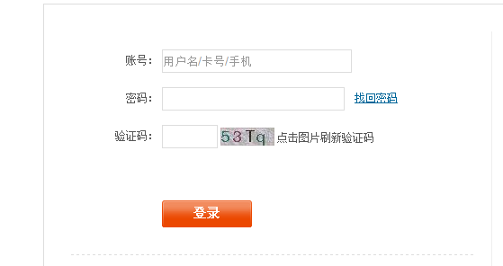

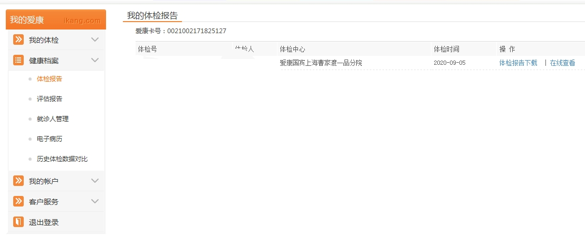

方法二：爱康APP下载电子报告：登录爱康APP，点击底部“我的”、中间“我的报告”、右上角更多、查看PDF报告并下载

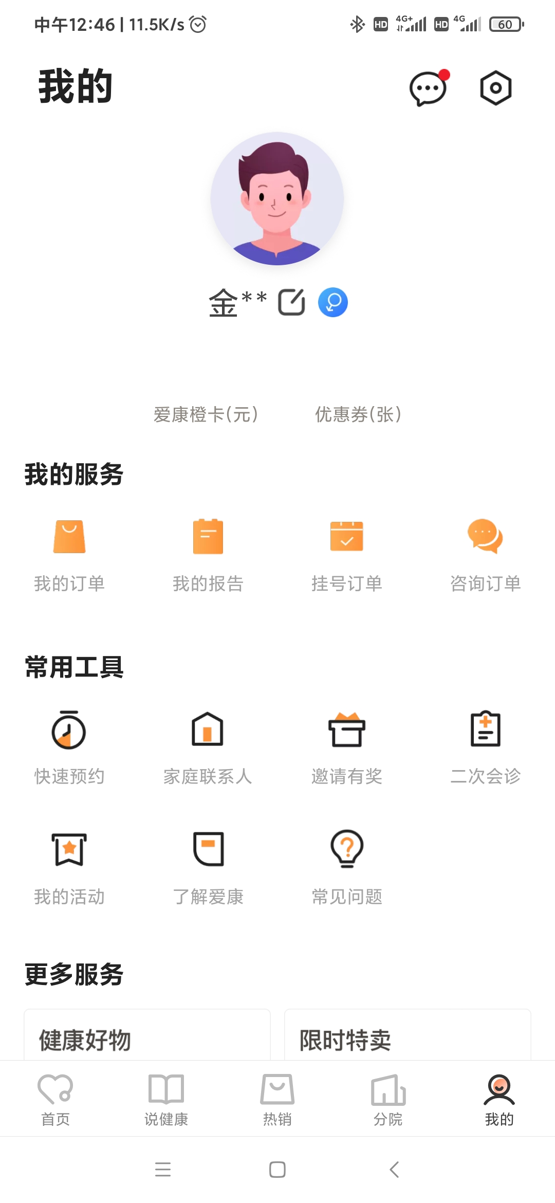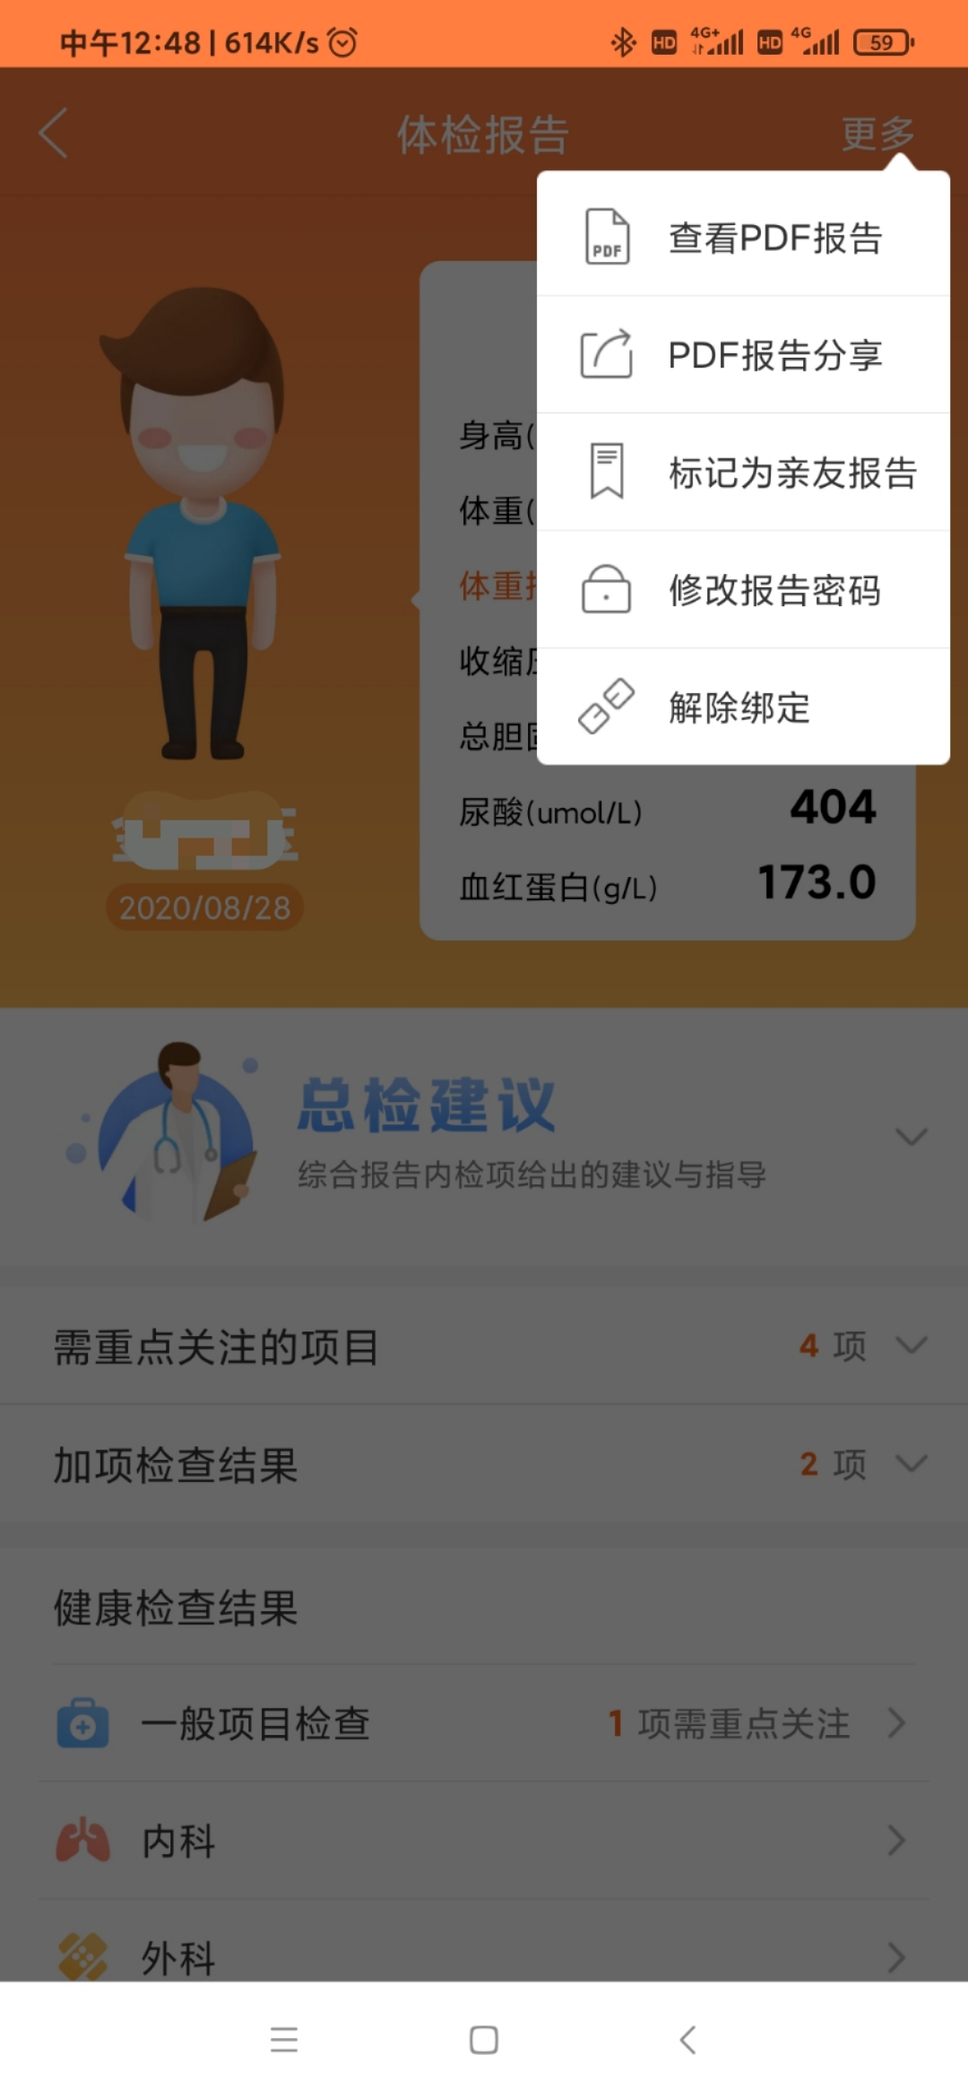Approach 2 – Download the **Physical examination report** from ikang APP. Click tab of ‘我的’ in buttom, click “ 我的报告” in Middle, tab of “更多” in upper right corner and then download the report with PDF version.