# General Information

|  |  |
| --- | --- |
| **Position Title:** | Practice Manager |
| **Division/Department:** | Epworth Richmond - Epworth Doctor Supported Practice (EDSP) |
| **Position Reports to:** |  |
| **Enterprise/Individual Agreement:** | Individual Agreement |
| **Classification/Grade:** |  |
| **Location:** | Richmond |
| **Employment Status:** | Full time fixed term (12 months) |
| **Key Relationships - internal and external** | Epworth Doctors  Epworth Patients  Epworth Departments – incl. Business Development, GP Liaison, Theatre Management teams, etc.  Epworth Hospital Executives  Epworth staff and external stakeholders. |

1. **Overview of Epworth HealthCare**

Epworth HealthCare is Victoria’s largest not-for-profit private health care group, renowned for excellence in diagnosis, treatment, care and rehabilitation. Epworth

is an innovator in Australia’s health system, embracing the latest in evidence-based medicine to pioneer treatments and services for our patients.

Epworth’s values define our approach and our delivery. We pride ourselves on communicating our values and delivering on them in a real and meaningful way. Our Values are Compassion, Accountability, Respect and Excellence. More information can be found on the [Epworth website.](https://www.epworth.org.au/who-we-are/our-values)

Epworth’s purpose is Every Patient Matters.

Our Vision is Delivering another 100 years of exceptional healthcare and innovation to the Victorian community.

# Epworth HealthCare Strategy

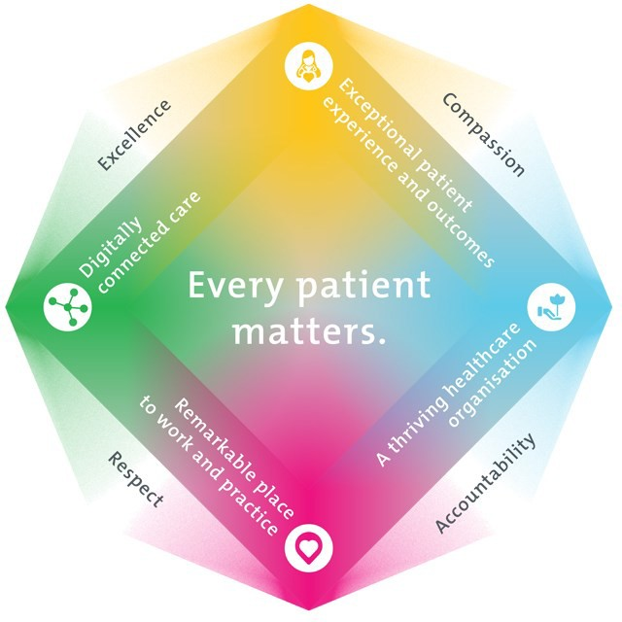

|  |
| --- |
| All roles are linked to the Epworth strategy and are fundamental in achieving its vision and purpose. |
| **Exceptional patient experience and outcomes -** To empower our patients and deliver compassionate, expert and coordinated care. |
| **A thriving healthcare organisation -** To adapt and grow in a changing healthcare landscape by delivering a unique private not-for-profit  healthcare organisation. |
| **Remarkable place to work and practice -** To ensure Epworth is an outstanding place to work and practice through a culture of care and  investment in our people. |
| **Digitally connected care -** To innovate and improve the digital experience, interactions and outcomes for our patients, staff and doctors. |

1. **Purpose of the Position**

Oversee the establishment and running of the new Epworth Doctor Supported Practice (EDSP) service efficiently and effectively, providing a high level of patient care and customer service.

# Clinical Governance Framework

This role is required to put into practice the Clinical Governance Framework at Epworth as every employee is accountable for ensuring that our patients and community receive safe, high quality and person-centred care in every interaction with Epworth. This is achieved through active participation in the five domains of clinical governance at Epworth:

|  |  |
| --- | --- |
| **Clinical Governance Domain** | **Role** |
| **Leadership and culture** | Promote and participate in a supportive, fair and transparent culture where lessons from previous outcomes are learned  and patient safety and quality is a priority at all levels of the organisation. |
| **Consumer Partnerships** | Understand and where relevant, ensure that each patient is actively involved in their own care and treatment including families/carers wherever possible. |
| **Effective Workforce** | Develop and maintain one’s own competency, skills and knowledge to ensure high quality service provision and care. |
| **Clinical Safety and Effectiveness** | Understand and where relevant, ensure, that the right care is provided to the right person at the right time, in the right  place and patient outcomes are monitored and improved. |
| **Risk Management** | Be responsible for identifying and reporting risks, hazards and near misses for people in our care and participating in risk  mitigation strategies. |

# Key Accountabilities

|  |  |
| --- | --- |
| **KEY RESPONSIBILITIES** | **MEASURES/KPIs TO BE ACHIEVED** |
| **Team Leadership & Service Excellence:**  Epworth is committed to the provision of excellent customer service to all of our people, customers and stakeholders including patients and external suppliers.  Superior patient service leads to improved healing in a trusting, caring environment and creates a safe environment for patients and employees.   * Coordinate daily operations of consulting rooms and minor procedure spaces, ensuring alignment with hospital protocols. * Serve as the primary point of contact for Doctors in the clinic, ensuring their clinical and administrative needs are met. * Provide helpful service to patients, visitors, staff and Doctors, ensuring high standard of professionalism and patient care. * Build positive relationships with patients, visitors and staff and Doctors. * Ensure solutions, practices and procedures (such as leader rounding) are carried out with empathy and compassion. * Leverage feedback sources (compliments, complaints, and Press Ganey data) to identify breakdowns in internal processes and systems that directly impact patient care and customer service. * Actively seek to understand expectations and issues, using multiple strategies. * Responds quickly and proactively escalate concerns when necessary. | * Patient / customer service satisfaction surveys within agreed targets * Use AIDET principles in all interactions * Compliments to complaints ratios * Completes leader rounding at agreed frequency * Issues are escalated to the manager and resolved in a timely manner |
| **Stakeholder Engagement & Referral Pathways:**   * Collaborate with Business Development and GP Liaison teams to identify opportunities to build and strengthen Doctor referral networks. * Liaise with other hospital departments (e.g. theatre, CSSD, IT, facilities, etc) to ensure seamless support and service. * Be involved in VMO referral and networking events such as dinners and other engagement initiatives. * Maintain strong relationships with hospital executives, allied health providers, and external partners. | * Referral contacts established / grown. * Referrer retention rate. * Stakeholder satisfaction within agreed targets. * Decrease in the number of patients referred outside of Epworth |
| **Strategic Contribution & Growth Enablement:**   * Completed review of service at 12 months. * Contribute to other initiatives such as program expansion to other sites and fellowship program development. * Provide insights from room operations and Doctor feedback. * Assist in evaluating new workflows or partnerships that enhance the value proposition of the service. | * Annual review of service – including service achievements / challenges and financial outcomes. * Project involvement as required. |
| **Financial Management**:   * Oversee billing and revenue processes for the clinic, including Medicare claims, private health insurance processing, gap payments, and hospital-integrated billing platforms. * Assist in managing VMO room usage agreements, ensuring compliance with hospital policies and service expectations. * Compile & reconcile monthly invoices for Doctors and coordinate payment collection. * Monitor financial performance indicators, and contribute insights to hospital leadership through regular reporting. * Proactively manage patient accounts to minimise outstanding balances and reduce bad debt. * Implement strong cash-handling protocols to ensure financial security and compliance with hospital procedures. | * Accurate and timely accounting records. * Minimal bad debts. * Monthly expenses and salary to meet targets. * Month by month or Year by year increase in room generated revenue growth * Number of VMOs operating within the agreed terms and usage contract |
| **IT: PC + Software:**   * Configure and implement practice management software tailored for clinic operations * Ensure hospital and clinic IT systems are used effectively and securely. * Maintain all clinic software, ensuring timely upgrades and issue resolution. * Oversee functionality / servicing of IT hardware, including PCs, scanners, printers, and the phone system. * Proficient in Microsoft Office (Word, Excel and Outlook) to support daily operations. * Proficient in use of MyRoster and TechOne for rostering and ordering. | * Computer hardware and software implemented and maintained. * Audit results for privacy and cybersecurity protocols |
| **Human Resources:**   * Ensure MyRoster is current, manage leave and liabilities. * Facilitate onboarding of new Doctors in partnership with Business Development team. * Create and maintain onboarding training manual for the clinic. * Promote a culture of courtesy, pride and success. * Complete mandatory online training annually. | * Doctor/ team satisfaction * Staff engagement * Leave liability within targets * Labour hours within targets * Completion of mandatory training activities |
| **Safety and Wellbeing:**   * To ensure a safe workplace is provided for Doctors and other personnel including contractors, agency staff, volunteers, and students. * All personnel under the authority of the manager are fully informed of the hazards associated with their work activities, adequately trained and instructed in safe work procedures and appropriately supervised. Participate actively and positively in the area of health and safety to reduce all hazards and incidents within the workplace * Integrate and review OHS performance in PDP * Ensure all personnel are held accountable for safety performance and actions | * Adhere to infection control/personal hygiene precautions * Implement and adhere to Epworth OHS policies, protocols and safe work procedures * Ensure all hazards, incidents and injuries are reported in Riskman within 24 hours * Ensure all hazards, incidents and injuries are investigated and corrective actions implemented within agreed timeframes |

1. **Position Requirements/Key Selection Criteria**

|  |  |
| --- | --- |
| **COMPONENT** |  |
| Qualifications | **Essential**   * Diploma of Management   **Desirable**   * Administration or health education |
| Previous Experience | **Essential**   * Practice Management experience in a service-oriented environment * Strong financial management experience |
| Required Knowledge & Skills | **Essential**   * Extensive Medical software experience and a willingness to learn new systems * Strong working knowledge of medical and radiology terminology * Strong computer literacy, including ability to utilise databases, proficiency in Word, Excel, Outlook and PowerPoint * Prepared to commit to Epworth’s Vision and Values * Proven commitment to continuous improvement practices * Excellent problem solving and decision-making skills * High level of discretion and understanding of privacy issues |

|  |  |
| --- | --- |
| Personal Attributes & Values  All employees are expected to consistently work in accordance with Epworth’s values and behaviours   * Compassion * Accountability * Respect * Excellence | **Essential**   * Proven ability to communicate clearly, both verbally and in writing, in a professional environment. * Excellent organisational skills and attention to detail * Self- Motivated and able to work autonomously * Experience and a natural ability to liaise with doctors and fellow staff * Willingness to work positively within a team to achieve team goals and the provision of excellence in service delivery * A strong team contributor with excellent customer service, high level interpersonal, communication, administrative, organisational presentation and networking skills. * Ability to set priorities and work under pressure with well-developed organisational skills * Capacity for training and developing Doctors and team members * Innovative, proactive and creative attitude * Demonstrated ability to maintain high levels of confidentiality and the ability to establish and maintain strong customer (internal and external) relationships at all levels. |

**Document Control**

|  |  |  |
| --- | --- | --- |
| Date Developed: | Date Last Reviewed: | Developed and Reviewed By (Position Title): |
| 14th July 2024 | 14th July 2024 | Business Development Manager. |

# Employee Position Declaration

I have read and understand the requirements and expectations of the above Position Description. I agree that I have the physical ability to fulfil the inherent physical requirements of the position, and accept my role in fulfilling the Key Accountabilities. I understand that the information and statements in this position description are intended to reflect a general overview of the responsibilities and are not to be interpreted as being all-inclusive.

|  |  |
| --- | --- |
| Employee Signature: | |
| Print Name: | Date: |