General Information

Position Title: | Project Support Officer
Division/Department: | Academic and Medical Services, Julia Argyrou Endometriosis Centre at Epworth
Position Reports to: | Centre Program Manager, Julia Argyrou Endometriosis Centre at Epworth
Enterprise/Individual Agreement: | Epworth HealthCare Individual agreement
Classification/Grade: | n/a
Location: | Epworth, 185-187 Hoddle St, Richmond
Resource Management  (for Management positions only)  Number of Direct Reports:  Budget under management: | n/a
Key Relationships - internal and external | Internal:  - Julia Argyrou Endometriosis Centre at Epworth staff  - Hospital staff and multidisciplinary team members  - Epworth Medical Foundation as required  - Patients, inclusive of family members(s) & visitors  External:  - Patients / Consumers  - State and government bodies  - Non-government organisations  - Appropriate Professional bodies  - Appropriate Funding bodies and benefactors  - External hospitals, primary health providers, private practices and diagnostic imaging centres

- Overview of Epworth HealthCare
Epworth HealthCare is Victoria’s largest not-for-profit private health care group, renowned for excellence in diagnosis, treatment, care and rehabilitation. Epworth
is an innovator in Australia’s health system, embracing the latest in evidence-based medicine to pioneer treatments and services for our patients.
Epworth’s values define our approach and our delivery. We pride ourselves on communicating our values and delivering on them in a real and meaningful way. Our Values are Respect, Excellence, Community, Compassion, Integrity and Accountability. More information can be found on the Epworth website.

Epworth’s purpose is Every Patient Matters. We strive to improve health outcomes and experience through compassion, collaboration, learning and Innovation. Our Vision is Caring for People. Innovating for a healthy community.

Epworth HealthCare Strategy
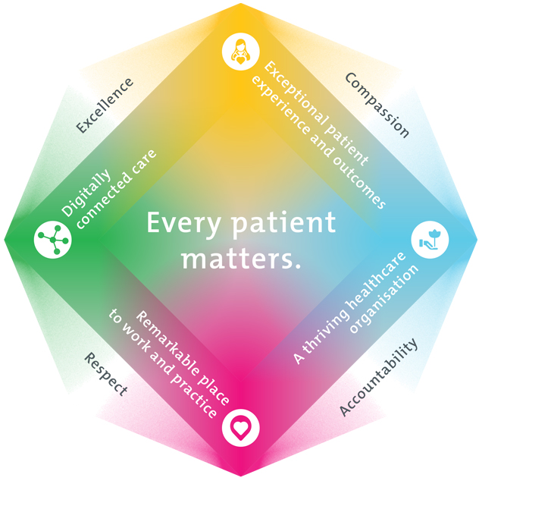

All roles are linked to the Epworth strategy and are fundamental in achieving its vision and purpose.
Connected Care – Partner with our patients and doctors to provide high-quality care through an integrated, holistic experience tailored
to their needs and choices
Empowered People – Enable and empower our people and teams to be their best and make a difference to the patient experience
Innovative Practice – Informing and enabling health within our community through encouraging the ideas of our people and finding
new and better ways to care and support care delivery
Sustainability – Be accountable to use resources wisely; to ensure organisational and environmental sustainability, enhance access,
support the patient journey and create greater capacity for care.
- Purpose of the Position
In this fixed-term (1 year), full-time role the Project Support Officer will oversee the increase and updating of endometriosis resources that aim to improve the health literacy for those affected by endometriosis, their carers, and the health professionals involved in treating them. The Project Support Officer would also act as a conduit between research and clinical staff - supporting the translation of research into practice. This would involve many smaller, medium, and larger scale projects including:
  - continuing to update our existing resources (including patient guides, patient toolkit, website information, newsletters etc),
  - organise Centre education webinars on relevant patient-centred topics,
  - writing of JAECE Centre guidelines, assessment proformas and referral pathways as guided by subject matter experts (for adoption in the Centre and possibly other clinicians Australia-wide),
- in collaboration with the new Epworth Nursing Academy and as guided by subject matter experts, help coordinate the development of a unit of study about endometriosis for the Epworth Nursing Academy and an endometriosis study day (or symposium) for medical professionals including for GP outreach and education,
  - assist in data collection pertaining to clinic utilisation and Centre resource(s) uptake,
  - in collaboration with JAECE researchers, undertake an evaluation project on the clinic activities at the Centre,
  - establish and build relationships between JAECE and relevant NGOs and the Government-funded Endometriosis and Pelvic Pain centres were appropriate.
This position engages with JAECE team members; Centre Director, Program Manager, Nurse Coordinators and research staff. In addition, the Project Support Officer will engage with Epworth clinicians, the Epworth Medical Foundation and the Epworth Brand team. Some out of hours work will be expected in this role. Ability to be flexible in working hours/days is highly desirable. Travel between campuses is necessary (namely between the Richmond, Hoddle St site and the two Freemasons campuses in East Melbourne). Travel to the Geelong and Eastern campuses may also be required from time to time.

Clinical Governance Framework
This role is required to put into practice the Clinical Governance Framework at Epworth as every employee is accountable for ensuring that our patients and community receive safe, high quality and person-centred care in every interaction with Epworth. This is achieved through active participation in the five domains of clinical governance at Epworth:

Clinical Governance Domain | Role
Leadership and culture | Promote and participate in a supportive, fair and transparent culture where lessons from previous outcomes are learned and patient safety and quality is a priority at all levels of the organisation.
Consumer Partnerships | Understand and where relevant, ensure that each patient is actively involved in their own care and treatment including  families/carers wherever possible.
Effective Workforce | Develop and maintain one’s own competency, skills and knowledge to ensure high quality service provision and care.
Clinical Safety and Effectiveness | Understand and where relevant, ensure, that the right care is provided to the right person at the right time, in the right  place and patient outcomes are monitored and improved.
Risk Management | Be responsible for identifying and reporting risks, hazards and near misses for people in our care and participating in risk  mitigation strategies.

Key Accountabilities

KEY RESPONSIBILITIES | MEASURES/KPIs TO BE ACHIEVED
Operational Requirement of the Project Support Officer  Coordinate the day to day running of multiple smaller, medium, and larger scale projects in conjunction with the JAECE team, that will improve endometriosis health literacy / education, research translation and uniformity of care | - Use initiative and judgement to interpret the needs and priorities of the Centre to ensure the provision of timely and effective project officer support  - Work with relevant external NGOs and external clinics to build relationships and identify common priorities  - Work to ensure all projects and clinic evaluations are met in the designated timelines, in an organised manner and in accordance with Centre priorities  - Oversee entry of clinic data and resource utilisation into relevant unit database/s (e.g. REDCap)

- Work with attention to detail to ensure all data entered is accurate and verifiable against source data
- Proactively identify project administrative issues
- Demonstrated initiative in expanding nurse-led endometriosis clinics through strategic coordination and stakeholder engagement, aligned with Centre priorities (10% in 12months).
- Applied judgement and subject matter expertise to refine and update JAECE resources, including their development and implementation to ensure they remain relevant and accessible for both patients and clinicians.
- Effectively organised and hosted JAECE 6 webinars, 2 study days, and 2 GP education days annually ensuring timely delivery of content and availability of recorded sessions on the Centre’s website to maximise reach and engagement.
- Prepared and maintained high-quality JAECE guidelines, assessment proformas, and referral pathways in collaboration with clinical experts, supporting consistent care practices across the Centre and external clinics.
- Developed guidelines for MDT navigation and clinical practice tools, ensuring alignment with multidisciplinary care models and enhancing clinical decision-making processes.
Research Excellence  Successfully complete the JAECE clinic evaluation study | - Demonstrated compliance with the requirements of ICH GCP, TGA guidelines and the NHMRC National Statement on Ethical Conduct in Research Involving Humans, ensuring that research is performed within these guidelines and in accordance with the policies of the pharmaceutical and/or device companies sponsoring the research.  - Efficiently organise elements related to participant recruitment, assessments, and any other elements as described in the research protocol  - Demonstrated maintenance of accurate research study files, documentation and related records and data both in hard copy and electronically within specified time frames.  - Works with the JAECE research team to complete evaluation of services and publish.  - Demonstrated collaboration with the JAECE research team to conduct comprehensive evaluations of service delivery, ensuring findings are documented and disseminated through publication to support advocacy for the expansion of nurse-led endometriosis clinics.
Communication  Professionally engage key internal and external stakeholders | - Maintain appropriate communication with key internal and external parties  - Communicate effectively with stakeholders, sponsors, patients, research participants, NGO’s and external clinics  - Liaise with relevant stakeholders, including NGO’s and external clinics to develop partnerships and identify priorities  - Prepare high quality written reports as required  - Maintain and enhance communication strategies to increase engagement with JAECE newsletters, resulting in a measurable growth in subscriber numbers (10% in 12 months).  - Support the dissemination of Centre resources by promoting and tracking downloads, ensuring accessibility and relevance to target audiences.  - Facilitate broader reach and impact of educational content by increasing viewership of JAECE webinars, including promotion through appropriate communication channels.
Education  Maintain the highest standard of knowledge and skills required for undertaking the role | - Follows instructions and undertakes additional training in order to acquire the knowledge and skills needed to implement new study protocols from a variety of clinical specialties  - Attend and present (if relevant) at various research forums  - Provide/reinforce information to participants and their family/carers as required for continual participation and/or as per the study protocol, explaining practical aspects of clinical trials  - Coordinate the development and delivery of an endometriosis study day for healthcare professionals, ensuring content is evidence-based and aligned with Centre priorities.  - Engage in education outreach to general practitioners, providing relevant information and resources to support improved clinical understanding and management of endometriosis.  - Support the preparation and implementation of a unit of study for the Brookes Academy for Nursing and Midwifery at Epworth, in collaboration with subject matter experts and educational stakeholders.
Team  - Successful team integration and support  - Provides positive and constructive feedback to other team members  - Actively participates as a member of the team | - Works cooperatively and collaboratively with all colleagues, Epworth staff and external parties  - Attend all team meetings as is required and/or feasible  - Provide support for other colleagues and studies within the team and shares workload when capacity allows  - Undertake key tasks or projects as requested by management
Quality Improvement  - Strives to consistently improve service delivery  - Provides suggestions and feedback to the Director on quality activities  - Actively participates in quality improvement activities within the department | - Evidence of participation in quality activities  - Improved customer service  - Improvement in performance of unit and Epworth healthcare site  - Show a proactive attitude in reviewing, supporting and implementing customer-focused initiatives
Governance  Meet all governance standards and benchmarks required for research | - Ensure all research is conducted according to study protocols and relevant legal and regulatory bodies including GCP and the International Conference of Harmonisation (ICH) guidelines  - Adhere to and compliance with research specific policies, clinical policies, including drug policies, standard operating procedures and guidelines
Personal and Professional Development  - Participates in prescribed performance development system annually  - Evaluates personal performance and plans self-development  Participates in the orientation of staff | - Completion of annual performance appraisal  - Completion of objectives outlined in self-development plan (provide evidence of)  - Training of staff in department specific activities (when requested)
Safety and Wellbeing  To ensure a safe workplace is provided for all employees and other personnel including contractors, agency staff, volunteers and students.  - All employees and other personnel under the authority of the manager are fully informed of the hazards associated with their work activities, adequately trained and instructed in safe work procedures and appropriately supervised.  Participate actively and positively in the area of health and safety to reduce all hazards and incidents within the workplace  Integrate and review OHS performance in staff PDPs | - Adhere to infection control/personal hygiene precautions  - Implement and adhere to Epworth OHS policies, protocols and safe work procedures  - Ensure all hazards, incidents and injuries are reported in Riskman within 24 hours  - Ensure all hazards, incidents and injuries are investigated and corrective actions implemented within agreed timeframes  - Mandatory training completed at agreed frequency

- Position Requirements/Key Selection Criteria

COMPONENT
Qualifications | Essential  - Tertiary qualification in health, health promotion, public health or relevant discipline  Desirable  - Experience in Women’s Health and or gynaecology
Previous Experience | Essential  - Demonstration of strong verbal, interpersonal, collaboration and written communication skills  - Proven ability to prepare high level reports  - Knowledge of project management principles and methodologies  - Related experience in a health-related project officer role or similar role  Desirable  - Experience in supporting clinical research or clinical trials including working knowledge of Australian and International statutory and regulatory requirements including the Therapeutic Goods Administration (TGA), Food and Drug Administration (FDA) and European Medicines Evaluation Agency (EMEA)
Required Knowledge & Skills | Essential  - Strong organisational skills and the ability to set priorities, work effectively, and achieve desired outcomes within specific timeframes  - Critical thinking and problem solving abilities  - Demonstrate role model behaviour  - Demonstrable excellence in customer service  - Demonstrates attention to detail  - Demonstrates time management skills  - Effective communication and interpersonal skills  - Sound computer literacy and a sound understanding of word, excel, email etiquette and research databases/online systems  Desirable  - Demonstrable understanding of REDCap design and implementation  - Evidence of Good Clinical Practice Training

Personal Attributes & Values  All employees are expected to consistently work in accordance with Epworth’s values and behaviours  - Respect  - Excellence  - Compassion  - Community  - Integrity  - Accountability | Essential  - Belief in patient centred care  - Committed to providing a safe environment for patients & colleagues  - Commitment to continuous improvement and customer service  - Commitment to self-development & learning  - Demonstrate an innovative, proactive and creative mindset  - Professional work ethic  - Practices within the ethos of the Epworth HealthCare Values & Behaviours
Document Control
Date Developed: | Date Last Reviewed: | Developed and Reviewed By (Position Title):
November 13, 2023 | August 22, 2025 | Developed by Sarah Holdsworth-Carson (RPM)  Reviewed by Veronica Abruzzo (CPM)

Employee Position Declaration
I have read and understand the requirements and expectations of the above Position Description. I agree that I have the physical ability to fulfil the inherent physical requirements of the position, and accept my role in fulfilling the Key Accountabilities. I understand that the information and statements in this position description are intended to reflect a general overview of the responsibilities and are not to be interpreted as being all-inclusive.

Employee Signature:
Print Name: | Date:

