- General Information
Position Title: | Infrastructure Specialist – Citrix and Desktop Compute
Division/Department: | Information Technology – Richmond Pelaco
Position Reports to: | Director of Cloud and IT Infrastructure
Enterprise/Individual Agreement: | Individual Agreement
Classification/Grade: | NA
Location: | Richmond, Pelaco
Employment Status: | Full Time
Resource Management  (for Management positions only)  Number of Direct Reports:  Budget under management: | 0
Key Relationships - internal and external | CIO Team  ICT Team  Vendor Management

2. Overview of Epworth HealthCare
Epworth HealthCare is Victoria’s largest not-for-profit private health care group, renowned for excellence in diagnosis, treatment, care and rehabilitation. Epworth is an innovator in Australia’s health system, embracing the latest in evidence-based medicine to pioneer treatments and services for our patients.

Epworth’s values define our approach and our delivery. We pride ourselves on communicating our values and delivering on them in a real and meaningful way. Our Values are Respect, Excellence, Community, Compassion, Integrity and Accountability. More information can be found on the Epworth website.

Epworth’s purpose is Every Patient Matters. We strive to improve health outcomes and experience through compassion, collaboration, learning and Innovation. Our Vision is Caring for People. Innovating for a healthy community.
3. Epworth HealthCare Strategy
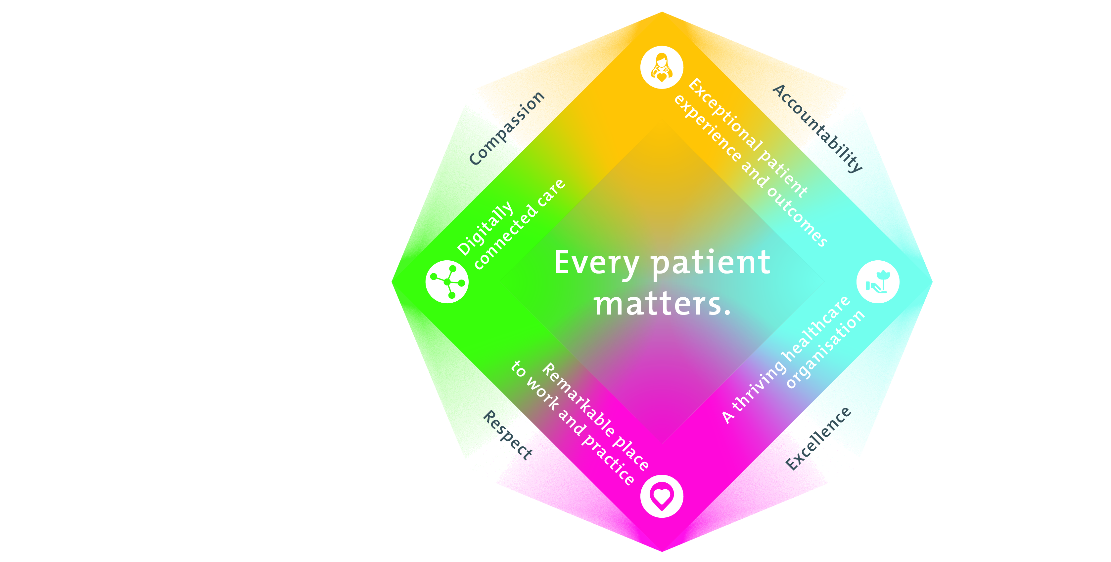

All roles are linked to the Epworth strategy and are fundamental in achieving its vision and purpose.
Connected Care – Partner with our patients and doctors to provide high-quality care through an integrated, holistic experience tailored to their needs and choices
Empowered People – Enable and empower our people and teams to be their best and make a difference to the patient experience
Innovative Practice – Informing and enabling health within our community through encouraging the ideas of our people and finding new and better ways to care and support care delivery
Sustainability – Be accountable to use resources wisely; to ensure organisational and environmental sustainability, enhance access, support the patient journey and create greater capacity for care.
4. Purpose of the Position
The infrastructure specialist will work as a member of the cloud and infrastructure team providing system support and administration of Epworth IT on premises and cloud platforms. The role will have a primary focus on supporting Epworth’s Citrix and end user compute platforms. Additionally, the position will provide broad support across all infrastructure components including networking, storage, cloud, virtualization, authentication, security, regular maintenance, documentation and user support. The Infrastructure Specialist will work closely with the Senior Technical Manager – Application Delivery and other IT Specialists to ensure the hospital infrastructure, servers and environments are supported in alignment with strategic direction, industry best practice and security standards. This role will report to Director Cloud and Infrastructure Services.

5. Clinical Governance Framework
This role is required to put into practice the Clinical Governance Framework at Epworth as every employee is accountable for ensuring that our patients and community receive safe, high quality and person-centred care in every interaction with Epworth. This is achieved through active participation in the five domains of clinical governance at Epworth:

Clinical Governance Domain | Role
Leadership and culture | Promote and participate in a supportive, fair and transparent culture where lessons from previous outcomes are learned and patient safety and quality is a priority at all levels of the organisation.
Consumer Partnerships | Understand and where relevant, ensure that each patient is actively involved in their own care and treatment including families/carers wherever possible.
Effective Workforce | Develop and maintain one’s own competency, skills and knowledge to ensure high quality service provision and care.
Clinical Safety and Effectiveness | Understand and where relevant, ensure, that the right care is provided to the right person at the right time, in the right place and patient outcomes are monitored and improved.
Risk Management | Be responsible for identifying and reporting risks, hazards and near misses for people in our care and participating in risk mitigation strategies.
6. Key Accountabilities
KEY RESPONSIBILITIES | MEASURES/KPIs TO BE ACHIEVED
Deployment of infrastructure technology and supporting systems | - Timely, efficient and problem free deployments  - Ensure minimal to no interruption of end user systems  Adherence to change management process
Systems administration and support  Manage systems administration and support activities as directed by the team leader | - Triaging and handling of day-to-day Infrastructure support jobs  - Carrying out routine Infrastructure maintenance (patching/updates)  - Ensuring IT security requirements are assessed as part of all changes as required  - Act as a 2nd level escalation point for the resolution of technology problems and events, collaborating with internal and external partners to resolve complex problems
Continuous Quality Improvement  Assist in the ongoing reliability, availability and security of ICT systems. | - Identify areas of value-added process improvement and projects  - Complete tasks accurately  - Maintain documentation (diagrams, instructions, plans)  - Assist with planned scheduled maintenance  - Ensure industry best practice and compliance with organisational and security requirements
Collaboration  Work collaboratively with internal stakeholders, customers and vendors with service professionalism and integrity | - Collaborate with business users and members of the IT teams to identify and plan staged deployment of systems  - Learn and develop infrastructure knowledge from one on one training and professional development where required  - Share knowledge within the IT department
Teamwork/Team effectiveness/Professional development  Develop and maintain effective working relationships with all ICT staff | - Collaborate with other IT teams to deliver deployments and upgrades  - Responsible for providing estimates of work where required and work to agreed timelines  - Perform other duties as requested
Customer Service  Epworth is committed to the provision of excellent customer service to all our people, customers and stakeholders including patients and external suppliers.  Superior patient service leads to improved healing in a trusting, caring environment and creates a safe environment for patients and employees.  - Provide excellent, helpful service to patients, visitors, and staff  - Communicate with clear and unambiguous language in all interactions, tailored to the audience  - Build customer relationships and greet customers and patients promptly and courteously  - Actively seek to understand patients' and their family's (customers) expectations and issues | - Ensure issues are escalated and resolved in a timely manner  - Attend to and close calls as indicated by the SLA  - Provide excellent communication between the IS department and Epworth staff
Safety and Wellbeing  Participate actively and positively in health and safety to reduce all hazards and incidents within the workplace  Report all hazards, incidents, injuries and near misses immediately to your manager and log them in RiskMan | - Adhere to infection control/personal hygiene precautions  - Implement and adhere to Epworth OHS policies, protocols, and safe work procedures  - Mandatory training completed at agreed frequency

7. Position Requirements/Key Selection Criteria
COMPONENT
Qualifications | Essential  - Tertiary qualification in an ICT or related field or equivalent work experience  Desirable  - Recognised certification in cloud computing, networking, server management or equivalent work experience  - Healthcare experience
Previous Experience | Essential  - 5 plus years of experiencing working and supporting a large Citrix environment  - 3 plus years of desktop and end user device experience  - 3 plus years of server support experience  - Experience in the supporting a large multi-site infrastructure set primarily using remote access.  Desirable  - Experience with modern platforms in Azure (Microsoft PaaS\SaaS services)  - Experience with Office 365 management\support  - Previous support in a Healthcare environment.
Required Knowledge & Skills | Essential  IT Technical Skills  - Strong Knowledge of Citrix Apps and Desktops (CVAD) including:  - Application and Desktop publishing  - Machine Catalogs and Delivery Groups  - Citrix Studio and Director  - Citrix StoreFront and Citrix Gateway  - Citrix Profile Manager  - Citrix Cloud  - Citrix Netscalers  - Strong knowledge in supporting End User Devices including Thin Clients, Desktops and Laptops  - Strong Knowledge of Windows 10/11 and Server 2016/2019/2022  - Experience with managing and deployment of policy/OS via Intune and SCCM  - Experience with VMware and Server hardware and Networking  - Experience with Group Policy and Active Directory  - Experience with DNS, DHCP, and Networking Basics  - Demonstrated systematic approach to problem solving  - Broad knowledge of Information Technology, systems and ITIL processes  - Competent with troubleshooting performance, application delivery, and end-user issues across EUC platforms  - Understanding of the IT security risk landscape and ability to consider the implications as part of daily work.  Training and Education  - Provide technical education training, assistance and ongoing support  - Identify and resolve client concerns  Reporting Skills  - Good technical and practical documentation skills  Communication Skills  - Excellent listening and verbal communication skills.  - The ability to properly understand end-user issues and communicate solutions to non-technical staff  Desirable  - Administration, organisational, and reporting skills  - Experience with application monitoring tools such as Logic Monitor and Control Up
Personal Attributes & Values  All employees are expected to consistently work in accordance with Epworth’s values and behaviours  - Respect  - Excellence  - Compassion  - Community  - Integrity  - Accountability | Essential  - Excellent verbal and written communication skills  - Ability to work autonomously where appropriate, but to proactively engage with/escalate matters to the Epworth Management when warranted.  - Proactive, self-motivated, and hard-working.  - Flexible, adaptable, and able to multi-task.  - Logical and efficient, with keen attention to detail, and ability to follow tasks through to completion.  - High level of emotional maturity and personal integrity.  - Ability to effectively prioritise and execute tasks, while under pressure.  - Demonstrate initiative, exercises good judgment, and can achieve results.  - Calm in the face of adversity or challenge.  - Committed to improving patient safety, quality of clinical care and reducing clinical error  - Energetic, enthusiastic, and passionate for the role

Document Control
Date Developed: | Date Last Reviewed: | Developed and Reviewed By (Position Title):
13th May 2025 | 13th May 2025 | Director of Cloud and IT Infrastructure Services

8. Employee Position Declaration
I have read and understand the requirements and expectations of the above Position Description. I agree that I have the physical ability to fulfil the inherent physical requirements of the position and accept my role in fulfilling the Key Accountabilities. I understand that the information and statements in this position description are intended to reflect a general overview of the responsibilities and are not to be interpreted as being all-inclusive.
Employee Signature:
Print Name: | Date:

