- General Information
Position Title: | Director of Clinical Services, Epworth Geelong
Division/Department: | Epworth Geelong, Management/Executive
Position Reports to: | Executive General Manager, Epworth Geelong
Enterprise/Individual Agreement: | Epworth HealthCare Individual Agreement
Classification/Grade: | N/A
Location: | Geelong
Employment Status: | Full Time
Resource Management  (for Management positions only)  Number of Direct Reports:  Budget under management: | > 250 FTE Nursing Staff  > $40M
Key Relationships - internal and external | - Executive General Manager, Epworth Geelong  - Executive Team, Epworth Geelong  - Chief Nursing Officer & Executive Director Clinical Services  - Directors of Clinical Services at other Epworth divisions  - Corporate Clinical Services  - Nursing, Allied Health and other clinical staff, Epworth Geelong  - Epworth Doctors and Visiting Medical Officers (VMOs)  - Patients and families
2. Overview of Epworth HealthCare
Epworth HealthCare is Victoria’s largest not-for-profit private health care group, renowned for excellence in diagnosis, treatment, care and rehabilitation. Epworth is an innovator in Australia’s health system, embracing the latest in evidence-based medicine to pioneer treatments and services for our patients.

Epworth’s values define our approach and our delivery. We pride ourselves on communicating our values and delivering on them in a real and meaningful way. Our Values are Compassion, Accountability, Respect and Excellence. More information can be found on the Epworth website.

Epworth’s purpose is Every Patient Matters. Our Vision is Delivering another 100 years of exceptional healthcare and innovation to the Victorian community.
3. Epworth HealthCare Strategy
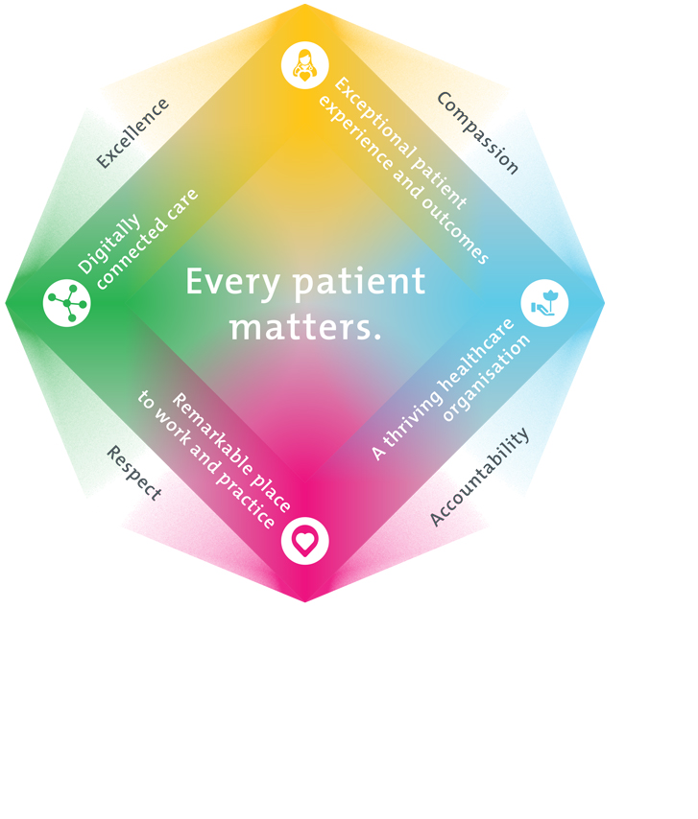
All roles are linked to the Epworth strategy and are fundamental in achieving its vision and purpose.
Exceptional patient experience and outcomes - To empower our patients and deliver compassionate, expert and coordinated care.
A thriving healthcare organisation - To adapt and grow in a changing healthcare landscape by delivering a unique private not-for-profit healthcare organisation.
Remarkable place to work and practice - To ensure Epworth is an outstanding place to work and practice through a culture of care
and investment in our people.
Digitally connected care - To innovate and improve the digital experience, interactions and outcomes for our patients, staff and doctors.
4. Purpose of the Position
The primary function of the Director Clinical Services is to undertake the role of clinical site manager, providing strong professional clinical leadership and effective operational management of the health services provided within the hospital. This position is a senior role within the Epworth Geelong Executive Management Team and is required to liaise with executive management and leadership teams across the organisation in relation to issues of site and clinical governance, risk management, nursing and midwifery workforce, education and learning, patient satisfaction, business development and business continuity.
The Director of Clinical Services will be focused on improving excellence in core clinical services provision through outcome reviews and patient engagement and contemporary knowledge of clinical service trends.
The Director Clinical Services has responsibility for the clinical quality and deployment of and health service outcomes desired by the hospital, ensuring consistency with Epworth’s vision, values and commitment to excellence in care and service delivery.
5. Clinical Governance Framework
This role is required to put into practice the Clinical Governance Framework at Epworth as every employee is accountable for ensuring that our patients and community receive safe, high quality and person-centred care in every interaction with Epworth. This is achieved through active participation in the five domains of clinical governance at Epworth:

Clinical Governance Domain | Role
Leadership and culture | Promote and participate in a supportive, fair and transparent culture where lessons from previous outcomes are learned and patient safety and quality is a priority at all levels of the organisation.
Consumer Partnerships | Understand and where relevant, ensure that each patient is actively involved in their own care and treatment including families/carers wherever possible.
Effective Workforce | Develop and maintain one’s own competency, skills and knowledge to ensure high quality service provision and care.
Clinical Safety and Effectiveness | Understand and where relevant, ensure, that the right care is provided to the right person at the right time, in the right place and patient outcomes are monitored and improved.
Risk Management | Be responsible for identifying and reporting risks, hazards and near misses for people in our care and participating in risk mitigation strategies.

6. Key Accountabilities
KEY RESPONSIBILITIES | MEASURES/KPIs TO BE ACHIEVED
Leadership  - Lead and engage the nursing and clinical workforce to achieve agreed clinical services and outcomes  - Provide professional oversight and direction  - Articulate and communicate the vision and clinical excellence standards across the clinical workforce  - Building relationships with key internal and external stakeholders  - Risk Management capability including OH&S and Infection Control and safety leadership including leading and implementing work, health, safety and wellbeing strategies, plans and initiatives  - Oversight and influence across key nurse sensitive patient care indicators and safety  - Lead and support operational excellence including timely patient access and flow across the organisation  - Direct involvement in the assembly and execution of initiating new health service clinical care and operational models as agreed by the Executive  - Lead and drive continuous clinical performance improvement, change management and best practice agenda  - Ensure professional standards of practice are in place and monitored  - Ensure the effective implementation of agreed service and clinical improvement plans, programs and policies to achieve best practice patient care and agreed targets with a focus on achieving high levels of patient satisfaction | - Excellence in operational performance; including key financial, operational and quality KPIs (management of labour hours, agree pt access and flow indicators, quality indicators)  - Achieve and present on agreed KPIs across all areas of responsibility in the areas of patient care, quality and safety, HR, OHS, employee engagement and workforce planning and finance/budget  - Provision of data to support the Business Development Manager in achieving hospital growth in line with the Geelong Growth Strategy  - Accreditation and quality control standards achieved  - Assembly and execution of tasks to support the Epworth Geelong Operational business plan and Geelong Growth Strategy  - High and efficient utilisation of available operating time and beds
Human Resource Management  - Development and implementation of an outstanding orientation program for all new staff at Epworth Geelong  - Implement and maintain a competency based performance management system for nursing and midwifery staff  - Monthly review, and response to, key KPI’s  - Development and execution of staff recruitment/retention, leadership development and workforce plans  - Rostering and management of an appropriate level of clinical resources | - High quality nursing leadership team is recruited to Epworth Geelong  - Epworth Geelong workforce plan targets met  - High levels of satisfaction with orientation program by staff  - HR report card KPIs kept within target  - Annual nurse and health professional registration and credentialing are met  - Reliance on Agency resources is < 5%  - Staff Engagement and Safety culture plans kept up to date and actioned
Professional Practice, Leadership and Development  - Provide mentorship and guidance to nurse leaders and nurses  - Review nursing and clinical education programs to ensure that they align with the needs of the organisation  - Ensure there is compliance with all regulatory requirements as they relate to nursing practice  - Initiate and lead professional practice discussion and encourage practice enquiry  - Ensure professional practice standards are communicated and monitored  - Participate in the wider nursing profession through professional associations such as Australian College of Nursing | - Clinical staff compliance with mandatory education programs  - Nurses seek to develop and advance their practice and careers  - The annual review and update of the Poisons Control Plan is submitted to DHHS for certification  - There is leadership of and participation in research activities by nurses and allied health professionals  - External participation in wider professional activities
Business Development  - Meet with specialists to maintain a positive and collaborative relationship with the clinical team at Epworth Geelong  - Develop strategies and programs to recruit designated specialists  - Actively support the marketing and recruitment of medical staff  - Assist the Executive to identify the medical practitioner profile required to support the strategic plan and operation of the hospital | - Business development targets for Epworth Geelong are met  - There is a strong and cohesive relationship between the medical and nursing staff at Epworth Geelong
Customer Service  Epworth is committed to the provision of excellent customer service to all of our people, customers and stakeholders including patients and external suppliers.  Superior patient service leads to improved healing in a trusting, caring environment and creates a safe environment for patients and employees.  - Role model and actively promote a culture of high quality patient care  - Provide excellent, helpful service to patients, visitors and staff  - Communicate with clear and unambiguous language in all interactions, tailored to the audience  - Build customer relationships and greet customers and patients promptly and courteously  - Actively seek to understand patients' and their family's expectations and issues, using multiple strategies  - Uses data (such as compliments, complaints and Press Ganey) to identify breakdowns in internal processes and systems that directly impact patient care and customer service  - Responds quickly and proactively escalate concerns when necessary  - Role model and actively promote a culture of high quality patient care and experience by ensuring that solutions, practices and procedures (such as hourly rounding, leader rounding and bedside handover) are carried out with empathy and compassion | - Patient and customer service satisfaction surveys within agreed targets  - Use AIDET principles in all interactions  - Compliments to complaints ratios  - Completes leader rounding at agreed frequency  - Issues are escalated to the manager and resolved in a timely manner
Safety and Wellbeing  To ensure a safe workplace is provided for all employees and other personnel including contractors, agency staff, volunteers and students.  - All employees and other personnel under the authority of the manager are fully informed of the hazards associated with their work activities, adequately trained and instructed in safe work procedures and appropriately supervised. Participate actively and positively in the area of health and safety to reduce all hazards and incidents within the workplace  - Integrate and review OHS performance in staff PDPs  - Ensure all direct reports are held accountable for safety performance and actions | - Adhere to infection control/personal hygiene precautions  - Implement and adhere to Epworth OHS policies, protocols and safe work procedures  - Ensure all hazards, incidents and injuries are reported in Riskman within 24 hours  - Ensure all hazards, incidents and injuries are investigated and corrective actions implemented within agreed timeframes  - Mandatory training completed at agreed frequency

7. Position Requirements/Key Selection Criteria
COMPONENT
Qualifications | Essential  - Registered Nurse, with current registration with the Australian Health Practitioners Registration Authority  - Relevant post graduate leadership and management qualifications
Previous Experience | Essential  - Demonstrated experience in senior leadership roles  - Relevant clinical, quality, risk management and workforce management experience  - Business and operational leadership
Required Knowledge & Skills | Essential  - Excellent written and verbal communication skills  - Advanced critical thinking and problems solving skills  - A commitment to excellence in customer service and patient experience  - Committmnet to supporting professional development and mentoring of staff, through the utilisation of a performance development and framework and access to relevant learning opportunities  - Innovative mindset: will continually search for innovative ways to improve services and grow new service streams consistent with the organisation’s vision and values, through the application of quality improvement principles  - Understanding of quality protocols: The ability to identify and manage unexpected or sentinel events in the organisation  - Knowledge and experience in managing work health safety issues and maintaining a healthy and safe work environment for staff and patients  - Experienced in performance management including performance coaching skills  - Ability to facilitate change  - Directly participate in and facilitate appropriate, data driven decision making with senior staff and the Executive Team
Personal Attributes & Values  All employees are expected to consistently work in accordance with Epworth’s values and behaviours  - Compassion  - Accountability  - Respect  - Excellence | Essential  - Be passionate about the provision of excellent patient care and have the ability to lead and support all aspects of clinical service delivery in accordance with legislated requirements, industry codes of practice and relevant standards and organisational policy and procedures  - Demonstrated management of human and material resources to meet the organisational requirement for cost efficient service delivery whilst maintaining the safety of patients, visitors and staff  - Contribute to the development of a cohesive, facilitative and inclusive team based culture, embracing high levels of service orientation  particularly towards the Hospital VMO’s and all patients  o A ‘can-do’ attitude and solutions focussed approach with a proven track record in improving excellence in core clinical services  provision and meeting KPIs including key labour management targets  - Committed to Epworth’s mission and values  - Superior communication, influencing, interpersonal and relationship management skills, including effective presentation and public speaking skills  - Commitment to the “Code of Professional Conduct for Nurses”  - Supports an environment of continuous learning and quality improvement  - Advanced skills in prioritising, problem solving, systems and process management  - Able to engage and empower nurses and provide them with a sense of being valued

Document Control
Date Developed: | Date Last Reviewed: | Developed and Reviewed By (Position Title):
June 2022 | August 2024 | Kate Gillan

8. Employee Position Declaration
I have read and understand the requirements and expectations of the above Position Description. I agree that I have the physical ability to fulfil the inherent physical requirements of the position, and accept my role in fulfilling the Key Accountabilities. I understand that the information and statements in this position description are intended to reflect a general overview of the responsibilities and are not to be interpreted as being all-inclusive.
Employee Signature:
Print Name: | Date:

