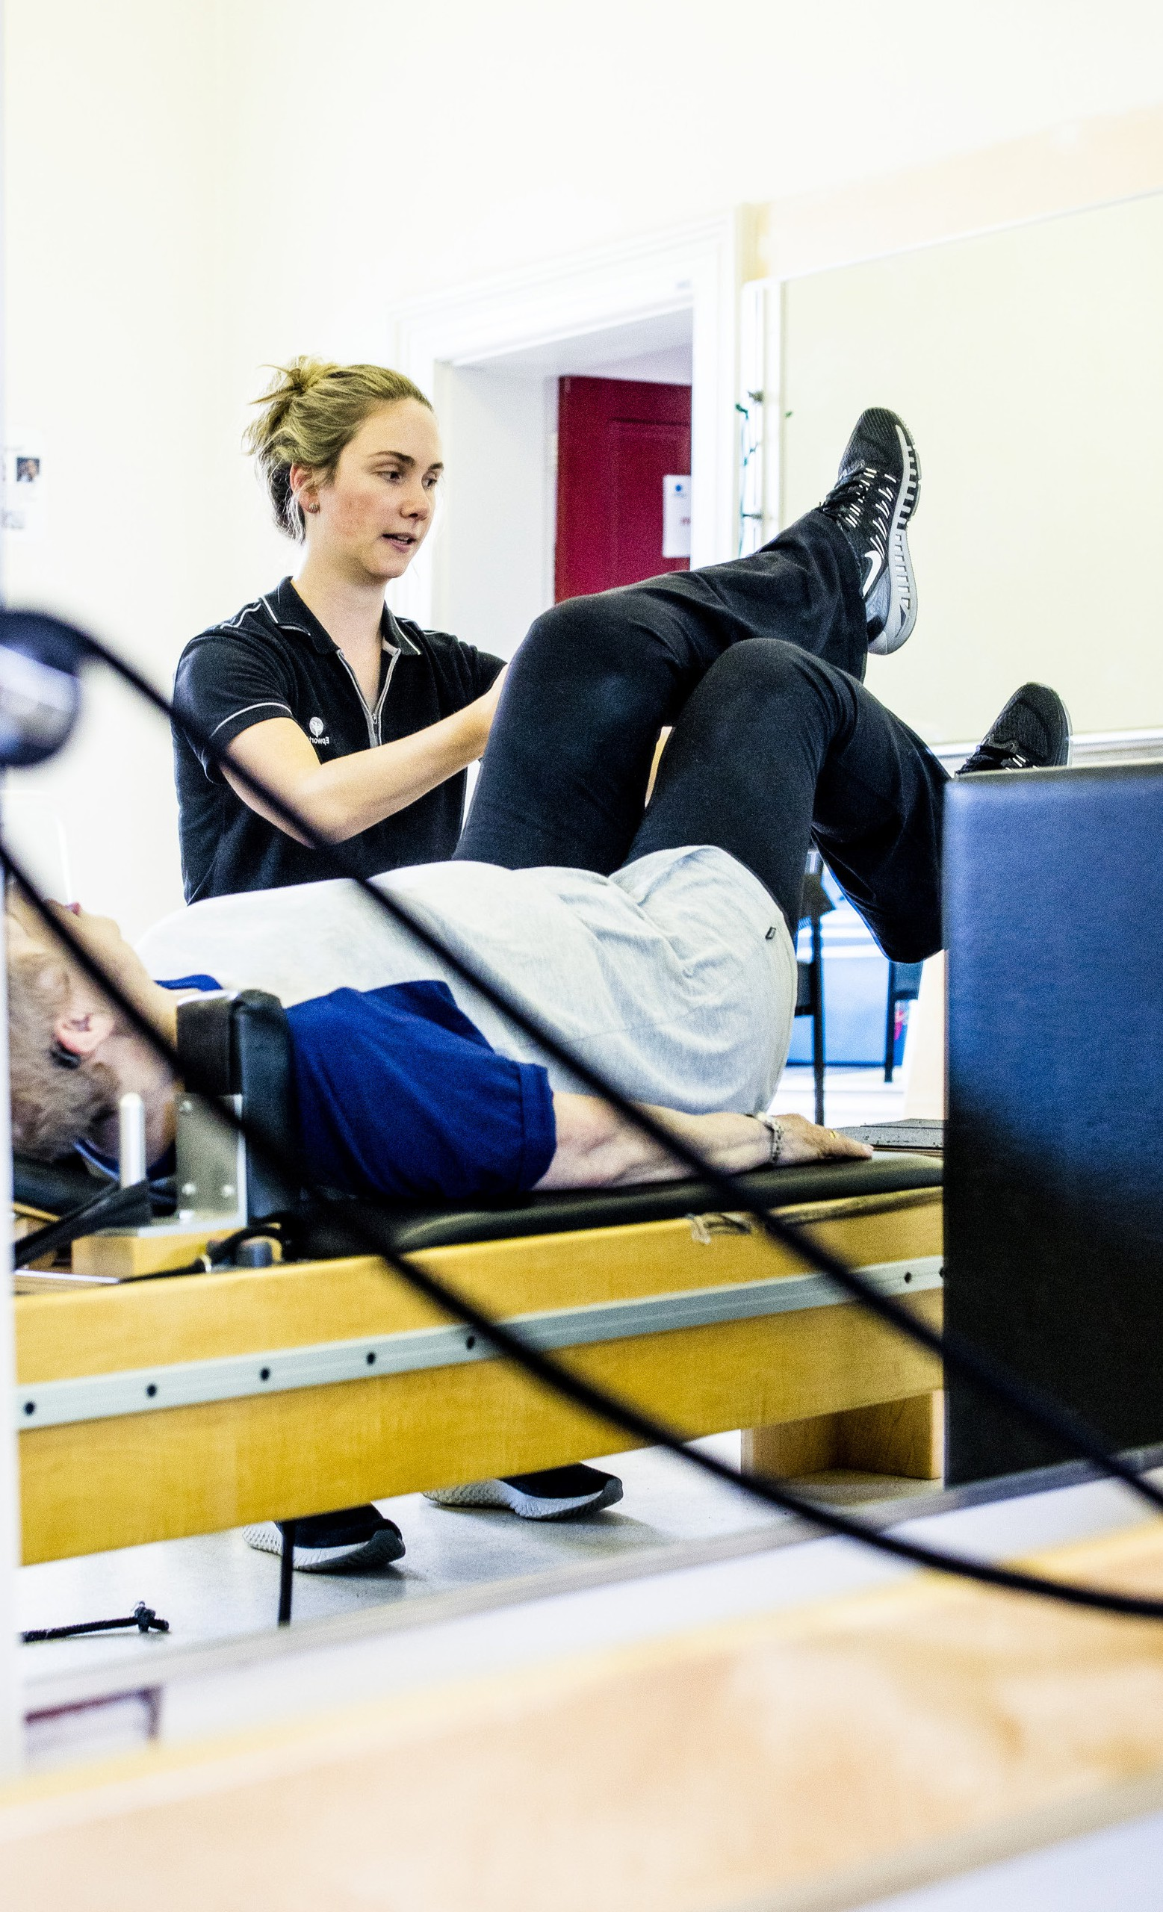

Physiotherapy Grade 1

Program 2025

(Metro Melbourne)

NP2210_RIC_0920

Epworth HealthCare is Victoria’s largest

**at you will get**

omprehensive rotating grade 1 program onthly rotations

table for both graduates and experienced de 1 physiotherapists

ellent senior support and clinical supervision

ll established continuing cation programs

ary packaging opportunities

**ical rotations**

e Grade 1 Program contains rotations and ve-relieving roles across a broad range of ical areas, including:

ute specialties

*hmond and Freemasons )*

not-for-profit private hospital group, renowned for excellence in diagnosis, treatment, care and rehabilitation.

Epworth is an innovator in Australia’s health system, embracing the latest in evidence-based medicine to pioneer treatments and services for our patients.

# Overview of the program

* A comprehensive rotating grade 1 program
* 4-monthly rotations
* Suitable for both graduates and experienced grade 1 physiotherapists
* Excellent senior support and clinical supervision
* An extensive range of educational, research and scholarship opportunities

rdiorespiratory/ICU thopaedics urosciences

neral Medical cology

y surgery

habilitation specialties

ghton, Camberwell, Hawthorn and Richmond)

tpatients uatic Therapy

rdiorespiratory inpatients urology inpatients thopaedic inpatients

onditioning/Chronic Disease inpatients sistent Pain

uma

* The highest level of salary packaging available in healthcare (up to **$15,900** pre-tax annually, plus

**$2,650** pre-tax for personal hospitality expenses)

# Clinical rotations

Rotations and leave-relieving roles are across a broad range of clinical areas, including:

Acute specialties

*(Eastern, Freemasons and Richmond)*

* Cardiorespiratory/ICU
* Day surgery
* General medical
* Neurosciences
* Oncology
* Orthopaedics

Rehabilitation specialties (inpatient and outpatient)

*(Camberwell, Hawthorn and Richmond)*

* Amputees and multi-trauma orthopaedics
* Aquatic therapy
* Cardiorespiratory
* Chronic diseases including heart failure, persistent pain and oncology)
* Neurology (including Parkinson’s, MS and stroke)
* Orthopaedics
* Reconditioning and active ageing
* Traumatic Brain Injury

epworth.org.au