- General Information
Position Title: | Group Manager Risk and Compliance
Division/Department: | Legal & Governance
Position Reports to: | Chief Legal Officer
Enterprise/Individual Agreement: | Individual
Classification/Grade: | Not Applicable
Location: | Pelaco Building, Richmond and works across all sites
Employment Status: | Permanent Position
Resource Management | - N/A
Key Relationships - internal and external | Internal:  - Group Executive  - Executive General Managers and local executives  - Legal Counsel  - Site Risk and Compliance Officers  - Group Director Health Safety and Wellbeing  External:  - Internal Auditors  - Contractors / Consultants
2. Overview of Epworth HealthCare
Epworth HealthCare is Victoria’s largest not-for-profit private health care group, renowned for excellence in diagnosis, treatment, care and rehabilitation. Epworth is an innovator in Australia’s health system, embracing the latest in evidence-based medicine to pioneer treatments and services for our patients.

Epworth’s values define our approach and our delivery. We pride ourselves on communicating our values and delivering on them in a real and meaningful way. Our Values are Compassion, Accountability, Respect and Excellence. More information can be found on the Epworth website.

Epworth’s purpose is Every Patient Matters.

Our Vision is Delivering another 100 years of exceptional healthcare and innovation to the Victorian community.

3. Epworth HealthCare Strategy
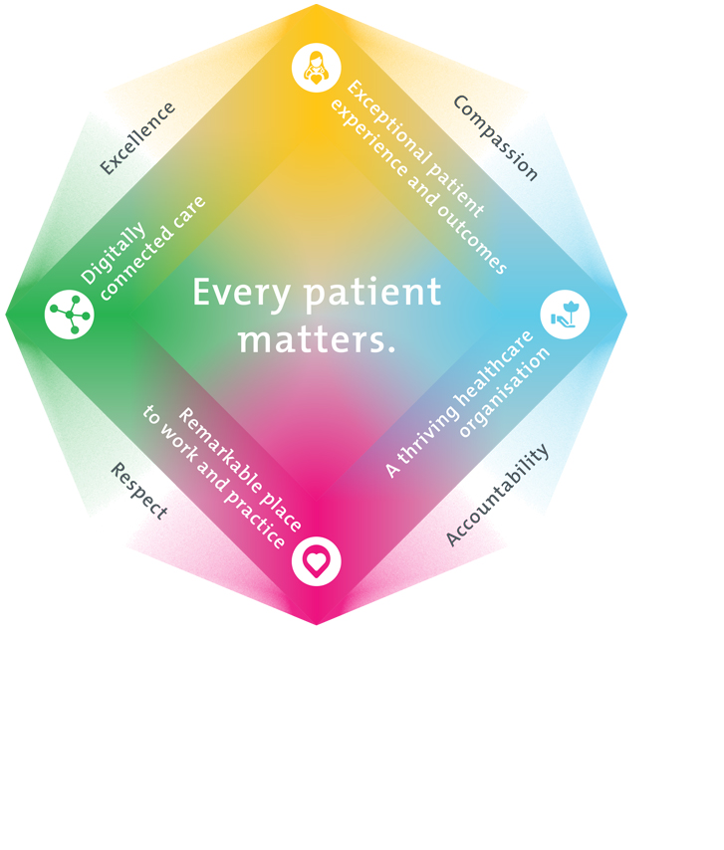
All roles are linked to the Epworth strategy and are fundamental in achieving its vision and purpose.
Exceptional patient experience and outcomes - To empower our patients and deliver compassionate, expert and coordinated care.
A thriving healthcare organisation - To adapt and grow in a changing healthcare landscape by delivering a unique private not-for-profit healthcare organisation.
Remarkable place to work and practice - To ensure Epworth is an outstanding place to work and practice through a culture of care
and investment in our people.
Digitally connected care - To innovate and improve the digital experience, interactions and outcomes for our patients, staff and doctors.
4. Purpose of the Position
Reporting to the Chief People Officer, this position is responsible for the management and operational oversight to achieve best practice in Risk Management, Governance and Compliance to meet legislative requirements.

With a focus of collaboration, integration and consistency and working closely with site Executive General Managers this role will support the organisational requirements in alignment with agreed strategic goals and operational plans and priorities.
5. Clinical Governance Framework
This role is required to put into practice the Clinical Governance Framework at Epworth as every employee is accountable for ensuring that our patients and community receive safe, high quality and person-centred care in every interaction with Epworth. This is achieved through active participation in the five domains of clinical governance at Epworth:

Clinical Governance Domain | Role
Leadership and culture | Promote and participate in a supportive, fair and transparent culture where lessons from previous outcomes are learned and patient safety and quality is a priority at all levels of the organisation.
Consumer Partnerships | Understand and where relevant, ensure that each patient is actively involved in their own care and treatment including families/carers wherever possible.
Effective Workforce | Develop and maintain one’s own competency, skills and knowledge to ensure high quality service provision and care.
Clinical Safety and Effectiveness | Understand and where relevant, ensure, that the right care is provided to the right person at the right time, in the right place and patient outcomes are monitored and improved.
Risk Management | Be responsible for identifying and reporting risks, hazards and near misses for people in our care and participating in risk mitigation strategies.

6. Key Accountabilities
KEY RESPONSIBILITIES | MEASURES/KPIs TO BE ACHIEVED
Leadership  - Lead risk, compliance and internal audit across Epworth, partnering with senior leaders and frontline staff  - Actively engaged with all sites and balance group strategy with local site needs and goals in the interests of providing best practice across all risk and compliance at Epworth.  - Support Epworth to develop and implement strategic and operational risk management and compliance plans across portfolio.  - Create a culture of risk awareness, accountability and action  - Model and develop a culture of mutual respect, care, compassion and accountability  - At all times act and behave in line with Epworth’s values and behaviours, | - % of business units actively engaged in risk planning  - Executive feedback on leadership  - Operational Plan documented and actioned  - Delivery of strategic projects as outlined in Epworth HealthCare Strategic plan on time and as agreed
Operational management  - Provide specialist expertise and professional knowledge in relation to risk management, compliance and internal audit at Epworth.  - Monitor compliance, review obligation alerts, and support reporting to meet evolving regulatory requirements.  - Facilitate workshops, support control uplift, and embed proactive risk culture  - Act as a chief point of professional risk, compliance and internal advice for key stakeholders within Epworth  - Provide high quality reports for the Board Risk & Sustainability Committee  - Up lift the maturity and culture of risk management and compliance across Epworth  - Maintain enterprise risk, compliance, and assurance frameworks; manage CAMMS registers and QA systems.  - Maintain Risk Appetite Statements and monitor KRIs to detect exposures or weaknesses.  - Support mitigation strategies and remediation of ineffective controls.  - Update frameworks, policies, and procedures; provide governance input on remediation.  - Report regularly to the executive team on identification and mitigation of key enterprise-wide risk and compliance matters  - Interact, liaise and engage with senior executives and provide strategic advice about key enterprise-wide risks, project and program risks  - Engage with and participate in relevant sector forums, bodies or committees relating to risk management and compliance  - Routinely monitor and respond to the changing operating environment to identify and manage risks and identify new or changing compliance obligations  - Ensure the internal audit plan is risk based and provides appropriate assurance to the executive on the internal control environment  - Support the Internal Audit provider to monitor, track and report on internal audit recommendations  - Oversee the management of contracts in relation to the delivery of internal audit services, as required, and ensure high standards of performance and value are obtained  - Provide leadership and specialist advice to the Group for all nominated projects | - Customer satisfaction  - Operational performance targets, including financial measures  - Stakeholder feedback  - Compliance breach rate  - Timeliness of papers to the Executive Committee and Board Committees  - Number of workshops conducted  - Staff engagement scores on risk culture  - Framework review cycle completion  - Accuracy and completeness of CAMMS entries  - Frequency of KRI reviews  - Number of early warning triggered by KRIs  - Time to remediate key control failures  - Internal audit plan completion rate
Sustained Financial Performance  - Development of annual operational budgets and financial projections aligned with group position  - Monitor and report progress against budget as per reporting processes  - Work within the approved delegations of authority | - Achievement of key financial performance measures
Quality and Risk  - Lead and build on a culture of continuous performance improvement  - Lead culture of performance improvement and align quality activities with group strategy.  - Act as a coach to help staff apply risk and compliance practices effectively.  - Educate teams on responsibilities and embed best practices.  - Support quality activities, ensuring they are consistent with the Epworth Health Group activities  - Ensure accreditation standards are maintained  - Ensure appropriate risk management plans in accordance with the risk framework for all existing and future developments within the Hospital  - Ensure appropriate input re risks and compliance activities are included in relevant business cases | - Achievement of ACHS accreditation  - Compliance with state & commonwealth legislation requirements  - Enterprise Risk Dashboards – regularly reviewed  - Operational Risks – regularly reviewed.
Customer Service  Epworth is committed to the provision of excellent customer service to all our people, customers and stakeholders including patients and external suppliers.  Superior patient service leads to improved healing in a trusting, caring environment and creates a safe environment for patients and employees.  - Provide excellent, helpful service to patients, visitors and staff  - Communicate with clear and unambiguous language in all interactions, tailored to the audience  - Build customer relationships and greet customers and patients promptly and courteously  - Actively seek to understand patients' and their family's (customers) expectations and issues | - Patient and customer service satisfaction surveys within agreed targets  - Issues are escalated to the manager and resolved in a timely manner
Safety and Wellbeing  Participate actively and positively in health and safety to reduce all hazards and incidents within the workplace  - Report all hazards, incidents, injuries and near misses immediately to your manager and log them in RiskMan | - Adhere to infection control/personal hygiene precautions  - Implement and adhere to Epworth Health, Safety and Wellbeing policies, protocols and safe work procedures  - Mandatory training completed at agreed frequency
7. Position Requirements/Key Selection Criteria
COMPONENT
Qualifications | Essential  - Tertiary qualification in business, health administration or a related discipline or demonstrated competency in Risk and Compliance (Senior level), minimum 10 years  Desirable  Completion of an MBA  Post-secondary qualifications in business, finance, insurance, law, governance, audit  Previous risk and compliance experience in healthcare
Previous Experience | Essential  - Tertiary qualification in business, health administration or a related discipline or demonstrated competency in Risk and Compliance (Senior level), minimum 10 years  - Deep expertise in compliance, audit, or risk management role in a highly regulated environment  - Proven delivery of business management strategies to drive organisation-wide initiatives and strong organisational, planning and prioritising ability  - Robust leadership capability with high-level communication skills including effective presentation and public speaking skills  - Exposure to a range of regulatory frameworks and requirements.  - Advanced skills in prioritising, problem solving, systems and process management  - Demonstrated experience reporting regularly to boards and executive teams on identification and mitigation of key enterprise-wide risk and compliance matters
Required Knowledge & Skills | Essential  - Understanding and knowledge of the Legislation, Guidelines, Frameworks and Standards for which healthcare facilities are to be maintained and operate within  - Demonstrated leadership skills in communication (verbal, written and online) and presentation  - Ability to drive organisation-wide initiatives and strong organisational, planning and prioritising ability  - Higher order problem-resolution, lateral thinking and creative skills, and ability to think laterally and strategically, to meet deadlines and productive quality work under pressure  - Excellent computer literacy including MS Office suite and understanding of property / facility systems and prior experience with CAMMS  - Ability to challenge current practices and develop and promote new innovative systems  - Ability to facilitate change  - Ability to manage multiple stakeholder expectations and business requirements
Personal Attributes & Values  All employees are expected to consistently work in accordance with Epworth’s values and behaviours  - Respect  - Excellence  - Compassion  - Accountability | - Passionate about the provision of leadership and support all aspects of service delivery in accordance with legislated requirements, industry codes of practice and relevant standards and organisational policy and procedures  - Demonstrated management of human and material resources to meet the organisational requirement for cost efficient service delivery  - Contribute to the development of a cohesive, facilitative and inclusive team-based culture, embracing high levels of service  - Prepared to make a commitment to Epworth’s mission and values  - Excellent communication, influencing, interpersonal and relationship management skills, including effective presentation and public speaking skills  - Supports an environment of continuous learning and quality improvement  - Advanced skills in prioritising, problem solving, systems and process management  - Enthusiasm to be agile and mobile across sites as required  - Have a high level of resilience and ability to perform in a constant and busy environment  - Ability to build and maintain rapport and effective relationships with key internal and external stakeholders, including the ability to provide advice that positively influences strategic direction  - Ability to consider and effectively manage competing priorities and strategic directions when achieving Group-wide and site-based planning and performance outcomes  - High attention to detail to meet quality and compliance requirements

Document Control
Date Developed: | Date Last Reviewed: | Developed and Reviewed By (Position Title):
May 2020 | July 2025 | Chief Legal Officer

8. Employee Position Declaration
I have read and understand the requirements and expectations of the above Position Description. I agree that I have the physical ability to fulfil the inherent physical requirements of the position and accept my role in fulfilling the Key Accountabilities. I understand that the information and statements in this position description are intended to reflect a general overview of the responsibilities and are not to be interpreted as being all-inclusive.
Employee Signature:
Print Name: | Date:

