- General Information
Position Title: | Operations Manager
Division/Department: | Epworth Eastern
Position Reports to: | Executive General Manager Epworth Eastern
Enterprise/Individual Agreement: | Individual Agreement
Location: | Epworth Eastern – Box Hill
Employment Status: | Permanent Full Time
Resource Management  (for Management positions only)  Number of Direct Reports:  Budget under management: | All management roles relating to access and flow of the hospital such as:  - Emergency Department Liaison Nurse team  - Patient Service Centre
Key Relationships - internal and external | Epworth Eastern Executive leadership team, Operations Managers at other sites, VMOs, Patients and Families, Executive Team, Operational Leadership Team, Front line leadership team, Epworth Eastern and Corporate teams
2. Overview of Epworth HealthCare
Epworth HealthCare is Victoria’s largest not-for-profit private health care group, renowned for excellence in diagnosis, treatment, care and rehabilitation. Epworth is an innovator in Australia’s health system, embracing the latest in evidence-based medicine to pioneer treatments and services for our patients.

Epworth’s values define our approach and our delivery. We pride ourselves on communicating our values and delivering on them in a real and meaningful way. Our Values are Respect, Excellence, Community, Compassion, Integrity and Accountability. More information can be found on the Epworth website.

Epworth’s purpose is Every Patient Matters. We strive to improve health outcomes and experience through compassion, collaboration, learning and Innovation. Our Vision is Caring for People. Innovating for a healthy community.
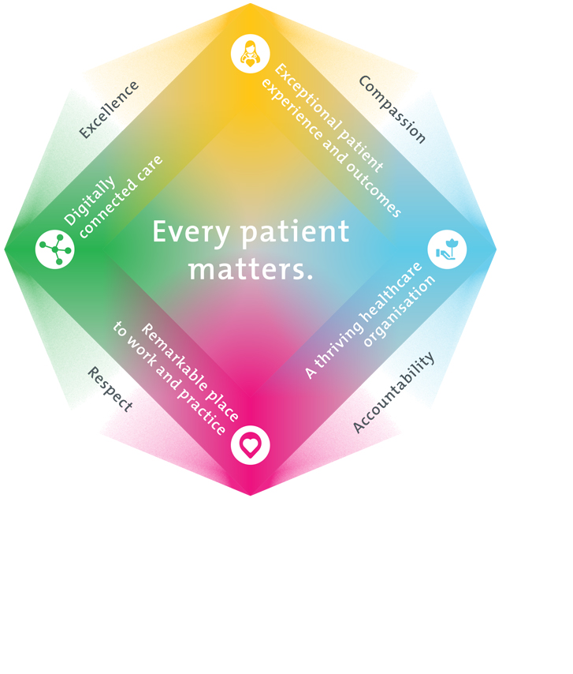
3. Epworth HealthCare Strategy
All roles are linked to the Epworth strategy and are fundamental in achieving its vision and purpose.
Connected Care – Partner with our patients and doctors to provide high-quality care through an integrated, holistic experience tailored to their needs and choices
Empowered People – Enable and empower our people and teams to be their best and make a difference to the patient experience
Innovative Practice – Informing and enabling health within our community through encouraging the ideas of our people and finding new and better ways to care and support care delivery
Sustainability – Be accountable to use resources wisely; to ensure organisational and environmental sustainability, enhance access, support the patient journey and create greater capacity for care.
4. Purpose of the Position
The Operations Manager is a key leadership role and is a member of the Epworth Eastern Executive team. The Operations Manager Operation will hold responsibility for the delivery of key operational priorities that benefit hospital access and flow, patient experience and hospital operational efficiency as well as providing day to day operational management of planned and unplanned infrastructure/IT works and coordination of emergency management and Business Continuity processes across the site.

Responsibilities includes:
- Day to day hospital operational matters including facilities/infrastructure and IT planned and unplanned works/interruptions.
- Site emergency management lead, working closely with the Group Director Emergency management and Business Continuity
- Direct admission pathways and models of care, including the development and implementation of new pathways
- Operational efficiency and optimisation of access and flow across the site
- Working closely with key stakeholders and Visiting Medical Officers to development and implementation of new models of care/services
- Public in Private partnerships (primary point of contact for all public in private partnerships)
- Patient Services Department
- Leadership and coordination of operational projects and delivery of projects on time and within project outlines
- Delivery of operational performance metrics such as bed days, admissions, length of stay
- In conjunction with the Executive General Manager and Eastern Executive team, develop yearly activity targets, hospital bed plan (including low activity plan)
- Work closely with the Director of Clinical Services (DCS) to ensure appropriate resource management, and that labour management aligns with operational requirements
- Financial management and delivery of activity within budget for cost centres reporting to the Operations Manager role
- The execution of relevant projects as identified by the Executive General Manager

The Operations Manager will use their clinical knowledge and experience to provide a strategic approach to optimising operational efficiency for access and flow initiatives across the Hospital. The Operations Manager will lead and coordinate operational projects and initiatives across the site/Epworth wide to support hospital performance.

The Operations Manager works in close partnership with senior leaders to prioritise, plan and roadmap the delivery of key initiatives and projects across Epworth Eastern.

The Operations Manager operates at an operational and strategic level to identify and implement service improvements and opportunities for service growth and expansion. The Operations Manager will be part of the Executive on Call Team at Epworth Eastern.
5. Key Accountabilities
KEY RESPONSIBILITIES | MEASURES/KPIs TO BE ACHIEVED
Clinical Expertise and Leadership  - Leadership, coordination of operational projects  - Work closely and engage with multidisciplinary teams and stakeholders  - Leading and engaging their direct workforce to achieve agreed services  and outcomes.  - Building and maintaining relationships with key internal and external  stakeholders.  - Provide strong leadership and clinical expertise  - Act as a clinical role model by ensuring the highest standard of patients care and service.  - Actively resolve or address local and/or immediate issues/delays that may affect the journey of the patient.  - Contribute to the strategic objectives and development of nursing and clinical services at Epworth Eastern.  - Actively seek and respond to constructive feedback relation to performance  - Development of business cases and proposals | - Review, monitor and report on key operational and financial KPIs  - Completion of mandatory competency requirements  - Completion of annual performance review  - Delivery of strategic projects on time and budget  - Strong and collaborative relationships with support services and other Epworth hospitals.
Patient Experience  Oversees the delivery of a seamless and timely patient-centred experience and  continues to implement strategies to enhance the patient experience, journey  and their overall satisfaction with Epworth Eastern:  - Ensures all areas maintain Epworth’s focus on customer service and  - Ensures all areas maintain Epworth’s reputation for excellence and identify  opportunities to build and promote this.  - Establish and maintain relationships with key stakeholders  - Acts as a role model to exemplify customer service focus and quality performance  - Builds and establishes positive relationships internally and external to the organisation | - Patient experience scores  - Key stakeholder feedback  - Patient Satisfaction  - Quality indicators
High Quality and Safe Patient Care  - Develop and implement suitable quality activities that promote evidence-based practice  - Active participation in the Australian Council of Healthcare Standards (ACHS) accreditation process  - Facilitate and ensure quality patient outcomes are achieved within an efficient and cost-effective framework  - Challenge current practices and lead organisational change towards improved patient outcomes  - Actively promote and support research into best practice and innovation | - Quality outcomes  - ACHS accreditation  - Evidence of service improvement activities  - Promotion of research
Operational Management  - Lead and coordinate Strategic projects and engage a broad range of stakeholders  - Explore and implement strategies to reduce expenditure while maintaining safe and effective care delivery and service provision, including strategies to improve efficiencies in rostering and staffing models.  - Support the development of systems (people, processes and technology) that improve accurate and timely data on access and operational performance. | - High and efficient utilisation of available beds and resources as measured.  - New Business Plans: Participate and/or lead the assembly and execution of new business and service opportunities as agreed by the Executive
Financial Management  - Achievement of operational KPIs  - Strategic and operational plan/s completed, reviewed and reported on monthly and as required  - Achievement of financial KPIs  - Ensure effective labour management | - Monthly financial and operational KPIs  - Labour hours/ LHPPD KPIs  - Completion of Business cases as required  - Implementation of actions to address budget variances  - Resource optimisation  - Identification and implementation of growth strategies
Customer Service  Epworth is committed to the provision of excellent customer service to all of our people, customers and stakeholders including patients and external suppliers.  Superior patient service leads to improved healing in a trusting, caring environment and creates a safe environment for patients and employees.  - Role model and actively promote a culture of high-quality patient care  - Provide excellent, helpful service to patients, visitors and staff  - Communicate with clear and unambiguous language in all interactions, tailored to the audience  - Build customer relationships and greet customers and patients promptly and courteously  - Actively seek to understand patients' and their family's expectations and issues, using multiple strategies  - Uses data (such as patient experience feedback) to identify opportunities for improvement in internal processes and systems that directly impact patient care and customer service  - Responds quickly and proactively escalate concerns when necessary  - Role model and actively promote a culture of high-quality patient care and experience by ensuring that solutions, practices and procedures (such as hourly rounding, leader rounding and bedside handover) are carried out with empathy and compassion | - Patient and customer service satisfaction surveys within agreed targets  - Compliments to complaints ratios  - Completes leader rounding at agreed frequency  - Issues are escalated to the manager and resolved in a timely manner
Safety and Wellbeing  To ensure a safe workplace is provided for all employees and other personnel including contractors, agency staff, volunteers and students.  - All employees and other personnel under the authority of the manager are fully informed of the hazards associated with their work activities, adequately trained and instructed in safe work procedures and appropriately supervised. Participate actively and positively in the area of health and safety to reduce all hazards and incidents within the workplace  - Integrate and review OHS performance in staff PDPs  - Ensure all direct reports are held accountable for safety performance and actions | - Adhere to infection control/personal hygiene precautions  - Implement and adhere to Epworth OHS policies, protocols and safe work procedures  - Ensure all hazards, incidents and injuries are reported in Riskman within 24 hours  - Ensure all hazards, incidents and injuries are investigated and corrective actions implemented within agreed timeframes  - Mandatory training completed at agreed frequency
6. Position Requirements/Key Selection Criteria
COMPONENT
Qualifications | Essential  - Registered Nurse with Nursing and Midwifery Board of Australian Health Practitioner Regulation Agency (AHPRA)  Desirable  - Post Graduate qualifications in the area of leadership and management
Previous Experience | Essential  - Previous and recent acute nursing experience  Desirable  - Recent experience in project management and delivery
Required Knowledge & Skills | Clinical Experience  - Demonstrated clinical expertise and experience in patient care co-ordination and post-acute service needs  - Evidence of a commitment to patient/customer service, clinical governance and quality improvement  - Positive role model to staff in terms of commitment to the delivery of high-quality patient care  - Knowledge and understanding of the National Safety and Quality Health Service Standards and ACHS Accreditation program  - Awareness of the private health environment, particularly as it relates to documentation and private health funding arrangements  - Knowledge and understanding of professional issues in nursing and the healthcare system  - Experience with service delivery model of care development  Interpersonal Skills  - Excellent interpersonal skills that inspire trust and confidence and the ability to communicate effectively with the multidisciplinary team  - Ability to work both autonomously and as part of a team  - Demonstrated ability to build strong relationships and work collaboratively with peers and superiors, and to contribute to quality outcomes and improvements  - Demonstrated capability for and focus on innovation through initiating and implementing improvements to service delivery, models of care, evidence-based practice and practice development
Personal Attributes & Values  All employees are expected to consistently work in accordance with Epworth’s values and behaviours  - Respect  - Excellence  - Compassion  - Community  - Integrity  - Accountability | Essential  - A ‘can-do’ attitude and solutions focussed approach with a proven track record in meeting KPIs and project management.  - Ability to manage differing and sometimes conflicting needs.  - Ability to manage/lead with resilience around ambiguity in a fast-paced changing environment.  - Advanced skills in prioritising, problem solving, systems and process analysis.  - Strong customer focus to drive holistic patient centred care and to provide support to carers and families  - Ability to develop and maintain strong relationships with internal and external stakeholders

Document Control
Date Developed: | Date Last Reviewed: | Developed and Reviewed By (Position Title):
February 2025 | February 2025 | Executive General Manager Epworth Eastern

7. Employee Position Declaration
I have read and understand the requirements and expectations of the above Position Description. I agree that I have the physical ability to fulfil the inherent physical requirements of the position and accept my role in fulfilling the Key Accountabilities. I understand that the information and statements in this position description are intended to reflect a general overview of the responsibilities and are not to be interpreted as being all-inclusive.
Employee Signature:
Print Name: | Date:

