- General Information
Position Title: | Self Funded Officer – Self Funded Estimates
Division/Department: | Health Partnerships
Position Reports to: | Group Director Health Partnerships
Enterprise/Individual Agreement: | Epworth HealthCare Health and Allied Services Enterprise Agreement 2018
Classification/Grade: | COF03 - COFO5
Location: | To Be Advised
Employment Status: | Permanent
Resource Management  (for Management positions only)  Number of Direct Reports:  Budget under management: | None
Key Relationships - internal and external | Patient Services Teams, Patient Revenue, Internal Stakeholder VMO’s, Practice Managers, GP’s & General Public
2. Overview of Epworth HealthCare
Epworth HealthCare is Victoria’s largest not-for-profit private health care group, renowned for excellence in diagnosis, treatment, care and rehabilitation. Epworth is an innovator in Australia’s health system, embracing the latest in evidence-based medicine to pioneer treatments and services for our patients.

Epworth’s values define our approach and our delivery. We pride ourselves on communicating our values and delivering on them in a real and meaningful way. Our Values are Compassion, Accountability, Respect and Excellence. More information can be found on the Epworth website

Epworth’s purpose is Every Patient Matters.

Our Vision is Delivering another 100 years of exceptional healthcare and innovation to the Victorian community.

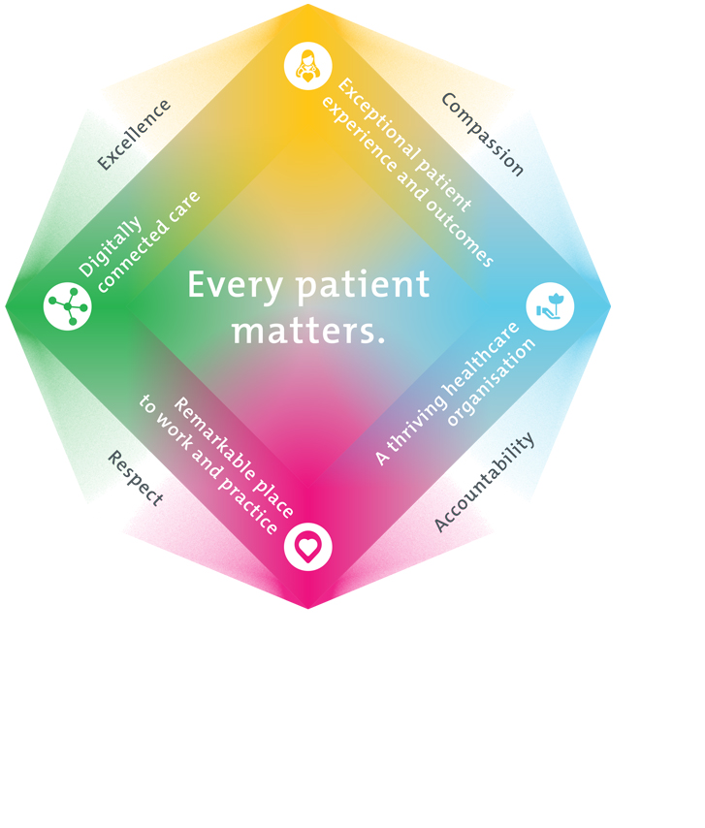
3. Epworth HealthCare Strategy

All roles are linked to the Epworth strategy and are fundamental in achieving its vision and purpose.
Exceptional patient experience and outcomes - To empower our patients and deliver compassionate, expert and coordinated care.
A thriving healthcare organisation - To adapt and grow in a changing healthcare landscape by delivering a unique private not-for-profit healthcare organisation.
Remarkable place to work and practice - To ensure Epworth is an outstanding place to work and practice through a culture of care
and investment in our people.
Digitally connected care - To innovate and improve the digital experience, interactions and outcomes for our patients, staff and doctors.

4. Purpose of the Position
Preparation of estimates for Epworth HealthCares self-funded patients. This role will assist in setting up a central process to engage with key stakeholders including the patient services teams, VMO’s, GP’s and the General Public. The role will be customer centric and continue to evolve the benefits delivered as part of the Self Funded Team.
5. Clinical Governance Framework
This role is required to put into practice the Clinical Governance Framework at Epworth as every employee is accountable for ensuring that our patients and community receive safe, high quality and person-centered care in every interaction with Epworth. This is achieved through active participation in the five domains of clinical governance at Epworth:

Clinical Governance Domain | Role
Leadership and culture | Promote and participate in a supportive, fair and transparent culture where lessons from previous outcomes are learned and patient safety and quality is a priority at all levels of the organisation.
Consumer Partnerships | Understand and where relevant, ensure that each patient is actively involved in their own care and treatment including families/carers wherever possible.
Effective Workforce | Develop and maintain one’s own competency, skills and knowledge to ensure high quality service provision and care.
Clinical Safety and Effectiveness | Understand and where relevant, ensure, that the right care is provided to the right person at the right time, in the right place and patient outcomes are monitored and improved.
Risk Management | Be responsible for identifying and reporting risks, hazards and near misses for people in our care and participating in risk mitigation strategies.

6. Key Accountabilities
KEY RESPONSIBILITIES | MEASURES/KPIs TO BE ACHIEVED
Service Delivery  - Provide a customer centric, consistent, streamlined and centralised process for acute self-funded estimates  - Continue to develop resource tools, protocols and policies to enable and support the growth of self-insured patient estimate requests  - Provide training where appropriate for key stakeholders of any relevant products and processes  - Continue to evolve the role in line with the Self-Funded Strategy | - One consistent approach to estimates across all sites and services  - 24 - 48 hour turn around on completed estimates  - Measuring of calls received and point of origination  - Regular follow to understand pricing success  - Half Yearly key stakeholder feedback  - Follow up to all quotes improving the understanding of why quotes may not have been accepted
Communication & Engagement  - Provide response and lead communication process for all self-insured estimate enquiries to key stakeholders  - Provide regular communication regarding feedback, themes, issues, changes and process improvements to key stakeholders  - Manage VMO portfolio to ensure positive relationships | - Monthly engagement with key stakeholders  - Increasing knowledge of processes for Practice Managers and VMO’s
Financial/Operational  - As a team, coordinate the process for review and updating of Self-Funded pricing schedule across key stakeholders, including sites and VMO’s.  - Ensure a consistent and transparent process for all existing self-insured (formal and informal) arrangements  - Continue recommendations for change to existing self-insured arrangements and process  - Monthly reporting of call volumes, call origination (for Marketing), Estimate success rate and accuracy | - Focus on improving the success rate of quotes to bookings  - Share pricing intelligence where competitor pricing is better than Epworth Healthcare  - Ensure pricing for all Epworth Self-Funded activities does not lose money.  - Estimates provided within 24 hours 70% of the time  - 100% of calls answered and responded to
Customer Service  Epworth is committed to the provision of excellent customer service to all our people, customers and stakeholders including patients and external suppliers.  Superior patient service leads to improved healing in a trusting, caring environment and creates a safe environment for patients and employees.  - Role model and actively promote a culture of high-quality patient care  - Provide excellent, helpful service to patients, visitors and staff  - Communicate with clear and unambiguous language in all interactions, tailored to the audience  - Build customer relationships and greet customers and patients promptly and courteously  - Actively seek to understand patients' and their family's expectations and issues, using multiple strategies  - Uses data (such as compliments, complaints and Press Ganey) to identify breakdowns in internal processes and systems that directly impact patient care and customer service  - Responds quickly and proactively escalate concerns when necessary  - Role model and actively promote a culture of high-quality patient care and experience by ensuring that solutions, practices and procedures (such as hourly rounding, leader rounding and bedside handover) are carried out with empathy and compassion | - Patient and customer service satisfaction surveys within agreed targets  - Use AIDET principles in all interactions  - Compliments to complaints ratios  - Completes leader rounding at agreed frequency  - Issues are escalated to the manager and resolved in a timely manner
Safety and Wellbeing  To ensure a safe workplace is provided for all employees and other personnel including contractors, agency staff, volunteers and students.  - All employees and other personnel under the authority of the manager are fully informed of the hazards associated with their work activities, adequately trained and instructed in safe work procedures and appropriately supervised. Participate actively and positively in health and safety to reduce all hazards and incidents within the workplace  - Integrate and review OHS performance in staff PDPs  - Ensure all direct reports are held accountable for safety performance and actions | - Adhere to infection control/personal hygiene precautions  - Implement and adhere to Epworth OHS policies, protocols and safe work procedures  - Ensure all hazards, incidents and injuries are reported in Rickman within 24 hours  - Ensure all hazards, incidents and injuries are investigated and corrective actions implemented within agreed timeframes  - Mandatory training completed at agreed frequency
7. Position Requirements/Key Selection Criteria
COMPONENT
Qualifications | Essential  - Working with Children Check
Previous Experience | Essential  - 2-3 years Healthcare Administration experience  - Health estimates experience
Required Knowledge & Skills | Essential  - Strong computer skills  - Great coaching and communication skills  - Ability to improve processes  Desirable  - Previous experience with IPM  - Medical terminology knowledge
Personal Attributes & Values  All employees are expected to consistently work in accordance with Epworth’s values and behaviours  - Compassion  - Accountability  - Respect  - Excellence | Essential  - Belief in patient centred care  - Committed to providing a safe environment for patients & colleagues  - Professional work ethic  - Practices within the ethos of the Epworth HealthCare Values & Behaviours  - Agility with a focus on accuracy and attention to detail within a dynamic environment  - Effective communication and interpersonal skills, with an ability to liaise effectively face to face and via telephone  - An autonomous self-starter with a proactive approach to workload management  - Professional approach with excellent personal presentation  - Well-developed problem-solving skills  - Ability to set priorities and work well under pressure  - Willingness to participate in a team-based environment

Document Control
Date Developed: | Date Last Reviewed: | Developed and Reviewed By (Position Title):
11.6.21 | 14.11.2024 | Self-Funded Officer< Group Director Health Partnerships

8. Employee Position Declaration
I have read and understand the requirements and expectations of the above Position Description. I agree that I have the physical ability to fulfil the inherent physical requirements of the position, and accept my role in fulfilling the Key Accountabilities. I understand that the information and statements in this position description are intended to reflect a general overview of the responsibilities and are not to be interpreted as being all-inclusive.
Employee Signature:
Print Name: | Date:

