- General Information
Position Title: | Store Person
Division/Department: | Corporate Services, Supply and Logistics
Position Reports to: | Warehouse/Site Team Leader
Enterprise/Individual Agreement: | Health & Allied Services Enterprise Agreement
Classification/Grade: | SSP01 – SSP05
Location: | Mount Waverley, Eastern, Rehabilitation & Mental Health, Richmond, Freemasons or Geelong
Employment Status: | Permanent or Casual
Resource Management  (for Management positions only)  Number of Direct Reports:  Budget under management: | NA
Key Relationships - internal and external | - Procurement Leadership Team  - Supply & Logistics Team  - Freight and Courier drivers  - Hospital department managers, clinical and allied health staff, ward administration team
2. Overview of Epworth HealthCare
Epworth HealthCare is Victoria’s largest not-for-profit private health care group, renowned for excellence in diagnosis, treatment, care and rehabilitation. Epworth is an innovator in Australia’s health system, embracing the latest in evidence-based medicine to pioneer treatments and services for our patients.

Epworth’s values define our approach and our delivery. We pride ourselves on communicating our values and delivering on them in a real and meaningful way. Our Values are Compassion, Accountability, Respect and Excellence. More information can be found on the Epworth website.

Epworth’s purpose is Every Patient Matters.

Our Vision is Delivering another 100 years of exceptional healthcare and innovation to the Victorian community.

3. Epworth HealthCare Strategy
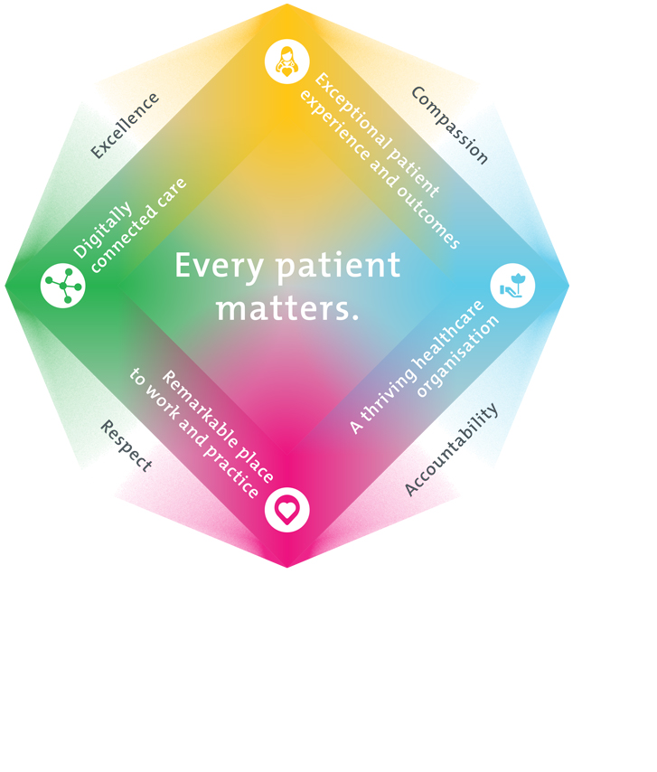
All roles are linked to the Epworth strategy and are fundamental in achieving its vision and purpose.
Exceptional patient experience and outcomes - To empower our patients and deliver compassionate, expert and coordinated care.
A thriving healthcare organisation - To adapt and grow in a changing healthcare landscape by delivering a unique private not-for-profit healthcare organisation.
Remarkable place to work and practice - To ensure Epworth is an outstanding place to work and practice through a culture of care
and investment in our people.
Digitally connected care - To innovate and improve the digital experience, interactions and outcomes for our patients, staff and doctors.
4. Purpose of the Position
Site Supply
This position is responsible for the maintaining of the onsite supply stores, wards, departments and units storage spaces of the required stock to the min/max par levels. As a member of the Supply team, this role provides an efficient and smooth process for the supply chain of stock coming from the central warehouse to the onsite location and being dispatched to the required department or site location to ensure staff and doctors are able to continue to provide the highest quality patient care
Warehouse Supply
This position is responsible for pick/packing and dispatching the day to day orders and the receival of Inward goods and restocking of the warehouse. As a member of the Warehouse team you will participate actively and positively in the area of health and safety to reduce all hazards and incidents within the workplace. The role requires active participation in the continuous improvement activities.
5. Clinical Governance Framework
This role is required to put into practice the Clinical Governance Framework at Epworth as every employee is accountable for ensuring that our patients and community receive safe, high quality and person-centred care in every interaction with Epworth. This is achieved through active participation in the five domains of clinical governance at Epworth:

Clinical Governance Domain | Role
Leadership and culture | Promote and participate in a supportive, fair and transparent culture where lessons from previous outcomes are learned and patient safety and quality is a priority at all levels of the organisation.
Consumer Partnerships | Understand and where relevant, ensure that each patient is actively involved in their own care and treatment including families/carers wherever possible.
Effective Workforce | Develop and maintain one’s own competency, skills and knowledge to ensure high quality service provision and care.
Clinical Safety and Effectiveness | Understand and where relevant, ensure, that the right care is provided to the right person at the right time, in the right place and patient outcomes are monitored and improved.
Risk Management | Be responsible for identifying and reporting risks, hazards and near misses for people in our care and participating in risk mitigation strategies.
6. Key Accountabilities
KEY RESPONSIBILITIES | MEASURES/KPIs TO BE ACHIEVED
Best Practice in Warehousing  - Acts in accordance with legislative and common law requirements  - Actively participate in a team charter  - Utilises a reflective, critical thinking and evidence based approach to deliver best practice in stock movement  - Timely reporting of events to Warehouse Manager or delegate  - Practices in accordance with Safety Standards  - Actively receipt, put away, pick and dispatch of product:  - Picking is performed accurately and in a timely manner to ensure all Departments receive their delivery promptly  - Check inward goods as per organisational protocols  - Maintenance of records of receipt of goods at the warehouse  - Perform clerical functions associated with general store duties  - Stock counting and replenishment as required  - Contribute to and participate in maintaining excellent housekeeping of the warehouse, site and common shared areas including the tea room  - Performs store duties at other campuses as required or directed  - Participate in internal and external audits as requested by Warehouse Manager or delegate  - Scan and stock Imprest as per the PAR level  - Ensure that the requirements of wards and departments are issued on requisition or imprest as required  - Ensure prompt and accurate delivery of non-imprest stock to appropriate delivery point  - Setup and maintain ward/department and site store locations in accordance with agreed standards | - Compliance with mandatory and department specific competencies every 12 months or as prescribed  - Prescribed PPE is worn at all times by self and staff  - Compliance with legislative and common law requirements  - Customer service satisfaction surveys to be within organisational targets  - Sound relationships developed and maintained with customers  - Compliance with EEO & Social Medial Policies and Protocols of Epworth HealthCare  - Goods receipted within 4 hours arrival at warehouse  - Time from receiving to pick location within agreed timeframes  - Achieves number lines receipted & dispatched per day within agreed measures  - Inventory accuracy maintained at >90% or agreed standards  - Outcome of twice yearly stocktake of central warehouse to be at agreed measure  - Maintain an excellent housekeeping standard  - Accurate data entry for processing of orders, returns and other inventory tasks  - Deliver stores to departments throughout the campus as required  - PAR Level of stock is maintained  - Annual imprest review is to agreed standards and organisational targets
Team Work  - Works cooperatively and collaboratively with all members of the procurement and supply team  - Provides positive and constructive feedback to others team members  - Actively participates as a member of the purchasing and logistics team  - Participates in the orientation of new and casual staff  - Participates in education to purchasing & logistics team | - Assists in training of staff in relevant department specific activities (when requested by Warehouse Manager or delegate)  - Participation in in-services, department education and team meetings  - Attends and actively participates in department and team meetings  - Feedback from team members
Personal and Professional Development  - Participates in prescribed performance development system annually  - Evaluates personal performance and plans self-development | - Completion of annual performance appraisal  - Completion of objectives outlined in self-development plan (provide evidence of)
Quality Improvement  - Strives to consistently improve service delivery  - Provides suggestions and feedback to Warehouse Manager or delegate on quality activities  - Actively participates in quality improvement activities within the department | - Evidence of participation in quality improvement activities  - Improvement in performance of department and Epworth healthcare site  - Show a proactive attitude in reviewing, supporting and implementing best practice in logistics and warehousing
Customer Service  Epworth is committed to the provision of excellent customer service to all of our people, customers and stakeholders including patients and external suppliers.  Superior patient service leads to improved healing in a trusting, caring environment and creates a safe environment for patients and employees.  - Role model and actively promote a culture of high quality patient care  - Provide excellent, helpful service to patients, visitors and staff  - Communicate with clear and unambiguous language in all interactions, tailored to the audience  - Build customer relationships and greet customers and patients promptly and courteously  - Actively seek to understand patients' and their family's expectations and issues, using multiple strategies  - Uses data (such as compliments, complaints and Press Ganey) to identify breakdowns in internal processes and systems that directly impact patient care and customer service  - Responds quickly and proactively escalate concerns when necessary  - Role model and actively promote a culture of high quality patient care and experience by ensuring that solutions, practices and procedures (such as hourly rounding, leader rounding and bedside handover) are carried out with empathy and compassion | - Patient and customer service satisfaction surveys within agreed targets  - Use AIDET principles in all interactions  - Compliments to complaints ratios  - Completes leader rounding at agreed frequency  - Issues are escalated to the manager and resolved in a timely manner
Safety and Wellbeing  Participate actively and positively in the area of health and safety to reduce all hazards and incidents within the workplace  - Report all hazards, incidents, injuries and near misses immediately to your manager and log them in RiskMan | - Adhere to infection control/personal hygiene precautions  - Implement and adhere to Epworth OHS policies, protocols and safe work procedures  - Mandatory training completed at agreed frequency
7. Position Requirements/Key Selection Criteria
COMPONENT
Qualifications | Essential  - Year 12 High School certificate  - Valid Victorian Driver’s licence  - MR licence  Desirable  - Valid Forklift licence
Previous Experience | Essential  - Previous store person experience in a medium to large Healthcare organisation  Desirable  - Barcode Scanning  - Similar store person experience in medium to large organisations
Required Knowledge & Skills | Essential  - Knowledge and commitment to Acts, Agreements and Epworth Healthcare directions, policies, procedures and staff code of conduct  - Sound computer literacy and a sound understanding of word, excel & email etiquette  - Demonstrate role model behaviour  - Sound time management skills  - Demonstrable excellence in customer service  - Effective communication and interpersonal skills  Desirable  - WMS/MRP/ERP system exposure i.e. TechOne experience
Personal Attributes & Values  All employees are expected to consistently work in accordance with Epworth’s values and behaviours  - Compassion  - Accountability  - Respect  - Excellence | Essential  - Belief in patient centred care  - Committed to providing a safe environment for patients & colleagues  - Commitment to continuous improvement and customer service  - Commitment to self-development & learning  - Demonstrate an innovative, proactive and creative mindset  - Professional work ethic  - Practices within the ethos of the Epworth HealthCare Values & Behaviours  Desirable  - Self-motivated and self-directed

Document Control
Date Developed: | Date Last Reviewed: | Developed and Reviewed By (Position Title):

8. Employee Position Declaration
I have read and understand the requirements and expectations of the above Position Description. I agree that I have the physical ability to fulfil the inherent physical requirements of the position, and accept my role in fulfilling the Key Accountabilities. I understand that the information and statements in this position description are intended to reflect a general overview of the responsibilities and are not to be interpreted as being all-inclusive.
Employee Signature:
Print Name: | Date:

