# General Information

|  |  |
| --- | --- |
| **Position Title:** | People Experience Coordinator |
| **Division/Department:** | People and Culture |
| **Position Reports to:** | Group Director, People Experience |
| **Enterprise/Individual Agreement:** | Individual Agreement |
| **Classification/Grade:** | N/A |
| **Location:** | Pelaco - Richmond |
| **Employment Status:** | 0.6 FTE |
| **Resource Management**  (for Management positions only)  **Number of Direct Reports:**  **Budget under management:** | N/A |
| **Key Relationships - internal and external** | * People and Culture Practitioners * Senior Leaders and People Leaders * All members of the Epworth Community |

1. **Overview of Epworth HealthCare**

Epworth HealthCare is Victoria’s largest not-for-profit private health care group, renowned for excellence in diagnosis, treatment, care and rehabilitation. Epworth is an innovator in Australia’s health system, embracing the latest in evidence-based medicine to pioneer treatments and services for our patients.

Epworth’s values define our approach and our delivery. We pride ourselves on communicating our values and delivering on them in a real and meaningful way. Our Values are Compassion, Accountability, Respect and Excellence. More information can be found on the Epworth website.

Epworth’s purpose is Every Patient Matters.

Our Vision is Delivering another 100 years of exceptional healthcare and innovation to the Victorian community.

# Epworth HealthCare Strategy

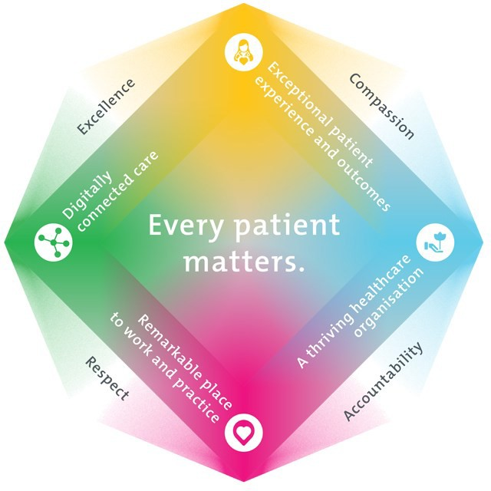

|  |
| --- |
| All roles are linked to the Epworth strategy and are fundamental in achieving its vision and purpose. |
| **Exceptional patient experience and outcomes -** To empower our patients and deliver compassionate, expert and coordinated care. |
| **A thriving healthcare organisation -** To adapt and grow in a changing healthcare landscape by delivering a unique private not-for-profit  healthcare organisation. |
| **Remarkable place to work and practice -** To ensure Epworth is an outstanding place to work and practice through a culture of care  and investment in our people. |
| **Digitally connected care -** To innovate and improve the digital experience, interactions and outcomes for our patients, staff and doctors. |

1. **Purpose of the Position**

The People Experience Coordinator is responsible for providing high-quality administrative and project support and coordination, as well as data analysis and reporting, across the People Experience portfolio. This role ensures the effective administration and maintenance of People Experience policies, procedures, programs, and communication and reporting frameworks. The incumbent will work proactively to streamline processes, enhance efficiency, and deliver timely support to the People Experience team. This includes contributing to the continuous improvement of team operations and ensuring compliance with internal and external requirements.

The People Experience Coordinator will be responsible for:

* Providing administrative support for People Experience initiatives, activities, and enquiries, ensuring timely and accurate responses.
* Coordinating learning, leadership, engagement, and recognition programs, including:
* Managing registrations and program administration for the Elevate Leadership suite.
* Maintaining and updating eLearning modules as required.
* Reviewing and updating relevant policies and procedures.
* Responding to reporting requests and general queries related to programs such as LinkedIn Learning, Elevate, Epworthy, Epworth Essentials, and Recognition of Service.
* Managing dedicated mailboxes for specific initiatives.
* Supporting the coordination and delivery of both existing and new People Experience programs of work across Epworth.
* Providing project support, including tracking progress, maintaining documentation, and assisting with implementation.
* Preparing high-quality documentation, communications, reports, and presentations to support program delivery and decision-making.
* Assisting with budget administration, including invoice tracking, processing, and reconciliation.
* Assisting with the planning, coordination, and delivery of People Experience events, workshops, and initiatives.
* Responding to internal and external queries in a timely and professional manner.
* Collaborating with stakeholders across the organisation to support the successful delivery of People Experience projects.

# Clinical Governance Framework

This role is required to put into practice the Clinical Governance Framework at Epworth as every employee is accountable for ensuring that our patients and community receive safe, high quality and person-centred care in every interaction with Epworth. This is achieved through active participation in the five domains of clinical governance at Epworth:

**Clinical Governance Domain Role**

|  |  |
| --- | --- |
| ***Leadership and culture*** | Promote and participate in a supportive, fair and transparent culture where lessons from previous outcomes are learned  and patient safety and quality is a priority at all levels of the organisation. |
| ***Consumer Partnerships*** | Understand and where relevant, ensure that each patient is actively involved in their own care and treatment including families/carers wherever possible. |
| ***Effective Workforce*** | Develop and maintain one’s own competency, skills and knowledge to ensure high quality service provision and care. |
| ***Clinical Safety and Effectiveness*** | Understand and where relevant, ensure, that the right care is provided to the right person at the right time, in the right  place and patient outcomes are monitored and improved. |
| ***Risk Management*** | Be responsible for identifying and reporting risks, hazards and near misses for people in our care and participating in risk  mitigation strategies. |

# Key Accountabilities

| **KEY RESPONSIBILITIES** | **MEASURES/KPIs TO BE ACHIEVED** |
| --- | --- |
| **General Administrative Support**  **General Program Management - End to end Learner experience**   * Coordination of program Registrations, responding to queries and planning and executing communications to participants and the organisation as required. * Program support including room scheduling, catering, materials preparation, participant recruitment, selection and registrations, communications, provision of completion certificates, records management and monitoring and administering MS Teams Chats * Coordinate and administer the following programs, but not limited to:   + Elevate   + Conversations That Count   + Coach M Program   + Elevate Insights   + Epworth Essentials (Induction)   + Specific Learning interventions including Presenting with Impact, Board Writing Skills, Emerging Women Leaders (examples only)   + Melbourne Business School Leader Development   + Elevate Insights - End to end audience and presenter experience * Scheduling Webinars - Town Halls - Presenters and Audience Links * Providing Speaker Briefings * Moderate Webinars and maintain attendance records * Upload recordings and maintain intranet * Coordinate communications   **EpWORTHY Program Management**   * Coordinate ongoing communications and promotion of the recognition program * Liaise with sites and manage the nomination and selection process and the presentation to winners   **LinkedIn Learning**   * Program Administration including but not limited to the issuing of Licenses, the revoking of Licenses, assisting users with navigation queries * Promoting courses as required and executing the communications plan in partnership with the Communications and Engagement Team   **Belong / Include**   * Days of Significance – support as required   **Recognition of Service**   * Manage the master data of invited employees to our Recognition of Service ceremony, updating eligible employees and their RSVP * Support the project team with event planning and event management on the day. * Liaise with sites to ensure all outstanding awards are presented. | * **Deliver high-quality, customer-focused service** by providing timely, accurate, and professional support that fosters strong business relationships. * **Build and maintain effective working relationships** with the People & Culture team, as well as internal and external stakeholders, to support collaboration and program success. * **Achieve reporting targets** by contributing to the delivery of periodic People & Culture metrics, ensuring both qualitative and quantitative data are accurate and insightful. * **Ensure compliance with People & Culture KPIs**, including timely completion of Performance Development Plans (PDPs) and mandatory compliance training. * **Establish and maintain clear procedures** that drive operational efficiency and consistency across all People Experience programs and initiatives. |
| **Financial Administration Responsibilities**   * Maintain accurate and up-to-date **budget records** for the People Experience portfolio. * Monitor the **submission, tracking, and payment of invoices in TechOne**, ensuring timely processing and resolution of outstanding items. * Respond to **budget-related queries**, including follow-ups on outstanding invoices and clarification of financial processes. * Educate and support People Experience team members on **finance procedures and compliance requirements**, promoting consistent and accurate financial practices. * Coordinate and lead **monthly budget review meetings** with the Group Director, People Experience, providing updates on cost centre balances, transactions, and variances. * Support the team in the **annual budget planning process**, including preparation and maintenance of relevant documentation and forecasts. | * All invoices are sent to accounts payable and monitored * Positive feedback from stakeholders – e.g., PE Team and Finance Manager |

|  |  |
| --- | --- |
| **Project Management**   * Develop and manage the People Experience workplan, coordinating requirements to deliver all initiatives on the plan in a timely manner. * Continuously identify areas of improvement and communicate suggestions to the People Experience team. | * Complete tasks/projects within scope, time and budget. * Supporting team if milestones are not being met |
| **Customer Service**  Epworth is committed to the provision of excellent customer service to all of our people, customers and stakeholders including patients and external suppliers.  Superior patient service leads to improved healing in a trusting, caring environment and creates a safe environment for patients and employees.   * Provide excellent, helpful service to patients, visitors and staff * Communicate with clear and unambiguous language in all interactions, tailored to the audience * Build customer relationships and greet customers and patients promptly and courteously * Actively seek to understand patients' and their family's (customers) expectations and issues | * Patient and customer service satisfaction surveys within agreed targets * Use AIDET principles in all interactions * Issues are escalated to the manager and resolved in a timely manner |
| **Safety and Wellbeing**  Participate actively and positively in the area of health and safety to reduce all hazards and incidents within the workplace   * Report all hazards, incidents, injuries and near misses immediately to your manager and log them in RiskMan | * Adhere to infection control/personal hygiene precautions * Implement and adhere to Epworth OHS policies, protocols and safe work procedures * Mandatory training completed at agreed frequency |

1. **Position Requirements/Key Selection Criteria**

|  |  |
| --- | --- |
| **COMPONENT** |  |
| Qualifications | **Essential**   * Tertiary qualification in HR or related discipline (or working towards) |
| Previous Experience | **Essential**   * Previous experience providing Tier 1 HR support   **Desirable**   * P&C shared services experience in medium to large organisation |
| Required Knowledge & Skills | * Strong **customer-centric focus**, with the ability to deliver responsive and professional service. * Proficient in **Microsoft Office applications**, particularly **Microsoft Teams, Office, Excel, Powerpoint** and **Planner**. * **Self-motivated** and capable of working independently with minimal supervision. * Excellent **written and verbal communication skills**, with the ability to communicate with **tact and diplomacy**. * Comfortable working in **ambiguous environments**, with the ability to adapt and make sound decisions. * (Optional) **Working knowledge of employment laws and HR practices** – *include if the role requires HR compliance or advisory responsibilities.* |
| Personal Attributes & Values  All employees are expected to consistently work in accordance with Epworth’s values and behaviours   * Compassion * Accountability * Respect * Excellence | **Essential**   * Demonstrates and role models **Epworth’s Values** and associated behaviours in all interactions. * Strong belief in and commitment to **patient-centred care**. * Dedicated to maintaining a **safe environment** for both patients and colleagues. * Displays a **positive, proactive, and professional approach** with a “can-do” attitude. * Resilient and adaptable, with the ability to manage **competing priorities** and shifting demands. * Works effectively as part of a **collaborative team** and contributes to a supportive team culture. * Comfortable working in **ambiguous or evolving environments**, with the ability to navigate complexity. * Self-directed and **results-oriented**, with a strong sense of accountability. * Exercises **sound judgement, discretion, and political acumen** in sensitive or complex situations. * Committed to delivering **exceptional customer service** to internal and external stakeholders. * Actively pursues **self-development and continuous learning**. * Maintains a high standard of **professionalism and work ethic**. * Embraces a **continuous improvement mindset**, seeking opportunities to enhance processes and outcomes. |

**Document Control**

|  |  |  |
| --- | --- | --- |
| Date Developed: | Date Last Reviewed: | Developed and Reviewed By (Position Title): |
| 15/05/2025 | 15/5/2025 | Group Director People Experience |

# Employee Position Declaration

I have read and understand the requirements and expectations of the above Position Description. I agree that I have the physical ability to fulfil the inherent physical requirements of the position, and accept my role in fulfilling the Key Accountabilities. I understand that the information and statements in this position description are intended to reflect a general overview of the responsibilities and are not to be interpreted as being all-inclusive.

Employee Signature: Print Name: Date: