- General Information
Position Title: | Clinical Neuropsychologist
Division/Department: | Epworth Rehabilitation & Mental Health, Psychology
Position Reports to: | Psychology Manager and Grade 3’s
Enterprise/Individual Agreement: | Epworth Healthcare Dietitians, Psychologists, Medical Scientists and Medical Physicists Enterprise Agreement
Classification/Grade: | Grade 2: P21 –P25, Specialist Clinician Psychologist (SCP)
Location: | Brighton, Camberwell, Hawthorn and Richmond Rehabilitation
Employment Status: | Casual
Resource Management  (for Management positions only)  Number of Direct Reports:  Budget under management: | N/A
Key Relationships - internal and external | - Patients and family members & visitors  - Multi-disciplinary team members and Nursing staff  - Rehabilitation Consultants, Medical Staff & VMO’s  - Service providers and external referrers
2. Overview of Epworth HealthCare
Epworth HealthCare is Victoria’s largest not-for-profit private health care group, renowned for excellence in diagnosis, treatment, care and rehabilitation. Epworth is an innovator in Australia’s health system, embracing the latest in evidence-based medicine to pioneer treatments and services for our patients.

Epworth’s values define our approach and our delivery. We pride ourselves on communicating our values and delivering on them in a real and meaningful way. Our Values are Respect, Excellence, Community, Compassion, Integrity and Accountability. More information can be found on the Epworth website.

Epworth’s purpose is to improve the health, wellbeing and experience of every patient by integrating clinical practice with education and research and our vision is to consistently deliver excellent patient-centred care with compassion and dignity.
3. Epworth HealthCare Strategy
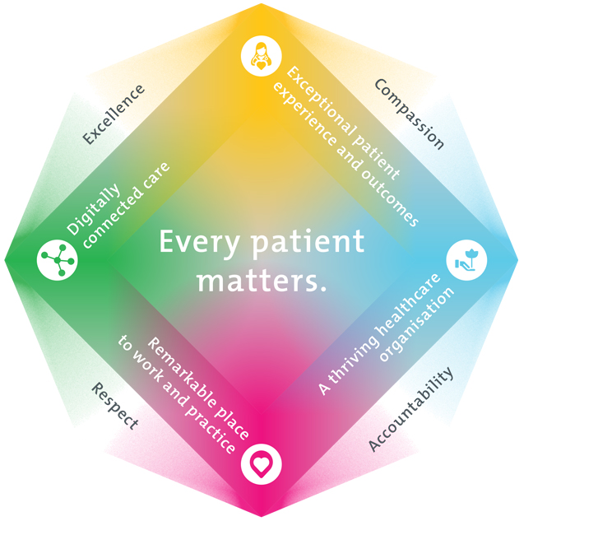
All roles are linked to the Epworth strategy and are fundamental in achieving its vision and purpose.
Exceptional patient experience and outcomes - To empower our patients and deliver compassionate, expert and coordinated care.
A thriving healthcare organisation - To adapt and grow in a changing healthcare landscape by delivering a unique private not-for-profit healthcare organisation.
Remarkable place to work and practice - To ensure Epworth is an outstanding place to work and practice through a culture of care
and investment in our people.
Digitally connected care - To innovate and improve the digital experience, interactions and outcomes for our patients, staff and doctors.

4. Purpose of the Position
To provide casual staffing for the neuropsychology team within the Rehabilitation and Mental Health Division. This position requires the flexibility to work at any of our rehabilitation sites: Richmond, Camberwell, Hawthorn, and Brighton. Your aim will be to provide optimal psychological services and positive clinical outcomes to patients ensuring long-term health and wellbeing that is consistent with Epworth HealthCare's Vision and Values. Working within a multidisciplinary team, provide (under the supervision of a Grade 3 Neuropsychologist) effective clinical, educational, emotional support and holistic best practice care to the patient and the family.
5. Key Accountabilities
KEY RESPONSIBILITIES | MEASURES/KPIs TO BE ACHIEVED
Clinical Care/Professional Practice  - Ensure optimal level of function and independence for all patients in the clinical caseload by appropriate psychological assessments and treatments, provided in both individual and group sessions  - Assess patient performance in relation to behavioural, cognitive, psychological aspects and their environment and determine appropriate interventions to improve and promote their psychological health  - Establish and maintain appropriate standards of practice relating to patient admission, assessment, treatment, family liaison and discharge planning  - Implement, monitor and modify treatment programs within the clinical area as appropriate  - Demonstrate empathy and compassion and encourage patient and family members participation in all stages of care  - Practice within the scope of registration of a Psychologist with AHPRA  - Practice in accordance with the National Safety and Quality Health Services(NSQHS) Standards  - Maintain patient confidentiality as prescribed by the relevant acts and organizational policies and procedures  - Understand and implement Epworth HealthCare Policies and Procedures and departmental work place instructions  - Contribute to the development and maintenance of new and established clinical services and the broader team | - Appropriate standards of practice relating to assessments and treatments are implemented in a timely manner  - Compliance with mandatory and team based documentation in patients’ medical records within agreed timeframes  - Direct patient care provided within allocated time frames from referral to treatment and within funding parameters  - Timely intervention is provided to support the team in achieving patients length of stay goals  - Sound relationships are developed and maintained with customers, family and colleagues  - Patient satisfaction results meet organisational targets  - Compliance with NSQHS and clinical competencies  - Compliance with accepted professional standards and Australian Psychological Society Code of Ethics  - Compliance with legislative and common law requirements including Privacy Act and Health Records Act  - Adherence to all Epworth Policies and Procedures
Customer Service  Epworth is committed to the provision of excellent customer service to all of our people, customers and stakeholders including patients and external suppliers. Superior patient service leads to improved recovery in a trusting, caring environment and also creates a safe environment for patients and employees.  - Provide excellent, helpful service to patients, visitors and staff  - Communicate with clear and unambiguous language in all interactions, tailored to the audience  - Build customer relationships and greet customers and patients promptly and courteously  - Actively seek to understand patients' and their family's circumstances, expectations and issues | - Patient and customer service satisfaction surveys within agreed targets  - Ensure the patients have the opportunity to actively participate in their treatment planning and implementation  - Use AIDET principles in all interactions  - Issues or concerns are proactively escalated to the manager and resolved in a timely manner  - Compliments recorded on Riskman  - Consistently meet or exceeds the expectations of our patients and customers at all times  - Awareness of Epworth HealthCare's complaints process and assistance provided to patients if required
Team Work /Communication  - Actively participate as a member of the department and multidisciplinary team  - Provide positive and constructive feedback to other team members | - Collaborate effectively with all other team members and external agencies for efficient patient management  - Attendance and active participation in departmental and multidisciplinary team meetings
Continuous Quality Improvement  - Actively participate in Quality activities ensuring opportunities for improvement are actively explored and best practice is achieved  - Provide suggestions and feedback to consistently improve service delivery, clinical practice and patient satisfaction  - Promote and enhance Epworth HealthCare and the department’s positive image within the community | - Evidence of participation in quality enhancement activities  - Quality projects are completed within agreed time frame  - Demonstrated commitment to Australian Commission on Safety and Quality in Health Care, National Safety and Quality HealthCare Services (NSQHS) Standards  - Under direction of senior staff departmental resources, equipment and educational information are maintained and updated
Personal and Professional Development  - Participate in ongoing professional development by upgrading clinical competencies and knowledge and participating in both internal and external educational opportunities  - Actively participate in Performance Development Plan annually and evaluate personal performance  - Educate and support AHA staff and students as required  - Contribute to student development programs as directed | - Participation in Psychology Week if applicable  - Attendance in internal and external professional development educational forums as required  - Participation in in-service and education activities as required  - Completion of performance review and development plan for casual staff member
Safety and Wellbeing  - Participate actively and positively in the area of health and safety to reduce all hazards and incidents within the workplace  - Report all hazards, incidents, injuries and near misses immediately to the manager and log them in RiskMan where appropriate | - Adhere to infection control/personal hygiene precautions  - Adherence to Epworth OHS policies, protocols and safe work procedures at all times  - Mandatory training completed at agreed frequency
6. Position Requirements/Key Selection Criteria
COMPONENT
Qualifications | Essential  - Masters or Doctoral Degree in Clinical Neuropsychology or equivalent  - Psychologist registration with the Australian Health Practitioner Regulation Agency (AHPRA)  - Board endorsed Supervisor for Specialist Clinician Psychologist Grade  Desirable  - Endorsement in Clinical Neuropsychology with AHPRA or enrolled in an approved Registrar Program to gain endorsement in Clinical Neuropsychology  - Eligible for membership of the College of Clinical Neuropsychologists of the Australian Psychological Society  - Eligible for membership of Australian Psychological Society (APS)
Previous Experience | Desirable  - Relevant experience in a hospital, rehabilitation or community setting
Required Knowledge & Skills | Essential  - Proficiency in conducting neuropsychological assessments with inpatients with acquired brain injury  - Knowledge and skill in providing clinical interventions to clients with acquired brain injury including psychoeducation, counselling and behaviour management  - Well developed organisational and planning skills  - Skills in assessing and managing at risk patients  - Ability to interact and collaborate with all members of a multidisciplinary team  - Ability to engage and work effectively with families  - Good verbal and written communication and presentation skills  - Innovative, proactive and creative attitude to problem solving  - Excellent computer literacy including MS Office Word & Excel  - Knowledge and understanding of the National Standards and ACHS Accreditation Standards  - Is customer-focussed/person-centred in service provision and evaluation  Desirable  - Assessment and management of patients in post-traumatic amnesia  - Skills in conflict resolution and ability to manage challenging behaviour  - Knowledge of medico-legal and health and safety issues as they relate to health care  - Appropriate knowledge of community resources and services  - Ability to drive a motor vehicle and holds a full current driver’s licence
Personal Attributes & Values  All employees are expected to consistently work in accordance with Epworth’s values and behaviours  - Respect  - Excellence  - Compassion  - Community  - Integrity  - Accountability | Essential  - Flexible and be generally available for two days of work per week  - Professional Development is regarded as a priority  - Ability to work autonomously  - Sensitive to the psychosocial implications of illness  - Sensitive to cultural, racial and gender differences  - Helpful and professional manner  Desirable  - Flexibility to assist others within the department and across sites as required
Document Control

Date Developed: | Date Last Reviewed: | Developed and Reviewed By (Position Title):
August 2016 | August 2023 | Psychology Manager

Employee Position Declaration
I have read and understand the requirements and expectations of the above Position Description. I agree that I have the physical ability to fulfil the inherent physical requirements of the position, and accept my role in fulfilling the Key Accountabilities. I understand that the information and statements in this position description are intended to reflect a general overview of the responsibilities and are not to be interpreted as being all-inclusive.
Employee Signature:
Print Name: | Date:

