- General Information
Position Title: | Data Governance Lead
Division/Department: | Digital and Technology
Position Reports to: | Chief Technology Officer
Enterprise/Individual Agreement: | Individual Agreement
Classification/Grade: | Not applicable
Location: | Epworth Pelaco, 21 Goodwood Street Richmond
Employment Status: | Full Time
Resource Management  (for Management positions only)  Number of Direct Reports:  Budget under management: | Nil  Approved project budget
Key Relationships - internal and external | - Data Owners, Data Stewards, IT, Strategy  - Business stakeholders (Operational teams, finance teams etc.)
2. Overview of Epworth HealthCare
Epworth HealthCare is Victoria’s largest not-for-profit private health care group, renowned for excellence in diagnosis, treatment, care and rehabilitation. Epworth is an innovator in Australia’s health system, embracing the latest in evidence-based medicine to pioneer treatments and services for our patients.

Epworth’s values define our approach and our delivery. We pride ourselves on communicating our values and delivering on them in a real and meaningful way. Our Values are Compassion, Accountability, Respect and Excellence. More information can be found on the Epworth website.

Epworth’s purpose is Every Patient Matters.

Our Vision is Delivering another 100 years of exceptional healthcare and innovation to the Victorian community.

3. Epworth HealthCare Strategy
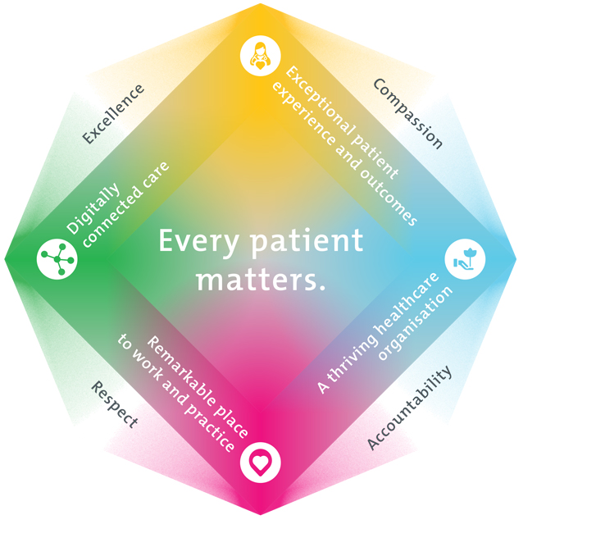
All roles are linked to the Epworth strategy and are fundamental in achieving its vision and purpose.
Exceptional patient experience and outcomes - To empower our patients and deliver compassionate, expert and coordinated care.
A thriving healthcare organisation - To adapt and grow in a changing healthcare landscape by delivering a unique private not-for-profit healthcare organisation.
Remarkable place to work and practice - To ensure Epworth is an outstanding place to work and practice through a culture of care
and investment in our people.
Digitally connected care - To innovate and improve the digital experience, interactions and outcomes for our patients, staff and doctors.
4. Purpose of the Position
The Data Governance Lead is responsible for establishing, maintaining, and overseeing data governance frameworks, policies, and procedures to ensure data accuracy, security, compliance, and effective management across the organization. This role ensures that data assets are properly classified, protected, and optimized for business use while aligning governance strategies with regulatory requirements and industry best practices. The Data Governance Lead collaborates closely with internal stakeholders, including business units, IT, and analytics teams, to promote a culture of responsible data management and continuous improvement.
5. Clinical Governance Framework
This role is required to put into practice the Clinical Governance Framework at Epworth as every employee is accountable for ensuring that our patients and community receive safe, high quality and person-centred care in every interaction with Epworth. This is achieved through active participation in the five domains of clinical governance at Epworth:

Clinical Governance Domain | Role
Leadership and culture | Promote and participate in a supportive, fair and transparent culture where lessons from previous outcomes are learned and patient safety and quality is a priority at all levels of the organisation.
Consumer Partnerships | Understand and where relevant, ensure that each patient is actively involved in their own care and treatment including families/carers wherever possible.
Effective Workforce | Develop and maintain one’s own competency, skills and knowledge to ensure high quality service provision and care.
Clinical Safety and Effectiveness | Understand and where relevant, ensure, that the right care is provided to the right person at the right time, in the right place and patient outcomes are monitored and improved.
Risk Management | Be responsible for identifying and reporting risks, hazards and near misses for people in our care and participating in risk mitigation strategies.
6. Key Accountabilities
KEY RESPONSIBILITIES | MEASURES/KPIs TO BE ACHIEVED
Data Governance Framework & Strategy  - Develop and implement a comprehensive data governance strategy aligned with business objectives.  - Define and enforce data governance policies, standards, and best practices across the organization.  - Ensure data assets are structured, classified, and accessible in a secure and compliant manner.  - Monitor regulatory and compliance requirements, adapting governance policies accordingly. | - Compliance Adherence – Successful alignment with regulatory requirements and industry standards  - Governance – Full suite of data governance frameworks developed and embedded in the business
Data Quality & Integrity  - Establish data quality standards and validation processes to ensure accuracy and consistency.  - Identify and resolve data discrepancies, inconsistencies, and integrity issues.  - Work with business units to improve data entry, processing, and maintenance practices.  - Develop and manage processes for monitoring data lineage and lifecycle management | - Data Quality & Accuracy – Percentage of data errors identified and corrected  - Impact – Data error / data accuracy rate over time
Compliance & Risk Management  - Ensure data governance policies align with industry regulations  - Lead audits and assessments to maintain compliance with data security and privacy standards.  - Establish risk mitigation strategies related to data governance and regulatory requirements.  - Work with legal, security, and IT teams to manage data protection initiatives. | - Risk Mitigation Effectiveness – Reduction in data governance-related risks and incidents.
Collaboration & Stakeholder Engagement  - Develop and embed new operating models and ways of working (e.g. cross functional squads, Data Owner and Data Steward roles)  - Act as a liaison between business, IT, and analytics teams to support effective data governance.  - Educate and train stakeholders on data governance policies, processes, and compliance requirements.  - Develop strong partnerships with key stakeholders to ensure governance frameworks are effectively implemented.  - Drive a culture of data responsibility and continuous improvement across the organization. | - Training & Awareness – Percentage of employees trained on data governance principles.  - Stakeholder Engagement – Number of business units successfully adopting data governance practices.
Data Governance Technology & Infrastructure  - Oversee governance tools and platforms for data classification, cataloguing, and policy enforcement.  - Support the development and implementation of metadata management and data dictionaries.  - Collaborate with IT and analytics teams to ensure governance controls are embedded within data systems.  - Evaluate and recommend technologies that enhance governance, security, and data quality. | - Alignment – There is a ‘single source of truth’ for data definitions, calculations and sources
Customer Service  Epworth is committed to the provision of excellent customer service to all of our people, customers and stakeholders including patients and external suppliers.  Superior patient service leads to improved healing in a trusting, caring environment and creates a safe environment for patients and employees.  - Provide excellent, helpful service to patients, visitors and staff  - Communicate with clear and unambiguous language in all interactions, tailored to the audience  - Build customer relationships and greet customers and patients promptly and courteously  - Actively seek to understand patients' and their family's (customers) expectations and issues | - Patient and customer service satisfaction surveys within agreed targets  - Use AIDET principles in all interactions  - Issues are escalated to the manager and resolved in a timely manner
Safety and Wellbeing  Participate actively and positively in the area of health and safety to reduce all hazards and incidents within the workplace  Report all hazards, incidents, injuries and near misses immediately to your manager and log them in RiskMan | - Adhere to infection control/personal hygiene precautions  - Implement and adhere to Epworth OHS policies, protocols and safe work procedures  - Mandatory training completed at agreed frequency
7. Position Requirements/Key Selection Criteria
COMPONENT
Qualifications | Essential  - Tertiary qualification in Computer Science, Machine Learning, Data Science, Statistics, or related field.  - Post Graduate qualification in business or data
Previous Experience | Essential  - 3+ years working in data management, with governance frameworks, and compliance.  - Data Governance Strategy – Experience in developing and executing data governance strategies.  - Change Management – Understanding of change management concepts, ability to lead change, communicate policies, and collaborate with stakeholders including communication and culture change.  - Data Compliance & Security – Knowledge of legal and regulatory requirements for data governance.  - Data Analytics & Quality – Familiarity with data analytics and ensuring data integrity
Required Knowledge & Skills | Essential  - Proven experience in data governance, data management, or related fields.  - Strong understanding of data governance frameworks, regulatory compliance, and best practices.  - Knowledge of data quality, metadata management, and data lifecycle processes.  - Familiarity with data governance tools and technologies.  - Excellent stakeholder collaboration, communication, and training skills.  - Ability to lead and influence cross-functional teams.  - Strong analytical and problem-solving skills related to data integrity and security.  Desirable  - Excellent knowledge of health care sector and sound knowledge of drivers and levers of hospital commercial and operational performance
Personal Attributes & Values  All employees are expected to consistently work in accordance with Epworth’s values and behaviours  - Compassion  - Accountability  - Respect  - Excellence | - Strong management, interpersonal, and organizational abilities  - Skilled in problem-solving, decision-making, and lateral thinking  - High-level analytical, conceptual, and data interpretation capabilities  - Professional work ethic, self-motivated, and responsible for ongoing development  - Committed to patient safety, clinical quality, and risk reduction  - Enthusiastic, energetic, and passionate about the role  - Flexible, adaptable, and able to prioritize under pressure  - High level of emotional maturity, integrity, and judgment  - Strong communication and stakeholder relationship management  - Dedicated to customer service, continuous learning, and quality improvement  - Able to function effectively in dynamic environments with shifting priorities  - Practices within the Epworth HealthCare Values & Behaviour

Document Control
Date Developed: | Date Last Reviewed: | Developed and Reviewed By (Position Title):
07/07/2025 |  | Chief Technology Officer

8. Employee Position Declaration
I have read and understand the requirements and expectations of the above Position Description. I agree that I have the physical ability to fulfil the inherent physical requirements of the position, and accept my role in fulfilling the Key Accountabilities. I understand that the information and statements in this position description are intended to reflect a general overview of the responsibilities and are not to be interpreted as being all-inclusive.
Employee Signature:
Print Name: | Date:

