- General Information
Position Title: | Deputy Chief Medical Officer (DCMO), Academia
Position Reports to: | Chief Medical Officer, Director Academic and Medical Services
Enterprise/Individual Agreement: | Individual Agreement
Location | Richmond/Pelaco/Hoddle street
Resource Management  Direct Reports: | In consultation with CMO  Group Director Research/Chief Research officer  Epworth Clinical School Director/ Dean  Medical Education Events Coordinator  Manager Knowledge Services
Key Relationships - internal and external | Internal  Executive Director Academic & Medical - Chief Medical Officer,  Chief Executive and Executive Directors  Group and Epworth Site Medical Advisory Committees  Directors of Clinical Institutes, VMOs, Specialists, Doctors in Training, Employed Doctors, GPs  Colleague Deputy Chief Medical Officer/s, Directors of Medical Services, NUMs, Practice Managers & Medical Services staff  External  Universities, Monash Partners (and other Academic and Research partners), Department of Health, RACMA, Other Colleges, Other Victorian public and private health services, Primary Health Network and Community Health partners, Safer Care Victoria.
2. Overview of Epworth HealthCare
Epworth HealthCare is Victoria’s largest not-for-profit private health care, renowned for excellence in diagnosis, treatment, care and rehabilitation. Epworth is an innovator in Australia’s health system, embracing the latest in evidence-based medicine to pioneer treatments and services for our patients.
Epworth’s values define our approach and our delivery. We pride ourselves on communicating our values and delivering on them in a real and meaningful way. Our Values are Compassion, Accountability, Respect and Excellence. More information can be found on the Epworth website.
Epworth’s purpose is Every Patient Matters.
Our Vision is Delivering another 100 years of exceptional healthcare and innovation to the Victorian community.

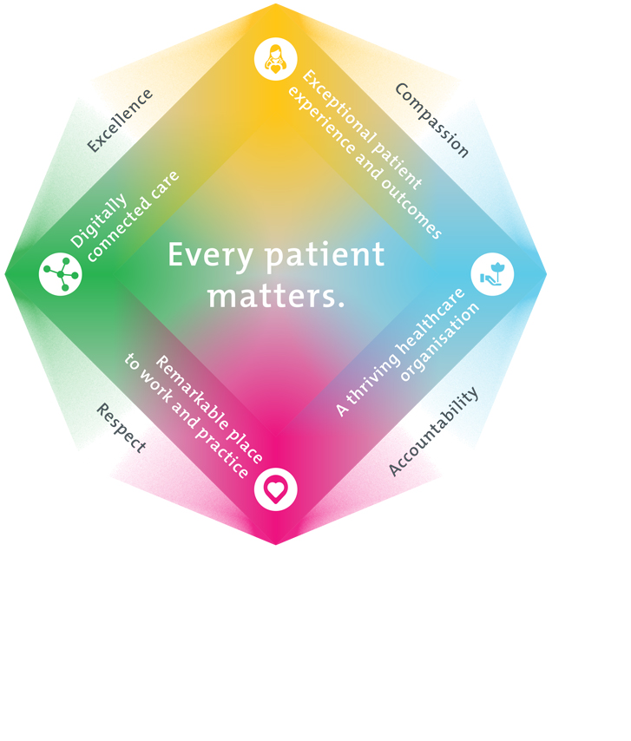
3. Epworth HealthCare Strategy
All roles are linked to the Epworth strategy and are fundamental in achieving its vision and purpose.
Exceptional patient experience and outcomes - To empower our patients and deliver compassionate, expert and coordinated care.
A thriving healthcare organisation - To adapt and grow in a changing healthcare landscape by delivering a unique private not-for-profit healthcare organisation.
Remarkable place to work and practice - To ensure Epworth is an outstanding place to work and practice through a culture of care
and investment in our people.
Digitally connected care - To innovate and improve the digital experience, interactions and outcomes for our patients, staff and doctors.
4. Purpose of the Position
This key medical leadership role supports the Chief Medical Officer (CMO)/ Executive Director, Academic and Medical Services in delivering effective leadership across the academic, medical and clinical governance portfolios of Epworth HealthCare. The role requires a medical administrator passionate about:
1) Effective professional and operational medical education and research
2) Leading safe, high-quality research and education, engaging with stakeholders to advance academic productivity and reputation
3) Promoting an organisational culture that embraces medical education and research

The role will support the Chief Medical Officer in managing a range of units within the Academic and Medical Services Division, as well as providing expertise, leadership and participation in the range of medical education and research programs of work across Epworth HealthCare, ensuring compliance.
5. Clinical Governance Framework
This role is required to put into practice the Clinical Governance Framework at Epworth as every employee is accountable for ensuring that our patients and community receive safe, high quality and person-centred care in every interaction with Epworth. This is achieved through active participation in the five domains of clinical governance at Epworth:

Clinical Governance Domain | Role
Leadership and culture | Promote and participate in a supportive, fair and transparent culture where lessons from previous outcomes are learned and patient safety and quality is a priority at all levels of the organisation.
Consumer Partnerships | Understand and where relevant, ensure that each patient is actively involved in their own care and treatment including families/carers wherever possible.
Effective Workforce | Develop and maintain one’s own competency, skills and knowledge to ensure high quality service provision and care.
Clinical Safety and Effectiveness | Understand and where relevant, ensure, that the right care is provided to the right person at the right time, in the right place and patient outcomes are monitored and improved.
Risk Management | Be responsible for identifying and reporting risks, hazards and near misses for people in our care and participating in risk mitigation strategies.

6. Key Accountabilities
KEY RESPONSIBILITIES | MEASURES/KPIs TO BE ACHIEVED
Overarching Responsibilities  - Deputise for the CMO as required  - Supervision and support of RACMA registrar/s  - Participate in the out of hours CMO on call roster  Undertake activity relating to role as a medical administrator at Epworth Healthcare (including as a designated officer for tissue and organ donation and consent for needle stick and splash injury issues).  Medical education and research  Responsibilities:  - Provide strategic leadership and oversight for all academic programs within the organisation, including the medical school/s, postgraduate medical education, and research initiatives.  - Collaborate with the Dean of the medical school to develop and implement curriculum enhancements that align with industry standards and accreditation requirements.  - Foster a culture of academic excellence and innovation among faculty, staff, and students, promoting interdisciplinary collaboration and knowledge exchange.  - Establish and maintain partnerships with universities and academic institutions to facilitate research collaborations, student exchange programs, and joint educational initiatives.  - Support the recruitment and retention of top-tier faculty members, providing mentorship and professional development opportunities to enhance their academic careers.  - Ensure compliance with regulatory standards and ethical guidelines in all academic activities, including research protocols and student evaluations.  - Manage relationships with philanthropic donors and external funding agencies to secure financial support for named professorial roles, research projects, and academic programs.  - Oversee the Office of Research Governance to ensure the responsible conduct of research and adherence to ethical principles and regulatory requirements.  - Provide guidance and support to medical students, residents, and fellows throughout their academic journey, including supporting career counselling and residency placement assistance.  - Collaborate with industry partners to enhance opportunities for clinical research and technology transfer, promoting innovation and advancements in healthcare delivery.  - Represent Epworth in academic consortia, professional associations, and government agencies to advocate for policies and initiatives that support medical education and research.  - Monitor and evaluate academic program outcomes and performance metrics, implementing continuous improvement strategies to enhance program effectiveness and student success.  Provide strong clinical and medical leadership ensuring high quality medical education and research is delivered in a cohesive Epworth wide framework.  - Work with Epworth partners to support a high functioning teaching and research environment for staff and VMOs with streamlined, consistent processes and procedures.  - Create a performance culture within academia, focused on the delivery of key academic, but also financial and academic relationship outcomes  - Undertake other tasks relevant to clinical and medical governance as directed by the CMO  - Work with the Group Director Research and the Dean of Medical Students to develop and implement strategic initiatives to enhance academic performance and reputation, ensuring compliance with hospital accreditation standards, regulatory requirements, and quality assurance protocols.  - Lead the development and implementation of research and education frameworks, policies, and procedures to promote medical academia at Epworth  - Collaborate with IT and informatics teams to leverage data analytics and technology solutions for research initiatives and partnerships.  - Collaborate with clinical services and multidisciplinary teams to develop evidence-based clinical guidelines, protocols, and best practices.  - Chair or participate in academic committees and working groups to drive academic programs and monitor progress towards Epworth goals.  - Provide leadership and support for Epworth initiatives related to medical student and postgraduate doctor education, and research.  - Ensure regular audits and assessments of academic process and outcomes to identify opportunities for quality improvement and risk mitigation.  - Serve as a liaison with external academic and credentialing bodies, regulatory agencies, and government stakeholders to maintain compliance with national standards and guidelines.  - Develop and deliver training programs and educational resources to support staff and VMO awareness and engagement in academic programs.  - Monitor, follow up and report on academic and teaching quality performance and continuous improvement initiatives.  - Work with and lead VMOs through research development in close collaboration with the Group director of Research and the Epworth Executive  - Participating as a member of Clinical Institute Executive Committees according to defined specialties in support of audit, education, research, and strategic development  - Providing support to the Chair of the site MAC and related committees  - Participate as a member of the Group Medical Advisory Council and the Group Executive Medical Services  - Establish and support site based Clinical Review Committee meetings and processes.  - Ensure appropriate research governance and contractual agreements in conjunction with the Chief Medical Officer | - Medical Education and Research oversight  - Medical school student feedback and results.  - Meeting attendance  - Effective governance of research and ethics including financial  - Feedback from Executive team members  - Feedback from Specialists/VMOs  - All relationships have contracts and agreements that remain current  - Academic programs are delivered within budget  - Research program delivers comprehensive reports relating to ethical, financial, publication, and other activity.  - Research and medical education risks are monitored, reported, and managed
Patient experience & service enhancement  Ensure the delivery of excellent customer service to patients and their families and to other target stakeholders.  - Support of clinical leadership teams in the management of academic programs  - Review and improve patient, family, and doctor engagement in teaching, training, and research to improve efficiency, responsiveness, and satisfaction with the process  - Actively participate in the management of and the response to complaints related to teaching and research  - Proactively look for opportunities to improve processes and practices to enhance the patient journey and experience.  - Lead the medical components of research and education | - Patients all provide appropriate informed consent for involvement in research and teaching
Business Support  To provide advice and action where applicable to support the effective and efficient delivery of academic services  - Monitor VMO quality, productivity and engagement to ensure individual VMO practice is appropriate and consistent with Epworth HealthCare Values and Behaviours  - Support processes to ensure effective research and education management  - Support the Executive, with monitoring of research and education activity | - Research KPls achieved
Business Development & Planning  Working with relevant Executive members and other key stakeholders, develop  service enhancements and practice change which will improve patient outcomes.  - Participate in the development of education plans and research development activities for Epworth HealthCare  - Provide medical leadership and advice for the development of academic services and the expansion of existing services  - Support research leaders and teachers in recruiting new collaborators  - Advise on new services and technologies for strategic purposes is timely and accurate. | - Operational objectives achieved  - Completion of relevant tasks/projects assigned
Leadership  Demonstrate initiative, consultation, motivation and self-confidence  - Establish and embed effective mechanisms for communication to all medical practitioners  - Promote and represent Epworth education and research programs internally and externally  - Have a strong presence in clinical areas, including perioperative environment  - Provide peer support and supervision as required  - Effectively manage poor behaviour of all medical and academic personnel  - Support the wider clinical institute framework | - Medical workforce KPls achieved  - Doctor satisfaction KPls achieved
Customer Service  Epworth is committed to the provision of excellent customer service to all of our people, customers and stakeholders including patients and external suppliers. Superior patient service leads to improved healing in a trusting, caring environment and creates a safe environment for patients and employees.  - Role model and actively promote a culture of high quality patient care  - Provide excellent, helpful service to patients, visitors and staff  - Communicate with clear and unambiguous language in all interactions, tailored to the audience  - Build customer relationships and greet customers and patients promptly and courteously  - Actively seek to understand patients' and their family's expectations and issues, using multiple strategies  - Uses data (such as VMO and research feedback) to identify opportunities for improvement in internal processes and systems that directly impact academic performance  - Responds quickly and proactively escalate concerns when necessary  - Role model and actively promote a culture of high-quality patient care and experience by ensuring that education and research practices and procedures are carried out professionally and with empathy and compassion | - Patient and customer service satisfaction surveys within agreed targets  - Use AIDET principles in all interactions  - Compliments to complaints ratios  - Completes leader rounding at agreed frequency
Safety and Wellbeing  To ensure a safe workplace is provided for all employees and other personnel including contractors, agency staff, volunteers and students.  - All employees and other personnel under the authority of the manager are fully informed of the hazards associated with their work activities, adequately trained and instructed in safe work procedures and appropriately supervised. Participate actively and positively in the area of health and safety to reduce all hazards and incidents within the workplace  - Integrate and review OHS performance in staff PDPs  - Ensure all direct reports are held accountable for safety performance and actions | - Adhere to infection control/personal hygiene precautions  - Implement and adhere to Epworth OHS policies, protocols and safe work procedures  - Ensure all hazards, incidents and injuries are reported in Riskman within 24 hours  - Ensure all hazards, incidents and injuries are investigated and corrective actions implemented within agreed timeframes  - Mandatory training completed at agreed frequency
7. Position Requirements/Key Selection Criteria
COMPONENT
Qualifications | Essential  • MBBS- Current registration with the Australian Health Practitioner Regulation Agency  Desirable  • Post Graduate Qualifications in Health Administration/ Business Management  • Post Graduate higher degree in research and or education  • Fellowship of the Royal Australasian College of Medical Administrators (FRACMA) or substantial progress toward completion of FRACMA
Previous Experience | Essential  - Sound knowledge of the health industry and experience of medical and clinical service delivery in Australian healthcare, both private and public  Desirable  - Proven experience in medical administration and senior leadership in a health service
Required Knowledge & Skills | Essential  • Experience in a major health care institution, preferably a tertiary, research-oriented health service  • Demonstrated capacity to operate as a senior member of an acute health service team  • High level of skill in analysing medical policy and planning issues and applying knowledge to real world situations  - Experience in the successful development and implementation of initiatives to improve medical professional and clinical governance  - Demonstrated effective oral and written communication skills including the ability to communicate, consult and negotiate effectively with a wide range of stakeholders  - Knowledge of contemporary clinical and medical governance systems and processes  - Demonstrated high level negotiation, problem solving and change management skills  - Thorough knowledge of the Australian public health system and the Victorian system in particular; including the registration, management, industrial and training frameworks for the medical workforce  - Experience with or knowledge of quality and accreditation systems, for example Australian Council on Healthcare Standards’ (ACHS), PMCV and the learned Colleges  - Understanding of medico-legal issues associated with clinical care  - Demonstrated leadership skills with proven ability to exercise sound judgment and provide leadership in professional standards, ethics and a commitment to research and innovation  - Innovative thinking for complex problems  - Good analytical, clinical and financial data management skills  - Clinical experience in hospitals and understanding of VMO business model  - Highly developed interpersonal and written communication skills  - Understanding of contemporary clinical practice in a broad range of specialties and future trends in disease profiles and demographics  - Highly developed clinical governance skills, including medical credentialing and root cause analysis  - Ability to work autonomously, possess excellent conceptual and organisational skills, and utilise objective analysis of multiple viewpoints to incorporate staff input, feedback and ideas  - Broad understanding of the organisational structures, policies and practices in relation to the health and medical workforce including demographic projections  - Demonstrated understanding of funding arrangements in relation to the health professions and compliance with relevant acts and industry regulations including AHPRA  - Working knowledge of the medical education sector and the role of the Royal Colleges in professional development and training  - Ability to provide operational advice and experience in managing the development and implementation of new initiatives  - Experience in leading, coaching and managing staff to ensure they are developed and delivering to their full potential  - Extensive experience in identifying, managing and reducing risk and successfully conducting incident investigation and management, including open disclosure.  - Ability to support medical teaching programs at undergraduate, post graduate and specialty training level, and to foster research  - High level of digital literacy in a range of technologies including Microsoft office software, operational system/databases, mobile software and internet applications
Personal Attributes & Values  All employees are expected to consistently work in accordance with Epworth’s values and behaviours  - Compassion  - Accountability  - Respect  - Excellence | Essential  - Demonstrates leadership initiative, motivation and self-confidence with the capacity to communicate vision and set clear strategic directions for staff  - Consultative leadership style with the ability to influence at senior management level and act as a role model for professional leadership  - Ability to build and maintain effective relations with key stakeholders and customers  - Motivated to approach challenges enthusiastically with a ‘can-do’ attitude  - Capacity to present Epworth HealthCare in a strong and positive manner to all stakeholders  - Supports Epworth's Vision and Values and demonstrates a commitment to customer service and capacity to lead the implementation of quality solutions

Document Control
Date Developed: | Date Last Reviewed: | Developed and Reviewed By (Position Title):
May 2024 | May 2024 | Executive Director Academic Services, Chief Medical Officer

8. Employee Position Declaration
I have read and understand the requirements and expectations of the above Position Description. I agree that I have the physical ability to fulfil the inherent physical requirements of the position, and accept my role in fulfilling the Key Accountabilities. I understand that the information and statements in this position description are intended to reflect a general overview of the responsibilities and are not to be interpreted as being all-inclusive.
Employee Signature:
Print Name: | Date:

