- General Information

Position Title: | Senior Mental Health Clinician (Psychology or OT)
Division/Department: | Epworth Clinic Allied Health
Position Reports to: | Program Manager for Mental Health
Enterprise/Individual Agreement: | Epworth Healthcare Health Professionals Enterprise Agreement (2022) /  Epworth HealthCare Dietitians/Psychologists/Medical Scientists/Medical Physicist Enterprise Agreement 2021- 2025
Classification/Grade: | P3/HP3
Location: | Epworth Camberwell
Employment Status: | Part-Time (minimum 0.6)
Resource Management  (for Management positions only)  Number of Direct Reports:  Budget under management: | N/A
Key Relationships - internal and external | - Patients and family members & visitors  - Multi-disciplinary team members and Nursing staff  - Rehabilitation Consultants, Medical Staff & VMO’s  - External service providers and referrers
- Overview of Epworth HealthCare
Epworth HealthCare is Victoria’s largest not-for-profit private health care group, renowned for excellence in diagnosis, treatment, care and rehabilitation. Epworth is an innovator in Australia’s health system, embracing the latest in evidence-based medicine to pioneer treatments and services for our patients.

Epworth’s values define our approach and our delivery. We pride ourselves on communicating our values and delivering on them in a real and meaningful way. Our Values are Compassion, Accountability, Respect and Excellence. More information can be found on the Epworth website.

Epworth’s purpose is Every Patient Matters.

Our Vision is Delivering another 100 years of exceptional healthcare and innovation to the Victorian community.

- Epworth HealthCare Strategy
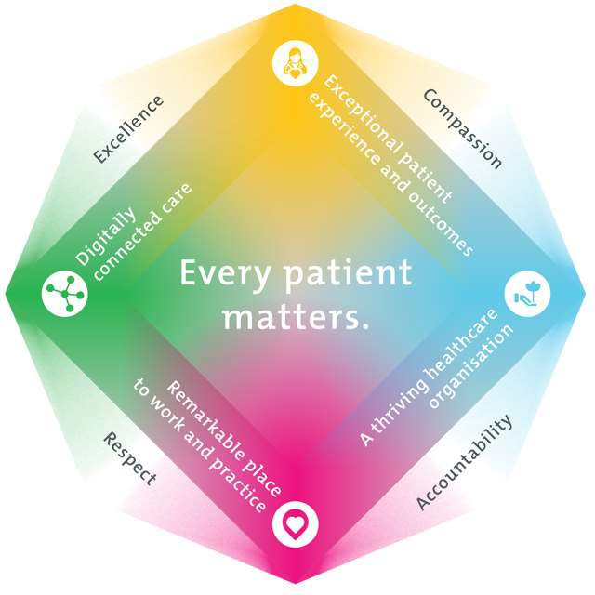

All roles are linked to the Epworth strategy and are fundamental in achieving its vision and purpose.
Exceptional patient experience and outcomes - To empower our patients and deliver compassionate, expert and coordinated care.
A thriving healthcare organisation - To adapt and grow in a changing healthcare landscape by delivering a unique private not-for-profit
healthcare organisation.

Remarkable place to work and practice - To ensure Epworth is an outstanding place to work and practice through a culture of care
and investment in our people.
Digitally connected care - To innovate and improve the digital experience, interactions and outcomes for our patients, staff and doctors.

- Purpose of the Position
The role of Senior Mental Health Clinician is to provide optimal mental health interventions to consumers at Epworth Clinic through the use of individualised recovery goals, evidence based clinical interventions that promote long-term health and wellbeing, that are consistent with Epworth's Mission and Values. Epworth Clinic currently provides targeted psychological interventions across our adult inpatient unit, outpatient day programs and allied health private practice.

This senior clinical role will support the ongoing provision of holistic care to our consumers and their families, by providing effective clinical, educational and emotional support. This includes, but is not limited to direct service provision, risk assessment and management, and clinical oversight of appropriately related programs, staff, students and Epworth Clinic consumers.

This role also includes the provision of supervision, quality improvement activities and the ongoing professional development of the Epworth Clinic therapeutic team members. We support our colleagues by sharing knowledge and expertise and promoting our excellence to our consumers and the wider community marketplace. Inherent in this role is ongoing stakeholder management, including Visiting Medical Officers (VMOs), General Practitioners (GPs) intra-service departments and consumer families and support networks.

- Key Accountabilities
KEY RESPONSIBILITIES | MEASURES/KPIs TO BE ACHIEVED
Professional Practice / Clinical Proficiency  - Providing best practice mental health interventions, assessment and interventions to Epworth clients in individual and group settings.  - Assessment and management of clinical risk  - Provision of ongoing evidence-based therapy  - Clinical leader in a specialist area, demonstrating superior consolidated skills and the application of theory to practice. | - Proficiency in psychological assessment and intervention for patients experiencing mental ill- health in both acute and outpatient setting.  - Knowledge in clinical mental health psychology and skills in applying knowledge to practice

- Sensitive to the psychosocial implications of illness.  - Sensitive to cultural, racial and gender differences.  - Maintain patient confidentiality as prescribed by relevant Acts and Organisation’s policy and procedures  - Provide patient care within allocated time frames from referral to treatment.  - Prioritise clinical and administrative workloads effectively  - Adhere to Epworth HealthCare policies and procedures and departmental protocols  - Provide strong clinical leadership and supervision of other team members  - Maintain clear clinical notes as per medico-legal requirements and to ensure best practise standards are maintained.  - Innovative, proactive and creative attitude to problem solving.  - Interacts effectively with primary work team  - Consultative and flexible work style  - Program development and evaluation  - Flexibility to assist others within the department, across campuses and on evening as required | - Skills in assessing and managing at risk patients  - Ability to provide individual and group-based interventions  - Proven inter-disciplinary skills  - Proven work experience in mental health and outpatient therapy  - Proven experience in the provision of multiple therapeutic modalities including DBT, ACT  - Achieving key performance indicators set out by Epworth Clinic  - Satisfactory progress in Performance Development Reviews  - Compliance with clinical competencies  - Compliance with mandatory and team based documentation in patients’ medical record  - Compliance with legislative and common law requirements  - Compliance with Epworth HealthCare policies, protocols and code of conduct  - Compliance registration and/or specific discipline code of ethics and guidelines  - Compliance with mandatory Epworth training
Team Work  - Collaborate effectively, formally and informally, with all other team members and external agencies, for efficient, effective, caring patient management.  - Provide positive and constructive feedback to other team members  - Respond constructively to feedback from team members  - Undertaking reviews and writing up reports to offer improvements for quality processes and therapeutic outcomes for patients  - Stakeholders internal and external VMOs, rehab and acute hospitals | - Attendance and contribution to department and team meetings  - Be open to developmental and positive feedback from team members, consumers and other stakeholders  - Engage in leadership opportunities to improve our internal processes

Communication  - Demonstrate ability to initiate discussions with manager, supervisor or supervisees regarding issues of concern  - Consult both up and down the line of accountability  - Identify issues, consider solutions and present these to senior management | - Positive feedback from team members and customers indicates early resolution of issues  - Senior staff notified of issues in a timely manner
Personal and Professional Development  - Participate in the ongoing professional development of self, colleagues and the wider Epworth community by upgrading clinical competencies and knowledge and participating in both internal and external educational opportunities.  - Actively participate in relevant professional organisations.  - Participate in annual performance appraisals | - Approach all interactions from a values based perspective  - Positive feedback from team members and consumers  - Timely and compassionate complaint management engagement leading to early resolution of issues  - Escalation of issues in a timely manner
Quality Improvement  - Strive to consistently improve service delivery and clinical practice  - Initiate and participate in Quality activities within the department and clinical team  - Ensure opportunities for improvement are actively explored and best practice is achieved.  - Contribute to the updating of department resources, equipment and educational information | - Evidence of participation in quality improvement activities  - Register of projects on department Quality register  - Improvement in patient care
Marketing  - Strive to consistently enhance the department's and Epworth HealthCare's positive image within the community. | - Promotes Epworth HealthCare and relevant discipline within clinical teams and the wider community
Customer Service | - Patient and customer service satisfaction surveys within agreed targets  - Use AIDET principles in all interactions

Epworth is committed to the provision of excellent customer service to all of our people, customers and stakeholders including patients and external suppliers.  Superior patient service leads to improved healing in a trusting, caring environment and creates a safe environment for patients and employees.  - Provide excellent, helpful service to patients, visitors and staff  - Communicate with clear and unambiguous language in all interactions, tailored to the audience  - Build customer relationships and greet customers and patients promptly and courteously  - Actively seek to understand patients' and their family's (customers) expectations and issues | - Issues are escalated to the manager and resolved in a timely manner
Safety and Wellbeing  Participate actively and positively in the area of health and safety to reduce all hazards and incidents within the workplace  - Report all hazards, incidents, injuries and near misses immediately to your manager and log them in RiskMan | - Adhere to infection control/personal hygiene precautions  - Implement and adhere to Epworth OHS policies, protocols and safe work procedures  - Mandatory training completed at agreed frequency
- Position Requirements/Key Selection Criteria
COMPONENT
Qualifications | Essential  - For Psychology applicants - Masters or Doctoral degree in Clinical Psychology or equivalent, Psychologist registration with the Australian Health Practitioner Regulation Agency (AHPRA), Endorsement in Clinical/Health/Counselling Psychology  - For Occupational Therapist applicants – Bachelor of Applied Science (Occupational Therapy) or equivalent as recognised by the World Federation of Occupational Therapy, and current registration with the Australian Health Practitioner Regulation Agency (AHPRA).  - Current working with children’s check

- Current (or eligible) for Medicare Provider number

Desirable
- Relevant post-graduate qualification
Previous Experience | Essential  - Demonstrated proficiency and sound theoretical knowledge of current psychiatric interventions and best practice. Particularly in assessment and intervention for consumers experiencing mental ill- health in both acute and outpatient setting.  - Proven skills and experience in assessing and managing at risk consumers  - Previous experience in the provision of mental health interventions and therapy in a clinical setting. Specifically experience in Dialectic Behaviour Therapy (DBT).  - Experience in group facilitation  - Relevant experience in a hospital, rehabilitation or community setting  - Experience in service review and development  - Previous experience in a similar leadership or supervisory role  Desirable  - At least 5 years clinical experience  - Experience and training in psychological therapies other than DBT (ACT, CBT etc)  - Clinical experience working with Eating Disorders
Required Knowledge & Skills | - Knowledge and experience with risk assessment and mitigation strategies  - Sophisticated knowledge of multidisciplinary reviews and discharge planning  - Skills engaging with carers and facilitating family meetings  - Well-developed skills for managing challenging behaviours and demonstrates skills in conflict resolution  - Superior verbal and written communication skills  - Well-developed organisational skills.  - Innovative, proactive and creative attitude to problem solving.  - Consultative and flexible work style  - Interest and experience in program development and evaluation

 | - Able to constructively supervise, mentor and educate mental health allied health team, nursing team, students and others where instructed
Personal Attributes & Values  All employees are expected to consistently work in accordance with Epworth’s values and behaviours  - Respect  - Excellence  - Compassion  - Community  - Integrity  - Accountability | - Self-motivated and self-directed with an ability to work autonomously.  - Values driven  - Team oriented  - Customer service oriented  - Professional work ethic  - Sensitive to cultural, racial and gender differences.  - Pre-employment medical check and Police check may be required
Document Control
Date Developed: | Date Last Reviewed: | Developed and Reviewed By (Position Title):
2/07/2020 | 14/11/2023 | Program Manager for Mental Health

Employee Position Declaration
I have read and understand the requirements and expectations of the above Position Description. I agree that I have the physical ability to fulfil the inherent physical requirements of the position, and accept my role in fulfilling the Key Accountabilities. I understand that the information and statements in this position description are intended to reflect a general overview of the responsibilities and are not to be interpreted as being all-inclusive.

Employee Signature: Print Name: Date:

