- General Information
Position Title: | Quality Manager
Division/Department: | Epworth Richmond
Position Reports to: | Clinical Governance Manager Epworth Richmond
Enterprise/Individual Agreement: | Epworth HealthCare Nurses and Midwives Enterprise Agreement
Classification/Grade: | Quality Manager
Location: | Epworth Richmond
Employment Status: | Permanent
Resource Management  (for Management positions only)  Number of Direct Reports:  Budget under management: | Nil  Nil
Key Relationships - internal and external | Patient liaison officer, Safer Care Victoria, Health Complaints Commisioner, Epworth Richmond Executives and leadership groups, Group Direcotor Clinical Goverance, Australian Council on Healthcare Standards
2. Overview of Epworth HealthCare
Epworth HealthCare is Victoria’s largest not-for-profit private health care group, renowned for excellence in diagnosis, treatment, care and rehabilitation. Epworth is an innovator in Australia’s health system, embracing the latest in evidence-based medicine to pioneer treatments and services for our patients.

Epworth’s values define our approach and our delivery. We pride ourselves on communicating our values and delivering on them in a real and meaningful way. Our Values are Compassion, Accountability, Respect and Excellence. More information can be found on the Epworth website.

Epworth’s purpose is Every Patient Matters.

Our Vision is Delivering another 100 years of exceptional healthcare and innovation to the Victorian community.

3. Epworth HealthCare Strategy
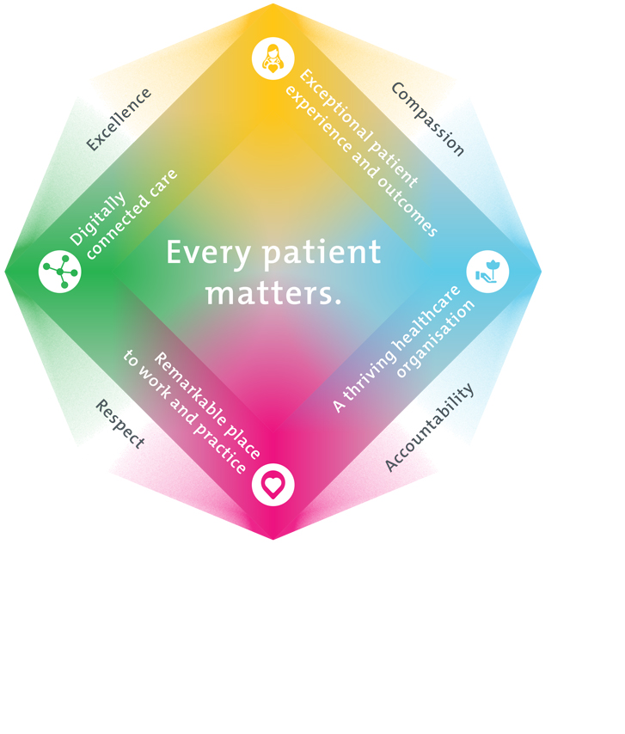
All roles are linked to the Epworth strategy and are fundamental in achieving its vision and purpose.
Exceptional patient experience and outcomes - To empower our patients and deliver compassionate, expert and coordinated care.
A thriving healthcare organisation - To adapt and grow in a changing healthcare landscape by delivering a unique private not-for-profit healthcare organisation.
Remarkable place to work and practice - To ensure Epworth is an outstanding place to work and practice through a culture of care
and investment in our people.
Digitally connected care - To innovate and improve the digital experience, interactions and outcomes for our patients, staff and doctors.
4. Purpose of the Position
The purpose of this role is to provide leadership, expertise and advice in quality improvement, patient feedback, clinical risk management, incident management and clinical audit to the hospitals’ leadership team.

The position is responsible for ensuring timely coordination of critical incident assessment and managing the incident review processes in collaboration with the accountable operational leaders. The role will act as a key support to the Directors of Clinical Services and the Medical Directors.
5. Clinical Governance Framework
This role is required to put into practice the Clinical Governance Framework at Epworth as every employee is accountable for ensuring that our patients and community receive safe, high quality and person-centred care in every interaction with Epworth. This is achieved through active participation in the five domains of clinical governance at Epworth:

Clinical Governance Domain | Role
Leadership and culture | Promote and participate in a supportive, fair and transparent culture where lessons from previous outcomes are learned and patient safety and quality is a priority at all levels of the organisation.
Consumer Partnerships | Understand and where relevant, ensure that each patient is actively involved in their own care and treatment including families/carers wherever possible.
Effective Workforce | Develop and maintain one’s own competency, skills and knowledge to ensure high quality service provision and care.
Clinical Safety and Effectiveness | Understand and where relevant, ensure, that the right care is provided to the right person at the right time, in the right place and patient outcomes are monitored and improved.
Risk Management | Be responsible for identifying and reporting risks, hazards and near misses for people in our care and participating in risk mitigation strategies.
6. Key Accountabilities
KEY RESPONSIBILITIES | MEASURES/KPIs TO BE ACHIEVED
Quality Program  - Coordinate and oversees continuous improvement activities (clinical and non- clinical), utilising analysis of all relevant data (including key performance indicators, audits, surveys, incident data and feedback/complaint data) ensuring improvement focus aligns with Epworth strategic priorities  - Work collaboratively within the allocated division, with the Clinical Services team and other divisional quality and risk staff to optimise the systems and processes to support staff in delivering safe and effective care including coordinating and facilitating:  - the clinical audit program  - quality improvement activities  - accreditation requirements  - Provide support, advice, education and mentoring to staff regarding utilisation of quality improvement methodology.  - Actively participates in the development of policies and procedures that comply with legal or other regulations or requirements where appropriate | - Divisional quality improvement activities are completed and evaluated.  - Divisional audits are completed within expected timeframes and reports distributed to divisional leadership team and Clinical Services.  - Actively participates in quality committees and working groups and meeting forums  - Support ongoing accreditation preparedness for clinical and non-clinical departments
Clinical Risk Management & Incident/Feedback Management  - Lead a robust clinical risk management process which ensures appropriate reporting of incidents and risks and thorough review and trend analysis of incident themes and implementation of recommendations across the allocated division. Work collaboratively within the allocated division and with the Group Clinical Services team to optimise the systems and processes to identify, assess and address clinical risks including leading and facilitating, at a divisional level, the  - incident and feedback management system  - clinical risk register / profile process (Enterprise Risk Management Framework)  - Provide support, advice, education and mentoring to staff regarding utilisation of:  - incident investigation methodology, including Root Cause Analysis methodology  - incident and feedback management systems  - clinical risk assessment and documentation.  - Ensures compliance to the Clinical Governance framework at a divisional level  - Review, analyse and respond to patient feedback and patient experience data in collaboaration with the patient liaison officer | - Maintain the divisional incident management and feedback management system (RiskMan) including:  - reporting of incidents, hazards and near misses,  - posting of incidents and feedback within expected timeframes.  - Coordinate serious adverse patient safety event management processes ensuring  - support the review of clinical incidents and patient feedback in line with Statutory duty of candour requeirements  - investigations are completed within timeframes,  - contributing factors are identified  - recommendations are developed and implemented  - learnings and recommendations are shared within the division and with the Epworth Group  - Support development and delivery of incident management and feedback management educational resources, in collaboration with the group and divisional clinical governance teams  - Develop and support delivery of Clinical Risk educational resources, in collaboration with the group and divisional clinical governance teams  - Contribute to clinical risk assessment documentation and reporting as designated.  - Consolidates data and prepares reports for various Clinical Governance forums  - Provides responses for requests for information data and reports within agreed timeframes
Customer Service  Epworth is committed to the provision of excellent customer service to all of our people, customers and stakeholders including patients and external suppliers.  Superior patient service leads to improved healing in a trusting, caring environment and creates a safe environment for patients and employees.  - Role model and actively promote a culture of high quality patient care  - Provide excellent, helpful service to patients, visitors and staff  - Communicate with clear and unambiguous language in all interactions, tailored to the audience  - Build customer relationships and greet customers and patients promptly and courteously  - Actively seek to understand patients' and their family's expectations and issues, using multiple strategies  - Uses data (such as patient experience feedback) to identify opportunities for improvement in internal processes and systems that directly impact patient care and customer service  - Responds quickly and proactively escalate concerns when necessary  - Role model and actively promote a culture of high-quality patient care and experience by ensuring that solutions, practices and procedures (such as hourly rounding, leader rounding and bedside handover) are carried out with empathy and compassion | - Patient and customer service satisfaction surveys within agreed targets  - Use AIDET principles in all interactions  - Compliments to complaints ratios  - Completes leader rounding at agreed frequency  - Issues are escalated to the manager and resolved in a timely manner
Safety and Wellbeing  To ensure a safe workplace is provided for all employees and other personnel including contractors, agency staff, volunteers and students.  - All employees and other personnel under the authority of the manager are fully informed of the hazards associated with their work activities, adequately trained and instructed in safe work procedures and appropriately supervised. Participate actively and positively in the area of health and safety to reduce all hazards and incidents within the workplace  - Integrate and review OHS performance in staff PDPs  - Ensure all direct reports are held accountable for safety performance and actions | - Adhere to infection control/personal hygiene precautions  - Implement and adhere to Epworth OHS policies, protocols and safe work procedures  - Ensure all hazards, incidents and injuries are reported in Riskman within 24 hours  - Ensure all hazards, incidents and injuries are investigated and corrective actions implemented within agreed timeframes  - Mandatory training completed at agreed frequency
7. Position Requirements/Key Selection Criteria
COMPONENT
Qualifications | Essential  - Registered Nurse with Bachelor of Nursing or equivalent  Desirable  - Post graduate qualifications in project management or health management or equivalent highly regarded
Previous Experience | Essential  - Minimum two-three years’ experience working in the clinical risk management and/or quality program of a large health service
Required Knowledge & Skills | Essential  - Evidence of current and emerging patient safety issues nationally  - Experience in clinical safety systems  - Experience in root cause analysis and case review investigation techniques  - Experience in working collaboratively with a range of professionals and staff to deliver quality and clinical auditing projects that support improved patient outcomes  - Highly developed written and verbal communication and interpersonal skills, with a demonstrated ability to communicate and present effectively and collaboratively with a broad array of stakeholders  - Knowledge of the ACSQHC NSQHS standards  - Proven ability to analyse and synthesize data, and use it to drive improvement through the production of presentations, reports and submissions  - Proven ability to lead projects and teams through change engaging staff effectively  - Proficiency in Microsoft Word, Excel and PowerPoint, Microsoft Teams, Sharepoint
Personal Attributes & Values  All employees are expected to consistently work in accordance with Epworth’s values and behaviours  - Compassion  - Accountability  - Respect  - Excellence | Essential  - Customer service focus  - Role models team work and collaboration.  - A passion for patient safety and a strong understanding of the quality cycle  - The ability to plan, set priorities and implement change  - Highly developed investigation, analytical and numeric skills with strong attention to detail  - A high degree of initiative and ability to work collaboratively and effectively with others

Document Control
Date Developed: | Date Last Reviewed: | Developed and Reviewed By (Position Title):
January 2019 | January 2020  Decebmer 2023  April 2025 | Group Director Quality, Safety and Clinical Effectiveness  DCS, Epworth Geelong  Clinical Governance Manager - Richmond

8. Employee Position Declaration
I have read and understand the requirements and expectations of the above Position Description. I agree that I have the physical ability to fulfil the inherent physical requirements of the position, and accept my role in fulfilling the Key Accountabilities. I understand that the information and statements in this position description are intended to reflect a general overview of the responsibilities and are not to be interpreted as being all-inclusive.
Employee Signature:
Print Name: | Date:

