General Information

Position Title: | Hospitality Services Operations Manager – Environmental Services
Division/Department: | Group Support Services
Position Reports to: | Group Director of Support Services
Enterprise/Individual Agreement: | Individual Agreement
Classification/Grade: | N/A
Location: | Richmond
Employment Status: | Full Time
Resource Management  (for Management positions only)  Number of Direct Reports:  Budget under management: | 150  $10million +
Key Relationships - internal and external | Support Services Operations Management Team  Group Hospitality Quality and Contracts Officer Department Managers and NUMs  Allied Health Professionals  Hospitality Services Team Members (Food, Enviro, Patient Transport/Orderlies, Tenant Cleaning) Patients, inclusive of family members, and visitors  Key Contractors and Suppliers

- Overview of Epworth HealthCare
Epworth HealthCare is Victoria’s largest not-for-profit private health care group, renowned for excellence in diagnosis, treatment, care and rehabilitation. Epworth is an innovator in Australia’s health system, embracing the latest in evidence-based medicine to pioneer treatments and services for our patients.

Epworth’s values define our approach and our delivery. We pride ourselves on communicating our values and delivering on them in a real and meaningful way. Our Values are Respect, Excellence, Community, Compassion, Integrity and Accountability. More information can be found on the Epworth website.

Epworth’s purpose is Every Patient Matters. We strive to improve health outcomes and experience through compassion, collaboration, learning and Innovation. Our Vision is Caring for People. Innovating for a healthy community.

Epworth HealthCare Strategy
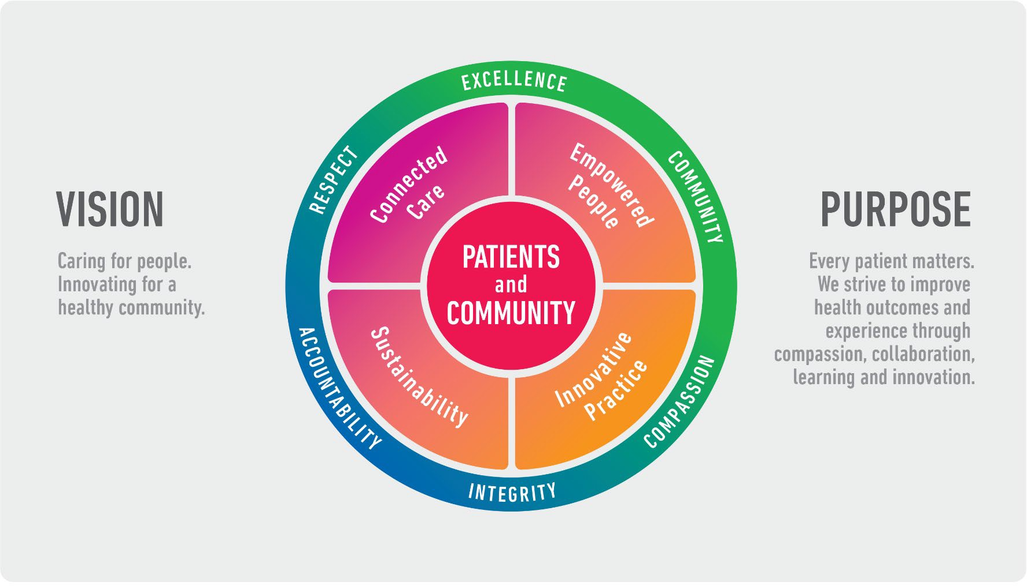

All roles are linked to the Epworth strategy and are fundamental in achieving its vision and purpose.
Connected Care – Partner with our patients and doctors to provide high-quality care through an integrated, holistic experience tailored
to their needs and choices

Empowered People – Enable and empower our people and teams to be their best and make a difference to the patient experience
Innovative Practice – Informing and enabling health within our community through encouraging the ideas of our people and finding
new and better ways to care and support care delivery
Sustainability – Be accountable to use resources wisely; to ensure organisational and environmental sustainability, enhance access,
support the patient journey and create greater capacity for care.

- Purpose of the Position
The Hospitality Services Operations Manager is responsible for leading and managing the Food Services, Functions, Retail, Environmental Services, Patient Transport/Orderlies and Tenant Cleaning, including the ongoing strategic and operational development of these departments across any Epworth Hospital Site. This position will also be responsible for a specific portfolio as assigned by the Group Director of Support Services.

This will be achieved by:
  - Working together with other Hospitality Services Operations Managers to ensure a consistent and united approach across all Epworth sites.
  - Having a flexible approach with the willingness and ability to work at any of the Epworth Group’s sites.
  - Leading a patient-oriented team toward the timely and safe delivery of Hospitality Services to all our patients, which, in turn, will result in an exceptional patient experience.
  - Driving a culture of accountability, where high performing teams operate within a framework of best practice in customer service delivery.
  - Effectively managing all resources with the aim of optimising quality, activity, business development and financial performance through continuous improvement.
  - Overseeing the maintenance of operating environments to ensure the safety and wellbeing of our patients, visitors and staff.
  - Contributing to the ongoing development of Epworth HealthCare’s internal culture and external reputation through:
    - Demonstrating behaviours and attitudes that are consistent with Epworth’s Vision and Values and professional Hospitality Services philosophy.
    - Working with other Hospitality Services Operations Managers in order to build strong and trusting relationships with internal and external stakeholders, thus maintaining the reputation and brand of Epworth HealthCare

Hospitality & Clinical Governance Framework
This role is required to put into practice the Hospitality and Clinical Governance Framework at Epworth as every employee is accountable for ensuring that our patients and community receive safe, high quality and person-centred care in every interaction with Epworth. This is achieved through active participation in the five domains of clinical governance at Epworth:

Clinical Governance Domain | Role

Leadership and culture | Promote and participate in a supportive, fair and transparent culture where lessons from previous outcomes are learned  and patient safety and quality is a priority at all levels of the organisation.
Consumer Partnerships | Understand and where relevant, ensure that each patient is actively involved in their own care and treatment including  families/carers wherever possible.
Effective Workforce | Develop and maintain one’s own competency, skills and knowledge to ensure high quality service provision and care.
Clinical Safety and Effectiveness | Understand and where relevant, ensure, that the right care is provided to the right person at the right time, in the right place and patient outcomes are monitored and improved.
Risk Management | Be responsible for identifying and reporting risks, hazards and near misses for people in our care and participating in risk  mitigation strategies.

Key Accountabilities

KEY RESPONSIBILITIES | MEASURES/KPIs TO BE ACHIEVED
Customer Centred Leadership  Focus on the provision of leadership in a customer centred environment.  - Establish and promote a culture of excellence in customer service to patients, visitors, and staff.  - Has a ‘can do’ attitude that drives and implements the development and leadership of a diverse team to deliver timely, person centred, care to patients in a cost-effective manner that optimises operational and financial performance.  - Ensure Epworth HealthCare Policy and Protocols are communicated and adhered to at all times by team members.  - Responsible for the development of an open and inclusive culture with feedback to all staff regarding department performance and other relevant information  - Undertake leadership and patient rounding and have a strong presence in the department and with colleagues | - Patient Satisfaction  Relevant Insync mean and percentile score  - Employee Satisfaction Build and maintain departmental teams to a Culture of Success as reflected in the Employee Engagement Survey
Leadership  Undertake appropriate workforce planning to build and maintain team.  - Promote staff engagement and positive attendance - acknowledge and  celebrate team successes | - Staff development  Maintain 100% compliance with mandatory and unit specific competencies every 12 months or as prescribed

- Work cooperatively and collaboratively with peers across all sites  - Ensure staff have access to appropriate resources and training in order to maintain customer service and technical skills and adhere to the safety/quality standards.  - Ensure each staff member has an annual performance and personal development/management plan that sets out work related goals, standards and behaviours.  Foster a culture of ongoing development and improvement.  Drive a culture that enables:  - Practices of constructive giving and receiving of feedback  - An environment of reflection that holds people accountable for areas of responsibility and actions taken.  Active succession planning and capability building in leadership team.  - Actively build capability and accountability within leadership team in all matters relating to leadership and management of the service by delegating and monitoring portfolios | - Team effectiveness  Sick leave rate equal to or less than target  - Leader Rounding  All staff are rounded on at a minimum of agreed frequency
Operational Management  Develops strategies and actions to meet budget.  - Work in collaboration with the Group Director of Hospitality Services to implement departmental budgets in a manner that ensures all resources including human, financial and physical, are used to deliver safe, high-quality services in a cost-effective manner.  - Oversee the development and implementation of staff rosters that optimise staffing to ensure the provision of high-quality services to patients.  - Understand daily requirements and forecasting activity to facilitate appropriate resource management.  Department Business Planning  - Work closely with the appropriate groups across Epworth HealthCare to ensure best practice and continuity of service | - Direct Costs  Direct costs within agreed target  - Labour costs  Labour rate within department budget  (includes factors such as utilisation of agency and casual staff)  - Leave Management  Annual leave liability rate less than agreed rate.  - Business Planning  Meet targets identified in annual operational plan

- Manage and monitor risks within area/s of responsibility and report key/emerging risks and opportunities to relevant manager.
- Develop an annual department operational plan in line with the divisional
operational & broader strategic plan
- Benchmark performance of the department both internally and externally
- Actively develop strategies and implement practices to attract, recruit and retain customer service-oriented team members.
- Develop & review revenue targets for Retail and Functions departments.
- Prepare, execute and review business plans for Retail & Functions departments.
Variance Analysis & Reporting
- Provide information in relation to variances against budget to management.
- Seek input and feedback from direct reports to develop an understanding of departmental performance
Risk and Quality Management  - Management of all mandatory reporting for the departments in Hospitality Services  - Effective operational performance of all Hospitality Services departments  - Compliance with all components of the accreditation cycle quality improvement process  - Cleaning standards in accordance with the Victorian Public Hospitals Cleaning Standards  - Strive to consistently improve service delivery toward hospitality best practice.  - Actively drive quality improvement activities within the departments or department in accordance with the ACHS Accreditation Standards, National Food Safety Standards, ISO 22000 Accreditation Standards and Australian Cleaning Standards. | - Food Safety Plan is reviewed and regularly updated & compliance with legislative requirements for Food Safety  - Review data collected by Group Quality and Contracts Officer for all required audits within Hospitality Services  - Compliance for services delivered in accordance with legislative requirements, relevant codes of practice and hospital policies and protocols.  - Facilitation of a culture of data driven decision making and evaluation within the departments  - Commitment to the Leadership and Development of quality improvement in performance  - Compliance with the hospital’s infection control program applicable for all Hospitality services departments  - Compliance within established standards for:  - Annual external cleaning audit results  - External Food Safety auditing results  - Council reports

Implementation of risk management strategies across all Hospitality Services Departments
- Evidence of participation in quality activities
- Improved patient care
- Improved performance of Hospitality Services Departments and the Epworth Healthcare site
- Proactive review, support and implementation of relevant research into the Hospitality Services environment
Customer Service  Epworth is committed to the provision of excellent customer service to all of our people, customers and stakeholders including patients and external suppliers.  Superior patient service leads to improved healing in a trusting, caring environment and creates a safe environment for patients and employees.  - Establish, promote, and lead a culture of customer service with all service users and key stakeholders.  - Ensure high quality service delivery across all Hospitality Services Departments  - With the Group Quality and Contracts Officer monitor Linen Supply Contract and feedback concerns to group supply team  - Role model and actively promote a culture of high-quality patient care.  - Provide excellent, helpful service to patients, visitors and staff.  - Communicate with clear and unambiguous language in all interactions, tailored to the audience.  - Build customer relationships and greet customers and patients promptly and courteously.  - Actively seek to understand patients' and their family's expectations and issues, using multiple strategies | - Patient and customer service satisfaction surveys within agreed targets  - Use AIDET principles in all interactions.  - Compliments to complaints ratios  - Completes leader rounding at agreed frequency.  - Issues are escalated to the manager and resolved in a timely manner.  - Proactively escalates concerns when necessary to ensure resolution of any current or potential breakdown in processes and systems that impact patient care and customer service.  - Consistently meet or exceed the expectations of our patients and customers at all times

- Use data, such as compliments, complaints and Press Ganey (Insync), to identify breakdowns in internal processes and systems that directly impact patient care and customer service.
- Respond quickly and proactively escalate concerns when necessary.
- Role model and actively promote a culture of high-quality patient care and experience by ensuring that solutions, practices and procedures (such as hourly rounding, leader rounding and bedside handover) are carried out with empathy and compassion
Personal and Professional Development  - Participate in prescribed performance development system annually.  - Evaluate personal performance and plan self-development | - Completion of annual performance appraisal  Completion of objectives outlined in self-development plan and provide evidence of
Safety and Wellbeing  To ensure a safe workplace is provided for all employees and other personnel including contractors, agency staff, volunteers and students.  - All employees and other personnel under the authority of the manager are fully informed of the hazards associated with their work activities, adequately trained and instructed in safe work procedures and appropriately supervised. Participate actively and positively in the area of health and safety to reduce all hazards and incidents within the workplace.  - Integrate and review OHS performance in staff PDPs.  - Ensure all direct reports are held accountable for safety performance and actions | - Adhere to infection control/personal hygiene precautions.  - Implement and adhere to Epworth OHS policies, protocols and safe work procedures.  - Ensure all hazards, incidents and injuries are reported in RiskMan within 24 hours.  - Ensure all hazards, incidents and injuries are investigated and corrective actions implemented within agreed timeframes.  - Mandatory training completed at agreed frequency.  - Comply with all Epworth’s OHS policies, protocols and safe work procedures at all times.  - Ensure your actions do not put yourself or others at risk (as per Sections 21 & 22 under the OHS Act 2004)  - Report all hazards, incidents, injuries and near misses immediately to the Group Director of Hospitality Services and log them into RiskMan.  - Participate in and complete mandatory safety training on an annual basis and as required.  - Actively participate and contribute to the OHS consultation processes

- Position Requirements/Key Selection Criteria

COMPONENT
Qualifications | Essential  - Tertiary qualification, or equivalent, in related discipline e.g. Hospitality Management, Leadership or working towards or willingness to commence within agreed period.  Desirable  - Tertiary qualification or equivalent in related discipline. E.g. Hospitality Management, or Leadership Management.
Previous Experience | Essential  - Previous relatable experience managing a multi-disciplinary team within Hospitality Services  Desirable  - Previous experience in managing a team of varying sizes.  - Minimum of 10 years’ experience in managing a team within Hospitality Services
Required Knowledge & Skills | Essential  - Commitment to exceptional patient/customer service and quality improvement – demonstrated capability and focus on innovation.  - Positive role model to all levels of staff - Demonstrated ability to build strong relationships with staff and management alike.  - Demonstrated leadership competency with relevant service industry, human resource and financial management exposure.  - Expertise in setting and managing elements of a budget, including strong resource management skills.  - Demonstrated ability to lead, assist and support organisational change.  - Knowledge and understanding of Legislation, OH&S principles and relevant awards.  - Knowledge and commitment to Acts, Agreements and Epworth Healthcare directions, policies, procedures and staff code of conduct.  - Sound computer literacy in Microsoft Applications  - Superior and effective conflict resolution skills  Desirable  - Knowledge and understanding of the ACHS Accreditation Standards  - Knowledge and understanding of all relevant standards

Personal Attributes & Values  All employees are expected to consistently work in accordance with Epworth’s values and behaviours.  - Respect  - Excellence  - Compassion  - Community  - Integrity  - Accountability | Essential  - Compassionate Customer service focus – Belief in patient centred care.  - Ability to adapt readily to change with the flexibility to work at any Epworth site.  - Strong advocate of self-development and professional learning for self and members of the Hospitality Services Team  - Committed to the development of staff, and practices, which engage and value the contribution of the team.  - Driven to provide a safe environment for Patients, Visitors and staff.  - Professional and diligent work ethic  - Lives by the ethos of Epworth’s Values and Behaviours  - Highly self-motivated

Document Control
Date Developed: | Date Last Reviewed: | Developed and Reviewed By (Position Title):
September 2020 | September 2020 | Group Director of Hospitality Services

Employee Position Declaration
I have read and understand the requirements and expectations of the above Position Description. I agree that I have the physical ability to fulfil the inherent physical requirements of the position and accept my role in fulfilling the Key Accountabilities. I understand that the information and statements in this position description are intended to reflect a general overview of the responsibilities and are not to be interpreted as being all-inclusive.

Employee Signature:
Print Name: | Date:

