- General Information
Position Title: | Occupational Therapist Grade 2
Division/Department: | Epworth Rehabilitation & Mental Health, Community Integration Team (CIT)
Position Reports to: | Community Rehabilitation Manager and CIT Team Leader
Enterprise/Individual Agreement: | Epworth Healthcare Health Professional Enterprise Agreement
Classification/Grade: | Grade 2, HP 21-25
Location: | Richmond
Employment Status: | Part time
Key Relationships - internal and external | - Clients and family members  - Community Integration Team staff  - Multi-disciplinary team members  - Rehabilitation consultants  - Service providers and insurers
2. Overview of Epworth HealthCare
Epworth HealthCare is Victoria’s largest not-for-profit private health care group, renowned for excellence in diagnosis, treatment, care and rehabilitation. Epworth is an innovator in Australia’s health system, embracing the latest in evidence-based medicine to pioneer treatments and services for our patients.

Epworth’s values define our approach and our delivery. We pride ourselves on communicating our values and delivering on them in a real and meaningful way. Our Values are Respect, Excellence, Community, Compassion, Integrity and Accountability. More information can be found on the Epworth website.

Epworth’s purpose is to improve the health, wellbeing and experience of every patient by integrating clinical practice with education and research and our vision is to consistently deliver excellent patient-centred care with compassion and dignity.
3. Epworth HealthCare Strategy
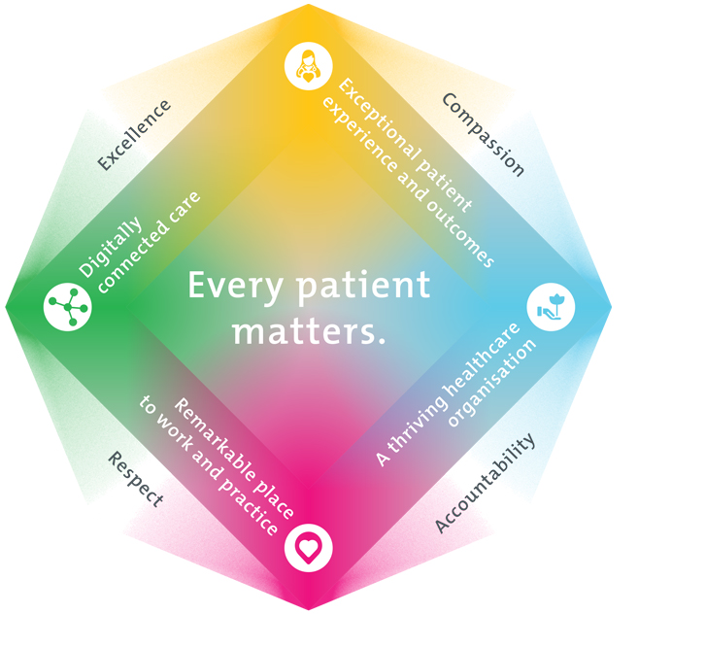
All roles are linked to the Epworth strategy and are fundamental in achieving its vision and purpose.
Connected Care – Partner with our patients through an integrated, holistic experience tailored to their needs and choices, enabling them to achieve their wellness potential
Empowered People – Enable and empower our people and teams to be their best and make a difference to the patient experience
Innovative Practice – Make a difference to our community through encouraging the ideas of our people and finding new and better ways to care and support care delivery
Sustainability – Be accountable to use resources wisely; to ensure organisational sustainability, enhance access, support the patient journey and create greater capacity for care.
4. Purpose of the Position
To provide optimal Occupational Therapy services and positive clinical outcomes to the patient ensuring long-term health and wellbeing that is consistent with Epworth HealthCare's Vision and Values. Working within a multidisciplinary community team, provide effective clinical, educational, functional and holistic best practice care to the clients with an acquired brain injury and their family. Promote excellence to our customers and the marketplace and support colleagues by sharing knowledge and expertise.
5. Key Accountabilities
KEY RESPONSIBILITIES | MEASURES/KPIs TO BE ACHIEVED
Clinical Care/Professional Practice  - Ensure optimal level of function and independence for all clients through appropriate functional assessments and treatments, provided in a community setting  - Assess client performance in relation to behavioural, cognitive and environmental factors, determining appropriate interventions to improve and promote their overall wellbeing  - Establish and maintain appropriate standards of practice relating to client admission, assessment, treatment, family liaison and discharge planning  - Implement, monitor and modify treatment programs within the clinical area as appropriate  - Demonstrate empathy and compassion and encourage client and family members participation in all stages of care  - Practice within the scope of registration of an Occupational Therapist with AHPRA  - Practice in accordance with the National Safety and Quality Health Services(NSQHS) Standards  - Maintain patient confidentiality as prescribed by the relevant acts and organizational policies and procedures  - Understand and implement Epworth HealthCare Policies and Procedures and departmental work place instructions  - Contribute to the development and maintenance of new and established clinical services and the broader team | - Appropriate standards of practice relating to assessments and treatments are implemented in a timely manner  - Compliance with mandatory and team-based documentation in the client’s electronic medical records within agreed timeframes  - Direct client care provided within allocated time frames from referral to treatment and within funding parameters  - Timely intervention is provided to support the team in achieving patients length of stay goals  - Sound relationships are developed and maintained with customers, family and colleagues  - Client satisfaction results meet organisational targets  - Compliance with NSQHS and clinical competencies  - Compliance with accepted professional standards  - Compliance with legislative and common law requirements including Privacy Act and Health Records Act  - Adherence to all Epworth Policies and Procedures
Customer Service  Epworth is committed to the provision of excellent customer service to all of our people, customers and stakeholders including patients and external suppliers. Superior patient service leads to improved recovery in a trusting, caring environment and also creates a safe environment for patients and employees.  - Provide excellent, helpful service to patients, visitors and staff  - Communicate with clear and unambiguous language in all interactions, tailored to the audience  - Build customer relationships and greet customers and patients promptly and courteously  - Actively seek to understand a client’s family circumstances, expectations and issues | - Client and customer service satisfaction surveys within agreed targets  - Ensure the clients have the opportunity to actively participate in their treatment planning and implementation  - Issues or concerns are proactively escalated to the manager and resolved in a timely manner  - Compliments recorded on Riskman  - Consistently meet or exceeds the expectations of our clients and customers at all times  - Awareness of Epworth HealthCare's complaints process and assistance provided to clients if required
Team Work /Communication  - Actively participate as a member of the department and multidisciplinary team  - Provide positive and constructive feedback to other team members | - Collaborate effectively with all other team members and external agencies for efficient patient management  - Attendance and active participation in departmental and multidisciplinary team meetings
Continuous Quality Improvement  - Actively participate in Quality activities ensuring opportunities for improvement are actively explored and best practice is achieved  - Provide suggestions and feedback to consistently improve service delivery, clinical practice and patient satisfaction  - Promote and enhance Epworth HealthCare and the department’s positive image within the community | - Evidence of participation in quality enhancement activities  - Quality projects are completed within agreed time frame  - Demonstrated commitment to Australian Commission on Safety and Quality in Health Care, National Safety and Quality HealthCare Services (NSQHS) Standards  - Under direction of senior staff departmental resources, equipment and educational information are maintained and updated
Personal and Professional Development  - Participate in ongoing professional development by upgrading clinical competencies and knowledge and participating in both internal and external educational opportunities  - Actively participate in Performance Development Plan annually and evaluate personal performance and plan self-development  - Contribute to student development programs as directed | - Attendance in internal and external professional development educational forums  - Participation in in-service and education activities  - Completion of performance review and development plan
Safety and Wellbeing  - Participate actively and positively in the area of health and safety to reduce all hazards and incidents within the workplace  - Report all hazards, incidents, injuries and near misses immediately to the manager and log them in RiskMan | - Adhere to infection control/personal hygiene precautions  - Adherence to Epworth OHS policies, protocols and safe work procedures at all times  - Mandatory training completed at agreed frequency
6. Position Requirements/Key Selection Criteria
COMPONENT
Qualifications | Essential  - Bachelor or Master’s Degree in Occupational Therapy  - Occupational Therapist registration with the Australian Health Practitioner Regulation Agency (AHPRA)  Desirable  - Eligible for membership with Occupational Therapy Australia
Previous Experience | Desirable  - Relevant experience in a hospital, rehabilitation or community setting
Required Knowledge & Skills | Essential  - Proficiency in conducting functional Occupational Therapy assessments with brain injured clients  - Knowledge and skill in providing clinical interventions to clients with acquired brain injury including memory strategies and behaviour management  - Well-developed organisational and planning skills  - Skills in assessing and managing at risk patients  - Ability to interact and collaborate with all members of a multidisciplinary team  - Ability to engage and work effectively with families  - Good verbal and written communication and presentation skills  - Innovative, proactive and creative attitude to problem solving  - Excellent computer literacy including MS Office Word & Excel  - Knowledge and understanding of the National Standards and ACHS Accreditation Standards  - Is customer-focussed/person-centred in-service provision and evaluation  - Ability to drive a motor vehicle and holds a full current driver’s licence  Desirable  - Skills in conflict resolution and ability to manage challenging behaviour  - Knowledge of medico-legal and health and safety issues as they relate to health care  - Appropriate knowledge of community resources and services
Personal Attributes & Values  All employees are expected to consistently work in accordance with Epworth’s values and behaviours  - Respect  - Excellence  - Compassion  - Community  - Integrity  - Accountability | Essential  - Professional Development is regarded as a priority  - Ability to work autonomously  - Sensitive to cultural, racial and gender differences  - Helpful and professional manner  Desirable  - Flexibility to assist others within the department and across sites as required

Document Control

Date Developed: | Date Last Reviewed: | Developed and Reviewed By (Position Title):
October 2020 | March 2023 | Community Rehabilitation Manager & Occupational Therapy Manager

Employee Position Declaration
I have read and understand the requirements and expectations of the above Position Description. I agree that I have the physical ability to fulfil the inherent physical requirements of the position, and accept my role in fulfilling the Key Accountabilities. I understand that the information and statements in this position description are intended to reflect a general overview of the responsibilities and are not to be interpreted as being all-inclusive.
Employee Signature:
Print Name: | Date:

