- General Information
Position Title: | Trades Assistant – (General Maintenance)
Position Reports to: | Facilities Supervisor- Richmond
Enterprise/Individual Agreement: | Allied Services Enterprise Agreement
Classification/Grade: | EHP05 - Trades Assistant
Location: | Richmond and other Epworth sites as requested
Employment Status: | Full Time
Key Relationships - internal and external | Internal: Facilities Manager, Facilities Supervisor, maintenance personnel and facilities administrative staff.  External: Construction and Maintenance 3rd party contractors (Building, Electrical, Plumbing, etc)
2. Overview of Epworth HealthCare
Epworth HealthCare is Victoria’s largest not-for-profit private health care group, renowned for excellence in diagnosis, treatment, care and rehabilitation. Epworth is an innovator in Australia’s health system, embracing the latest in evidence-based medicine to pioneer treatments and services for our patients.

Epworth’s values define our approach and our delivery. We pride ourselves on communicating our values and delivering on them in a real and meaningful way. Our Values are Compassion, Accountability, Respect and Excellence. More information can be found on the Epworth website.

Epworth’s purpose is Every Patient Matters.

Our Vision is Delivering another 100 years of exceptional healthcare and innovation to the Victorian community.

3. Epworth HealthCare Strategy
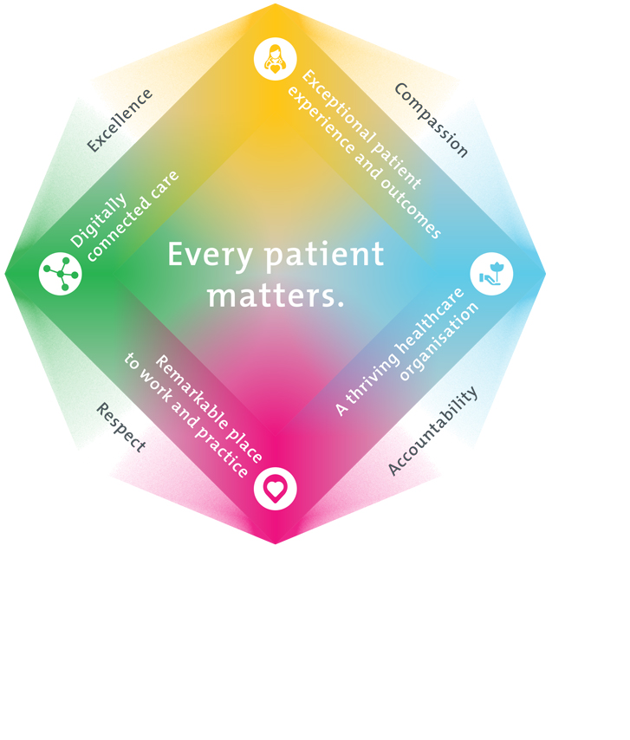
All roles are linked to the Epworth strategy and are fundamental in achieving its vision and purpose.
Exceptional patient experience and outcomes - To empower our patients and deliver compassionate, expert and coordinated care.
A thriving healthcare organisation - To adapt and grow in a changing healthcare landscape by delivering a unique private not-for-profit healthcare organisation.
Remarkable place to work and practice - To ensure Epworth is an outstanding place to work and practice through a culture of care
and investment in our people.
Digitally connected care - To innovate and improve the digital experience, interactions and outcomes for our patients, staff and doctors.
4. Purpose of the Position
To provide a quality maintenance service, as a qualified trades assistant – (General Maintenance), on corrective and preventative tasks, to Epworth Richmond and as requested at other Epworth sites on occasion. These tasks includes minor building fabric repairs ( fixtures, furniture, fittings, equipment etc).
In particular to utilise your skills, knowledge & experience with available resources to effectively maintain plant & equipment, building & fixtures as well as loose assets in a hospital environment.
This position covers a 38 hour work week from Monday to Friday between the hours of 9:00 AM to 5:00PM
This position will require the availability to work additional sick and annual leave shift cover and to be available for On Call once deemed sufficiently experienced in the workplace environment.
5. Key Accountabilities
KEY RESPONSIBILITIES | MEASURES/KPIs TO BE ACHIEVED
5.1 Administration  - To carry out inspections of building services, plant & equipment, and or building/fixtures.  - Raise work requests as required  - Close works orders as required  - Completion of E-learning modules  - Prepare scopes of work & Source quotations for the required task  - Compile list of consumables parts required associated with the task to be purchased  - Advise the Facilities Manager of any faults, defects or unsafe conditions found with any of the hospital services  - PPM report completion  - Filling out of permits for risk work as may be required  - Monitor / order med gases / stock levels  - Source quotes from suppliers as needed  - Quality & detailed Feedback on works order | - To work with the facilities management team to achieve the following KPI’s as measured by Technology One (CMMS)  - Corrective Maintenance work orders  - Priority 1 – 80% within 1 day, 95% within 3 days  - Priority 2 – 80% within 3 days, 95% within 5 days  - Priority 3 – 80% within 5 days, 95% within 15 days  - Preventative maintenance work orders  - Completion within 80% within 3 days, 95% within 6 days  - Minor project works & Duties  - Completed within agreed time frames  - The facility continuously meets the legislative and regulatory requirements that apply to the safe operation of a hospital.
5.2 Faults (Reactives/Breakdowns)  - Provide first line response to all urgent requests and breakdowns  - Prompt response to work requests and report where additional works required  - 1st response to patient room related issues  - Alter BMS settings/response to alarms  - Filling in of permits for risk work as may be required  - Unblock drains  - Assist team members  - Identify root causes & fix  - To be available for on call roster duty  - Minor building fabric repairs ( fixtures, furniture, fittings, equipment, loose assets etc)  - Replenish med gases stock levels  - Carry out repairs on plant & equipment and associated building services  - Monitor / order med gases / stock levels/swap cylinders | - Plant & equipment is fixed properly soonest & permanently.  - Plant & equipment is repaired to highest & acceptable standard.  - Work safely, use correct tools, parts & equipment  - Completed works orders with appropriate comments/data handed to administrators to capture in Tech 1.  - Ensure your actions do not put yourself or others at risk (as per Sections 21 & 22 under the OHS Act 2004)  - Approval of Permit content
5.3 PPM(Scheduled works)  - Promt response to PPM work orders  - Liaise with Facilities Administrator to procure sufficient spares/materials and ensure enough spares/materials are kept in stock to minimise any equipment downtime  - To carry out audits on plant and equipment as instructed  - Carry out other duties as directed by the Facility Manager and the Facilities Supervisor  - Routine Plant inspections  - Maintain office/workshop & storage areas  - Filling out of permits for risk works  - Housekeeping of works areas, plant rooms, store rooms, etc.  - To carry out non complex inspections on plant, equipment, store rooms as instructed | - Ensure your actions do not put yourself or others at risk  - Plant & equipment is inspected & serviced as per schedule.  - Work safely, use correct tools, parts & equipment  - Completed inspection schedules & works order handed to administrators with appropriate comments & data.
5.4 Safety and Wellbeing  - Wear PPE to suit the task  - For high risk tasks, complete RA’s & appropriate permits  - Keep workshop & work areas neat, clean & tidy including plant & equipment.  - Participate actively and positively in the area of health and safety to reduce all hazards and incidents within the workplace.  - Participate in and complete mandatory safety training as per training schedule, monitor monthly & keep up to date  - Report hazards and incidents in the workplace  - Participate in Toolbox Meetings  - Report all hazards, incidents, injuries and near misses immediately to your manager and log them in RiskMan | - Ensure your actions do not put yourself or others at risk (as per Sections 21 & 22 under the OHS Act 2004)  - Use lock out locks & complete lock out register as & when required.  - Record hazards, incidents, injuries and near misses immediately to your manager and log them in RiskMan  - Monitor mandatory on line safety training monthly & training kept up to date  - Follow requirements in the Epworth Emergency Policy & Procedure Manual, Engineering Policy & Procedure Manual and the Safework Practices Manual.  - Comply with all Epworth’s OHS policies, protocols and safe work procedures at all times  - Actively participate and contribute to the OHS consultation processes when required  - Adhere to infection control/personal hygiene precautions
5.5 Customer Service  - Prompt response to work orders  - "Epworth is committed to the provision of excellent customer service to all of our people, customers and stakeholders including patients and external suppliers.  - Follows Epworth Values and is guided by the Epworth Strategy. "  - Superior patient service leads to improved healing in a trusting, caring environment and creates a safe environment for patients and employees | - Build customer relationships, greet staff, customers and patients promptly and courteously.  - Proactively escalate concerns when necessary to ensure resolution of any current or potential breakdown in processes and systems that impact patient care and customer service  - Consistently meet or exceed the expectations of our patients and customers at all times
5.6 Team work  - Wear appropriate Epworth Uniform  - Asssist other trades as & when required  - Ask someone if in doubt  - Be prepared to work overtime as required  - Attend Functions as directed  - Treat each other with respect  - Share knowledge | - Share all hazards, incidents, injuries and near misses at the toolbox meeting.  - Keep up to date mandatory safety training (This affects the team compliance #’s for the whole team)  - Actively participate and contribute to the OHS consultation processes  - Adhere to infection control/personal hygiene precautions
6. Position Requirements/Key Selection Criteria
COMPONENT
Qualifications | Essential  - Qualified trades assistant or equivalent experience in a Facilities Maintenance role.  Desirable  - An experienced trades person i.e. Painter, Plasterer or Carpenter etc.
Previous Experience | Essential  - At least 5 years working in a Facilities Maintenance environment.  Desirable  - Healthcare facilities maintenance  - Previous Retail or commercial property facilities maintenance
Required Knowledge & Skills | Essential  - Prioritisation and time management skills,  - Work with managers to ensure high utilisation of available technology,  - Repairs to infrastructure fabric  - Basic computer skills, inclusive of Microsoft Office Excel, Word, email (outlook) etc & using file manager to manage files and folders.  Desirable  - Worked with a building management system (BMS)  - Can analyse situations and devise optimum solutions  - Demonstrated problem solving skills  - Handyman/handy person skills
Personal Attributes & Values  All employees are expected to consistently work in accordance with Epworth’s values and behaviours  - Compassion  - Accountability  - Respect  - Excellence | Essential  - Practices within the ethos of the Epworth HealthCare Values & Behaviours  - The ability to work as part of a team & fit into the team  - Committed to providing a safe environment for patients & colleagues  - Professional work ethic  - The ability to prioritise tasks taking into consideration the wider operational requirements of the hospital  - Communication skills that will lead to an understanding of the diverse requirements of the department’s various customers  Desirable  - Demonstrates initiative  - Self-motivated and self-directed  - Team Player

Document Control
Date Developed: | Date Last Reviewed: | Developed and Reviewed By (Position Title):
January 2022 | May 2025 – Jean-Marc Tait | Facilities Manager
January 2022 | May 2025 – Michael Robortaccio | Group Facilities Manager

7. Employee Position Declaration
I have read and understand the requirements and expectations of the above Position Description. I agree that I have the physical ability to fulfil the inherent physical requirements of the position, and accept my role in fulfilling the Key Accountabilities. I understand that the information and statements in this position description are intended to reflect a general overview of the responsibilities and are not to be interpreted as being all-inclusive.
Employee Signature:
Print Name: | Date:

