- General Information

Position Title: | Clinical Trials Assistant
Division/Department: | Academic & Medical Services, Medical Oncology Clinical Trial Unit (MOCTU)
Position Reports to: | Research Program Manager - MOCTU
Enterprise/Individual Agreement: | Individual Agreement
Classification/Grade: | Not Applicable
Location: | Epworth Corporate (Richmond)
Employment Status: | Full Time, Fixed Term 12 months
Resource Management  (for Management positions only)  Number of Direct Reports:  Budget under management: | Not Applicable
Key Relationships - internal and external | Internal:  - Director MOCTU (physician)  - MOCTU employees  - Epworth Office for Research and Group Manager Research Operations  - Clinical Trials and Research employees  - Principal investigators, Co-investigators and associated clinical trials medical staff  - Multidisciplinary team members  - Hospital employees as required in relevant patient care areas including Chemotherapy Day Unit (CDU), outpatient department (OPD), Ward nurses, diagnostic imaging and associated clinical trials medical staff.  - Research participants and their carers  - Epworth Medical Foundation as required  External:  - Research participants and their carers  - Pathology and other clinical staff at key collection centres  - Clinical Research Sponsor representatives from pharmaceutical companies and collaborative groups  - Surgical, pathology and other clinical staff at key collection centres  - Research coordinators and data managers at other hospital and research centres.  - External hospitals, laboratories, diagnostic imaging centres and Universities  - Appropriate Professional bodies  - State and government bodies  - Appropriate Funding bodies and benefactors

Overview of Epworth HealthCare
Epworth HealthCare is Victoria's largest not-for-profit private health care group, renowned for excellence in diagnosis, treatment, care and rehabilitation. Epworth is an innovator in Australia's health system, embracing the latest in evidence-based medicine to pioneer treatments and services for our patients.

Epworth's values define our approach and our delivery. We pride ourselves on communicating our values and delivering on them in a real and meaningful way. Our Values are Compassion, Accountability, Respect and Excellence. More information can be found on the Epworth website.

Epworth's purpose is Every Patient Matters.

Our Vision is Delivering another 100 years of exceptional healthcare and innovation to the Victorian community.

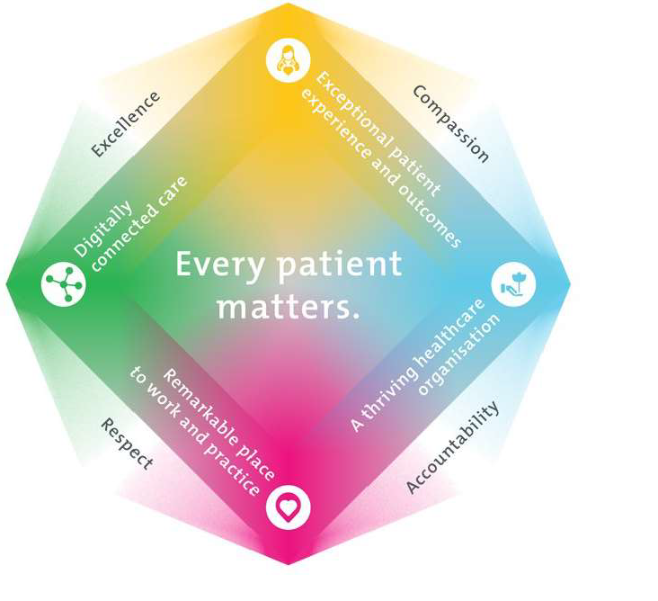
Epworth HealthCare Strategy

All roles are linked to the Epworth strategy and are fundamental in achieving its vision and purpose.
Exceptional patient experience and outcomes - To empower our patients and deliver compassionate, expert and coordinated care.
A thriving healthcare organisation - To adapt and grow in a changing healthcare landscape by delivering a unique private not-for-profit
healthcare organisation.
Remarkable place to work and practice - To ensure Epworth is an outstanding place to work and practice through a culture of care
and investment in our people.
Digitally connected care - To innovate and improve the digital experience, interactions and outcomes for our patients, staff and doctors.

Purpose of the Position
The Clinical trial Assistant role:

- Supports clinical research to be conducted safely, ethically and in compliance with Good Clinical Practice (GCP), regulatory requirements and Epworth policies, while supporting high‑quality patient care.
- Provides overall support for both industry sponsored and investigator-initiated research activities relating to Medical Oncology
- Processes biological specimens including the collection, receipt, storage, documentation and tracking of samples.
- Supports clinical research data entry requirements and query resolution
- Assists with general administrative work that pertains to Medical Oncology trials

Clinical Governance Framework
This role is required to put into practice the Clinical Governance Framework at Epworth as every employee is accountable for ensuring that our patients and community receive safe, high quality and person-centred care in every interaction with Epworth. This is achieved through active participation in the five domains of clinical governance at Epworth:

Clinical Governance Domain
Leadership and culture
Consumer Partnerships Effective Workforce
Clinical Safety and Effectiveness Risk Management
Role
Promote and participate in a supportive, fair and transparent culture where lessons from previous outcomes are learned and patient safety and quality is a priority at all levels of the organisation.
I
Understand and where relevant, ensure that each patient is actively involved in their own care and treatment including families/carers wherever possible.
I
I Develop and maintain one's own competency, skills and knowledge to ensure high quality service provision and care.
Understand and where relevant, ensure, that the right care is provided to the right person at the right time, in the right place and patient outcomes are monitored and improved.
I
Be responsible for identifying and reporting risks, hazards and near misses for people in our care and participating in risk mitigation strategies.
I

- Key Accountabilities

KEY RESPONSIBILITIES | MEASURES/KPls TO BE ACHIEVED
Clinical Research Responsibilities:  - Participate in and support investigator‑initiated and industry‑sponsored clinical research studies within MOCTU.  - Support MOCTU team in the delivery of research activities.  - Support coordination of protocol‑required procedures for allocated clinical trials, ensuring optimal care of consented participants.  - Maintain accurate and complete study documentation, including electronic and paper CRFs and trial databases.  - Support study governance and ethics documentation and reporting requirements.  - Support conduct of research activities in compliance with GCP, and relevant regulatory and organisational standards.  - Coordinate biological sample collection, processing, storage and transport for allocated studies in compliance with study protocols, GCP, GLP and relevant regulatory and organisational standards. | For allocated clinical trials and research studies:  - Clinical trials are conducted in accordance with approved protocols, GCP and ethical requirements.  - Minimal unplanned protocol deviations  - Study data, CRFs and documentation are accurate, complete and maintained within required timelines.  - Governance and ethics documentation is current, accurate and submitted on time.  - Biological samples are managed and documented in accordance with protocol and laboratory requirements.  - Biological samples are shipped without error in accordance with IATA regulations  - Preparation and destruction of laboratory kits as required
Research Excellence:  Successful completion of essential research activities:  - Ensure compliance with ICH‑GCP, TGA guidelines and the NHMRC National Statement on Ethical Conduct in Research Involving Humans.  - Support organisation and coordination of all trial‑related activities, including participant visits, in accordance with approved study protocols.  - Maintain accurate and up‑to‑date research study files, clinical documentation and data in both hard copy and within the clinical trials management system (CTMS).  - Assist in the management of study databases and visit payment tracking | - Research activities are conducted in compliance with applicable ethical, regulatory and sponsor requirements.  - Research documentation and CTMS data are accurate, complete and maintained within sponsor-specified timelines.  - Study databases are managed accurately and support timely invoicing and payment processes.  - Minimal unplanned protocol deviations  - Biological samples are managed and documented in accordance with protocol and laboratory requirements.  - Biological samples are shipped without error in accordance with IATA regulations
Education:  Maintain the highest standard of knowledge and skills in oncology clinical trials and in clinical research practice required for undertaking the role:  - Undertake additional training to maintain and develop the knowledge and skills required to implement new clinical trial protocols across a range of clinical specialties.  - Attend and, where appropriate, present at research forums to maintain contemporary knowledge of clinical research practices.  - Assist with the orientation and ongoing support of new research staff within the MOCTU. | - 100% compliance with required training and professional development activities.  - Participation in research forums contributes to continuous improvement and knowledge sharing within the research team.  - New research staff are supported effectively during orientation, with positive feedback from supervisors and team members.
Team:  Demonstrate the Epworth values and behaviours and provide support for colleagues associated with the research programs of the Centre  - Work cooperatively and collaboratively with colleagues, Epworth staff and external stakeholders to support the effective delivery of research activities.  - Attend research team and research meetings as required and feasible.  - Provide support to colleagues and contribute to other studies as required to meet team and organisational priorities.  - Assist with ad hoc research and quality improvement activities, including point prevalence studies, under the direction of the Research Program Manager. | - Positive feedback from research team and with broader stakeholders regarding effective collaboration  - Active participation in required meetings and team activities is evident.  - Corporate KPIs relating to attendance, engagement and professional development are met.
Governance:  Meet all governance standards and benchmarks required for clinical research:  - Ensure clinical trials are conducted in accordance with approved protocols and applicable regulatory and ethical requirements, including GCP and ICH.  - Adhere to and support research‑specific policies, standard operating procedures and clinical guidelines.  - Support coordination of trial visits in accordance with protocol requirements.  - Support the preparation and submission of required reports to the approving HREC and Office for Research. | - Clinical trials are conducted in compliance with approved protocols and regulatory requirements  - Minimal unplanned protocol deviations.  - Research policies and SOPs are followed consistently and support compliant trial conduct.  - Trial visits are delivered efficiently and within protocol‑defined timelines.  - HREC and Research Governance documentation is accurate and submitted within required timeframes.  - Governance support contributes to audit‑ready studies and effective trial delivery.  - CAPAs are completed accurately, within agreed timeframes and with evidenced preventative measures.
Customer Service  Epworth is committed to the provision of excellent customer service to all of our people, customers and stakeholders including patients and external suppliers.  Superior patient service leads to improved healing in a trusting, caring environment and creates a safe environment for patients and employees.  - Provide excellent, helpful service to visitors and staff  - Communicate with clear and unambiguous language in all interactions, tailored to the audience  - Build customer relationships and greet customers promptly and courteously  - Maintain effective, professional relationships with investigators, clinical teams and sponsors through courteous and inclusive communication. | - Customer service satisfaction surveys within agreed targets  - Use AIDET principles in all interactions  - Issues are escalated to the manager and resolved in a timely manner  - Consistently positive collaboration with trial stakeholders, with no substantiated concerns regarding professionalism or conduct.
Safety and Wellbeing  Participate actively and positively in the area of health and safety to reduce all hazards and incidents within the workplace  - Report all hazards, incidents, injuries and near misses immediately to your manager and log them in RiskMan. | - Adhere to infection control/personal hygiene precautions  - Implement and adhere to Epworth OHS policies, protocols and safe work procedures  - Mandatory training completed at agreed frequency

Position Requirements/Key Selection Criteria

COMPONENT
Qualifications | Essential  - A relevant tertiary qualification in science, health care or a related field  Desirable  - Extra qualifications in clinical research competency (eg GCP, GDP training etc)  - Exposure to laboratory techniques including but not limited to biological sample handling
Previous Experience | Essential  - Clinical research experience  Desirable  - Experience in research activity in medical oncology and/or Haematology  - Previous laboratory experience
Required Knowledge  & Skills | Essential  - Demonstrated computer literacy  - Highly organised with a proven ability to prioritise tasks  - Demonstrated data collection and management skills  - Proven ability to work independently and interact well as part of a busy team  Desirable  - Principles of Good Laboratory Practice (GLP) and Good Clinical Practice (GCP)  - Excellent communication and teamwork skills
Personal Attributes & Values  All employees are expected to consistently work in accordance with Epworth’s values and behaviours  - Compassion  - Accountability  - Respect  - Excellence | Essential  - Excellent communication skills  - Excellent problem solving and decision-making skills  - Demonstrated ability to contribute positively within a research team  - Demonstrated ability to effectively prioritise  - A professional and engaging approach to research  - Professional work ethic and flexible work style

Document Control
Date Developed: | Date Last Reviewed: | Developed and Reviewed By (Position Title):
February 2021 | October 2024 | Director, Medical Oncology Clinical Trials  Manager, Clinical Trials Epworth  Group Manager Research Operations

Employee Position Declaration
I have read and understand the requirements and expectations of the above Position Description. I agree that I have the physical ability to fulfil the inherent physical requirements of the position, and accept my role in fulfilling the Key Accountabilities. I understand that the information and statements in this position description are intended to reflect a general overview of the responsibilities and are not to be interpreted as being all-inclusive.
Employee Signature: Print Name: Date:

