- General Information
Position Title: | Infrastructure Specialist - Identity & M365 Administrator
Division/Department: | Information Technology
Position Reports to: | Senior Technical Manager - Microsoft and Cloud
Enterprise/Individual Agreement: | Individual Agreement
Location: | Richmond, Pelaco
Employment Status: | Contractor – 12-month fixed term
Key Relationships - internal and external | CIO Team  ICT Team  Vendor Management  IT Security  IT Incident and Change Management
2. Overview of Epworth HealthCare
Epworth HealthCare is Victoria’s largest not-for-profit private health care group, renowned for excellence in diagnosis, treatment, care and rehabilitation. Epworth is an innovator in Australia’s health system, embracing the latest in evidence-based medicine to pioneer treatments and services for our patients.

Epworth’s values define our approach and our delivery. We pride ourselves on communicating our values and delivering on them in a real and meaningful way. Our Values are Compassion, Accountability, Respect and Excellence. More information can be found on the Epworth website.

Epworth’s purpose is Every Patient Matters.

Our Vision is Delivering another 100 years of exceptional healthcare and innovation to the Victorian community.

3. Epworth HealthCare Strategy
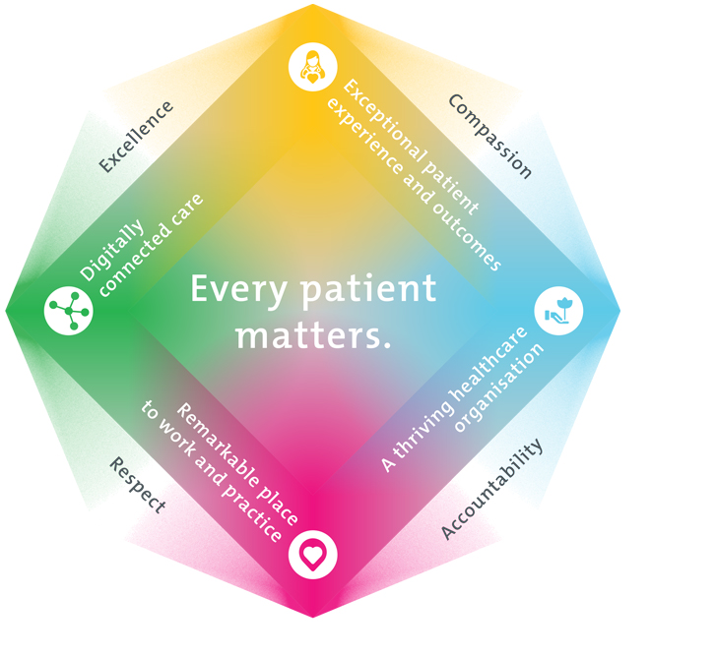
All roles are linked to the Epworth strategy and are fundamental in achieving its vision and purpose.
Exceptional patient experience and outcomes - To empower our patients and deliver compassionate, expert and coordinated care.
A thriving healthcare organisation - To adapt and grow in a changing healthcare landscape by delivering a unique private not-for-profit healthcare organisation.
Remarkable place to work and practice - To ensure Epworth is an outstanding place to work and practice through a culture of care
and investment in our people.
Digitally connected care - To innovate and improve the digital experience, interactions and outcomes for our patients, staff and doctors.
4. Purpose of the Position
As the Technical Specialist - Identity & M365 Administrator you will work as a member of a team that provides system support, administration and technical leadership of Epworth IT’s Microsoft M365 environment and identity platform. This primarily includes Exchange Online, SharePoint Online, Teams, Copilot, Entra ID (Azure Active Directory) and Active Directory; ensuring that Epworth lifecycle around access to systems and platforms is managed and maintained appropriately. As part of this, the role will also work within the team to support access to Epworth’s traditional on-premises systems and identity platform components (Active Directory, Group Policy). The role is to be an advocate for automation, the development of strong M365 Governance and management practices within the organisation and to support and improve Epworth’s user onboarding and offboarding processes (RBAC, automation) which is used to provide access Epworth’s cloud environment(s), connected SaaS platforms and on-premises systems.

Identity is a core part of this role which includes Microsoft’s Cloud environment, our data platform (GCP) and supporting our hospital’s digital transformation and digitisation efforts across data, applications, and artificial intelligence. While focused on support around our M365 estate (Exchange Online, SharePoint, Teams, and critically Entra ID), the growing portfolio of platform-as-a-service and innovative technology areas rapidly being onboarded is also part of this role.

Finally, the role will promote getting the best out of Microsoft software and services for both the wider IT and end users to help others better utilise the tools and technology available to help meet Epworth’s digital objectives.
5. Clinical Governance Framework
This role is required to put into practice the Clinical Governance Framework at Epworth as every employee is accountable for ensuring that our patients and community receive safe, high quality and person-centred care in every interaction with Epworth. This is achieved through active participation in the five domains of clinical governance at Epworth:

Clinical Governance Domain | Role
Leadership and culture | Promote and participate in a supportive, fair and transparent culture where lessons from previous outcomes are learned and patient safety and quality is a priority at all levels of the organisation.
Consumer Partnerships | Understand and where relevant, ensure that each patient is actively involved in their own care and treatment including families/carers wherever possible.
Effective Workforce | Develop and maintain one’s own competency, skills and knowledge to ensure high quality service provision and care.
Clinical Safety and Effectiveness | Understand and where relevant, ensure, that the right care is provided to the right person at the right time, in the right place and patient outcomes are monitored and improved.
Risk Management | Be responsible for identifying and reporting risks, hazards and near misses for people in our care and participating in risk mitigation strategies.
6. Key Accountabilities
KEY RESPONSIBILITIES | MEASURES/KPIs TO BE ACHIEVED
Technology Administration  - Provide technical leadership in the support and administration of the organisation’s Microsoft M365 environment (including Exchange Hybrid environment) and on-premises identity system (Active Directory).  - Continually improve the automation, security and system management of those platform(s) and the software and tools used to run and maintain them.  - Maintain and support the disaster recovery of those environments where applicable.  - Monitor cloud, network and infrastructure components utilising appropriate tools.  - Manage the M365 environment to maintain agreed financial and performance targets.  - Analyse, diagnose and resolve M365 faults and work with Microsoft Support where required to resolve issues.  - Work closely with application teams and the business on the delivery of components that are needed.  - Report on operational metrics for SLA reporting and capacity planning.  - Provide guidance and mentoring to other infrastructure team members.  - Perform support of Epworth technology platforms.  - Be responsible for documentation of the Microsoft M365 and Active Directory environment including but not limited to foundations, networking, disaster recovery documentation and procedural documentation.  - Ability to concisely document/whiteboard concepts in a design or troubleshooting scenario. | - Delivery of agreed IT Service and project KPIs.  - Deliver IT service improvement activities to agreed plan.  - Delivery of Microsoft M365 platform in line with project and OPEX budgets.  - Contribute to the Epworth digitisation program ensuring any related infrastructure activities are delivered per plan.  - Contribute to CIS 18 and essential 8 security targets.  - Ensure the achievement of service KPIs.  - Deliver IT security requirements as part of all changes.  - Achieve resolution of incidents as per IT SLAs.  - Plan, document and deliver any migrations without impact to services where possible.  - Implement all changes in line with change management process.
Collaboration and Customer Service  Collaborate with internal stakeholders and customers to perform services with team-based professionalism and integrity that is primarily service-focused  - Collaborate with business users and members of the infrastructure and cloud team to identify and plan changes with minimal distribution where possible.  - Learn and develop cloud\infrastructure knowledge from one-on-one knowledge transfer, training and professional development where required | - Service Availability SLAs  - Change success metrics
Continuous Quality Improvement  - Actively contribute to continuous improvement of work, standards, and methodologies.  - Conduct periodic monitoring, review of Cloud performance, and recommend proactive measures as appropriate. | - Evidence of participation in quality improvement activities.  - Demonstrate an initiative-taking attitude in reviewing, supporting and implementing best practice in Azure management and IT service delivery.
Teamwork/Team effectiveness/Professional development  - Provide technical coaching and mentorship to team members to uplift their cloud skills.  - Able to multi-task and prioritise issue resolution with colleagues within tight time constraints – sees a problem and can think of workable solutions under pressure.  - Communicate ideas which may improve the efficiency, performance, or standards of the IT Team  - Participate in a prescribed performance development plan annually and evaluate personal performance and self-development requirements.  - Foster and promote Epworth Values and Behaviours  - Partake in out-of-hours on call support rotation.  - Perform other duties as requested. | - Active participation in Infrastructure Team meetings and cross-functional IT team meetings.  - Attend workshops, seminars, conferences related to field of work.  - Completion of annual performance appraisal.  - Completion of objectives outlined in self-development plan (provide evidence of).  - Deliver individual/group trainings to fellow staff members (when requested by Manager or delegate).  - Attend individual/group trainings (when requested by Manager or delegate).  - Engage in self-learning to improve one’s skills relevant to field of work and IT in general.  - Feedback from Manager and team members.
Customer Service  Epworth is committed to the provision of excellent customer service to all our people, customers and stakeholders including patients and external suppliers.  Superior patient service leads to improved healing in a trusting, caring environment and creates a safe environment for patients and employees.  - Provide excellent, helpful service to patients, visitors, and staff.  - Communicate with clear and unambiguous language in all interactions, tailored to the audience.  - Build customer relationships and greet customers and patients promptly and courteously.  - Actively seek to understand patients' and their family's (customers) expectations and issues. | - Patient and customer service satisfaction surveys within agreed targets.  - Use AIDET principles (acknowledge, introduce, duration, explanation and thank you) in all interactions.  - Escalate issues to the manager and resolved in a timely manner.
Safety and Wellbeing  Participate actively and positively in health and safety to reduce all hazards and incidents within the workplace.  Report all hazards, incidents, injuries and near misses immediately to your manager and log them in RiskMan. | - Adhere to infection control/personal hygiene precautions.  - Implement and adhere to Epworth OHS policies, protocols, and safe work procedures.  - Mandatory training completed at agreed frequency.
7. Position Requirements/Key Selection Criteria
COMPONENT
Qualifications | Essential  - Microsoft Administrator Expert certification or equivalent experience  - Microsoft Windows Server Hybrid Administrator Associate or equivalent experience  - Microsoft Exchange certification or equivalent experience  Desirable  - Associate level certification from AWS, GCP or Azure  - Background in software engineering and development  - Professional level qualification from Microsoft, VMWare, or other infrastructure providers.  - Knowledge and understanding of Power Automate\Microsoft Flows\Logic Apps\Function Apps  - Supported web apps, containers or Kubernetes environments  - Microsoft Teams Administrator Associate or equivalent experience
Previous Experience | Essential  - Experience in supporting Microsoft M365 environments - 3+ years  - Experience in supporting and managing Active Directory hybrid environments (Entra ID\Azure Active Directory) - 3+ years  - Experience in supporting Exchange Hybrid (Online & On-Premises) environments - 3+ years  Desirable  - Google Identity platform experience and support  - Previous support experience in a Healthcare environment  - Experience in working in a CI/CD environment, infrastructure-as-code, automation  - Experience with modern platforms in Microsoft’s Azure or Google’s GCP platforms  - Experience with Microsoft Power Platform
Required Knowledge & Skills | Essential  - Expertise in Microsoft M365  - Expertise in Active Directory\Microsoft Server  - Expertise in Exchange Hybrid deployments  - Expertise in PowerShell scripting  - Familiarity in Copilot  Desirable  - Familiarity in other AI platforms (ChatGPT\Claude)
Personal Attributes & Values  All employees are expected to consistently work in accordance with Epworth’s values and behaviours  - Compassion  - Accountability  - Respect  - Excellence | Essential  - Displays initiative, motivation and self confidence  - Honest, competent, forward looking and inspiring  - Ability to develop and maintain professional and collaborative relationships with key internal and external stakeholders  - Works in accordance with Epworth’s values  - Team player who works collaboratively and makes a positive impression on others in a range of interpersonal contexts  - Clear communicator, both verbally and in writing with the ability to adapt to suit the context and the audience  - Attention to detail  - Passionate about producing quality work with a continuous improvement mindset  - Resilient  - Flexible and can respond positively to changing circumstances  - Reliable, demonstrated through ability to meet commitments and responsibilities  Desirable  - Ability to work within a self-directed framework  - Self-motivated and able to prioritise work and manage multiple tasks at a time

Document Control
Date Developed: | Date Last Reviewed: | Developed and Reviewed By (Position Title):
22nd January 2026 | 23nd March 2026 | Director of Infrastructure & Cloud

8. Employee Position Declaration
I have read and understand the requirements and expectations of the above Position Description. I agree that I have the physical ability to fulfil the inherent physical requirements of the position, and accept my role in fulfilling the Key Accountabilities. I understand that the information and statements in this position description are intended to reflect a general overview of the responsibilities and are not to be interpreted as being all-inclusive.
Employee Signature:
Print Name: | Date:

