- General Information
Position Title: | Grade 3 Instrument Technician
Division/Department: | CSSD
Position Reports to: | CSSD Manager
Enterprise/Individual Agreement: | Health and Allied Services Enterprise Agreement 2022
Classification/Grade: | Grade 3 Instrument Technician
Location: | Epworth Eastern (Box Hill)
Employment Status: | Casual
Resource Management
(for Management positions only)
Number of Direct Reports:
Budget under management:
Key Relationships - internal and external | - Patients, inclusive of family member(s) & visitors  - Company Representatives, Suppliers and Customer Service  - CSSD & Group Prosthesis Manager & Shift Team Leader  - Perioperative Services Manager, NUM, ANUM & Theatre Technicians  - Biomedical Engineering  - Supply Department  - Accounts Department
2. Overview of Epworth HealthCare
Epworth HealthCare is Victoria’s largest not-for-profit private health care group, renowned for excellence in diagnosis, treatment, care and rehabilitation. Epworth is an innovator in Australia’s health system, embracing the latest in evidence-based medicine to pioneer treatments and services for our patients.

Epworth’s values define our approach and our delivery. We pride ourselves on communicating our values and delivering on them in a real and meaningful way. Our Values are Respect, Excellence, Community, Compassion, Integrity and Accountability. More information can be found on the Epworth website.

Epworth’s purpose is Every Patient Matters. We strive to improve health outcomes and experience through compassion, collaboration, learning and Innovation. Our Vision is Caring for People. Innovating for a healthy community.

3. Epworth HealthCare Strategy
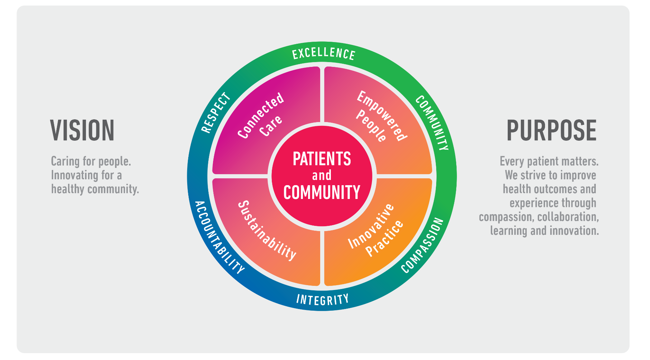
All roles are linked to the Epworth strategy and are fundamental in achieving its vision and purpose.
Connected Care – Partner with our patients through an integrated, holistic experience tailored to their needs and choices, enabling them to achieve their wellness potential
Empowered People – Enable and empower our people and teams to be their best and make a difference to the patient experience
Innovative Practice – Make a difference to our community through encouraging the ideas of our people and finding new and better ways to care and support care delivery
Sustainability – Be accountable to use resources wisely; to ensure organisational sustainability, enhance access, support the patient journey and create greater capacity for care.
4. Purpose of the Position
The purpose of this position is to contribute to Infection prevention and control and overall patient safety by provision of quality reusable medical devices through sterilization and disinfection processes. Working within a self-directed and cohesive team, the CSSD Technician will support the theatre team by collection, cleaning, decontamination, inspection, testing, packaging, sterilization, storage and distribution of reusable medical devices and equipment. The Instrument Technician will have to contribute to efficient workflow through the department regularly and utilize available resources effectively. The Technician will succeed in this key role by promoting and participating in all the required standards, quality activities, policies and procedures. A high standard of compliance in accordance with the Australian Sterilization Standard (AS5369:2023), National Safety and Quality Health Service (NSQHS) Standards and HICMR Guidelines for healthcare will need to be maintained by the Technician.
Under general supervision, the primary function of the Grade 3 CSSD Technicians is to work as a proactive member of the CSSD team to perform duties of general nature. Grade 3 Technicians can progress to undertake work of more complex nature, rotating through all reprocessing areas of CSSD. Reporting to the CSSD management, the Technician will play an active role in timely reprocessing and supply of reusable medical devices and equipment to end-users. The work of a CSSD Technician will ensure efficient service delivery to Epworth Eastern of sterile products to support patient care and ensure positive patient and clinical outcomes by effective team work and quality customer service.
Within the Epworth team, the Technician will participate in building community based culture that fosters a spirit of achievement, capability and development by ensuring consistency with Epworth’s Mission, Values and Behaviours that enables “Excellence - Everywhere, Everyday.”
5. Key Accountabilities

KEY RESPONSIBILITIES | MEASURES/KPIs TO BE ACHIEVED
Team Work  • Actively participates as a member of the CSSD team.  • Works cooperatively with the CSSD team members.  • Works collaboratively with other members of the multidisciplinary work environment.  • Treats team members in line with Epworth’s Values and Behaviours.  • Works within scope of practice in all areas as and when departmental needs arise.  • Continually assesses workload to ensure accurate and timely delivery of service to meet daily operational requirements.  • Ensures daily flow of work in CSSD, shares workload with team members fairly and functions harmoniously within the multicultural team.  • Participates and upholds an environment of trust and support.  • Builds and maintains constructive work relationships.  • Support new and existing CSSD Technicians with their training needs, ensuring approach is in line with Values and Behaviours.  • Participates in supervision of Grade 1 Technicians and trainee students. | • Attends and actively participates in department and team meetings and handovers.  • Attends operating theatre staff and other meetings when required.  • Receives feedback from team members positively and politely.  • Responds to constructive feedback and adjusts practice accordingly.  • Provides positive and constructive feedback to other team members.  • Demonstrates flexibility and works in all reprocessing areas and as per rostered shifts.  • Treats others with courtesy and respect.  • Models Epworth’s Values and Behaviours at all times.  • Participates in and supports training to department staff and students when required by CSSD Manager or Coordinator.  • Provides support in inducting and orientating new and casual staff and others.  • Offers support and assistance (with appropriate supervision)
Planning, Organising and Prioritizing  • Organizes, plans and prioritizes work to meet job daily demands.  • Assesses work load to ensure accurate and timely delivery of service.  • Inform supervisor of inability to meet time schedules and deadlines. | • Effectively organizes and plans work to meet job demands.  • Finishes work on time and to a high standard.  • Deadlines are met through fast tracking of instruments and prioritizing workloads.  • 100 % loan sets processed and ready for use and return (turnaround).
Quality Improvement  • Actively participates in quality improvement activities within the department in accordance with the National Safety and Quality Health Service (NSQHS) Standards and ACHS EQuIP National Accreditation Standards,  • Seeks ongoing continual improvement of standards and outcomes within CSSD.  • Strives to consistently improve service delivery and clinical practice.  • Provides suggestions and feedback to Coordinator or Manager on quality activities.  • Immediately notifies CSSD Manager of any quality issues arising and completes Riskman as required. | • Timelines and quality standards meet requirements and operational needs.  • Practices in accordance with AS5369:2023, ISO, NSQHS and ACHS Accreditation Standards and demonstrates compliance with AS5369:2023, ISO, NSQHS and ACHS Accreditation Standards.
Personal and Professional Development  • Continually develops, both personally and professionally to meet changing needs of career and industry.  • Participates in-services and mandatory trainings.  • Participates actively in prescribed performance development system annually.  • Participates in all annual competencies to ensure own competencies are up to date.  • Evaluates own personal performance to identify strengths and areas where development can occur.  • Identifies own development needs and plans self-development.  • Practice in accordance with legislative and common law requirements. | • Maintains an up-to-date knowledge of current trends within the speciality area of sterilizing and infection control.  • Attendance and active participation in all department in-services, education and other training and development as required.  • 100 % target to complete annual mandatory training refresher courses.  • Completes mandatory training requirements and competencies such as Living the Values and Emergency Preparedness to ensure they are up to date.  • Participates fully and actively in own PDP review process as required.  • Annual appraisals completed with agreed professional development goals.  • Compliance with mandatory and department specific competencies every 12 months or as prescribed.  • Assessment tools completed and deemed as competent.  • Personal development and competencies developed from training and assessments (e.g., manual handling and ergonomics, SWPs).  • Completion of objectives outlined in self-development plan (and able to provide evidence of).  • Seeks feedback, training or other development opportunities to develop knowledge and skills.  • Compliance with legislative and common law requirements.
Customer Service  • Anticipate the needs of CSSD customers and ensure reusable medical devices are available when required.  • Commitment to the provision of excellence in service delivery to all stakeholders.  • Treats all customers (patients, clients, relatives, visitors, staff, VMO’s, external suppliers) in a courteous and respectful manner.  • Provides excellent, helpful service to patients, clients, visitors, staff and students.  • Communicates openly and effectively with customers to ensure positive and efficient delivery of service.  • Respects and upholds the dignity and rights of consumers, relatives, carers, colleagues and other members of the community.  • Immediately notifies or escalates to CSSD Coordinator or Manager of customer complaints and service concerns.  • Maintains patient confidentiality as prescribed by the relevant Acts and Epworth policies, procedures and protocols. | • Nil customer complaints.  • Greet customers and patients promptly, politely and courteously.  • Participates in staff satisfaction surveys.  • Builds and maintains positive customer relationships, both with internal and external customers.  • Actively seeks to understand patients' and their family's (customers’) circumstances, expectations and issues.  • Use AIDET principles in all interactions with client and patients.  • Patient and customer service satisfaction surveys within agreed targets.  • Consistently meets or exceeds the expectations of our patients and customers at all times (patient and customer service satisfaction surveys within organizational targets).  • Contributes to superior patient service leading to improved healing in a trusting, caring environment and creates a safe environment for patients and employees.  • Proactively escalates concerns when necessary to ensure resolution of any current or potential breakdown in processes and systems that impact patient care and customer service.  • Service issues and customer concerns are escalated to CSSD management and resolved in a timely manner.  • Compliance with Information Privacy Act (2000) and the Health Records Act (2000).
Quality and Risk  • Practices in accordance with Infection Control and Sterilizing Standards.  • Ensures sterilising monitoring (batch, biological and chemical) and tracking practices are in line with quality assurance, standards and safe operating procedures and accurately documented.  • Ensures turnarounds for loans sets and prostheses are met and processed for use in line with required protocols and sterilizing standards (AS5369).  • Ensures full handover each shift to fellow colleagues, floor coordinator or manager.  • Assists in conducting risk audits and hazard reduction controls.  • Participates in quality activity projects within the CSSD.  • Contributes and seeks continuous improvement of standards and outcomes within CSSD.  • Sterile stock checked and rotated effectively and efficiently to maintain integrity. | • Compliance with all Epworth HealthCare policies, protocols, standard and guidelines.  • National accreditation status maintained.  • Quality activities and outcomes are documented and available.  • 100 % compliance with infection control and WHS policies and practices.  • Participating in department meetings, surveys and in-services.  • Involvement in quality projects, individually or in groups, demonstrates improvement.
Safety and Wellbeing  • Observe safety procedures and instructions provided, and work in a manner which minimises the risk of injury to themselves, fellow employees, patients and visitors.  • Ensuring a safe working environment and safe systems of work.  • Participate actively and positively in the areas of OHS to reduce all hazards and incidents within the workplace  • Complying with facility/site OHS policy, infection control standards and other relevant policy and procedures.  • Identify and report to the Manager and record onto Riskman all OHS hazards, incidents, injuries and near misses immediately to ensure a safe work environment.  • Participate in department mandatory safety training at an agreed frequency, annually and when required. | • Safely and efficiently operates all equipment in CSSD.  • Ensure your actions do not put yourself or others at risk (as per Sections 21 & 22 under the OHS Act 2004).  • Staff self “risk assess” manual tasks prior to performing.  • Actively participates and contributes to the OHS activities and consultation processes through handovers, team meetings, etc.  • Actively participates in routine monthly WHS environmental hazard inspections.  • Complies with employee obligations to the OHS Act 2014, Epworth OHS policies, protocols and safe work procedures at all times.  • Adhere to infection control, hand hygiene, personal hygiene, use of PPE and other standard precautions.  • Hazards are identified through safety observations, injuries/incidents or near misses and monthly environmental hazard inspections.  • All hazards, incidents, injuries and near misses are immediately reported to CSSD Manager and logged in RiskMan.  • Mandatory safety training related to OHS completed.  • Competencies developed and maintained in chemical safety, practical manual tasks and ergonomics.
6. Position Requirements/Key Selection Criteria
COMPONENT
Qualifications | Essential  • Minimum Sterilisation Services Certificate III or equivalent.  • Basic computer skills (MS Office, Excel, Outlook, etc.).  Desirable  - Other relevant tertiary qualifications helpful, but not essential.
Previous Experience | Essential  • Minimum 1 years’ technical experience in CSSD.  • Competence across all areas within CSSD, including scopes and surgical loans instrument reprocessing.  • Abilities to respond to direction, meet operational and service delivery requirements and deadlines.  • Demonstrates flexibility and adaptability to work in all reprocessing areas and as per rostered shifts.  • Commitment to excellent customer service with abilities to liaise with services users and staff at levels.  • Ability to support with training or mentoring of new and existing staff in current and new processes in CSSD.  • Commitment to delivering quality in healthcare.  • Good understanding of and commitment to quality improvements.
Required Knowledge & Skills | Essential  • Working knowledge of relevant regulations and standards impacting sterilising services (AS5369:2023, ISO, HICMR, NSQHS and ACHS Accreditation Standards).  • Demonstrated knowledge in application of infection prevention and control practices as it relates to sterilising services.  • High level of understanding and ability to apply workplace OHS requirements in sterilising services.  • Abilities to plan, organize and prioritise work.  • Effective communication skills (spoken and written), including good listening skills.  • Displays cultural sensitivity and ability to work within a multicultural team environment.  • Ability to positively contribute to the team.  • Professional and positive work ethics and belief in patient-centred care.  • Commitment to self-development and willingness to learn new skills.  Desirable  • Be a member of SRACA (Sterilising Research and Advisory Council of Australia).
Personal Attributes & Values  All employees are expected to consistently work in accordance with Epworth’s values and behaviours  - Respect  - Excellence  - Compassion  - Community  - Integrity  - Accountability | Essential  - Effective interpersonal and communication skills  - Willingness and ability to work within a team environment  - Ability to learn new skills  - Commitment to customer service and quality outcomes  - Ability to respond to direction  - Belief in patient centred care  - Professional work ethic  - Self-motivated and self-directed

Document Control
Date Developed: | Date Last Reviewed: | Developed and Reviewed By (Position Title):
24/2/2025 | 2/6/2026 | Jimmy Arrysandi

Employee Position Declaration
I have read and understand the requirements and expectations of the above Position Description. I agree that I have the physical ability to fulfil the inherent physical requirements of the position, and accept my role in fulfilling the Key Accountabilities. I understand that the information and statements in this position description are intended to reflect a general overview of the responsibilities and are not to be interpreted as being all-inclusive.

Employee Signature:
Print Name: | Date:

