- General Information

Position Title: | Data Strategy Program Manager
Division/Department: | Strategy and Performance
Position Reports to: | Group Director: Projects and Change
Enterprise/Individual Agreement: | Individual Agreement
Classification/Grade: | N/A
Location: | Corporate Office, Richmond
Employment Status: | Full Time FTC
Resource Management  (for Management positions only)  Number of Direct Reports:  Budget under management: | Direct Reports: TBC  Budget: Project Budgets as allocated
Key Relationships - internal and external | CIO  Chief Technology Officer  Director – Data and Integration  Data and Integration Team  Strategy team  Group Projects and Change team  Senior leaders and respective teams  Key vendors & subcontractors

Overview of Epworth HealthCare
Epworth HealthCare is Victoria's largest not-for-profit private health care group, renowned for excellence in diagnosis, treatment, care and rehabilitation. Epworth is an innovator in Australia's health system, embracing the latest in evidence-based medicine to pioneer treatments and services for our patients.

Epworth's values define our approach and our delivery. We pride ourselves on communicating our values and delivering on them in a real and meaningful way. Our Values are Respect, Excellence, Community, Compassion, Integrity and Accountability. More information can be found on the Epworth website.

Epworth's purpose is Every Patient Matters. We strive to improve health outcomes and experience through compassion, collaboration, learning and Innovation. Our Vision is Caring for People. Innovating for a healthy community.

Epworth HealthCare Strategy

All roles are linked to the Epworth strategy and are fundamental in achieving its vision and purpose.
Exceptional patient experience and outcomes - To empower our patients and deliver compassionate, expert and coordinated care.
A thriving healthcare organisation - To adapt and grow in a changing healthcare landscape by delivering a unique private not-for-profit healthcare organisation.
Remarkable place to work and practice - To ensure Epworth is an outstanding place to work and practice through a culture of care
and investment in our people.
Digitally connected care - To innovate and improve the digital experience, interactions and outcomes for our patients, staff and doctors.
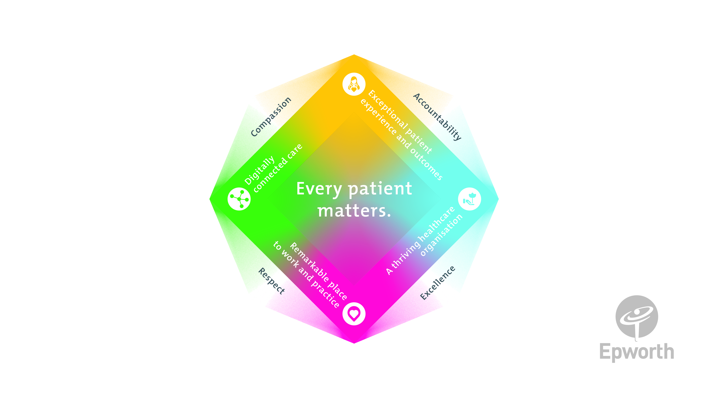

Purpose of the Position
The Data Strategy Program Manager position is an exciting position in positioning Epworth HealthCare for the planning and delivery of Epworth HealthCare's multi-year data strategy. This strategy will see the modernization of Epworth’s data infrastructure and operating model with a variety of new roles designed to support data-based decision making at Epworth.

Reporting to the Group Director – Projects and Change, this role will involve considerable communication and collaboration with key stakeholders, Executive Sponsors, and fellow program/project team members, both from within the IT team, the Strategy team, the Data and Analytics team and the Group Projects and Change team.

The Program Manager will work to ensure that projects are sequenced and coordinated, to ensure that dependencies are articulated and managed, and that costs are managed in line with the Program budget.

Clinical Governance Framework
This role is required to put into practice the Clinical Governance Framework at Epworth as every employee is accountable for ensuring that our patients and community receive safe, high quality and person-centred care in every interaction with Epworth. This is achieved through active participation in the five domains of clinical governance at Epworth:

Clinical Governance Domain Role

Consumer Partnerships
leadership and culture
Promote and participate in a supportive, fair and transparent culture where lessons from previous outcomes are learned
Iand patient safety and quality is a priority at all levels of the organisation.

Effective Workforce
Clinical Safety and Effectiveness
Risk Management
I
I
place and patient outcomes are monitored and improved.
B
Responsible for identifying and reporting risks, hazards and near misses for people in our care and participating in mitigation strategies
Understand and where relevant, ensure that each patient is actively involved in their own care and treatment including
Ifamilies/carers wherever possible.
I
Develop and maintain one's own competency, skills and knowledge to ensure high quality service provision and care.
Understand and where relevant, ensure, that the right care is provided to the right person at the right time, in the right

- Key Accountabilities

KEY RESPONSIBILITIES | MEASURES/KPls TO BE ACHIEVED
Program & Project Definition  Clearly and thoroughly identify the scope of the Program(s) & Project(s) by:  - Working collaboratively with internal and external stakeholders, at all levels within the organisation, to define and achieve mutual understanding of the scope;  - Highlight potential scoping considerations that may affect other programs & projects within the Epworth IT portfolio. | - Development and maintenance of program & project scoping documents to support the program & project outcomes;  - Timely briefings to internal and external stakeholders;  - Collaboratively establish program & project dependencies and ensure these are actively managed throughout the lifecycle.
Program & Project Planning  Collaboratively identify and schedule tasks required to achieve program & project outcomes in scope:  - Involve stakeholders as appropriate to develop and validate an end-to-end program & project schedule;  - Plan program(s) & project(s) in sufficient detail to ensure integration of all activities, identification of cross-portfolio dependencies, and understanding of critical paths and key milestones;  - Ability to assess and convey impacts to program & project schedules, scope and/or costs in response to business requirements;  - Obtain approval of the plan through effective communication;  - Ensure a comprehensive budget is prepared, reflecting the plan and all resource needs; | - Delivery and maintenance of a high-level plan(s) that shows key program & project phases and identified dependencies;  - Delivery and maintenance of an approved program & project execution plan, showing the critical path, key milestones and dependencies;  - Preparation of program & project budget and ongoing cost estimates in line with defined project gates confidence ratings and Epworth program & project accounting policies;  - Identification of constraints and risks that may impact ability to deliver the program & project on time, cost and to requirements.
Program & Project Resourcing  Identify program & project resourcing requirements in line with the program & project plan:  - Collaboratively identify cross-functional resources and associated  - effort required;  - Ensure an understanding of roles and responsibilities of all resources;  - Direct and motivate the program and project teams to achieve the desired outcomes;  - Source and effectively manage third-party resources and/or suppliers;  - Monitor, identify and escalate program and project resource issues. | - Program & project resources are clearly defined supporting effective Epworth IT Portfolio resource capacity planning;  - Resourcing requirements are endorsed by relevant IT Functional Managers;  - Identification of program and project resources with the skills and experience required to deliver the program and project outcomes;  - Delivery of outcomes that meet the defined requirements in line with program and project plan(s).
Program and Project Delivery and Control  Day-to-day management of the projects and program:  - Manage the program and project time, cost and quality activities within Epworth’s project framework  - Produce reporting in line with governance requirements;  - Ensure application of risk and issue management, mitigation actions, identify contingency plan, through the program and project lifecycle;  - Ensure effective communication to the program and project teams, internal and external stakeholders, partners, suppliers and customers  - Manage proposed changes to program and project scope, budget and schedules  - Monitor the quality of program and project deliverables and ensure program and project outcomes are met  - Conduct meetings and attend Epworth Project status review meetings where required  - Establish effective relationships with key stakeholders including Epworth IT and Group Projects and Change team | - Utilise Epworth tools templates to assist in project management and control, including Monday.com  - Delivery of program and project status reporting in line with Epworth governance requirements  - Successful completion of assigned program and project within scope, time and budget  - Facilitate Steering Committees covering the scope of the program
Stakeholder management and communication  - Effective engagement and management of all relevant stakeholders through identification of appropriate stakeholders, regular communication and responsiveness to queries and concerns.  - Collaborate with cross-functional teams, including IT, business units, and external partners, to align data initiatives with business needs. | - Stakeholder Satisfaction: Positive feedback from stakeholders regarding data initiatives and collaboration.  - Positive Executive Sponsor feedback  - Closer collaboration between the data teams and the business to ensure that the execution of the data strategy meets the needs of end users.

Customer Service  Epworth is committed to the provision of excellent customer service to all of our people, customers and stakeholders including patients and external suppliers.  Superior patient service leads to improved healing in a trusting, caring environment I  and creates a safe environment for patients and employees.  - Role model and actively promote a culture of high quality patient care  - Provide excellent, helpful service to patients, visitors and staff  - Communicate with clear and unambiguous language in all interactions, tailored to the audience  - Build customer relationships and greet customers and patients promptly and courteously  - Actively seek to understand patients' and their family's expectations and issues, using multiple strategies  - Uses data (such as compliments, complaints and Press Ganey) to identify breakdowns in internal processes and systems that directly impact patient care and customer service  - Responds quickly and proactively escalate concerns when necessary  - Role model and actively promote a culture of high quality patient care and experience by ensuring that solutions, practices and procedures (such as hourly rounding, leader rounding and bedside handover) are carried out with empathy and compassion | - Patient and customer service satisfaction surveys within agreed targets  - Use AIDET principles in all interactions  - Compliments to complaints ratio  - Completes leader rounding at agreed frequency  - Issues are escalated to the manager and resolved in a timely  - manner.
Safety and Wellbeing  To ensure a safe workplace is provided for all employees and other personnel including contractors, agency staff, volunteers and students.  - All employees and other personnel under the authority of the manager are fully informed of the hazards associated with their work activities, adequately trained and instructed in safe work procedures and appropriately supervised. Participate actively and positively in the area of health and safety to reduce all hazards and incidents within the workplace  - Integrate and review OHS performance in staff PDPs | - Adhere to infection control/personal hygiene precautions;  - Implement and adhere to Epworth OHS policies, protocols and safe work procedures;  - Ensure all hazards, incidents and injuries are reported in Riskman within 24 hours;  - Ensure all hazards, incidents and injuries are investigated and corrective actions implemented within agreed timeframes;  - Mandatory training completed at agreed frequency.

Position Requirements/Key Selection Criteria
COMPONENT
Qualifications | Essential  - Relevant Project Management qualifications.  Desirable  - Relevant Program Management qualifications;  - Tertiary qualifications in relevant Technology or equivalent work experience.
Previous Experience | Essential  - Minimum 4 years experience in technology Project Management roles;  Desirable  - Work on at least two projects related to data, preferably involving the migration from on premise to the cloud.  - Healthcare industry experience;  - Experience delivering projects in 24/7 operational environments;
Required Knowledge & Skills | - A track record of successful program & project implementations in diverse and complex organisation(s) as the Program and/or Project Manager;  - Demonstrated expertise at delivering technology solutions incl. requirements, scoping, program/project planning & implementation;  - Strong financial skills;  - Excellent administration, organisational and reporting skills;  - Good technical and practical documentation skills;  - Demonstrated Commercial and vendor management skills;  - Ability to mentor, develop, encourage and empower team members;  - Demonstrated relationship and people management skills;  - Demonstrated experience and knowledge in managing Project Risks and Issues;  - Strong Change Request Management skills and experience;

- Ability to function in a dynamic environment subject to changes in schedules and priorities;
- Prepared to make a commitment to Epworth HealthCare's mission and values;
- Develops a solid understanding of the organisation's goals and objectives;
- Demonstrate initiative, exercises good judgment and has the ability to achieve results;
- Ability to quickly appreciate and address organisational priorities;
- Ability to exercise sound judgment, working autonomously where appropriate and proactively engage with/escalate matters to the Epworth Management where circumstances warrant;
- Innovative thinking and awareness of emerging ICT trends and their potential impact on Epworth;
- Demonstrated skills in communication (verbal, written and online) and presentation;
- Ability to monitor and continually improve service delivery standards.
Personal Attributes & Values  All employees are expected to consistently work in accordance with Epworth's values and behaviours  - Respect  - Excellence  - Compassion  - Community  - Integrity  - Accountability | - Proactive, self-motivated and hard-working;  - Energetic, enthusiastic and passionate for the role;  - Flexible, adaptable and able to multi-task;  - Analytical thinker, ability to manage issues and problems in a logical and pragmatic approach;  - Attention to detail with a desire to ensure accuracy and quality in their work is achieved;  - High level of emotional maturity and personal integrity;  - Ability to effectively prioritise and execute tasks, while under pressure;  - Demonstrate initiative, exercises good judgment and has the ability to achieve results;  - Calm in the face of adversity or challenge;  - Flexibility in working hours;  - Committed to improving patient safety, quality of clinical care and reducing clinical error and risk;  - Committed to delivery and customer service;  - Ability to function in a dynamic environment subject to changes in schedules and priorities;  - Ability to communicate a clear message to a wide range of people from across all levels of the organisation;  - Developed negotiation, communication and interpersonal skills applicable to all levels of the business;  - Demonstrated ability to implement and manage change;  - Demonstrates initiative and creative thinking;  - High level of self-motivation and confidence;  - Excellent communication and interpersonal skills;  - Excellent time management and organisational skills;  - Takes responsibility for own professional development;

- Contributes to an environment of continuous learning and quality improvement;
- Ability to maintain professional relationships with key stakeholders/ organisational political astuteness;
- Ability to communicate a clear message to a wide range of people from across all levels of the organisation.

Document Control
Date Developed: | Date Last Reviewed: | Developed and Reviewed By (Position Title):
May 2025 | May 2025 | Group Director, Projects and Change

Employee Position Declaration
I have read and understand the requirements and expectations of the above Position Description. I agree that I have the physical ability to fulfil the inherent physical requirements of the position, and accept my role in fulfilling the Key Accountabilities. I understand that the information and statements in this position description are intended to reflect a general overview of the responsibilities and are not to be interpreted as being all-inclusive.

Employee Signature:

Print Name: Date:

