1. **General Information**

|  |  |
| --- | --- |
| **Position Title:** | Azure Cloud Engineer |
| **Division/Department:** | Information Technology |
| **Position Reports to:** | Senior Technical Manager – Cloud and Microsoft |
| **Enterprise/Individual Agreement:** | Individual Agreement |
| **Classification/Grade:** | NA |
| **Location:** | Richmond, Pelaco |
| **Employment Status:** | Full Time |
| **Resource Management**  (for Management positions only)  **Number of Direct Reports:**  **Budget under management:** |  |
| **Key Relationships - internal and external** | CIO Team  ICT Team  IT Security  IT Incident and Change Management |

**2. Overview of Epworth HealthCare**

Epworth HealthCare is Victoria’s largest not-for-profit private health care group, renowned for excellence in diagnosis, treatment, care and rehabilitation. Epworth is an innovator in Australia’s health system, embracing the latest in evidence-based medicine to pioneer treatments and services for our patients.

Epworth’s values define our approach and our delivery. We pride ourselves on communicating our values and delivering on them in a real and meaningful way. Our Values are Respect, Excellence, Community, Compassion, Integrity and Accountability. More information can be found on the [Epworth website](http://www.epworth.org.au/About-Us/our-values/Pages/Our-Values.aspx).

Epworth’s purpose is Every Patient Matters. We strive to improve health outcomes and experience through compassion, collaboration, learning and Innovation. Our Vision is Caring for People. Innovating for a healthy community.

**3. Epworth HealthCare Strategy**

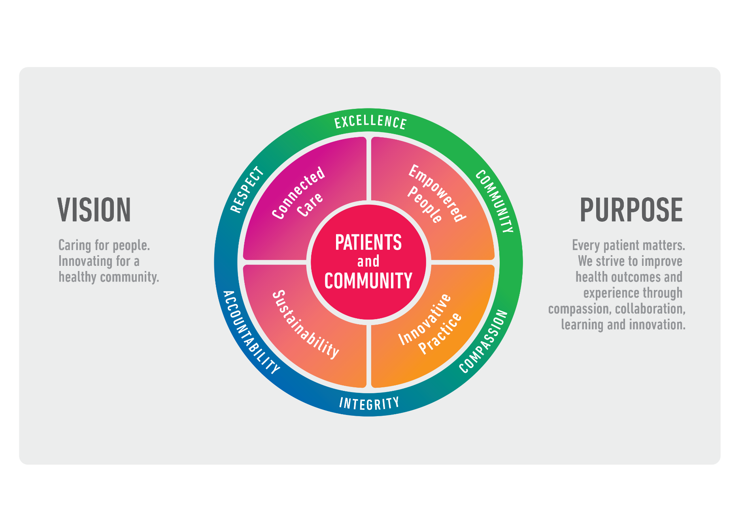

|  |
| --- |
| All roles are linked to the Epworth strategy and are fundamental in achieving its vision and purpose. |
| **Connected Care** – Partner with our patients and doctors to provide high-quality care through an integrated, holistic experience tailored to their needs and choices |
| **Empowered People** – Enable and empower our people and teams to be their best and make a difference to the patient experience |
| **Innovative Practice** – Informing and enabling health within our community through encouraging the ideas of our people and finding new and better ways to care and support care delivery |
| **Sustainability** – Be accountable to use resources wisely; to ensure organisational and environmental sustainability, enhance access, support the patient journey and create greater capacity for care. |

**4. Purpose of the Position**

The Azure Cloud Engineer will work as a member of the team that provides system support and administration of Epworth IT cloud environment – primarily within Microsoft Azure. The role will have a strong focus on supporting Epworth’s cloud infrastructure, services and supporting platforms (PaaS Services). The role will also involve working within the team to support some of Epworth’s traditional on-premises systems by bring their existing cloud\automation skills to help manage that environment more effectively in a hybrid manner. You will be an advocate for automation, the development of cloud operations skills within the organisation and support the team’s growing portfolio of critical applications which run from within Epworth’s cloud.

We seek individuals who bring innovative ideas, fresh approaches to existing practices, and a diverse mindset to support our hospital’s digital transformation and digitization efforts across data, applications, and artificial intelligence. Promoting this forward-thinking approach across the business is essential. While supporting our traditional infrastructure-as-a-service workloads is necessary, your real value will be in contributing to our growing portfolio of platform-as-a-service and other innovative technologies being rapidly onboarded.

Experience with Microsoft 365 administration, Power Automate, Entra ID, PowerBI, LogicApps and/or FunctionApps would also be advantageous to the successful applicant.

While we have some essentials that we’re looking for and some desirables, even if you feel you don’t meet all the requirements, we’d still like to hear from you.

**5. Clinical Governance Framework**

This role is required to put into practice the Clinical Governance Framework at Epworth as every employee is accountable for ensuring that our patients and community receive safe, high quality and person-centred care in every interaction with Epworth. This is achieved through active participation in the five domains of clinical governance at Epworth:

|  |  |
| --- | --- |
| **Clinical Governance Domain** | **Role** |
| ***Leadership and culture*** | Promote and participate in a supportive, fair and transparent culture where lessons from previous outcomes are learned and patient safety and quality is a priority at all levels of the organisation. |
| ***Consumer Partnerships*** | Understand and where relevant, ensure that each patient is actively involved in their own care and treatment including families/carers wherever possible. |
| ***Effective Workforce*** | Develop and maintain one’s own competency, skills and knowledge to ensure high quality service provision and care. |
| ***Clinical Safety and Effectiveness*** | Understand and where relevant, ensure, that the right care is provided to the right person at the right time, in the right place and patient outcomes are monitored and improved. |
| ***Risk Management*** | Be responsible for identifying and reporting risks, hazards and near misses for people in our care and participating in risk mitigation strategies. |

**6. Key Accountabilities**

|  |  |
| --- | --- |
| **KEY RESPONSIBILITIES** | **MEASURES/KPIs TO BE ACHIEVED** |
| **Technology Administration**   * Provide technical leadership in the support and administration of the organisation’s public cloud platform(s), IaaS, PaaS Integration, and application delivery. * Continually improve the automation, security and system management of the cloud platform(s) and the software and tools used to run and maintain them. * Maintain and support the cloud disaster recovery environment. * Monitor cloud, network and infrastructure components utilising appropriate tools. * Manage the cloud environment resources to maintain agreed financial and performance targets. * Analyse, diagnose and resolve cloud compute and faults across all environments. * Work closely with application and integration teams on the delivery of application services that exist in cloud environments. * Report on operational metrics for SLA reporting and capacity planning. * Provide guidance and mentoring to other infrastructure team members. * Perform support of Epworth technology platforms. * Be responsible for documentation of the organisation’s cloud environment including but not limited to the foundations, network, disaster recovery and procedural documentation. * Ability to concisely document/whiteboard concepts in a design or troubleshooting scenario. | * Delivery of agreed IT Service and project KPIs. * Deliver IT service improvement activities to agreed plan. * Delivery of cloud infrastructure transition project in line with project and OPEX budgets. * Contribute to the Epworth 2025 digitisation program ensuring infrastructure activities are delivered per plan. * Contribute to CIS 18 and essential 8 security targets. * Ensure the achievement of service KPIs. * Deliver IT security requirements as part of all changes. * Achieve resolution of incidents as per IT SLAs. * Plan, document and deliver cloud migrations without impact to services. * Implement all changes in line with change management process. |
| **Collaboration and Customer Service**  Collaborate with internal stakeholders and customers to perform services with team-based professionalism and integrity that is primarily service-focused   * Collaborate with business users and members of the infrastructure and cloud team to identify and plan changes with minimal distribution where possible. * Learn and develop infrastructure knowledge from one-on-one knowledge transfer, training and professional development where required | * Service Availability SLAs * Change success metrics |
| **Continuous Quality Improvement**   * Actively contribute to continuous improvement of work, standards, and methodologies. * Conduct periodic monitoring, review of Cloud performance, and recommend proactive measures as appropriate. | * Evidence of participation in quality improvement activities. * Demonstrate an initiative-taking attitude in reviewing, supporting and implementing best practice in Azure management and IT service delivery. |
| **Teamwork/Team effectiveness/Professional development**   * Provide technical coaching and mentorship to team members to uplift their cloud skills. * Able to multi- task and prioritise issue resolution with colleagues within tight time constraints – sees a problem and can think of workable solutions under pressure. * Communicate ideas which may improve the efficiency, performance, or standards of the IT Team * Participate in a prescribed performance development plan annually and evaluate personal performance and self-development requirements. * Foster and promote Epworth Values and Behaviours * Partake in out-of-hours on call support rotation. * Perform other duties as requested. | * Active participation in Infrastructure Team meetings and cross-functional IT team meetings. * Attend workshops, seminars, conferences related to field of work. * Completion of annual performance appraisal. * Completion of objectives outlined in self-development plan (provide evidence of). * Deliver individual/group trainings to fellow staff members (when requested by Manager or delegate). * Attend individual/group trainings (when requested by Manager or delegate). * Engage in self-learning to improve one’s skills relevant to field of work and IT in general. * Feedback from Manager and team members. |
| **Customer Service**  Epworth is committed to the provision of excellent customer service to all our people, customers and stakeholders including patients and external suppliers.  Superior patient service leads to improved healing in a trusting, caring environment and creates a safe environment for patients and employees.   * Provide excellent, helpful service to patients, visitors, and staff. * Communicate with clear and unambiguous language in all interactions, tailored to the audience. * Build customer relationships and greet customers and patients promptly and courteously. * Actively seek to understand patients' and their family's (customers) expectations and issues. | * Patient and customer service satisfaction surveys within agreed targets. * Use AIDET principles (acknowledge, introduce, duration, explanation and thank you) in all interactions. * Escalate issues to the manager and resolved in a timely manner. |
| **Safety and Wellbeing**  Participate actively and positively in health and safety to reduce all hazards and incidents within the workplace.   * Report all hazards, incidents, injuries and near misses immediately to your manager and log them in RiskMan. | * Adhere to infection control/personal hygiene precautions. * Implement and adhere to Epworth OHS policies, protocols, and safe work procedures. * Mandatory training completed at agreed frequency. |

**7. Position Requirements/Key Selection Criteria**

|  |  |
| --- | --- |
| **COMPONENT** |  |
| Qualifications | **Essential**   * Associate level certification from Azure or greater. * Supported IaaS infrastructure within Azure (primarily Microsoft Windows). * Experience in deploying and managing PaaS services (such as web apps, storage accounts) within Azure. * Experience in deploying and managing Cloud governance (such as Cloud Adoption Framework) and tooling (Azure Policy, Advisor, Defender for Cloud).   **Desirable**   * Associate level certification from AWS or GCP. * Background in software engineering and development. * Professional level qualification from Microsoft, VMWare, or other infrastructure providers. * Knowledge and understanding of Power Automate\Automation Accounts\LogicApps\FunctionApps. * Knowledge and understanding of other automation tools such as Ansible, PowerShell and\or Python. * Supported web apps, containers or Kubernetes environments. |
| Previous Experience | **Essential**   * Experience in supporting a Microsoft Azure cloud environment - 3 years. * Experience with the configuration of cloud compute tools and methodologies.   **Desirable**   * Experience with the configuration and ongoing maintenance of PaaS services such as Application Gateways, Azure Storage Accounts (Azure Files), virtual networking and associated services. * Experience with Microsoft 365 management\support. * Experience in supporting a hybrid cloud on-premises environment. * Experience in implementation\management of IaC CI/CD tooling (i.e. Azure DevOps). * Experience with modern platforms in Azure (Microsoft PaaS\SaaS services such as logic apps, function apps, automation accounts). * Previous cloud support in a Healthcare environment. |
| Required Knowledge & Skills | **Essential**   * Experience in supporting a Microsoft Azure cloud environment. * Utilize configuration management tools, to streamline system management. * Understanding of cloud recovery techniques. * Use of analytical skills and processes to solve IT infrastructure related problems and provide effective solutions. * Ability to work as part of a project team adhering to timelines project responsibilities while also participating in a operational role. * Contribute to collaborative work practices and a workplace environment focused on peer education, automation and efficient work practices.   **Desirable**   * Experience with Infrastructure-as-code tools such as Azure Resource Manager, Bicep or equivalent (i.e. AWS CloudFormation) * Experience with one or more automation tools such as Ansible, Terraform, Puppet, or Azure DevOps. * An understanding of relevant scripting tools such as Python and PowerShell would be advantageous. |
| Personal Attributes & Values | All employees are expected to consistently work in accordance with Epworth’s values and behaviours:   * Respect * Excellence * Compassion * Community * Integrity * Accountability |

**Document Control**

|  |  |  |
| --- | --- | --- |
| Date Developed: | Date Last Reviewed: | Developed and Reviewed By (Position Title): |
| 03rd February 2024 | 07/02/2024 | Senior Technical Manager – Cloud and Microsoft |

**8. Employee Position Declaration**

I have read and understand the requirements and expectations of the above Position Description. I agree that I have the physical ability to fulfil the inherent physical requirements of the position and accept my role in fulfilling the Key Accountabilities. I understand that the information and statements in this position description are intended to reflect a general overview of the responsibilities and are not to be interpreted as being all-inclusive.

|  |  |
| --- | --- |
| Employee Signature: |  |
| Print Name: | Date: |