- General Information
Position Title: | Epworth Healthcare Group - Food Services Dietitian
Division/Department: | Continuing Care and Support Services
Position Reports to: | Manager Speech Pathology & Dietetics, Continuing Care and Support Services (CCSS)
Enterprise/Individual Agreement: | Epworth Healthcare Dietitians, Psychologists, Medical Scientists and Medical Physicists Enterprise Agreement
Classification/Grade: | Grade 3: DTN31 - DTN34
Location: | Epworth Healthcare Group sites - Melbourne & Geelong
Employment Status: | Part-time
Resource Management  (for Management positions only)  Number of Direct Reports:  Budget under management: | N/A
Key Relationships - internal and external | - Group Director of Support Services (CCSS)  - Director Allied Health (CCSS)  - Multidisciplinary Allied Health Team  - Patients, family members & visitors  - Head Chefs  - Group Hospitality Quality Projects and Contracts Manager  - Multi-disciplinary team members and Nursing staff  - Food Services Teams  - Group Nutrition Governance Committee  - Group Senior Dietitian Committee  - External service providers and referrers

2. Overview of Epworth HealthCare
Epworth HealthCare is Victoria’s largest not-for-profit private health care group, renowned for excellence in diagnosis, treatment, care and rehabilitation. Epworth is an innovator in Australia’s health system, embracing the latest in evidence-based medicine to pioneer treatments and services for our patients.

Epworth’s values define our approach and our delivery. We pride ourselves on communicating our values and delivering on them in a real and meaningful way. Our Values are Compassion, Accountability, Respect and Excellence. More information can be found on the Epworth website.

Epworth’s purpose is Every Patient Matters.

Our Vision is Delivering another 100 years of exceptional healthcare and innovation to the Victorian community.

3. Epworth HealthCare Strategy
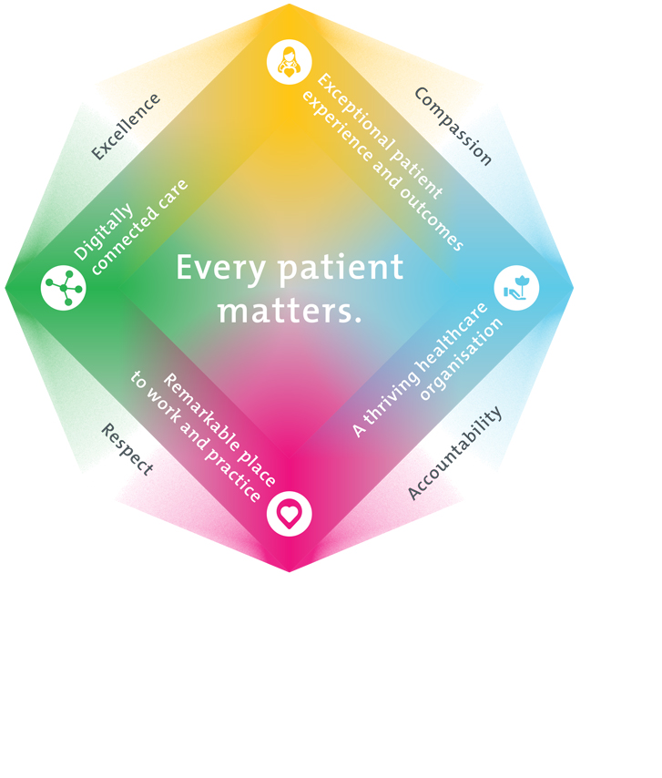
All roles are linked to the Epworth strategy and are fundamental in achieving its vision and purpose.
Exceptional patient experience and outcomes - To empower our patients and deliver compassionate, expert and coordinated care.
A thriving healthcare organisation - To adapt and grow in a changing healthcare landscape by delivering a unique private not-for-profit healthcare organisation.
Remarkable place to work and practice - To ensure Epworth is an outstanding place to work and practice through a culture of care
and investment in our people.
Digitally connected care - To innovate and improve the digital experience, interactions and outcomes for our patients, staff and doctors.
4. Purpose of the Position
To provide optimal Dietetic services support for the food services department while being responsible in monitoring compliance against food and nutrition policies, procedures and standards. To work across all food services departments across the group, and provide the highest nutritional standards, education and holistic best practice care to the patient and the family. To provide nutritional analysis and dietetic expertise to food services and education to food services staff. To be responsible in the development, implementation, review and auditing of food and nutrition.
5. Clinical Governance Framework
This role is required to put into practice the Clinical Governance Framework at Epworth as every employee is accountable for ensuring that our patients and community receive safe, high quality and person-centred care in every interaction with Epworth. This is achieved through active participation in the five domains of clinical governance at Epworth:

Clinical Governance Domain | Role
Leadership and culture | Promote and participate in a supportive, fair and transparent culture where lessons from previous outcomes are learned and patient safety and quality is a priority at all levels of the organisation.
Consumer Partnerships | Understand and where relevant, ensure that each patient is actively involved in their own care and treatment including families/carers wherever possible.
Effective Workforce | Develop and maintain one’s own competency, skills and knowledge to ensure high quality service provision and care.
Clinical Safety and Effectiveness | Understand and where relevant, ensure, that the right care is provided to the right person at the right time, in the right place and patient outcomes are monitored and improved.
Risk Management | Be responsible for identifying and reporting risks, hazards and near misses for people in our care and participating in risk mitigation strategies.
6. Key Accountabilities
KEY RESPONSIBILITIES | MEASURES/KPIs TO BE ACHIEVED
Clinical Care / Professional Practice  - Clinical patient care – ensure optimal level of function and independence for patients using appropriate assessments and treatments, in both individual and group sessions, considering physical, functional, psychological, environmental and behavioural factors to determine appropriate interventions that optimise the patients’ nutritional health and status and quality of life  - Diet Codes – ensures governance over all Diet Codes via iPM  - Delegate System – consistently oversee, review and update the nutritional database relating to specific ingredients and suppliers and conduct nutritional analysis of Delegate meals  - Food Allergy/ Allergen risk mitigation – ensure patient safety through the consistent application of procedures & processes relating to the identification, evaluation and communication of existing and emerging food allergies/allergens  - International Dysphagic Diet Standardisation Initiative (IDDSI) – consistently and collaboratively develop, embed and allocate required and/or new IDDSI related diet codes on iPM and Delegate systems. Ensure that there is access to safe / appropriately texture modified meals and a variety of dietary choices for all patients. Provide education to key food services staff regarding food texture changes  - Malnutrition - ensure that there is consistent and ready access to malnutrition appropriate therapeutic diets and other special dietary requirements.  - Menu review and development- work collaboratively with the Group Executive Chef / site based Food Services teams to ensure that menus, meal options and special dietary requirements available to patients across the organisation adhere to and comply with nutritional content, IDDSI and Food Allergy/Allergen safety criteria. In all food accessibility and food delivery that all religious requirements are met and that cultural diversity is respected  - Undertake and manage a food service workload and provide specialist knowledge and skills in this area  - In consultation with Food Services and Allied Health evaluate and maintain meals management system compliance in-line with legislative requirements  - Provide expert nutrition advice, analysis, support and education to food service staff  - Conduct and update vendor & purchasing information for all ingredients in the database  - Identify and manage all Nutritional related risks/issues while demonstrating solution based strategies.  - Monitoring compliance with Food and Nutrition Policies, procedures and standards  - Lead and oversee organisation wide annual meal audit reviewing compliance with IDDSI standards and portion sizes, including ensuring recommendations and outcomes are actioned  - Provide clinical leadership in food services, demonstrating well consolidated skills and the application of theory to practice  - Practise in accordance with the National Safety and Quality Health Services (NSQHS) Standards  - Understand and implement Epworth HealthCare Policies and Procedures and departmental work place instructions | - Support the dietetics service clinically, complying with local service delivery expectations to meet clinical caseload demands.  - Support is provided to the team in achieving patients length of stay goals  - Sound relationships are developed and maintained with customers, family and colleagues  - Patient satisfaction results meet organisational targets  - Compliance with NSQHS and clinical competencies  - Compliance with legislative and common law requirements including Privacy Act and Health Records Act  - Adherence to all Epworth Policies and Procedures contribute to the quarterly Nutrition Risk Register strategy updates where relevant ensure compliance with scheduled Delegate and IDDSI auditing processes across the organisation  - Develop & implement an organisational wide audit tool for assessing and monitoring the Epworth Food Allergy risk mitigation process  - Develop an organisational wide menu development / review process and template  - Annual meal audit is completed at all Epworth sites with outcomes/recommendations actioned in a timely manner
Leadership  - Lead and participate in the Hospitality Services department strategic planning  - Strive to enhance Epworth’s positive image within the community by promoting Dietetics and nutrition  - Monitor and proactively seek solutions to meeting nominated KPIs  - Submission of nominated reports as required  - Initiate and participate in research projects and advise regarding broader hospital based projects | - Supervision and oversight of Tertiary Institution Dietetic Food Services student placements and projects  - Staff supervision sessions and staff assessments completed and documented  - Assistance provided to Manager and to Group Director of Support Services (CCSS) to achieve identified KPI’s
Team Work /Communication  - Actively participate in relevant clinical and non-clinical meeting forums to ensure consistency of menu options across the organisation with regards to nutritional content, food allergen/allergy risk mitigation and texture modification  - Provide positive and constructive feedback to other team members  - Promote an open, friendly and professionally supportive and educative environment in the department | - Collaborate effectively with all other team members and external agencies, for efficient and effective caring patient management  - Attendance and active participation in Hospitality Governance Committee, Nutrition Governance Committee, and the Group Senior Dietitian meetings  - Positive feedback from team members regarding supervisory style
Customer Service  Epworth is committed to the provision of excellent customer service to all of our people, customers and stakeholders including patients and external suppliers.  Superior patient service leads to improved healing in a trusting, caring environment and creates a safe environment for patients and employees.  - Provide excellent, helpful service to patients, visitors and staff  - Communicate with clear and unambiguous language in all interactions, tailored to the audience  - Build customer relationships and greet customers and patients promptly and courteously  - Actively seek to understand patients' and their family's (customers) expectations and issues | - Patient and customer service satisfaction surveys within agreed targets  - Use AIDET principles in all interactions  - Issues are escalated to the manager and resolved in a timely manner
Safety and Wellbeing  Participate actively and positively in the area of health and safety to reduce all hazards and incidents within the workplace  - Report all hazards, incidents, injuries and near misses immediately to your manager and log them in RiskMan | - Adhere to infection control/personal hygiene precautions  - Implement and adhere to Epworth OHS policies, protocols and safe work procedures  - Mandatory training completed at agreed frequency

7. Position Requirements/Key Selection Criteria
COMPONENT
Qualifications | Essential  - Bachelor of Nutrition and Dietetics or equivalent degree  - Eligible for full membership of the Dietitians Australia (DA)  - Eligible for Accredited Practising Dietitian (APD) Program  Desirable  - Relevant Post Graduate qualification
Previous Experience | Essential  - Extensive clinical experience as a Dietitian (minimum 7 years experience)  - Comprehensive experience working with a Meals Management system & iPM Systems, including Diet Codes, ingredient and food allergy coding  Desirable  - Relevant experience in a hospital, rehabilitation or community setting  - Experience in food services  - Previous experience in a leadership role
Required Knowledge & Skills | Essential  - Demonstrated skill working as a member of a team and liaising, collaborating and negotiating with other service providers and agencies, patients, families and carers  - Demonstrated well-developed verbal and written communication and presentation skills  - Innovative, proactive and creative attitude to problem solving  - Ability to constructively supervise and educate staff  - Well-developed organisational skills  - Proven ability to interact and collaborate with all members of a multidisciplinary team  - Comprehensive knowledge and understanding of IDDSI Framework  - Understanding of Food Allergy Legislation  - Excellent computer literacy including MS Office, Word & Excel  - Knowledge and understanding of the National Standards and ACHS Accreditation Standards  - Appropriate knowledge of community resources and services  - Demonstrated customer service focus in service provision and evaluation  - Skills in conflict resolution and ability to manage challenging behaviour  Desirable  - Knowledge of meals management experience in a Hospital setting  - Ability to drive a motor vehicle and holds a full current driver’s licence
Personal Attributes & Values  All employees are expected to consistently work in accordance with Epworth’s values and behaviours  - Compassion  - Accountability  - Respect  - Excellence | Essential  - Belief in patient-centred care  - Ability to work autonomously  - Sensitive to the psychosocial implications of illness  - Sensitive to cultural, racial and gender differences  - Helpful and professional manner  - Professional work ethic  - Practice within the ethos of the Epworth HealthCare Values and Behaviours  - Ability to demonstrate role model behaviour for all staff  - Flexibility to assist others within the department and across sites as required  Desirable  - Flexible and available to work across sites

Document Control
Date Developed: | Date Last Reviewed: | Developed and Reviewed By (Position Title):
April 2021 | June 2025 | Manager, Speech Pathology & Dietetics, Continuing Care and Support Services (CCSS)

8. Employee Position Declaration
I have read and understand the requirements and expectations of the above Position Description. I agree that I have the physical ability to fulfil the inherent physical requirements of the position, and accept my role in fulfilling the Key Accountabilities. I understand that the information and statements in this position description are intended to reflect a general overview of the responsibilities and are not to be interpreted as being all-inclusive.
Employee Signature:
Print Name: | Date:

