- General Information
Position Title: | Database Administrator
Division/Department: | Information Technology
Position Reports to: | Adeel Khan
Enterprise/Individual Agreement: | Individual Agreement
Classification/Grade: | NA
Location: | Richmond, Pelaco
Employment Status: | Full Time
Resource Management
(for Management positions only)
Number of Direct Reports:
Budget under management:
Key Relationships - internal and external | CIO Team ICT Team  Vendor Management IT Security  IT Incident and Change Management
2. Overview of Epworth HealthCare
Epworth HealthCare is Victoria’s largest not-for-profit private health care group, renowned for excellence in diagnosis, treatment, care and rehabilitation. Epworth is an innovator in Australia’s health system, embracing the latest in evidence-based medicine to pioneer treatments and services for our patients.

Epworth’s values define our approach and our delivery. We pride ourselves on communicating our values and delivering on them in a real and meaningful way. Our Values are Compassion, Accountability, Respect and Excellence. More information can be found on the Epworth website.

Epworth’s purpose is Every Patient Matters.

Our Vision is Delivering another 100 years of exceptional healthcare and innovation to the Victorian community.

3. Epworth HealthCare Strategy
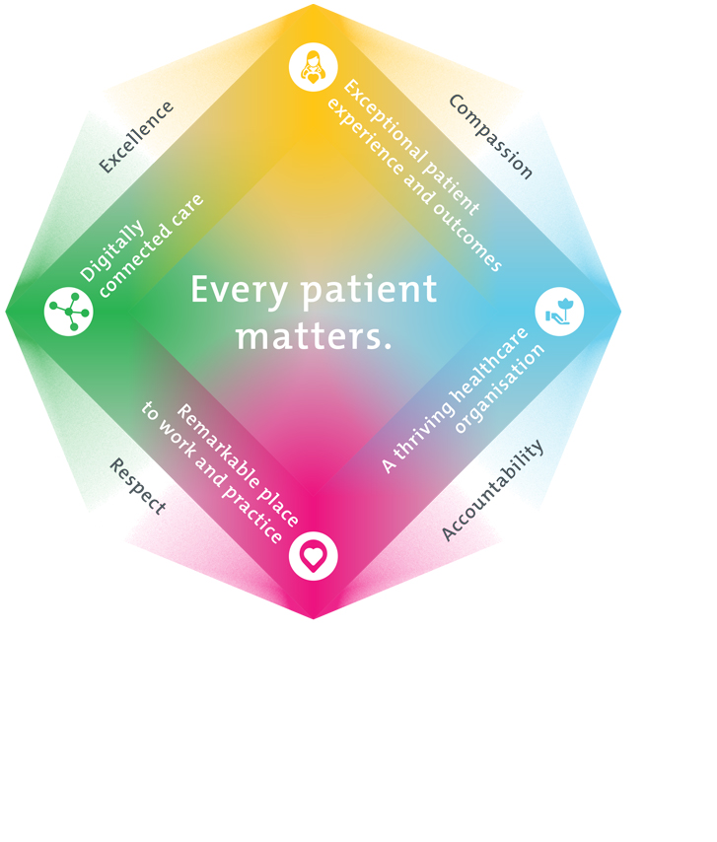
All roles are linked to the Epworth strategy and are fundamental in achieving its vision and purpose.
Exceptional patient experience and outcomes - To empower our patients and deliver compassionate, expert and coordinated care.
A thriving healthcare organisation - To adapt and grow in a changing healthcare landscape by delivering a unique private not-for-profit healthcare organisation.
Remarkable place to work and practice - To ensure Epworth is an outstanding place to work and practice through a culture of care
and investment in our people.
Digitally connected care - To innovate and improve the digital experience, interactions and outcomes for our patients, staff and doctors.
4. Purpose of the Position
The Database Administrator is a mid-level technical role within the Data Services team in the Information Technology Department, primarily responsible for supporting Epworth HealthCare’s databases and the applications that depend on them.

In this role, you will report to Senior DBA and assist with the day-to-day management of databases, ensuring they function efficiently both on-premises and in cloud environments. You will help maintain database performance, availability, and security, making sure that critical information is accessible when needed while safeguarding data integrity.

As a DBA, you will develop your technical, problem-solving, and communication skills while gaining hands-on experience in database management and support. An understanding of hospital operations and IT systems would be beneficial.

You will also work closely with end-users, IT team members, and vendors to understand database-related needs, troubleshoot issues, and support the implementation of solutions that align with the organisation’s technology strategy and governance standards.

This is an excellent opportunity to build expertise in database administration while contributing to a critical healthcare environment.
5. Clinical Governance Framework
This role is required to put into practice the Clinical Governance Framework at Epworth as every employee is accountable for ensuring that our patients and community receive safe, high quality and person-centred care in every interaction with Epworth. This is achieved through active participation in the five domains of clinical governance at Epworth:

Clinical Governance Domain | Role
Leadership and culture | Promote and participate in a supportive, fair and transparent culture where lessons from previous outcomes are learned and patient safety and quality is a priority at all levels of the organisation.
Consumer Partnerships | Understand and where relevant, ensure that each patient is actively involved in their own care and treatment including families/carers wherever possible.
Effective Workforce | Develop and maintain one’s own competency, skills and knowledge to ensure high quality service provision and care.
Clinical Safety and Effectiveness | Understand and where relevant, ensure, that the right care is provided to the right person at the right time, in the right place and patient outcomes are monitored and improved.
Risk Management | Be responsible for identifying and reporting risks, hazards and near misses for people in our care and participating in risk mitigation strategies.

Key Accountabilities

KEY RESPONSIBILITIES | MEASURES/KPIs TO BE ACHIEVED
Database Administration and Operational Management  - Implement, maintain and support of all Epworth database infrastructure  - Monitor database activity and resource usage, ensuring optimum performance and future capacity are maintained by regularly performing  - analysis, fine-tuning, and reporting of statistics (growth patterns, disk, CPU  - and Memory)  - Manage and test database back-up and recovery plans  - Prioritise and troubleshoot database issues that arise  - Participate in incident analysis and problem remediation activities, ensuring completeness of root cause analysis for problems, major/critical or recurring incidents, and where possible resolve or provide workarounds, suggestions and improvements to mitigate future incidents  - Develop and maintain effective security measures to safeguard the organisation data and databases  - Develop and maintain procedures and documentation for databases, ensuring up to date copies of relevant systems documentation are available as required  - Participate in release management activities  - Ensure all database servers are maintained with system patches and upgrades.  - Follow up escalations and provide ongoing information to facilitate issue resolution  - Communicate progress of outstanding support tickets to users  - Manage related support tickets logged to vendor support teams | - Adherence to ITIL framework  - Support tickets are responded, investigated, and resolved within agreed SLAs.  - Follow agreed process to escalate, monitor, and manage tickets with vendors  - Progress notes and Information for support tickets are updated timely and accurately.  - Root cause analysis for problems are conducted and documented, causes are identified accurately, and proposed solutions/workarounds are effective in mitigating future incidents  - Database servers are up-to-date with version releases, patches, and service packs in line with systems maintenance policies.  - Database performance measurement against agreed baselines.  - Conformance with agreed security standards  - Feedback from internal and external stakeholders  - Customer surveys of performance

- Provide out-of-hours database support for major IT incidents when required
Database Strategy and Planning  - Assist in the development of the Epworth’s Database architecture, policies and practices  - Participate in the development of a Disaster Recovery and Business Continuity Plan where it relates to Epworth’s production databases  - Participate in the setting of standards for security, integrity, and availability of organisation databases  - Conduct evaluation of new and existing databases to ensure alignment with Epworth’s database standards and architecture principles | - Ensure that database environments are established in accordance with business requirements and architecture principles.  - Contribution to Disaster Recovery and Business Continuity Plan where it relates to Epworth’s production databases  - Ensure databases meet Epworth’s target levels of data security, integrity, and availability  - Feedback from Senior DBA / Manager and IT Team Members  - Feedback from business stakeholders
Continuous Quality Improvement  - Actively contribute to continuous improvement of work, standards and methodologies  - Conduct periodic monitoring and review of database performance and recommend proactive measures as appropriate | - Evidence of participation in quality improvement activities  - Demonstrate a proactive attitude in reviewing, supporting and implementing best practice in database management and IT service delivery  - Improvement in performance of supported applications/databases
Teamwork/Team effectiveness/Professional development  - Able to multi- task and prioritise issue resolution with colleagues within tight time constraints  - Communicate ideas which may improve the efficiency, performance or standards of the IT Team  - Participate in prescribed performance development plan annually and evaluate personal performance and self-development requirements  - Share skills with other team members to ensure a high degree of continuity for supported databases and applications  - Foster and promote Epworth Values and Behaviours  - Partake in out-of-hours on call support rotation  - Perform other duties as requested | - Active participation in Database Team meetings and cross functional IT team meetings  - Attend workshops, seminars, conferences related to field of work  - Participate in internal and external groups in relation to the applications installed at Epworth HealthCare  - Completion of annual performance appraisal  - Completion of objectives outlined in self-development plan  - Deliver group trainings to fellow staff members (when requested by Manager or Senior DBA)  - Attend group trainings (when requested by Manager or Senior DBA)  - Engage in self-learning to improve one’s skills relevant to field of work and IT in general.

Customer Service  Epworth is committed to the provision of excellent customer service to all of our people, customers and stakeholders including patients and external suppliers.  Superior patient service leads to improved healing in a trusting, caring environment and creates a safe environment for patients and employees.  - Provide excellent, helpful service to patients, visitors and staff  - Communicate with clear and unambiguous language in all interactions, tailored to the audience  - Build customer relationships and greet customers and patients promptly and courteously  - Actively seek to understand patients' and their family's (customers) expectations and issues | - Patient and customer service satisfaction surveys within agreed targets  - Use AIDET principles in all interactions  - Issues are escalated to the manager and resolved in a timely manner
Safety and Wellbeing  Participate actively and positively in the area of health and safety to reduce all hazards and incidents within the workplace  - Report all hazards, incidents, injuries and near misses immediately to your manager and log them in RiskMan | - Adhere to infection control/personal hygiene precautions  - Implement and adhere to Epworth OHS policies, protocols and safe work procedures  - Mandatory training completed at agreed frequency
7. Position Requirements/Key Selection Criteria
COMPONENT
Qualifications | Essential  - Minimum Bachelor’s Degree in Information Technology or relevant field  Desirable  - Master Degree in Information Technology or relevant field  - Microsoft Azure DBA Certification DP-300
Previous Experience | Essential  - 3 to 5 years of technical experience and expertise in supporting critical business systems in large organizations in the capacity of a Database Administrator.  - Good background in implementing, supporting, and managing Microsoft SQL Database environments including SSIS/PowerBI on premises and in cloud environments  - Experience in project-based work  Desirable  - Knowledge of Project Management methodologies (e.g. Prince2, Agile)  - Experience and Good working knowledge of hospitals, hospital systems and processes
Required Knowledge & Skills | Essential:  - Good proficiency in MS SQL programming  - Knowledge of database clustering, Always On availability groups, replication, partitioning, performance tuning, and SQL/T-SQL optimization  - Ability to support, maintain, and implement databases and applications in Windows Server environments  - Strong problem-solving skills with the ability to troubleshoot database and application issues  - Basic understanding of cloud concepts and technologies  - Good stakeholder and vendor management skills  - Strong written and verbal communication skills, with the ability to explain technical concepts in a clear, user-friendly manner  - Good critical thinking and analytical skills  - Ability to create technical and user documentation  Desirable:  - Basic to intermediate scripting skills in PowerShell  - Some experience or knowledge in migrating databases from on-premises to cloud (preferably Azure)
Personal Attributes & Values  All employees are expected to consistently work in accordance with Epworth’s values and behaviours  - Compassion  - Accountability  - Respect  - Excellence | Essential  - Self-motivated and directed  - Keen attention to detail  - Committed to Excellence and a desire to ensure things are done properly  - Committed to ongoing professional development and learning  - Committed to high quality customer service and change management  - Committed to team development and improving group skills to enhance performance  - Ability to effectively prioritise and execute tasks in a high-pressure environment  - Willingness to participate in a cross-functional team-based environment  - Good interpersonal skills  Desirable  - Willingness to lead in a cross-functional team-based environment  - Strong interpersonal skills with an ability to bring people together for a common goal.

Document Control
Date Developed: | Date Last Reviewed: | Developed and Reviewed By (Position Title):
14th September 2024 | 9th October 2024 | CTO

8. Employee Position Declaration
I have read and understand the requirements and expectations of the above Position Description. I agree that I have the physical ability to fulfil the inherent physical requirements of the position, and accept my role in fulfilling the Key Accountabilities. I understand that the information and statements in this position description are intended to reflect a general overview of the responsibilities and are not to be interpreted as being all-inclusive.
Employee Signature:
Print Name: | Date:

