- General Information
Position Title: | Research Support Officer
Division/Department: | Epworth Office for Research
Position Reports to: | Group Manager Research Operations
Enterprise/Individual Agreement: | Individual Agreement
Classification/Grade: | N/A
Location: | Richmond
Employment Status: | Full time; Fixed term (12 months)
Resource Management  (for Management positions only)  Number of Direct Reports:  Budget under management: | N/A  N/A
Key Relationships - internal and external | Internal:  - Group Manager Research Operations  - Director of Research/Chief Research Officer  - Office for Research  - Research team specific colleagues e.g. clinical trial coordinators, clinical research nurses  - Principal Investigators (PIs)  - Visiting Medical Officers  - Staff in all relevant corporate departments (e.g. finance, people & culture)  - Epworth Medical Foundation | External:  - Representatives from research partners – including clinical trial sponsors, clinical research organisations (CROs) and partnering academic institutes.  - Vendors – including pathology services and couriers  - Relevant professional bodies  - Funders

2. Overview of Epworth HealthCare
Epworth HealthCare is Victoria’s largest not-for-profit private health care group, renowned for excellence in diagnosis, treatment, care and rehabilitation. Epworth is an innovator in Australia’s health system, embracing the latest in evidence-based medicine to pioneer treatments and services for our patients.

Epworth’s values define our approach and our delivery. We pride ourselves on communicating our values and delivering on them in a real and meaningful way. Our Values are Compassion, Accountability, Respect and Excellence. More information can be found on the Epworth website.

Epworth’s purpose is Every Patient Matters.

Our Vision is Delivering another 100 years of exceptional healthcare and innovation to the Victorian community.

Overview of the Office for Research
The Office for Research serves as Epworth’s central hub for research activity, partnering with researchers and teams to provide support, education and guidance across the ethical, regulatory and governance landscape of clinical research.
Our experienced multidisciplinary team enables high-quality, compliant and safe research by assisting with key aspects of project approvals, including feasibility and biostatistical advice, governance requirements and applications, as well as incident management and annual reporting.

3. Epworth HealthCare Strategy
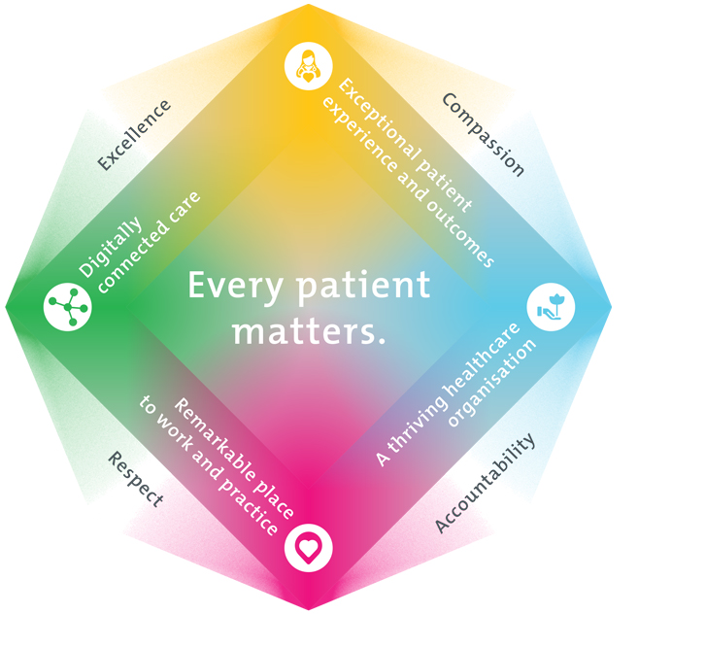
All roles are linked to the Epworth strategy and are fundamental in achieving its vision and purpose.
Exceptional patient experience and outcomes - To empower our patients and deliver compassionate, expert and coordinated care.
A thriving healthcare organisation - To adapt and grow in a changing healthcare landscape by delivering a unique private not-for-profit healthcare organisation.
Remarkable place to work and practice - To ensure Epworth is an outstanding place to work and practice through a culture of care
and investment in our people.
Digitally connected care - To innovate and improve the digital experience, interactions and outcomes for our patients, staff and doctors.
4. Purpose of the Position
The Research Support Officer will provide strategic leadership to advance research initiatives and clinical trial development to support the Epworth Research strategy. This position will scaffold the identification and development of research proposals and funding opportunities, and ensure proposals are clear, concise, and accurately reflect the project’s scope. For funded projects, this position will coordinate and drive the development of clinical trial proposals, encompassing budgets, timelines, and key deliverables. The Research Support Officer ensures the delivery of high-quality research outcomes, patient safety, and operational efficiency while fostering a collaborative and high-performing team culture.

5. Clinical Governance Framework
This role is required to put into practice the Clinical Governance Framework at Epworth as every employee is accountable for ensuring that our patients and community receive safe, high quality and person-centred care in every interaction with Epworth. This is achieved through active participation in the five domains of clinical governance at Epworth:

Clinical Governance Domain | Role
Leadership and culture | Promote and participate in a supportive, fair and transparent culture where lessons from previous outcomes are learned and patient safety and quality is a priority at all levels of the organisation.
Consumer Partnerships | Understand and where relevant, ensure that each patient is actively involved in their own care and treatment including families/carers wherever possible.
Effective Workforce | Develop and maintain one’s own competency, skills and knowledge to ensure high quality service provision and care.
Clinical Safety and Effectiveness | Understand and where relevant, ensure, that the right care is provided to the right person at the right time, in the right place and patient outcomes are monitored and improved.
Risk Management | Be responsible for identifying and reporting risks, hazards and near misses for people in our care and participating in risk mitigation strategies.

6. Key Accountabilities
KEY RESPONSIBILITIES | MEASURES/KPIs TO BE ACHIEVED
Research Advisory and Project Planning  Epworth is committed to providing a responsive and reliable advisory service to researchers and clinicians. This includes practical guidance on feasibility, approvals and funding pathways to enable well‑planned, compliant projects that commence on time and deliver value.  - Provide high‑quality customer service and practical advisory support on research planning, ethics, governance and funding requirements.  - Apply knowledge of relevant legislation, guidelines and institutional policies to support compliant research design and planning.  - Consult with researchers to provide guidance on feasibility, approval pathways, timelines and documentation requirements.  - Identify and promote relevant domestic and international research funding opportunities in collaboration with Epworth colleagues.  - Support early‑stage project development, including advice on required approvals, budgets and supporting documentation. | - Researcher enquiries responded to within agreed service standards.  - Positive stakeholder feedback regarding the clarity, accessibility and usefulness of advice provided.  - Demonstrated contribution to well‑planned, compliant research applications and funding submissions.  - Timely dissemination of relevant funding and project development opportunities.
Ethics and Governance Applications  Epworth is committed to safe, ethical and compliant research oversight. This includes coordinated review, timely monitoring and disciplined secretariat support to ensure approvals are secured efficiently and responsibilities are transparently met.  - Act as the primary liaison for researchers, providing clear advice on ethics and governance pathways, requirements and timelines.  - Support end‑to‑end preparation and submission of ethics and site governance applications in collaboration with Office for Research colleagues.  - Resolve review queries by coordinating clarifications, revisions and re‑submissions in line with regulatory and institutional requirements. | - ≥75% of first‑round submissions approved with conditions for HREC/governance review; reduction in avoidable resubmissions.  - Positive feedback from researchers and governance staff on clarity, usefulness and professionalism of liaison support  - ≥90% of submissions lodged to reviewing bodies within agreed preparation timeframes once documents are received complete.  - 100% of files complete and traceable with no material non‑conformances identified during internal checks or audits.
Post‑Approval Research Support and Coordination  Epworth aims to support researchers post‑approval to uphold high‑quality, efficient research conduct. This includes clear guidance on reporting and amendments, and coordination or data support as needed to help studies proceed smoothly and in line with approved arrangements.  - Provide post‑approval support to researchers who need a central point of contact for operational, coordination and reporting matters.  - Support researchers to meet post‑approval requirements, including amendments, monitoring, reporting and study close‑out.  - Provide coordination support from time to time, including assistance with participant visits, liaison with clinical teams and study procedures, as required.  - Provide ad‑hoc support for research data collection and documentation to ensure accuracy, completeness and compliance with approved requirements.  - Maintain accurate, secure and audit‑ready post‑approval records and support monitoring and audit activities as required.  - Guide researchers to meet post‑approval obligations, including amendments, annual and final reports, and safety or deviation notifications.  - Maintain accurate, audit‑ready records and contribute to guidance materials that improve researcher capability and reduce avoidable delays. | - Amendments, reports and post‑approval submissions are accurate, complete and submitted on time once documentation is finalised.  - Ad‑hoc coordination and data support is delivered effectively and in accordance with approved protocols when required.  - Post‑approval study documentation is complete, current and audit‑ready.  - Positive feedback from researchers regarding the clarity and usefulness of post‑approval support provided.
Continuous Improvement & Innovation  Epworth strives for excellence through continuous improvement and innovation in our research program and trial operations. Data-driven decision-making and process optimisation enhance efficiency and research impact.  - Identify and implement process improvements for trial operations.  - Contribute to SOP development and digital transformation initiatives.  - Monitor research and trial metrics and use data to drive efficiency.  - Contribute to developing templates, guidelines, and streamlined workflows that enhance efficiency across grants administration, protocol development and impact activities. | - Translation of at least one project into a documented process improvement, implemented annually.  - Portfolio metrics reported quarterly and used for decision-making.  - Research impact measures reviewed and reported annually.
Safety and Wellbeing  To ensure a safe workplace is provided for all employees and other personnel including contractors, agency staff, volunteers and students.  - All employees and other personnel under the authority of the manager are fully informed of the hazards associated with their work activities, adequately trained and instructed in safe work procedures and appropriately supervised.  - Participate actively and positively in the area of health and safety to reduce all hazards and incidents within the workplace  - Integrate and review OHS performance in staff PDPs  - Ensure all direct reports are held accountable for safety performance and actions | - Adhere to infection control/personal hygiene precautions  - Implement and adhere to Epworth OHS policies, protocols and safe work procedures  - Ensure all hazards, incidents and injuries are reported in Riskman within 24 hours  - Ensure all hazards, incidents and injuries are investigated and corrective actions implemented within agreed timeframes  - Mandatory training completed at agreed frequency
7. Position Requirements/Key Selection Criteria
COMPONENT
Qualifications | Essential  - Degree in Science, Nursing, Pharmacy, or related discipline.  - Current Good Clinical Practice (GCP) certification or willingness to obtain.  Desirable  - Postgraduate qualification in Clinical Research, Health Administration, Research Management or related field.
Previous Experience | Essential  - Minimum 2 years’ experience in clinical research coordination, development or management.  - Experience supporting researchers with ethics and/or governance submissions.  - Experience providing administrative or coordination support across the research lifecycle in a service‑focused environment.  Desirable  - Experience developing or supporting research budgets, project documentation or funding submissions.  - Previous exposure to ethics submissions and governance processes.  - Experience working within a large tertiary-level health service.
Required Knowledge & Skills | Essential  - Excellent written and verbal communication skills.  - Advanced academic writing with ability to translate complex and technical concepts into impactful and implementable documents.  - Sound knowledge of research ethics and governance principles, including familiarity with the NHMRC National Statement, privacy requirements and institutional research policies.  - Strong service orientation with ability to build rapport quickly to establish comfortable working relationships.  - Maintain a strong focus on detail and accuracy.  - Adaptable to changing demands, responding promptly and decisively.
Personal Attributes & Values  All employees are expected to consistently work in accordance with Epworth’s values and behaviours  - Compassion  - Accountability  - Respect  - Excellence | Essential  - Optimize time effectively to maximize productivity.  - Collaborative, proactive and solutions‑focused approach to supporting researchers and colleagues.  - High attention to detail and commitment to quality output.  - Commitment to high‑quality research conduct and continuous improvement in service delivery.  Desirable  - Ability to influence and drive continuous improvement

Document Control
Date Developed: | Date Last Reviewed: | Developed and Reviewed By (Position Title):
19 January 2026 |  | Project Director – Research Strategy  Deputy CMO – Academia  Group Director Research  Group Manager Research Operations

8. Employee Position Declaration
I have read and understand the requirements and expectations of the above Position Description. I agree that I have the physical ability to fulfil the inherent physical requirements of the position, and accept my role in fulfilling the Key Accountabilities. I understand that the information and statements in this position description are intended to reflect a general overview of the responsibilities and are not to be interpreted as being all-inclusive.
Employee Signature:
Print Name: | Date:

