# General Information

|  |  |
| --- | --- |
| **Position Title:** | Clinical Psychologist |
| **Division/Department:** | Epworth Rehabilitation & Mental Health, Psychology |
| **Position Reports to:** | Psychology Manager and Grade 3’s |
| **Enterprise/Individual Agreement:** | Epworth Healthcare Dietitians, Psychologists, Medical Scientists and Medical Physicists Enterprise Agreement |
| **Classification/Grade:** | Grade 2: P21 –P25 |
| **Location:** | Geelong |
| **Employment Status:** | Casual |
| **Resource Management**  (for Management positions only)  **Number of Direct Reports:**  **Budget under management:** | N/A |
| **Key Relationships - internal and external** | * Patients and family members & visitors * Multi-disciplinary team members and Nursing staff * Rehabilitation Consultants, Medical Staff & VMO’s * Service providers and external referrers |

1. **Overview of Epworth HealthCare**

Epworth HealthCare is Victoria’s largest not-for-profit private health care group, renowned for excellence in diagnosis, treatment, care and rehabilitation. Epworth is an innovator in Australia’s health system, embracing the latest in evidence-based medicine to pioneer treatments and services for our patients.

Epworth’s values define our approach and our delivery. We pride ourselves on communicating our values and delivering on them in a real and meaningful way. Our Values are Compassion, Accountability, Respect and Excellence. More information can be found on the Epworth website.

Epworth’s purpose is Every Patient Matters.

Our Vision is Delivering another 100 years of exceptional healthcare and innovation to the Victorian community.

# Epworth HealthCare Strategy

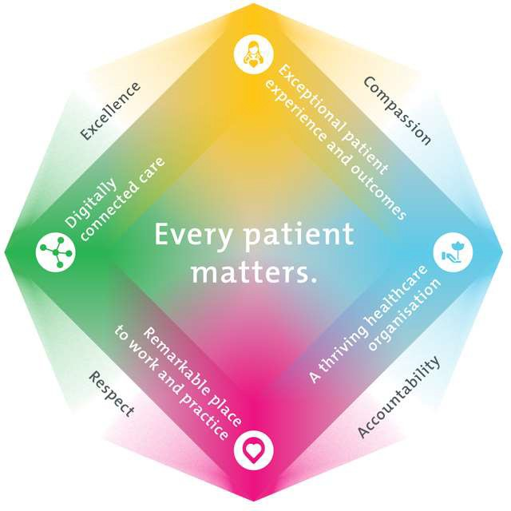

**Exceptional patient experience and outcomes -** To empower our patients and deliver compassionate, expert and coordinated care.

All roles are linked to the Epworth strategy and are fundamental in achieving its vision and purpose.

|  |
| --- |
| **A thriving healthcare organisation -** To adapt and grow in a changing healthcare landscape by delivering a unique private not-for-profit  healthcare organisation. |
| **Remarkable place to work and practice -** To ensure Epworth is an outstanding place to work and practice through a culture of care  and investment in our people. |
| **Digitally connected care -** To innovate and improve the digital experience, interactions and outcomes for our patients, staff and doctors. |

1. **Purpose of the Position**

To provide optimal Psychological services and positive clinical outcomes to Epworth patients ensuring long-term health and wellbeing that is consistent with Epworth HealthCare's Vision and Values. Working within a multidisciplinary team, provide (under the supervision of a Grade 3 Psychologist) effective clinical, educational, emotional support and holistic best practice care to the patient and the family. Promote excellence to our customers and the marketplace and support colleagues by sharing knowledge and expertise. This position may be based at one or multiple rehabilitation sites (Hawthorn, Richmond, Camberwell, Brighton).

# Clinical Governance Framework

This role is required to put into practice the Clinical Governance Framework at Epworth as every employee is accountable for ensuring that our patients and community receive safe, high quality and person-centred care in every interaction with Epworth. This is achieved through active participation in the five domains of clinical governance at Epworth:

**Clinical Governance Domain Role**

|  |  |
| --- | --- |
| ***Leadership and culture*** | Promote and participate in a supportive, fair and transparent culture where lessons from previous outcomes are learned  and patient safety and quality is a priority at all levels of the organisation. |
| ***Consumer Partnerships*** | Understand and where relevant, ensure that each patient is actively involved in their own care and treatment including  families/carers wherever possible. |
| ***Effective Workforce*** | Develop and maintain one’s own competency, skills and knowledge to ensure high quality service provision and care. |
| ***Clinical Safety and Effectiveness*** | Understand and where relevant, ensure, that the right care is provided to the right person at the right time, in the right place and patient outcomes are monitored and improved. |
| ***Risk Management*** | Be responsible for identifying and reporting risks, hazards and near misses for people in our care and participating in risk  mitigation strategies. |

# Key Accountabilities

|  |  |
| --- | --- |
| **KEY RESPONSIBILITIES** | **MEASURES/KPIs TO BE ACHIEVED** |
| **Clinical Care/Professional Practice**   * Provide best practice psychological assessments and interventions to inpatients and outpatients within a range of rehabilitation programs * Work with other team members to develop effective goal focussed rehabilitation programs for patients * Provide individual and group interventions as required * Establish and maintain appropriate standards of practice relating to patient admission, assessment, treatment, family liaison and discharge planning * Complete suicide risk assessments and develop appropriate management plans in accordance with Epworth policies * Implement, monitor and modify treatment programs within the clinical area as appropriate * Demonstrate empathy and compassion and encourage patient and family members participation in all stages of care * Practice within the scope of registration of a Psychologist with AHPRA * Practice in accordance with the National Safety and Quality Health Services(NSQHS) Standards * Demonstrate reflective, critical thinking and evidence based approach to the provision of patient care * Maintain patient confidentiality as prescribed by the relevant acts and organizational policies and procedures * Understand and implement Epworth HealthCare Policies and Procedures and departmental work place instructions * Contribute to the development and maintenance of new and established clinical services and the broader team | * Appropriate standards of practice relating to assessments and treatments are implemented in a timely manner * Compliance with mandatory and team based documentation in patients’ medical records within agreed timeframes * Effective participation in team based case discussions and family meetings * Direct patient care provided within allocated time frames from referral to treatment and within funding parameters * Outpatient KPI of 9 x (30-sessions) per day is achieved where applicable * Timely intervention is provided to support the team in achieving patients length of stay goals * Sound relationships are developed and maintained with customers, family and colleagues * Patient satisfaction results meet organisational targets * Compliance with NSQHS and clinical competencies * Compliance with accepted professional standards and Australian Psychological Society Code of Ethics * Compliance with legislative and common law requirements including Privacy Act and Health Records Act * Adherence to all Epworth Policies and Procedures |
| **Customer Service**  Epworth is committed to the provision of excellent customer service to all of our people, customers and stakeholders including patients and external suppliers. | * Patients are given the opportunity to actively participate in their treatment planning and implementation * Use AIDET principles in all interactions |

|  |  |
| --- | --- |
| Superior patient service leads to improved recovery in a trusting, caring environment and also creates a safe environment for patients and employees.   * Provide excellent, helpful service to patients, visitors and staff * Communicate with clear and unambiguous language in all interactions, tailored to the audience * Build customer relationships and greet customers and patients promptly and courteously * Actively seek to understand patients' and their family's circumstances, expectations and issues | * Issues or concerns are proactively escalated to the manager and resolved in a timely manner * Patient compliments and complaints are recorded in Riskman * Consistently meet or exceeds the expectations of our patients and customers at all times * Awareness of Epworth HealthCare's complaints process and assistance provided to patients if required * Effectively handle and resolve patient complaints in accordance with Patient Complaint Protocol |
| **Team Work /Communication**   * Actively participate as a member of the department and multidisciplinary team * Provide positive and constructive feedback to other team members | * Collaborate effectively with all other team members and external agencies for efficient patient management * Attendance and active participation in departmental and multidisciplinary team meetings * Positive feedback from team members * Timely and clear communication |
| **Continuous Quality Improvement**   * Actively participate in Quality activities ensuring opportunities for improvement are actively explored and best practice is achieved * Provide suggestions and feedback to consistently improve service delivery, clinical practice and patient satisfaction * Promote and enhance Epworth HealthCare and the department’s positive image within the community | * Evidence of participation in quality enhancement activities * Quality projects are completed within agreed time frame * Demonstrated commitment to Australian Commission on Safety and Quality in Health Care, National Safety and Quality HealthCare Services (NSQHS) Standards * Under direction of senior staff departmental resources, equipment and educational information are maintained and updated |
| **Personal and Professional Development** |  |

|  |  |
| --- | --- |
| * Participate in ongoing professional development by upgrading clinical competencies and knowledge and participating in both internal and external educational opportunities * Actively participate in Performance Development Plan annually and evaluate personal performance * Educate and support AHA staff and students as required * Contribute to student development programs as directed | * Participation in Psychology Week if applicable * Attendance in internal and external professional development educational forums as required * Participation in in-service and education activities as required * Completion of annual performance review and development plan * Meeting of registration standards for CPD |
| **Safety and Wellbeing**   * Participate actively and positively in the area of health and safety to reduce all hazards and incidents within the workplace * Report all hazards, incidents, injuries and near misses immediately to the manager and log them in RiskMan where appropriate | * Adhere to infection control/personal hygiene precautions * Adherence to Epworth OHS policies, protocols and safe work procedures at all times * Mandatory training completed at agreed frequency |

**6. Position Requirements/Key Selection Criteria**

|  |  |
| --- | --- |
| **COMPONENT** |  |
| Qualifications | **Essential**   * Masters or Doctoral degree in Psychology, (Clinical or Health or Counselling specialisation preferred) * Psychologist registration with the Australian Health Practitioner Regulation Agency (AHPRA) * Satisfactory Police check * Working with Children Check   **Desirable**   * Endorsement or working towards endorsement in Clinical/Health/Counselling Psychology with AHPRA * Eligible for membership of one of the Colleges of the Australian Psychological Society * Current Victorian driver’s licence * Pre employment medical check may be required |

|  |  |
| --- | --- |
| Previous Experience | **Essential**   * Experience in the selection, application and interpretation of psychological assessments and interventions for clients with medical related conditions   **Desirable**   * Previous experience in rehabilitation hospital setting |
| Required Knowledge & Skills | **Essential**   * Proficiency in psychological assessment and intervention for a range of client groups in a hospital / rehabilitation setting * Knowledge about rehabilitation psychology and skills in applying knowledge to practice * Demonstrated skill in working as a member of a team and liaising, collaborating and negotiating with other service providers and agencies, patient’s families and carers * Demonstrate well developed verbal and written communication and presentation skills * Innovative, proactive and creative attitude to problem solving * Well-developed organisational skills * Excellent computer literacy including MS Office Word & Excel * Knowledge and understanding of the National Standards and ACHS Accreditation Standards * Appropriate knowledge of community resources and services * Is customer-focussed/person-centred in services provision and evaluation * Skills in conflict resolution and ability to manage challenging behaviour   **Desirable**   * Knowledge of medico-legal and health and safety issues as they relate to the rehabilitation setting |
| Personal Attributes & Values  All employees are expected to consistently work in accordance with Epworth’s values and  behaviours | **Essential**   * Belief in patient centred care * Team oriented * Sensitive to the psychosocial implications of illness * Sensitive to cultural, racial and gender differences |

|  |  |
| --- | --- |
| * Compassion * Accountability * Respect * Excellence | * Helpful and professional manner * Professional work ethic * Practice within the ethos of the Epworth HealthCare Values and Behaviours * Demonstrate role model behaviour   **Desirable** |

**Document Control**

|  |  |  |
| --- | --- | --- |
| **Date Developed:** | **Date Last Reviewed:** | **Developed and Reviewed By (Position Title):** |
| August 2016 | 23 December 2024 | Allied Health Manager |

# Employee Position Declaration

I have read and understand the requirements and expectations of the above Position Description. I agree that I have the physical ability to fulfil the inherent physical requirements of the position, and accept my role in fulfilling the Key Accountabilities. I understand that the information and statements in this position description are intended to reflect a general overview of the responsibilities and are not to be interpreted as being all-inclusive.

Employee Signature: Print Name: Date: