- General Information
Position Title: | Cyber Security Administrator
Division/Department: | Information Technology
Position Reports to: | Group Manager Information Security
Enterprise/Individual Agreement: | Individual Agreement
Classification/Grade:
Location: | All Epworth Sites
Employment Status: | Full Time
Resource Management  (for Management positions only)  Number of Direct Reports:  Budget under management: | N/A
Key Relationships - internal and external
2. Overview of Epworth HealthCare
Epworth HealthCare is Victoria’s largest not-for-profit private health care group, renowned for excellence in diagnosis, treatment, care and rehabilitation. Epworth is an innovator in Australia’s health system, embracing the latest in evidence-based medicine to pioneer treatments and services for our patients.

Epworth’s values define our approach and our delivery. We pride ourselves on communicating our values and delivering on them in a real and meaningful way. Our Values are Compassion, Accountability, Respect and Excellence. More information can be found on the Epworth website.

Epworth’s purpose is Every Patient Matters.

Our Vision is Delivering another 100 years of exceptional healthcare and innovation to the Victorian community.

3. Epworth HealthCare Strategy
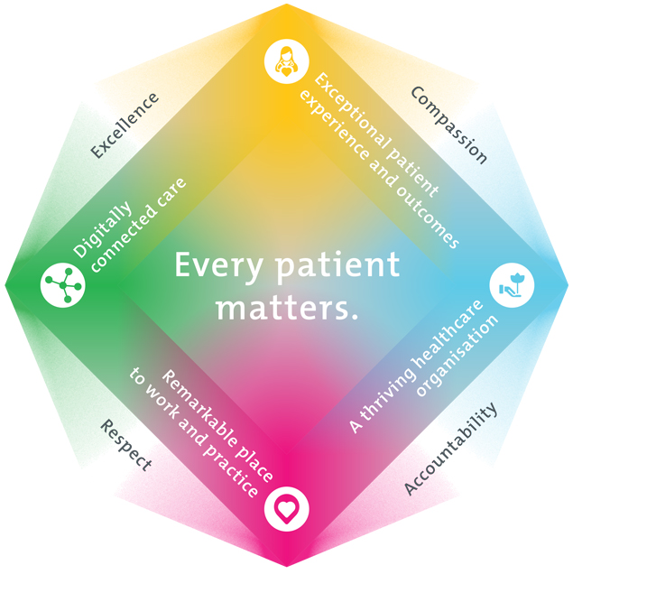
All roles are linked to the Epworth strategy and are fundamental in achieving its vision and purpose.
Exceptional patient experience and outcomes - To empower our patients and deliver compassionate, expert and coordinated care.
A thriving healthcare organisation - To adapt and grow in a changing healthcare landscape by delivering a unique private not-for-profit healthcare organisation.
Remarkable place to work and practice - To ensure Epworth is an outstanding place to work and practice through a culture of care
and investment in our people.
Digitally connected care - To innovate and improve the digital experience, interactions and outcomes for our patients, staff and doctors.
4. Purpose of the Position
This role will cover improving the business’s overall cyber security risk and compliance posture with a focus on meeting the SOCI criteria and improving our
security framework. This will include developing systems and processes to both solve business problems and enable project teams to deliver business initiatives. The role will also need to be able to help manage incidents and security related service requests under the direction of the Group Manager Information Security.
Emphasis will be placed on achieving the target CIS (Centre for Internet Security) score. Additional responsibilities include undertaking tasks and projects as determined by the Group Manager Information Security.
5. Clinical Governance Framework
This role is required to put into practice the Clinical Governance Framework at Epworth as every employee is accountable for ensuring that our patients and community receive safe, high quality and person-centred care in every interaction with Epworth. This is achieved through active participation in the five domains of clinical governance at Epworth:

Clinical Governance Domain | Role
Leadership and culture | Promote and participate in a supportive, fair and transparent culture where lessons from previous outcomes are learned and patient safety and quality is a priority at all levels of the organisation.
Consumer Partnerships | Understand and where relevant, ensure that each patient is actively involved in their own care and treatment including families/carers wherever possible.
Effective Workforce | Develop and maintain one’s own competency, skills and knowledge to ensure high quality service provision and care.
Clinical Safety and Effectiveness | Understand and where relevant, ensure, that the right care is provided to the right person at the right time, in the right place and patient outcomes are monitored and improved.
Risk Management | Be responsible for identifying and reporting risks, hazards and near misses for people in our care and participating in risk mitigation strategies.
6. Key Accountabilities
KEY RESPONSIBILITIES | MEASURES/KPIs TO BE ACHIEVED
Risk Management  Analyze keys systems for risks and hazards. Document and  suggest risk treatment options.  Analyse and document risks and hazards across all IT environments and systems  as required by the SOCI/SLACIP 2022 act.  • Compliance - Perform cyber compliance activities for SOCI and non SOCI,  ensuring controls are meeting and addressing the associated risks.  • Essential 8 - Assessment, Identification and documentation of Essential 8 gaps  and propose potential solutions.  • Implement: SOCI initiatives as defined by the CIO, CTO and GM Security  • Support - Provide cyber security support across the hospital, including  identification, protection, detection, response, and recovery from cyber security  events. As per Epworth cyber framework.  • Perform data analysis of application and system logs; monitoring, analysing and  contributing to the response of security events and threats; providing support to  ensure Hospitals products, systems and services manage security risks  appropriately.  • Automation and integration of security tools and processes.  • Configuration and support of Epworth’s selected security tools.  • Contribute to the execution of the Epworth Cyber Security strategy.  • Creating and maintaining support documentation and runbook processes.  • Analysing security requirements and recommending/implementing improvements  • Liaise with our SOC team and assist in resolving alerts and incidents | CIS18 Maturity Score = Agreed benchmark target achieved by  31/12/2025  • Essential 8 level 1 achieved and maintained  • All IT SLACIP requirements within 18 months of legislation  being approved  • No high-risk audit actions outstanding
Incident & Request fulfilment Management  • Log, review, escalate & closure of Cyber-Security incidents and service requests  in the ITSM toolset.  • Follow appropriate escalation procedures in an event the ticket cannot be resolved  immediately.  • Keep end-users informed throughout the life cycle of the Cyber-Security  incident/problem.  • Follow the Major incident management process  • Creation of knowledge management database articles for known fixes | • Review tickets logged in ITSM toolset on a weekly/monthly  basis  • Produce a report on key statistics such as incidents logged,  closed, escalated, etc.  • Knowledge transfer/Cross training/upskilling of Service Desk to  enable them with resolving Cyber-Security tickets to assist with  improving Fixed on First ratio and aiming at resolving 60% of  incidents at the Service Desk.
Communication  • Ensuring excellent business communication is maintained | • Ensuring superior customer follow up on incidents and service  requests  • Ensuring proper communication workflow channels are  maintained when a priority incident is logged and keeping  executive and other staff informed of the disruption and  resolution status  • Clear communication with vendors and partners.  • Setting up & managing planned/unplanned/change notification  templates for standard IT communication emails.
Continuous Quality Improvement  • Ensuring internal Cyber-Security processes are satisfied and kept up to date | • Review of existing Cyber-Security processes and procedures  • Update documentation and maintain version control  • Recommendation of pro-active measures where necessary
Customer Service  Epworth is committed to the provision of excellent customer service to all of our people, customers and stakeholders including patients and external suppliers.  Superior patient service leads to improved healing in a trusting, caring environment and creates a safe environment for patients and employees.  - Provide excellent, helpful service to patients, visitors and staff  - Communicate with clear and unambiguous language in all interactions, tailored to the audience  - Build customer relationships and greet customers and patients promptly and courteously  - Actively seek to understand patients' and their family's (customers) expectations and issues | - Patient and customer service satisfaction surveys within agreed targets  - Use AIDET principles in all interactions  - Issues are escalated to the manager and resolved in a timely manner
Safety and Wellbeing  Participate actively and positively in the area of health and safety to reduce all hazards and incidents within the workplace  - Report all hazards, incidents, injuries and near misses immediately to your manager and log them in RiskMan | - Adhere to infection control/personal hygiene precautions  - Implement and adhere to Epworth OHS policies, protocols and safe work procedures  - Mandatory training completed at agreed frequency
7. Position Requirements/Key Selection Criteria
COMPONENT
Qualifications | Desirable  - Cyber-Security related certificate or experience
Previous Experience | Essential  - A proven record of working in an IT environment for a minimum of 2 years, unless applying as an IT graduate.  Desirable  - Experience working in a Healthcare environment.  - Customer Service Experience
Required Knowledge & Skills | Essential  - Solid troubleshooting skills, with a logical mindset to be able to break down problems  - A motivated individual with the ability to work as a team and autonomously
Personal Attributes & Values  All employees are expected to consistently work in accordance with Epworth’s values and behaviours  - Compassion  - Accountability  - Respect  - Excellence | Essential  - Motivated with a desire to learn, investigate issues and problems  - Strong interpersonal skills  - Detail orientated

Document Control
Date Developed: | Date Last Reviewed: | Developed and Reviewed By (Position Title):

8. Employee Position Declaration
I have read and understand the requirements and expectations of the above Position Description. I agree that I have the physical ability to fulfil the inherent physical requirements of the position, and accept my role in fulfilling the Key Accountabilities. I understand that the information and statements in this position description are intended to reflect a general overview of the responsibilities and are not to be interpreted as being all-inclusive.
Employee Signature:
Print Name: | Date:

