

General Information

Position Title: | Mental Health Outpatient Coordinator
Division/Department: | Epworth Community Mental Health Programs - Patient Administration
Position Reports to: | MH Allied Health Program Manager
Enterprise/Individual Agreement: | Health & Allied Services Enterprise Agreement
Classification/Grade: | BOF
Location: | Camberwell
Employment Status: | Part Time
Key Relationships - internal and external | Patients, AH Therapists, Doctors (Referring and Treating VMO’s), Medical Receptionists, Administration Team, Health Insurers and other Funding bodies,

Overview of Epworth HealthCare
Epworth HealthCare is Victoria’s largest not-for-profit private health care group, renowned for excellence in diagnosis, treatment, care and rehabilitation. Epworth is an innovator in Australia’s health system, embracing the latest in evidence-based medicine to pioneer treatments and services for our patients.

Epworth’s values define our approach and our delivery. We pride ourselves on communicating our values and delivering on them in a real and meaningful way. Our Values are Respect, Excellence, Community, Compassion, Integrity and Accountability. More information can be found on the Epworth website.

Epworth’s purpose is to improve the health, wellbeing and experience of every patient by integrating clinical practice with education and research and our vision is to consistently deliver excellent patient-centred care with compassion and dignity.

Epworth HealthCare Strategy
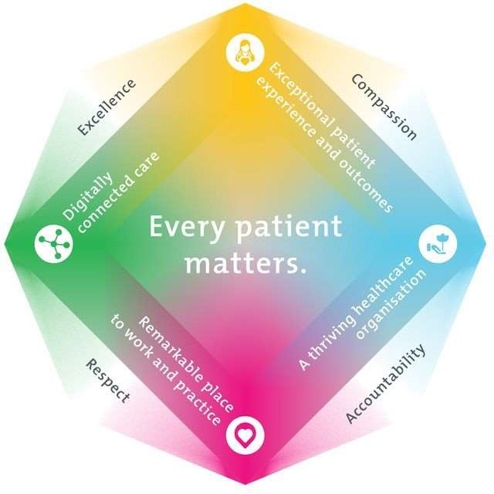

All roles are linked to the Epworth strategy and are fundamental in achieving its vision and purpose.
Exceptional patient experience and outcomes - To empower our patients and deliver compassionate, expert and coordinated care.
A thriving healthcare organisation - To adapt and grow in a changing healthcare landscape by delivering a unique private not-for-profit healthcare organisation.
Remarkable place to work and practice - To ensure Epworth is an outstanding place to work and practice through a culture of care and investment in our people.
Digitally connected care - To innovate and improve the digital experience, interactions and outcomes for our patients, staff and doctors.

Purpose of the Position
The primary function of the Outpatient Coordinator is to provide customer service and administrative support to Epworth staff, patients, visitors, relatives and medical staff. This role is based within the Mental Health Outpatient Program services and is multi-disciplined across outpatient administration department. This role is non- clinical and will incorporate effectively:
  - Providing a comprehensive reception service directing patients, visitors and staff to appropriate services
  - Management of the administrative processing of patients across all aspects of outpatient pre-admission, admission, service delivery and discharge phases.

Key Accountabilities

KEY RESPONSIBILITIES | MEASURES/KPIs TO BE ACHIEVED
Reception -  - Answer patient, visitors & staff enquiries.  - Maintain a neat and professional reception area at all times.  - Assist with internal and external inbound & outbound mail preparation | - Consistently facilitates the delivery of quality care and service.  - Development of working relationships with other hospital departments  - All correspondence is managed with the highest degree of confidentiality, efficiently and effectively
Administration –  - Management of all outpatient therapy department referrals  - Confirm Health fund eligibility and/or funding arrangements have been conducted prior to each patient’s outpatient admission  - Ensure patient’s outpatient admission and discharge processes are managed with a high degree of accuracy and efficiency  - Provision of daily diary schedules for all treating therapists  - Daily preparation of billing documents for provision to central Billing Department  - Maintain accurate patient records  - Taxi bookings for patient transfers  - Monitor and order stationary supplies | - Efficient admission to outpatient programs with no delays or adverse impact to patient continuum of care  - Provision of accurate information to patient and family members in relation to hospital charges and general information within the framework of privacy legislation requirements  - Evident focus on high level customer service and patient satisfaction  - Scheduling of all therapy programs for patients that result in publication to AH Staff Diaries  - Scheduling of outpatient programs within funding criteria for all private and compensable insured patients  - Accurate revenue cycle  - Accurate system data integrity that reflects the patient attendances
Administration Support -  - Assist the Team Leader to establish and maintain a departmental procedure manual  - Attend meetings on behalf of the department as required  - Produce computer reports as required  - Undertake any general administrative tasks as directed by the Team Leader | - Well trained and fully competent team with full access to comprehensive reference tools to support their roles

Continuous Quality Improvement –  - Actively contribute to continuous improvement of work, standards and methodologies  - Ensure appropriate administrative processes align to administrative governance  - Collection and recording of program specific data and outcome measures | - Ensure business requirements are satisfied through efficient administrative support
Customer Service – Staff  Epworth is committed to the provision of excellent customer service to all of our people, customers and stakeholders including patients and external suppliers.  Superior patient service leads to improved healing in a trusting, caring environment and creates a safe environment for patients and employees.  - Provide excellent, helpful service to patients, visitors and staff  - Communicate with clear and unambiguous language in all interactions, tailored to the audience  - Build customer relationships and greet customers and patients promptly and courteously  - Actively seek to understand patients' and their family's (customers) expectations and issues | - Patient and customer service satisfaction surveys within agreed targets  - Demonstrate commitment to Epworth Values and Behaviours  - Issues are escalated to the manager and resolved in a timely manner
Safety and Wellbeing – Staff  Participate actively and positively in the area of health and safety to reduce all hazards and incidents within the workplace  - Report all hazards, incidents, injuries and near misses immediately to your manager and log them in RiskMan | - Adhere to infection control/personal hygiene precautions  - Implement and adhere to Epworth OHS policies, protocols and safe work procedures  - Mandatory training completed at agreed frequency

- Position Requirements/Key Selection Criteria

COMPONENT | Essential/Desirable
Qualifications | - Training in Customer Service principles for a service-oriented environment  - Business Administration Certificate 3
Previous Experience | - Working knowledge in a service-oriented environment  - Working knowledge in a Hospital Administration/Patient Services role
Required Knowledge & Skills | - Strong customer service orientation, focussed on achieving results  - Excellent computer skills  - An aptitude for multi-tasking, prioritise and manage multiple tasks of moderate to high complexity to meet deadlines  - Excellent organisational skills  - Previous working knowledge of hospital Patient Management systems i.e. iPM/BOSSNet
Personal Attributes & Values  All employees are expected to consistently work in accordance with Epworth’s values and behaviours  - Respect  - Excellence  - Compassion  - Community  - Integrity  - Accountability | - Proactive and hard-working  - Flexible, adaptable and able to multi-task  - Ability to work autonomously as required but to also work collaboratively and effectively within a team environment  - Committed to delivery of Excellence in Customer Service  - Committed to and role model the organisational Values and Behaviours
Document Control
Date Developed: 4/1/19 | Date Last Reviewed: 5/5/22 Date Last Reviewed: 5/8/24 Date Last Reviewed: 19/2/25  February 2026 | Developed and Reviewed By (Position Title): Divisional Administration Manager Reviewed By (Position Title): Divisional Administration Manager  Reviewed By (Position Title): MH Program Manager  Reviewed By (Position Title): MH Program Manager

Employee Position Declaration
I have read and understand the requirements and expectations of the above Position Description. I agree that I have the physical ability to fulfil the inherent physical requirements of the position, and accept my role in fulfilling the Key Accountabilities. I understand that the information and statements in this position description are intended to reflect a general overview of the responsibilities and are not to be interpreted as being all-inclusive.

Employee Signature:

Print Name: Date:

