- General Information
Position Title: | Registered Nurse
Position Reports to: | Nurse Unit Manager (or nominee)
Enterprise/Individual Agreement: | Epworth HealthCare Nurses and Midwives Enterprise Agreement 2020-2024
Classification/Grade: | Grade 2
Key Relationships - internal and external | - Patients, inclusive of family member(s) & visitors  - Nurse Unit Manager and Associate Nurse Unit Manager  - Medical staff and VMOs and Hospital Medical Officers (HMO)  - Multi-disciplinary team colleagues Internal service providers Ie. pathology, patient transport, radiology
2. Overview of Epworth HealthCare
Epworth HealthCare is Victoria’s largest not-for-profit private health care group, renowned for excellence in diagnosis, treatment, care and rehabilitation. Epworth is an innovator in Australia’s health system, embracing the latest in evidence-based medicine to pioneer treatments and services for our patients.

Epworth’s values define our approach and our delivery. We pride ourselves on communicating our values and delivering on them in a real and meaningful way. Our Values are Compassion, Accountability, Respect and Excellence. More information can be found on the Epworth website.

Epworth’s purpose is Every Patient Matters.

Our Vision is Delivering another 100 years of exceptional healthcare and innovation to the Victorian community.

3. Epworth HealthCare Strategy
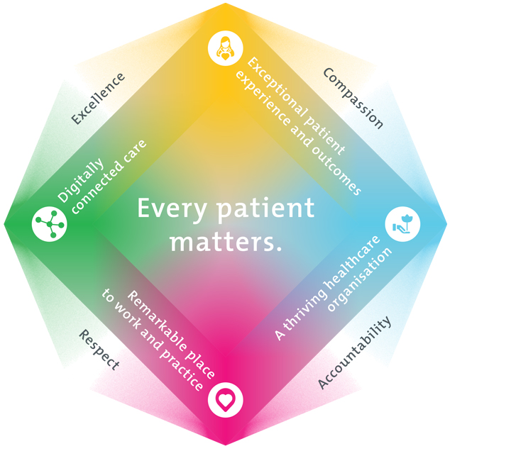
All roles are linked to the Epworth strategy and are fundamental in achieving its vision and purpose.
Exceptional patient experience and outcomes - To empower our patients and deliver compassionate, expert and coordinated care.
A thriving healthcare organisation - To adapt and grow in a changing healthcare landscape by delivering a unique private not-for-profit healthcare organisation.
Remarkable place to work and practice - To ensure Epworth is an outstanding place to work and practice through a culture of care
and investment in our people.
Digitally connected care - To innovate and improve the digital experience, interactions and outcomes for our patients, staff and doctors.
4. Purpose of the Position
To collaborate and provide best practice in high quality surgical nursing and patient assessment skills and experience that is in accordance with the patient’s physical, psychological, emotional, social and spiritual well being. In particular to utilise available resources, promote and participate in all national standards and quality activities and provide outstanding customer service to ensure positive clinical outcomes.
5. Clinical Governance Framework
This role is required to put into practice the Clinical Governance Framework at Epworth as every employee is accountable for ensuring that our patients and community receive safe, high quality and person-centred care in every interaction with Epworth. This is achieved through active participation in the five domains of clinical governance at Epworth:

Clinical Governance Domain | Role
Leadership and culture | Promote and participate in a supportive, fair and transparent culture where lessons from previous outcomes are learned and patient safety and quality is a priority at all levels of the organisation.
Consumer Partnerships | Understand and where relevant, ensure that each patient is actively involved in their own care and treatment including families/carers wherever possible.
Effective Workforce | Develop and maintain one’s own competency, skills and knowledge to ensure high quality service provision and care.
Clinical Safety and Effectiveness | Understand and where relevant, ensure, that the right care is provided to the right person at the right time, in the right place and patient outcomes are monitored and improved.
Risk Management | Be responsible for identifying and reporting risks, hazards and near misses for people in our care and participating in risk mitigation strategies.
6. Key Accountabilities
KEY RESPONSIBILITIES | MEASURES/KPIs TO BE ACHIEVED
Clinical Care  - Practice in accordance with Nursing and Midwifery Board of Australia (NMBA) National Competency Standards for Registered Nurses  - Practice in accordance with the National Safety and Quality Health Service (NSQHS) Standards  - Practice in accordance with legislative and common law requirements  - Actively participate in a team nursing model of care  - Utilises a reflective, critical thinking and evidence based approach to the clinical care of patients  - Consistently conduct & participate in bedside handover  - Encourages patients and family members participation in all stages of care continuum  - Performs effective admission and discharge processes in accordance with organisation KPI  - Timely reporting of outcomes of nursing interventions to the Nurse Unit Manager (or delegate)  - Demonstrate empathy and compassion to patients and their family, colleagues and VMOs. Respect and uphold the dignity and rights of consumers, relatives, carers, colleagues and members of the community  - Maintain patient confidentiality as prescribed by the relevant Acts and organisational policies and protocols  - Practices in accordance with Infection Control Standards | - Compliance with mandatory and unit specific competencies every 12 months or as prescribed  - Compliance with NMBA National Competency Standards for Registered Nurses  - Compliance with NSQHS  - Compliance with legislative and common law requirements  - Compliance with discharge KPI  - Patient and customer service satisfaction surveys to be within organisational targets  - Sound relationships developed and maintained with customers  - Compliance with Information Privacy Act (2000) and the Health Records Act (2000)  - Compliance with EEO & Social Medial Policies and Protocols of Epworth HealthCare  - Compliance with Call Bell response KPI
Team Work  - Works cooperatively and collaboratively with all members of the multidisciplinary team  - Provides positive and constructive feedback to others team members  - Actively participates as a member of the units team | - Attends and actively participates in department and team meetings  - Feedback from team members
Quality Improvement  - Strives to consistently improve service delivery and clinical practice  - Provides suggestions, and feedback to ANUM and NUM on quality activities  - Actively participates in quality improvement activities within the unit or department in accordance with the National Standards for Clinical Excellence and ACHS Accreditation Standards | - Evidence of participation in quality activities  - Improved patient care  - Improvement in performance of unit and Epworth healthcare site  - Show a proactive attitude in reviewing, supporting and implementing relevant research into the clinical environment  - Provide leadership [with appropriate supervision] to other team members by acting as Nurse In Charge from time to time

Personal and Professional Development  - Participates in prescribed performance development system annually  - Evaluates personal performance and plans self-development  - Participates in supervision of Enrolled Nurses and students (where requested by NUM)  - Participates in the orientates new and casual staff  - Participates in and provides as requested by NUM (or delegate) education to unit staff and students | - Completion of annual performance appraisal  - Participation in in-services, ward education, ward meetings  - Completion of objectives outlined in self- development plan (provide evidence of)  - Training of staff in relevant ward/unit specific activities (when requested by NUM)
Customer Service  Epworth is committed to the provision of excellent customer service to all of our people, customers and stakeholders including patients and external suppliers.  Superior patient service leads to improved healing in a trusting, caring environment and creates a safe environment for patients and employees.  - Provide excellent, helpful service to patients, visitors and staff  - Communicate with clear and unambiguous language in all interactions, tailored to the audience  - Build customer relationships and greet customers and patients promptly and courteously  - Actively seek to understand patients' and their family's (customers) expectations and issues | - Patient and customer service satisfaction surveys within agreed targets  - Use AIDET principles in all interactions  - Issues are escalated to the manager and resolved in a timely manner
Safety and Wellbeing  Participate actively and positively in the area of health and safety to reduce all hazards and incidents within the workplace  - Report all hazards, incidents, injuries and near misses immediately to your manager and log them in RiskMan | - Adhere to infection control/personal hygiene precautions  - Implement and adhere to Epworth OHS policies, protocols and safe work procedures  - Mandatory training completed at agreed frequency
7. Position Requirements/Key Selection Criteria
COMPONENT
Qualifications | Essential  Registered Nurse with:  - Nursing and Midwifery Board of Australia [NMBA]  - Australian Health Practitioner Regulation Agency [AHPRA]  Desirable  - Relevant Post Graduate qualification
Previous Experience | Essential  - Broad knowledge and experience in surgical nursing  - Strength in patient assessment
Required Knowledge & Skills | Essential  - Knowledge and commitment to Acts, Agreements and Epworth Healthcare directions, policies, procedures and staff code of conduct  - Knowledge and understanding of National Standards for Clinical Excellence and ACHS Accreditation Standards  - Solid computer skills  Desirable  - Demonstrate role model behaviour  - Superior conflict resolution skills
Personal Attributes & Values  All employees are expected to consistently work in accordance with Epworth’s values and behaviours  - Compassion  - Accountability  - Respect  - Excellence | Essential  - Belief in patient centred care  - Committed to providing a safe environment for patients & colleagues  - Professional work ethic  - Practices within the ethos of the Epworth HealthCare Values & Behaviours  Desirable  - Self-motivated and self-directed

Document Control
Date Developed: | Date Last Reviewed: | Developed and Reviewed By (Position Title):

8. Employee Position Declaration
I have read and understand the requirements and expectations of the above Position Description. I agree that I have the physical ability to fulfil the inherent physical requirements of the position, and accept my role in fulfilling the Key Accountabilities. I understand that the information and statements in this position description are intended to reflect a general overview of the responsibilities and are not to be interpreted as being all-inclusive.
Employee Signature:
Print Name: | Date:

