General Information

Position Title: | Dietitian
Division/Department: | Epworth Acute / Allied Health Department
Position Reports To: | Epworth Eastern Allied Health Manager
Enterprise/Individual Agreement: | Epworth Healthcare Dietitians, Psychologists, Medical Scientists and Medical Physicists Enterprise Agreement
Classification/Grade: | Grade 1: DTN13 – DTN17
Location: | Epworth Eastern, Box Hill
Employment Status: | Casual
Key Relationships - Internal and External | - Patients, family members/carers & visitors  - Multidisciplinary team members including medical, nursing, food service & allied health staff  - External service providers and referrers
- Overview of Epworth HealthCare
Epworth HealthCare is Victoria’s largest not-for-profit private health care group, renowned for excellence in diagnosis, treatment, care and rehabilitation. Epworth
is an innovator in Australia’s health system, embracing the latest in evidence-based medicine to pioneer treatments and services for our patients.

Epworth’s values define our approach and our delivery. We pride ourselves on communicating our values and delivering on them in a real and meaningful way. Our Values are Respect, Excellence, Community, Compassion, Integrity and Accountability. More information can be found on the Epworth website.
Epworth’s purpose is to improve the health, wellbeing and experience of every patient by integrating clinical practice with education and research and our vision is to consistently deliver excellent patient-centred care with compassion and dignity.

Epworth HealthCare Strategy
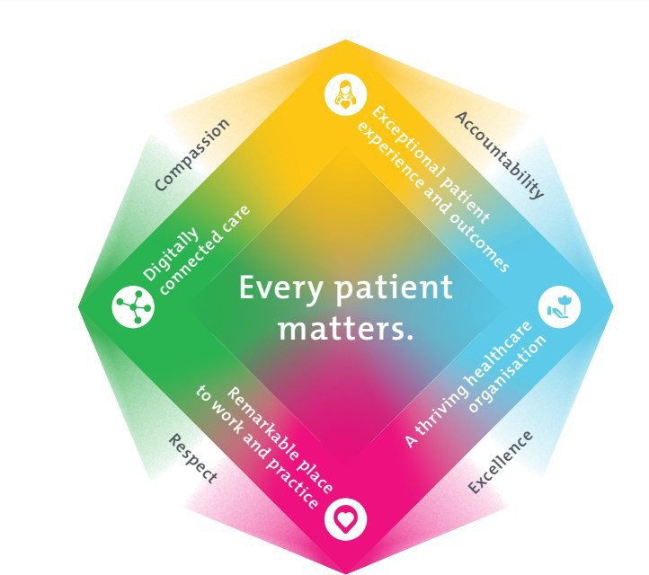

All roles are linked to the Epworth strategy and are fundamental in achieving its vision and purpose.
Exceptional patient experience and outcomes -To empower our patients and deliver compassionate, expert and coordinated care.
A thriving healthcare organisation - To adapt and grow in a changing healthcare landscape by delivering a unique private not-for-profit
healthcare organisation.
Remarkable place to work and practice - To ensure Epworth is an outstanding place to work and practice through a culture of care and
investment in our people.
Digitally connected care - To innovate and improve the digital experience, interactions and outcomes for our patients, staff and doctors.
- Purpose of Position
To provide optimal dietetic services to promote positive clinical outcomes that is consistent with Epworth HealthCare's Vision and Values. Working within a multidisciplinary team to provide effective evidence based clinical care and education to the patient and family. Promote excellence to our customers and support colleagues by sharing knowledge and expertise.

Clinical Governance Framework
This role is required to put into practice the Clinical Governance Framework at Epworth as every employee is accountable for ensuring that our patients and community receive safe, high quality and person-centred care in every interaction with Epworth. This is achieved through active participation in the five domains of clinical governance at Epworth:

Clinical Governance Domain | Role
Leadership and culture | Promote and participate in a supportive, fair and transparent culture where lessons from previous outcomes are learned and patient safety and quality is a priority at all levels of the organisation.
Consumer Partnerships | Understand and ensure that each patient is actively involved in their own care and treatment including  families/carers wherever possible.
Effective Workforce | Develop and maintain one’s own competency, skills and knowledge to ensure high quality service provision and care.
Clinical Safety and Effectiveness | Understand and ensure that the right care is provided to the right person at the right time, in the right  place and that patient outcomes are monitored and improved.
Risk Management | Be responsible for identifying and reporting risks, hazards and near misses for people in our care and participating in risk  mitigation strategies.

Key Accountabilities

KEY RESPONSIBILITIES | MEASURES/KPIs TO BE ACHIEVED
Clinical Care/Professional Practice  - Implement, monitor and modify nutrition care plans using an evidence-based and patient-centred approached  - Provide nutrition advice, support, counselling and education to patients and their family/carers  - Establish and maintain appropriate standards of practice relating to patient admission, assessment, treatment, family liaison and discharge planning  - Demonstrate empathy and compassion and encourage patient and family members participation in all stages of care  - Undertake required administrative tasks including documentation and activity reporting  - Practise in accordance with the National Safety and Quality Health Services(NSQHS) Standards | - Appropriate standards of practice relating to assessments and nutrition care plans are implemented in a timely manner  - Compliance with mandatory documentation in patients’ medical record within agreed timeframes  - Direct patient care provided within allocated time frames from referral to treatment  - Timely intervention is provided to support the team in achieving patients length of stay goals  - Sound relationships are developed and maintained with consultants, family and colleagues  - Patient satisfaction results meet organisational targets

- Maintain patient confidentiality as prescribed by the relevant acts and organisational policies and procedures  - Understand and implement Epworth HealthCare Policies and Procedures and departmental work place instructions  - Contribute to the development and maintenance of new and established clinical services within the dietetics department | - Compliance with NSQHS and clinical competencies  - Compliance with accepted Dietetics professional standards and Code of Conduct  - Compliance with legislative and common law requirements including Privacy Act and Health Records Act  - Adherence to all Epworth Policies and Procedures
Customer Service  Epworth is committed to the provision of excellent customer service to all of our people, customers and stakeholders including patients and external suppliers.  Superior patient service leads to improved recovery in a trusting, caring environment and also creates a safe environment for patients and employees.  - Provide excellent, helpful service to patients, visitors and staff  - Communicate with clear and unambiguous language in all interactions, tailored to the audience  - Build customer relationships and greet customers and patients promptly and courteously  - Actively seek to understand patients' and their family's circumstances, expectations and issues | - Patient and customer service satisfaction surveys within agreed targets  - Patients are given the opportunity to actively participate in their treatment planning and implementation  - Use AIDET principles in all interactions  - Issues or concerns are proactively escalated to the manager and resolved in a timely manner  - Consistently meet or exceed the expectations of our patients and customers at all times  - Awareness of Epworth HealthCare's complaints process and assistance provided to patients if required
Team Work /Communication  - Actively participate as a member of the department and multidisciplinary team  - Provide positive and constructive feedback to other team members | - Collaborate effectively with all other team members and external agencies for efficient patient management  - Attendance and active participation in departmental and multidisciplinary team meetings

Continuous Quality Improvement  - Actively participate in quality activities ensuring opportunities for improvement are actively explored and best practice is achieved  - Provide suggestions and feedback to consistently improve service delivery, clinical practice and patient satisfaction  - Promote and enhance Epworth HealthCare and the department’s positive  image within the community | - Evidence of participation in quality improvement activities  - Quality projects are completed within agreed time frame  - Demonstrated commitment to Australian Commission on Safety and Quality in Health Care and NSQHS Standards  - Departmental resources, equipment and educational materials are maintained and updated
Personal and Professional Development  - Participate in ongoing professional development by upgrading clinical competencies and knowledge and participating in both internal and external educational opportunities  - Actively participate in Performance Development Plan annually and evaluate personal performance and plan self-development  - Educate and support students as required  - Contribute to student development programs as directed | - Participation in Nutrition Fortnight  - Attendance at external professional development/educational forums  - Participation in in-service and education activities and events  - Completion of performance review and development plan
Safety and Wellbeing  - Participate actively and positively in the area of health and safety to reduce all hazards and incidents within the workplace  - Report all hazards, incidents, injuries and near misses immediately to the manager and log them in RiskMan | - Adhere to infection control/personal hygiene precautions  - Adherence to Epworth OHS policies, protocols and safe work procedures at all times  - Mandatory training completed at agreed frequency  - Incidents reported in RiskMan

6. Position Requirements/Key Selection Criteria

COMPONENT
Qualifications | Essential  - Qualified to practice as a dietitian in Australia, as recognised by Dietitians Australia (DA)  - Eligible for membership of DA and Accredited Practising Dietitian (APD) Program
Previous Experience | Desirable  - Recent clinical experience working in an acute hospital setting
Required Knowledge & Skills | Essential  - Demonstrated dietetic-related knowledge and skills across a range of clinical areas  - Well-developed organisational skills with the ability to prioritise and efficiently manage workload  - Ability to interact and collaborate with all members of the multidisciplinary team  - High-level written and verbal communication skills  - Innovative, proactive and creative attitude to problem solving  - Evidence of involvement in quality improvement activities related to dietetic care  - Excellent computer literacy skills  - Knowledge and understanding of the NSQHS Standards and ACHS Accreditation Standards  - Knowledge of medico-legal and health and safety issues as they relate to healthcare  - Current driver’s licence  Desirable  - Skills in conflict resolution and ability to manage challenging behaviour  - Knowledge of community resources and services available

Personal Attributes & Values  All employees are expected to consistently work in accordance with Epworth’s Values and Behaviours:  - Respect  - Excellence  - Compassion  - Community  - Integrity  - Accountability | Essential  - Professional development is regarded as a priority  - Ability to work autonomously  - Sensitive to the psychosocial implications of illness  - Ability to provide evidence based, patient-centred care  - Sensitive to cultural differences  - Friendly, helpful and professional manner  - Flexibility to assist others within the department and across sites as required  Desirable  - Flexible to work across other Epworth sites as required

Document Control

Date Developed: | Date Last Reviewed: | Developed and Reviewed By (Position Title):
August 2016 | September 2024 | People and Culture & Allied Health Manager

Employee Position Declaration
I have read and understand the requirements and expectations of the above Position Description. I agree that I have the physical ability to fulfil the inherent physical requirements of the position, and accept my role in fulfilling the Key Accountabilities. I understand that the information and statements in this position description are intended to reflect a general overview of the responsibilities and are not to be interpreted as being all-inclusive.

Employee Signature:
Print Name: | Date:

